Monkton Church of England Primary School

Physical Education Policy
Lead Person: Louise Warner

Policy Date: December 2022

Review Date: December 2025

Signatures:
__________________ _________________
Chair of Governors Executive Headteacher
Federation of Minster and Monkton Church of England Primary Schools

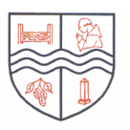

Monkton Church of England Primary School

Compassion, Courage, Justice
Jesus said, ‘Go and do the same.’
Our school has compassion at its heart, which inspires us to be people of courage, who care for ourselves, stand with others and seek justice as we grow and discover the world around us.

By knowing each individual, our learning environment is shaped to encourage creativity, promote challenge through our learning values and nurture spirituality, ensuring all thrive.

The Parable of the Good Samaritan

Luke 10:25-37 English Standard Version (ESV)

Christian Foundations
Compassion Courage
Justice
As a Federation, we are passionate about every individual flourishing, so that they can be nurtured and develop as well-rounded children, living life in all its fullness.

Every policy is written with our Christian Vision and Foundations in mind.

Introduction

Physical Education (PE) Policy

1 Aims and Objectives
1.1 Physical education develops the children’s knowledge, skills and understanding, so that they can perform with increasing competence and confidence in a range of physical activities. These include dance, games, gymnastics, swimming and water safety, athletics and outdoor adventure activities. Physical education promotes an understanding in children of their bodies in action. It involves thinking, selecting and applying skills and promotes positive attitudes towards a healthy lifestyle. Thus, children are enabled to make informed choices about physical activity throughout their lives. Since September 2012, our school has been part of the Thanet Passport to Sport whose aim is to support our school in the delivery of Physical Education and School Sports.

1.2 The aims of PE are:
- to enable children to develop and explore physical skills with increasing control and co-ordination;
- to encourage children to work and play with others in a range of group situations;
- to develop the way children, perform skills and apply rules and conventions for different activities;
- to increase children’s ability to use what they have learnt to improve the quality and control of their performance;
- to teach children to recognise and describe how their bodies feel during exercise;
- to develop the children’s enjoyment of physical activity through creativity and imagination;
- To develop an understanding in children of how to succeed in a range of physical activities and how to evaluate their own success.

2 Teaching and learning style
2.1 We use a variety of teaching and learning styles in PE lessons. Our principal aim is to develop the children’s knowledge, skills and understanding and we do this through a mixture of whole-class teaching and individual/group activities. At Monkton we have a specialist coaches – Team Theme, who deliver Key Stage 1 and 2 PE. The Physical Education coaches draw attention to good examples of individual performance as models for the other children and we encourage the children to evaluate their own work as well as the work of other children. Within lessons we give the children the opportunity both to collaborate and to compete with each other, and they have the opportunity to use a wide range of resources.

2.2 In all classes there are children of differing physical ability. Whilst recognising this fact, we provide suitable learning opportunities for all children by matching the challenge of the task to the ability of the child. We achieve this through a range of strategies:
- setting common tasks that are open-ended and can have a variety of results, e.g. timed events, such as an 50m sprint;
- setting tasks of increasing difficulty, where not all children complete all tasks, e.g. the long jump;
- grouping children by ability and setting different tasks for each group, e.g. different games;
- Providing a range of challenge through the provision of different resources, e.g. different gymnastics equipment.

3 PE Curriculum Planning
3.1 PE is a foundation subject in the National Curriculum. Team Theme are responsible for all PE planning our school. The planning for Key Stage 1 follows the National Curriculum guidance. In Key Stage 2 we teach compulsory dance, games, gymnastics, swimming, water safety, athletics and some outdoor activities as set out in the curriculum (September 2014) format.

3.2 The curriculum planning in PE is carried out in three phases (long-term, medium-term and short-term). The long-term plan maps out the PE activities covered in each term during the key stage. Team Theme plan all schemes of work for KS1 and KS2 and these are duly checked and signed off by the Head of School.

3.3 Medium-term plans by Team Theme give details of each unit of work for each term. These plans define what we teach and ensure an appropriate balance and distribution of work across each term. The Head of School has a copy of all these plans.

3.4 Team Theme complete the weekly plan for each PE lesson. These list the specific learning objectives for each lesson and give details of how the lessons are to be taught. These are shared with the teaching assistant in each class, as in some sessions the teaching assistant will take the lead with a small PE group or session.

3.5 We plan the PE activities so that they build upon the prior learning of the children. While there are opportunities for children of all abilities to develop their skills, knowledge and understanding in each activity area, there is planned progression built into the scheme of work, so that the children are increasingly challenged as they move up through the school.

3.6 Each lesson should contain the following elements:
Warm up
Activities including differentiation as required
Progression and continuity
Cool down, where appropriate

3.7 The whole school planning ensures that all children in Years 1-6 take part in 90 minutes of high-quality Physical Education each week. This consists of a weekly PE afternoon session for C2, C3 and C4. Each session starts at 1:30pm and ends @ 3:00pm. There are also opportunities for pupils to participate within a range of after school clubs which are run by experienced coaches from Team Theme assisted by a teaching assistant and accommodates both KS1 and KS2 throughout the academic year. In addition to this there is also a netball club organised and run by the teacher subject leader for PE.

4 The Early Years Foundation Stage
4.1 We encourage the physical development of our children in the reception class as an integral part of their curriculum. The reception class is part of the Early Years Foundation Stage. We relate the physical development of the children to the objectives set within the Good Levels of Development, which underpin the curriculum planning for children aged birth to five years of age. We encourage the children to develop confidence and control in the way they move, and the way they handle tools and equipment. We give all children the opportunity to undertake activities that offer appropriate physical challenge, both indoors and outdoors, using a wide range of resources to support specific skills. Early Years are also given the chance to participate in their own after school club run by sports coaches, in the latter part of the year.

5 Contribution of PE to teaching in other curriculum areas
5.1 English
PE contributes to the teaching of English in our school by encouraging children to describe what they have done and to discuss how they might improve their performance.

5.2 Computing
We use computing to support PE teaching when appropriate. In dance and gymnastics children can make video recordings of their performance, and use them to develop their movements and actions. Older children compare each other’s performance from recordings and use these to improve the quality of their work.

5.3 Personal, social and health education (PSHE) and citizenship
PE contributes to the teaching of personal, social and health education and citizenship. Children learn about the benefits of exercise and healthy eating, and how to make informed choices about these things.

5.4 Spiritual, moral, social and cultural development
The teaching of PE offers opportunities to support the social development of our children through the way we expect them to work with each other in lessons. Groupings allow children to work together and give them the chance to discuss their ideas and performance. Their work in general enables them to develop a respect for other children’s levels of ability, and encourages them to co-operate across a range of activities and experiences. Children learn to respect and work with each other, and develop a better understanding of themselves and of each other.

6 Teaching PE to children with Additional Educational Needs
6.1 Pupils with additional needs will be entitled to access the same range of physical education activities and school sports as their peers, as PE forms part of the school curriculum policy to provide a broad and balanced curriculum to all children. The PE provider plans learning opportunities that are matched to the needs of children with learning difficulties, and work in PE considers the targets set for individual children in their Personalised Support Plans or Education and Health Care Plans.

6.2 Pupils who are gifted and talented in aspects of physical education are identified and opportunities to develop their skills are provided through the school and Passport to Sport.

7 Assessment and Recording
7.1 The PE provider and class teaching assistant assess children’s work in PE by making assessments as they observe them working during lessons. They record the progress made by children against the learning objectives for their lessons. At the end of a unit of work, the coach makes a judgement against the National Curriculum levels of attainment. Team Theme use this information to plan the future work of each child. These records also enable the coach to make an annual assessment of progress for each child, as part of the child’s annual report to parents. The Team Theme coach will assess each child’s ability against the statements on Arbor, provided by the Subject Leader at the start of each term. These will be passed onto the class teachers to allow them to transfer this data to Arbor.

8 Resources
8.1 There is a wide range of resources to support the teaching of PE across the school. In our school hall, there is a climbing frame and a selection of gym benches and mats. Most of our small equipment is stored in the PE shed which is located in the playground; other resources such as multi skills and football equipment can be found in the P E cupboard in our school hall. Resources are only accessible to children under adult supervision. We use the school field for games and athletics activities and The Heron’s swimming pool for swimming lessons.

8.2 Our school has specialist coaches who deliver the planned sports curriculum to all pupils in KS1and KS2 supported by a classroom teaching assistant. The school is fully committed to improving the quality of PE through regular contact and active participation with Thanet Passport to Sport. The aim of the Passport to Sport is to aid our school in the participation of School Competitions as required. Experts are also used at different times of the year – e.g. Team Theme, staff from Passport to Sport, Invictus and Sports for Schools.

9 Health and Safety
9.1 The general teaching requirement for health and safety applies in this subject. We encourage the children to consider their own safety and the safety of others at all times. We expect them to change for PE into the agreed clothing for each activity area. The governing body expects the coaches and teaching assistant set a good example by wearing appropriate clothing when teaching PE. The policy of the governing body is that no jewellery is to be worn for any physical activity. It is also important that all children are aware of the correct way to handle equipment. High standards of behaviour are expected.

10 Extra-curricular Activities
The school offers a range of extra-curricular activities. These include multi-skills, netball, dance, archery football Skills, rounders’ and cross-country Training. The sports coach and school staff regularly inform the pupils of any extra-curricular activities from the Passport to Sport Partnership, local schools or the local community such as Monkton Youth Football Club. Our pupils have the opportunity to take part in matches against other schools in both netball and football. This introduces a competitive element to team games and allows the children to put into practice the skills that they have developed in their lessons. These opportunities foster a sense of team spirit and co-operation amongst our children.

11 Monitoring and Review
The monitoring of the standards of children’s work and of the quality of teaching in PE is the responsibility of both the subject leader and the coaches, who inform other staff about current developments in the subject, and provides a strategic lead and direction for the subject in the school. The Head of School works with the coach and other staff to organise a Sports Day each year.

12 Sports Funding
In April 2013, the Government announced new fund £150 million for physical education (PE) and sport in order to improve the quality and breadth of PE and sport provision. This funding is allocated to all maintained and state-funded schools with primary phase pupils from 1st September 2013. PE and Sports Premium Funding is confirmed for the academic year 2022-2023.
Schools are free to determine how best to use this funding to improve the quality and breadth of PE and sport provision, including increasing participation in PE and sport so that all pupils develop healthy lifestyles and reach the performance levels they are capable of. Details of how we spend our Sports Premium can be found in our report on the school website.
At Monkton CE Primary we are proud to provide a range of sports clubs and sporting experiences. It is important to us that our children are encouraged to live healthy active lifestyles, they enjoy and participate in physical activity, they develop the confidence, skills and attributes associated with good sportsmanship and leadership, as well as be given opportunities to engage in competitive sport and coaching.
Examples of provision at our school include: -
- weekly sport which includes, football, hockey, gymnastics, dance, multi- skills, rounders, games skills, basketball and athletics
- football, dodgeball, multi sports, lunchtime and after school clubs
- weekly access to qualified sports coaches
- access to competitive sports which include matches, tournaments and festivals, both after school and at weekends
- inter and intra school games
- Trained staff to deliver Forest School outdoor learning
- ‘sign posting’ pupils to extended school sports activities and clubs outside of school time
- sign posting pupils to holiday sporting activities
- celebrating sporting success in and outside school
- Key Stage 1 & 2 annual Sports Day
- dance activities
- sports activities during curriculum theme weeks
- swimming lessons in year 6 at a local pool

13 Swimming

Swimming lessons take place at Herons pool in Herne Bay, where the children are transported via coach. Years 5 and 6 take lessons for a total of 6 weeks each year.

13.1 Swimming is part of the National Curriculum and all children are therefore required to take part in swimming lessons. The school uses the local swimming pool in Herne Bay, and currently employs the pool’s swimming coaches to deliver swimming lessons. A qualified lifeguard is present at all times poolside when the children are in the water, this lifeguard is in addition to the swimming coaches.
13.2. Risk assessments have been conducted both by the pool and are kept by the office manager
13.3 Copies are kept of all swimming coaches’ qualifications are kept at the pool and at school, Safe Practice in Physical Education and School Sport, afPE (2008). The school has a swimming coordinator, normally the subject leader for PE.
13.4 Children will be escorted to the swimming pool by school staff who hold a current DBS check.
14 The Daily Mile
From Summer 2018 the children and staff at Monkton CEP School have been taking part in the Daily Mile. We want to get children here at Monkton fit for life and fit for learning. Therefore, our children take part in the Daily Mile. It is a physical activity which promotes, social, emotional and mental health and well-being, as well as fitness. It takes place outside on our school field, or on the playground if the grass is very wet or in the school hall on rainy days. Classes are free to choose the exact timing for the Daily Mile to take place in each school day, dependent on the curriculum and the needs of the children.

Progression of skills – see below.

Monkton currently employ Team Theme to deliver all curriculum PE lessons throughout the school week, with the exception of swimming lessons, which is delivered by swimming coaches at Herons in Herne Bay. Team Theme sports coaches are trained in a wide variety of sports and plan a balanced curriculum within each class. PE takes place over 1 afternoon a week, a total of 2 hours timetabled activity. In addition, each class is offered 1 after-school sports club each week, every term, in addition to any sports clubs offered by other members of staff such as netball. The children also take part in The Daily Mile during the course of each day with the exception of their allocated PE day.

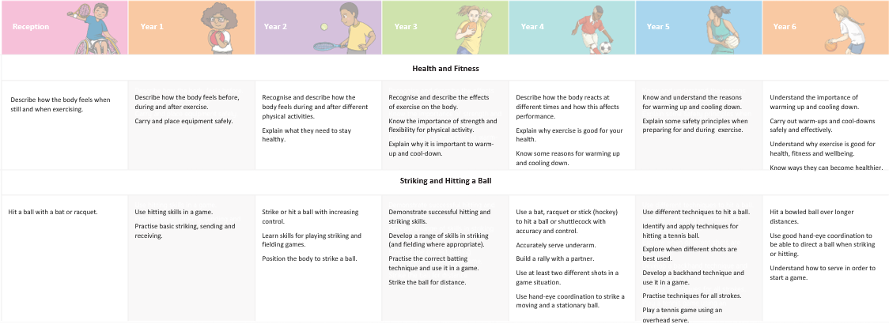
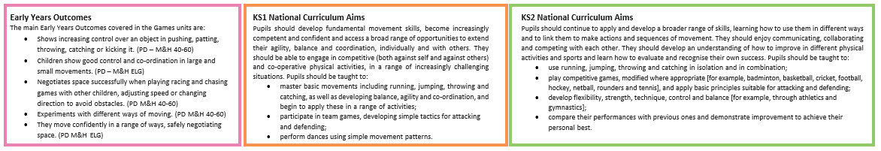
Games
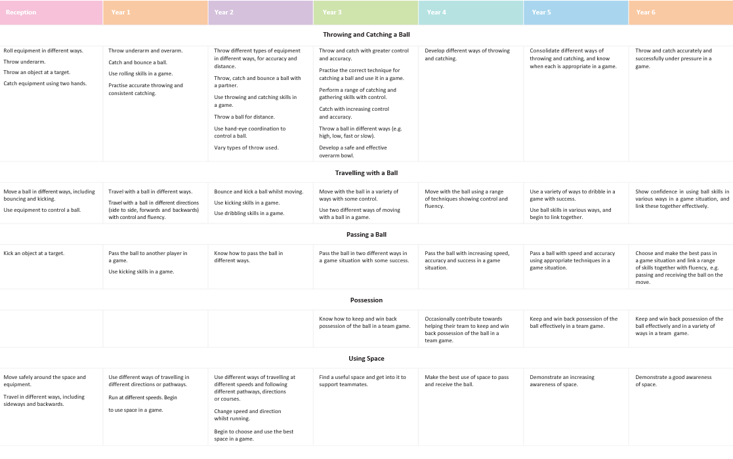
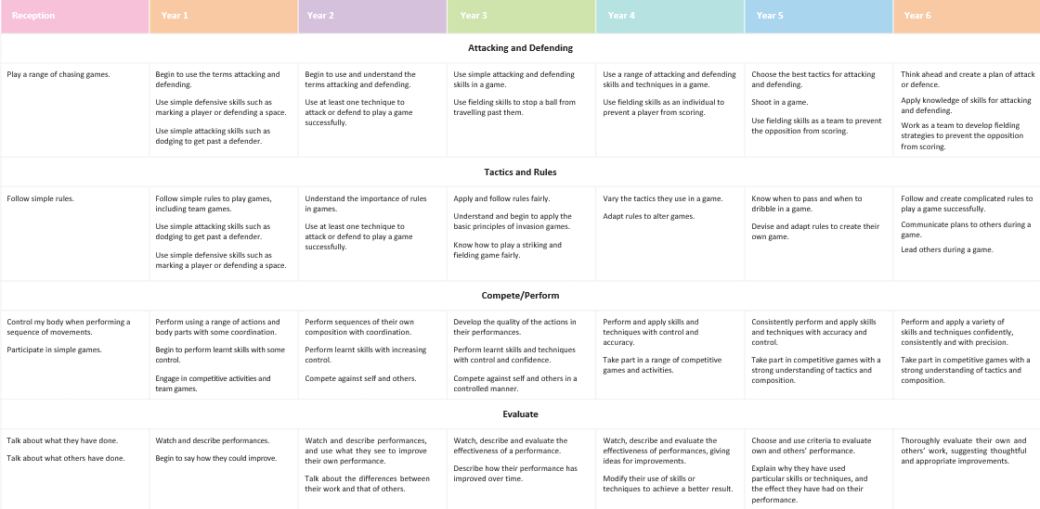
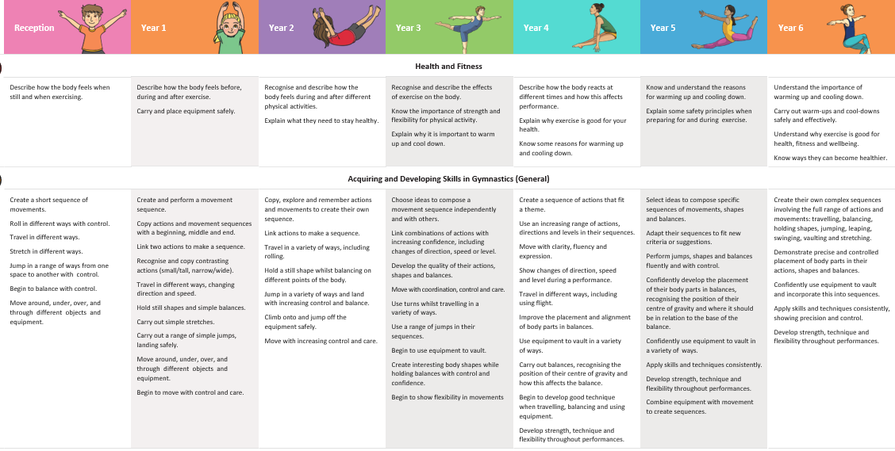
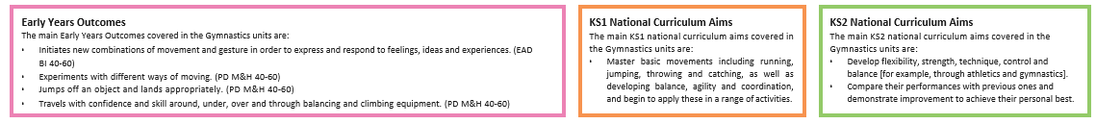
Gymnastics
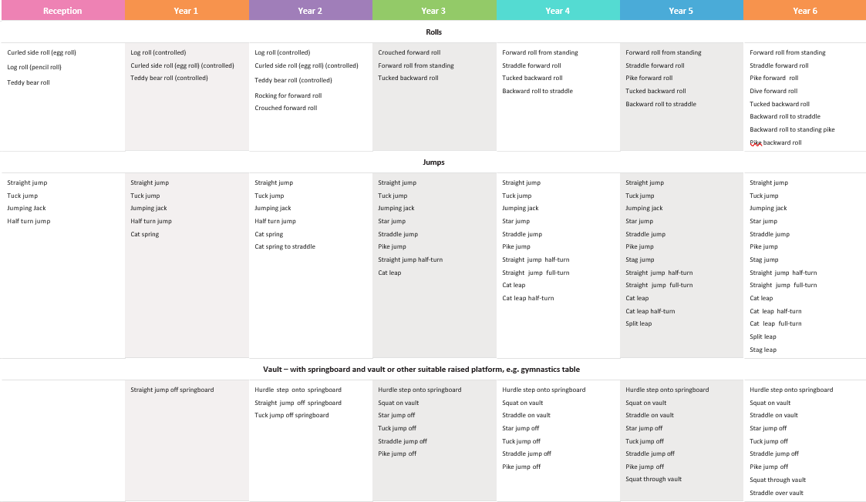
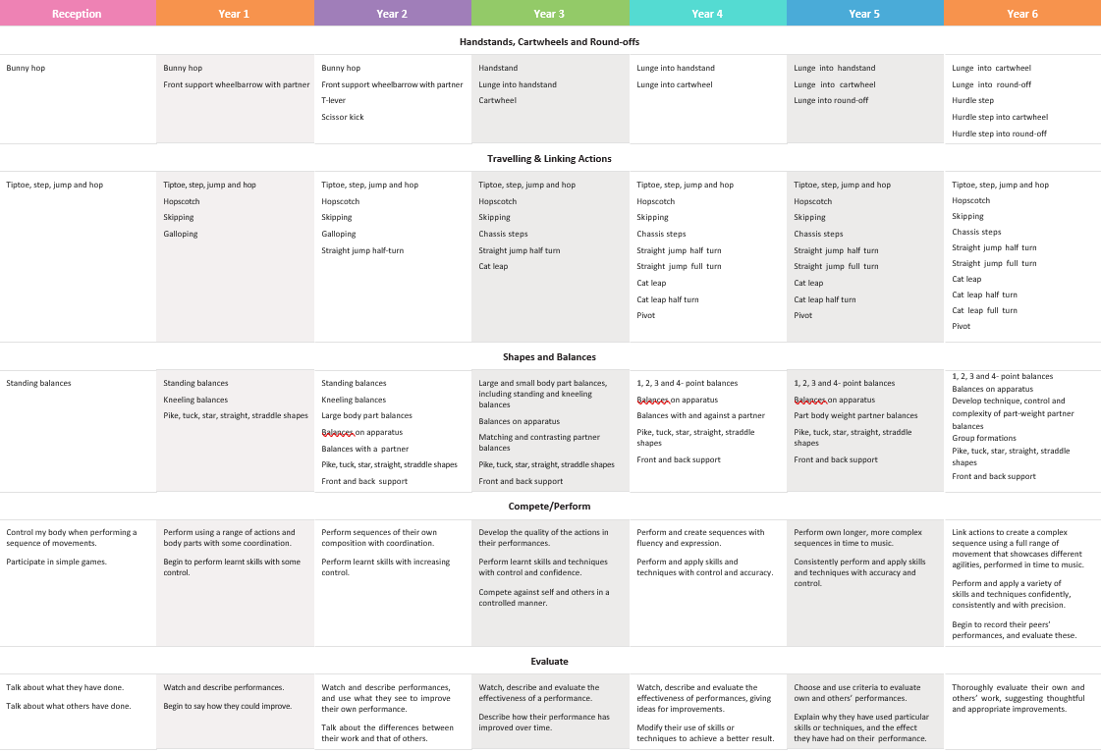
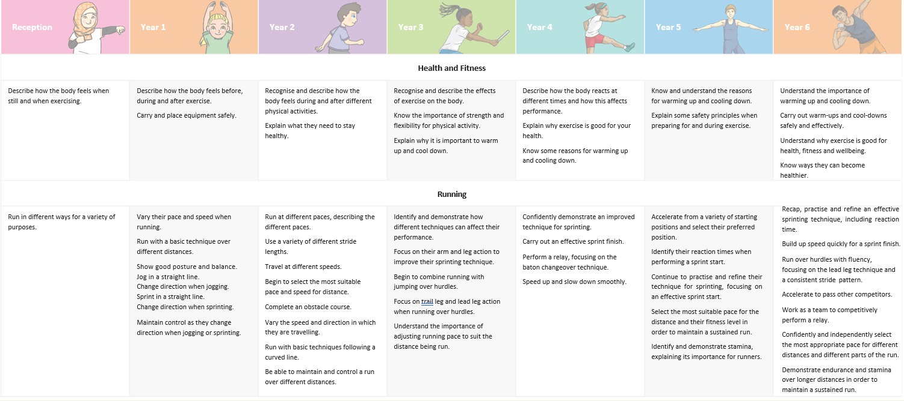
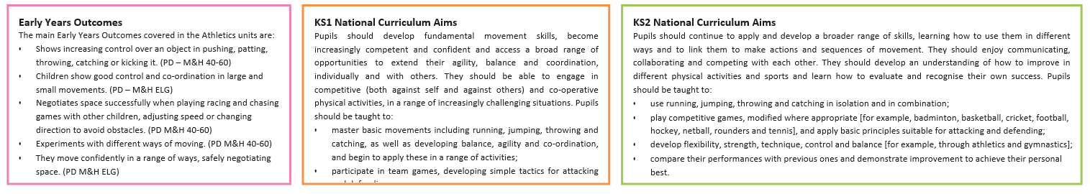
Athletics
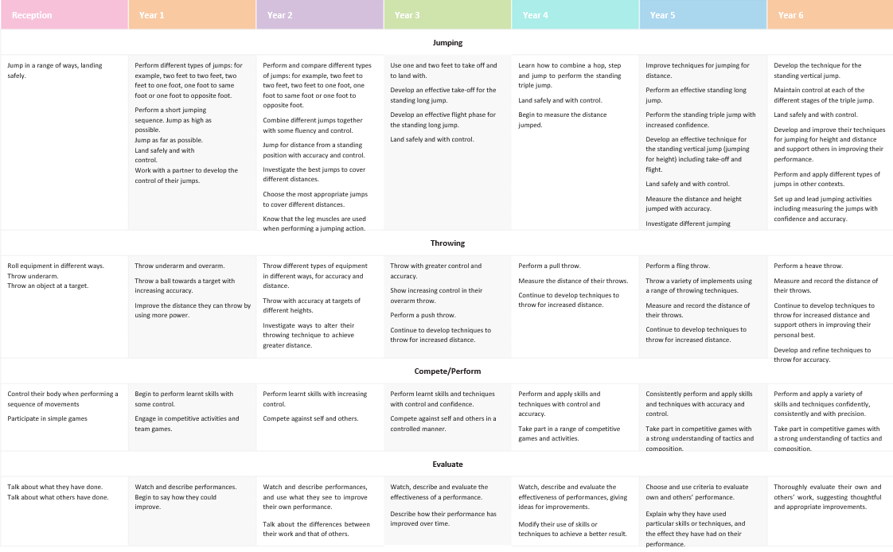
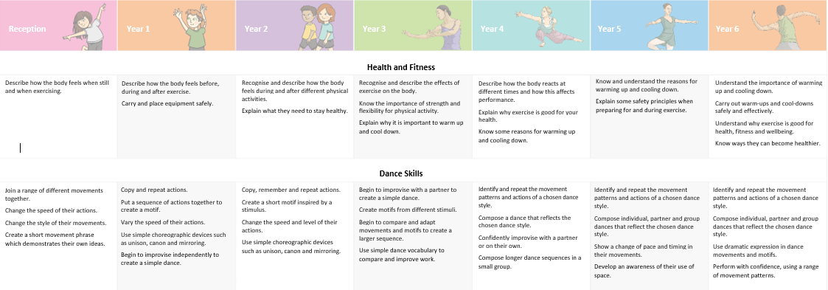
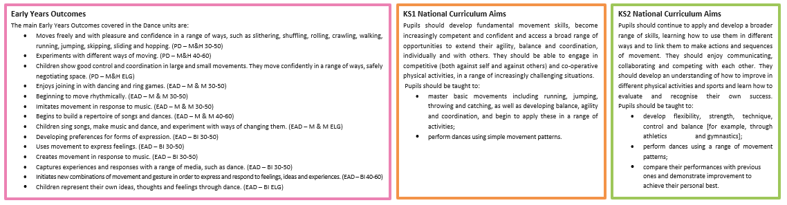
Dance
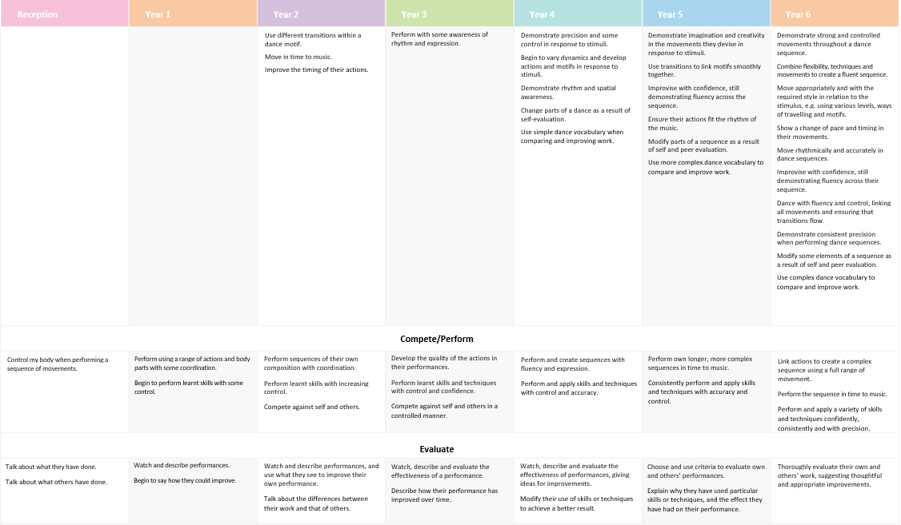
OAA- KS2 National Curriculum Aims
Pupils should continue to apply and develop a broader range of skills, learning how to use them in different ways and to link them to make actions and sequences of movement. They should enjoy communicating, collaborating and competing with each other. They should develop an understanding of how to improve in different physical activities and sports and learn how to evaluate and recognise their own success.
Pupils should be taught to:
- take part in outdoor and adventurous activity challenges both individually and within a team;
- compare their performances with previous ones and demonstrate improvement to achieve their personal best.
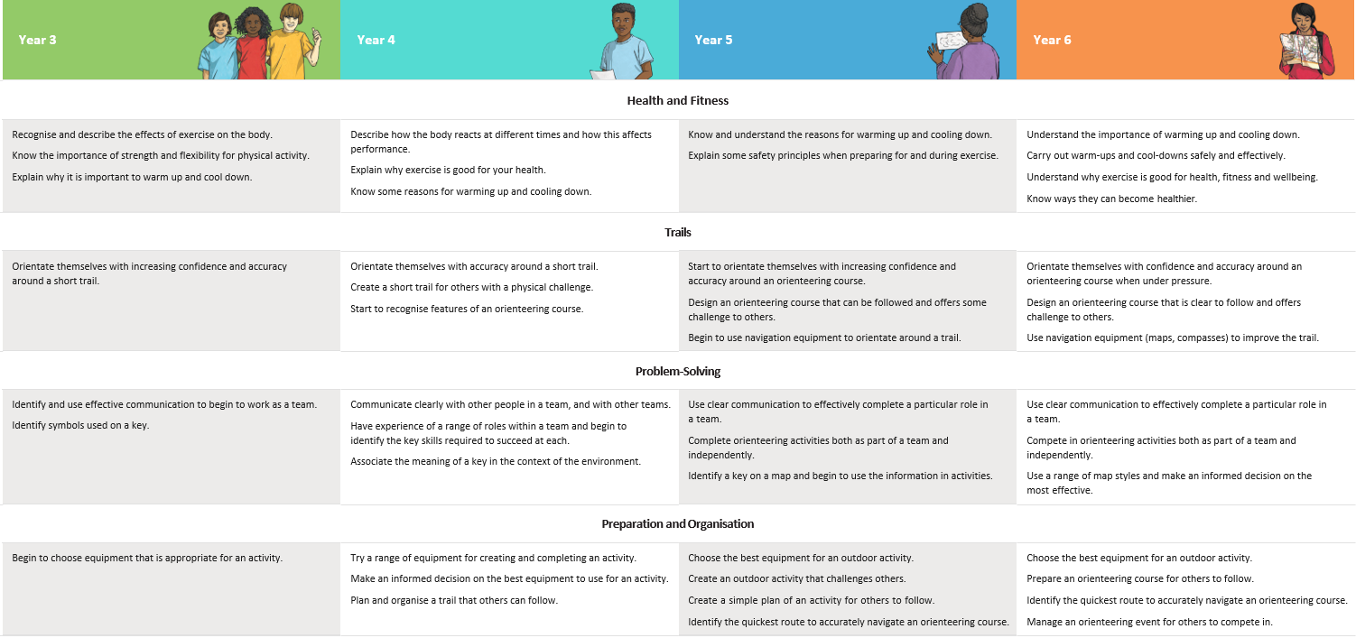
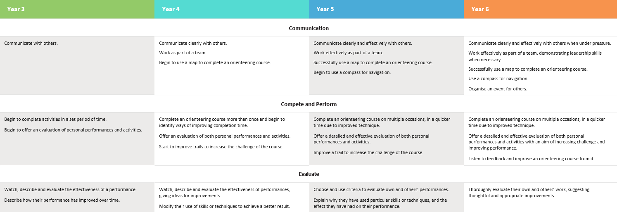

Swimming
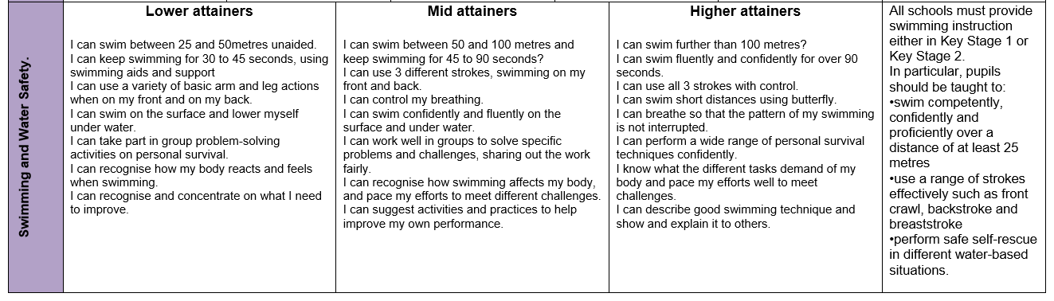
At Monkton, swimming takes place in years 5 and 6. This is provided by swim coaches at Herons Pool, Herne Bay for a total of 6 weeks each year.

