The Federation of Minster and Monkton Church of England Primary Schools

Relationships, Sex and Health Education Policy (RSHE)

Lead Person: Amy McCoy (Minster) Jo Guilder (Monkton)

Policy Date: October 2022

Review Date: October 2023

Signatures:

____________________ __________________
Chair of Governors Executive Headteacher

The Federation of Minster and Monkton Church of England Primary Schools

Our Joint Christian Values for the Federation

For the Federation process we have drawn on the story of the Road to Emmaus (Luke 24: 13-35). In this story, two disciples are journeying together talking about recent events. Someone, they later recognise to be Jesus, joins them and joins in the conversation reshaping what they know. When they eventually recognise who it is, the risen Jesus disappears; they return transformed to tell their story.

This story reflects the journey that the two schools have been walking together in recent times and how, through the process of Federation, the journey ahead will be one of transformation and growth.

Three values from this story are central to the Federation process for our two schools:

- Recognition – what are we seeing
- Communication – what are we saying
- Transformation – how can we change and grow

These three values will underpin the process towards Federation and the continued working together of the two schools.

Our Key Principles are:

- All children deserve the best opportunity to succeed and develop as a whole child
- We are committed to ensuring the wellbeing of all children and staff and providing an environment where each child is nurtured
- Children will grow and develop in a Christian setting, developing their individual spirituality
- We will celebrate the diversity and uniqueness of each individual’s skills and abilities
- To ensure the highest standards and best possible educational experience for all our children
- Providing a learning climate and culture that is fun and full of challenge, promoting independence,
resilience, engagement and high aspirations
- Passionate and effective leadership, supported by great teaching is the key to the continuous drive in
raising standards to be the best we can be
- Continuous professional development is a vital part of improving our school and we believe the most
effective form of this is learned from the sharing of good practice and working in partnership with
others, both in school and with other schools

Both schools have Christian Foundations that underpin everything we do and every policy is written with these in mind:

Minster Christian Foundations | Monkton Christian Foundations
Creation  Justice  Love  Forgiveness  Peace | Trust  Friendship  Compassion  Forgiveness  Justice

This SRE Policy clearly reflects the Federation values of:
Recognition / Communication / Transformation as the curriculum explores and communicates the emotional and physical development of children, recognises the importance of positive relationships and the equality of all.

It also directly links to many of the individual School Christian Foundations as above, emphasising how all individuals are created equally in the eyes of God and the different emotions and feelings that underpin relationships. It also shows the importance of both personal development and development in relation to the wider community mirroring the relationship of the Holy Trinity (three persons / one God).

Throughout the policy there are other specific references to how this relates to our Christian Foundations.

Contents
- Aims
- Statutory requirements
- Policy Development
- What we teach
- Curriculum Content
- Roles and Responsibilities
- Parents’ right to withdraw
- Training
- Monitoring Arrangements
- Links with other policies
- Appendices
Appendix 1 – Heartsmart coverage
Appendix 2 – Science and Sex education coverage
Appendix 3 – Parents letter to withdraw from Sex Education

1. Aims

At both Minster and Monkton we aim to provide a Relationships, Sex and Health Education (RSHE) programme that enables children to become healthy, independent and responsible members of their community and the wider society.
Our RSE education contributes to personal development by helping pupils to build their confidence, resilience and self-esteem, and to identify and manage risk, make informed choices and understand what influences their decisions. It enables them to recognise, accept and shape their identities, to understand and accommodate difference and change, to manage emotions and to communicate constructively in a variety of settings.
We aim to provide opportunities for children and young people to reflect on and clarify their own values and attitudes and explore the complex and sometimes conflicting range of values and attitudes they encounter now and in the future.
This develops an understanding of themselves, their empathy and the ability to work with others which will help pupils to form and maintain good relationships, develop the essential skills for future employability and better enjoy and manage their lives.

Our RSE education contributes to personal development by helping pupils to build their confidence, resilience and self-esteem, and to identify and manage risk, make informed choices and understand what influences their decisions. It enables them to recognise, accept and shape their identities, to understand and accommodate difference and change, to manage emotions and to communicate constructively in a variety of settings.
This develops an understanding of themselves, their empathy and the ability to work with others which will help pupils to form and maintain good relationships and better enjoy and manage their lives.
This policy reflects the Federation of Minster and Monkton Church of England Primary School’s ethos, Christian Foundations and philosophy to the teaching and learning of RSE.
It should be read in conjunction with the Relationships Education, Relationships and Sex Education (RSE) and Health Education document (DFE, 2019) and the Heartsmart Principles and values.

The aims of relationships, sex and health education (RSHE) at our school are to:
- Ensure children have a good understanding of how to form and maintain healthy relationships
- Provide a framework in which sensitive discussions can take place
- Prepare pupils for puberty, and give them an understanding of sexual development and the importance of health and hygiene
- Help pupils develop feelings of self-respect, confidence and empathy
- Create a positive culture around issues of sexuality and relationships
- Teach pupils the correct vocabulary to describe themselves and their bodies
- To allow pupils to understand how to keep themselves healthy

2. Statutory requirements

The DFE document states that:
‘Today’s children and young people are growing up in an increasingly complex world and living their lives seamlessly on and offline. This presents many positive and exciting opportunities, but also challenges and risks. In this environment, children and young people need to know how to be safe and healthy and how to manage their academic, personal and social lives in a positive way.’
(Secretary of State Foreword, 2019)

This is why RSHE is a vital aspect to our children’s education. Relationships education is the statutory part of it, however all of it is vital and inextricably linked with Character Education, which in both schools is an integral part of the intent of our curriculum.

As maintained primary schools we must provide relationships education to all pupils as per section 34 of the Children and Social work act 2017.
However, we are not required to provide sex education but we do need to teach the elements of sex education contained in the science curriculum.
In teaching Sex Education, we must have regard to guidance issued by the secretary of state as outlined in section 403 of the Education Act 1996.
At both Minster and Monkton Church of England Primary Schools we teach Sex Education as set out in this policy.

3. Policy development

This policy has been developed in consultation with staff, pupils and parents. The consultation and policy development process involved the following steps:
- Review – a member of staff or working group pulled together all relevant information including relevant national and local guidance

- Staff consultation – all school staff were given the opportunity to look at the policy and make recommendations

- Parent/stakeholder consultation – parents and any interested parties (including Governors) were invited to read the policy draft and respond with their thoughts. It was done in this way due to Covid-19 restrictions.

- Pupil consultation – we investigated what exactly pupils want from their RSHE

- Ratification – once amendments were made, the policy was shared with governors and ratified

4. What we teach

We want to deliver a very well rounded RSHE curriculum for our children. Therefore, we have a curriculum plan that we follow that covers the key aspects of RSHE as well as the areas of relationships, sex and health education that we are required to cover, as set out in the statutory guidance (linked to above).

Curriculum Content

In our Federation, RSHE is taught within our HeartSmart sessions, delivered weekly. The teachers will select the most appropriate way to deliver the sessions based on the age of the children and the nature of each individual lesson.
The Heartsmart curriculum helps to provide the toolkit for developing our children and their Character Education to ensure they have knowledge, understanding and experience of well-being education and practices and knowledge of how to develop healthy relationships.
Through 5 carefully planned topics (with our Christian Foundations as the backbone), we aim to embed our learning about personal development, building our children’s character and promoting a healthy lifestyle.
The RSHE Policy and our Character Education Policy are inextricably linked because of the way they develop our children as individuals, preparing them for life. For example, the RSHE education focuses on teaching the fundamental building blocks and characteristics of positive relationships including:
- Families and people who care for me
- Caring friendships
- Respectful relationships
- Online relationships
- Being safe

All of our RSHE areas of learning are taught within the context of family life taking care to ensure that there is no stigmatisation of children based on their home circumstances. Families can include single parent families, LGBT parents, families headed by grandparents, adoptive parents, foster parents/carers amongst other structures, along with reflecting sensitively that some children may have a different structure of support around them (for example: looked after children or young carers).

Our termly topics are:
- Get Heartsmart (meet Boris)
- Don’t Forget To Let Love In (I am Special)
- Too Much Selfie Isn’t Healthy (I love others)
- Don’t Rub It In, Rub It Out (I am a good friend)
- Fake Is A Mistake (I tell the truth)
- ‘No Way Through’, Isn’t true (I can do it!)

For further details please see the detailed framework showing coverage of RSHE at the end of this policy.
In our Federation, Sex Education is taught within the RSHE curriculum within our HeartSmart sessions, delivered weekly. Biological aspects of Sex Education are taught within the science curriculum, and other aspects are included in religious education (RE). The teachers will select the most appropriate way to deliver the sessions based on the age of the children and the nature of each individual lesson.
Our curriculum is formed by following the Heartsmart scheme of work and of course the relevant sections in the National Curriculum for Science. The detailed framework showing coverage of both Relationships and Health Education within Heartsmart is found at the end of this policy.
We have developed the curriculum in consultation with parents, pupils and staff, considering the age, needs and feelings of pupils. If pupils ask questions outside the scope of this policy, teachers will respond in an appropriate manner so they are fully informed and don’t seek answers online.

This is the statutory aspect of Relationship and Science education that as a parent you cannot opt out of.

However, as a Federation we have decided to offer sex education in Year 6 for our pupils. This will focus on:
- Preparing boys and girls for the changes that adolescence brings
- How a baby is conceived and born

We are happy to support parents in their understanding of the differences between what the children HAVE to learn and what they can be withdrawn from.
For more information about our curriculum, please see the Appendices. Please also see the document that outlines the aspects of the Science curriculum that form part of SRE as well as the stand-alone sex education for Year 6 children (Appendix 2).

6. Roles and responsibilities
6.1 The governing board
The governing board will approve the RSHE policy, and hold the headteacher to account for its implementation. For the purposes of this policy the word headteacher is used to represent the Executive Headteacher and the Heads of School.
6.2 The headteacher
The headteacher is responsible for ensuring that RSHE is taught consistently across the school, and for managing requests to withdraw pupils from [non-statutory/non-science] components of RSHE (see section 8).
6.3 The subject leader
- To undertake monitoring of standards in RSHE and use this to inform the subject action plan.
- Provide leadership and management of their subject to secure high-quality teaching and learning.
- Play a key role in motivating, supporting and modelling good practice for all staff.
- Take a lead in policy development and review
- To liaise with outside agencies and attend subject specific courses.
- To report to the Head teacher and Governing Body on RSHE-related issues.
- To plan and organise the allocation and purchase of resources in accordance with available budget.

6.4 Staff
Staff are responsible for:
- Delivering RSHE in a sensitive way
- Modelling positive attitudes to RSHE
- Monitoring progress
- Responding to the needs of individual pupils
- Liaising with Parents of children in their class where necessary
- Responding appropriately to pupils whose parents wish them to be withdrawn from the [non-statutory/non-science] components of RSHE

Staff do not have the right to opt out of teaching RSHE. Staff who have concerns about teaching RSHE are encouraged to discuss this with the Executive Headteacher/Head of School. This involves all staff as all teachers will be expected to teach Heartsmart and the Science curriculum that is appropriate for the year group they teacher. The Sex education section, which parents can opt out of, will take place as a short block of teaching in Year 6. Year 6 teachers are expected to lead this learning. For help and advice they can speak to the Relationships, Sex and Health Education leaders for the school, they are Amy McCoy at Minster and Jo Guilder at Monkton.
6.5 Pupils
All Pupils are expected to engage fully in RSHE and, when discussing issues related to RSHE, treat others with respect and sensitivity.
However, as a school we recognise that some children may need aspects of the curriculum, or how it is delivered to be adjusted in order to meet the needs of individuals.
Support for SEND children follows the school’s Inclusion Policy. The study of Heartsmart and Science will involve all children within the class in a variety of differentiated ways addressing all learning styles.

The class teacher will also ensure that the needs of any exceeding children, who require further challenge, in their class are met through the lesson planning for this subject.

7. Parents Right to Withdraw

Parents do not have the right to withdraw their children from relationships education.
Parents have the right to withdraw their children from the [non-statutory/non-science] components of sex education within RSHE which will take place in Year 6. A letter will be sent at the start of the term to introduce questions and areas that will be covered. See Appendix 3.
Requests for withdrawal should be put in writing using the form found in Appendix 4 of this policy and addressed to the headteacher.
Alternative work will be given to pupils who are withdrawn from sex education.

8. Training

Staff are trained on the delivery of RSHE as part of their induction and it is included in our continuing professional development calendar.
The headteacher will also invite visitors from outside the school, such as school nurses or sexual health professionals, to provide support and training to staff teaching RSHE as and when it is felt necessary.

9. Monitoring arrangements

The delivery of RSHE is monitored by the RSHE Leaders for the individual schools. They are Amy McCoy at Minster and Jo Guilder at Monkton. They will do this through:
- Observation of individual lessons and learning walks
- Monitoring of children’s books
- Discussions between teaching staff and with children
- Observation of the learning environment
- Regularly using Arbor

This policy will be reviewed every year as is the statutory requirement. It will be completed by the leaders of RSHE in each school working as a team. They will consult with other stakeholders and take account of any national changes that need to be addressed. The policy will then go to the relevant Governor team for review and minuted at the following Full Governing Body meeting that it has been reviewed.

10. Links with other policies

This policy links to the following policies and procedures:

- Character Education Policy
- Behaviour Policy

11. Appendices

Appendix 1 - Detailed Framework showing coverage of RSHE – cannot opt out

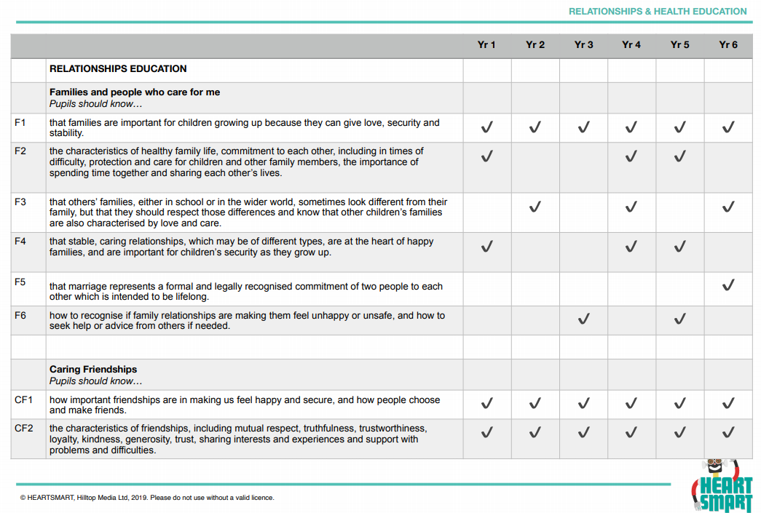

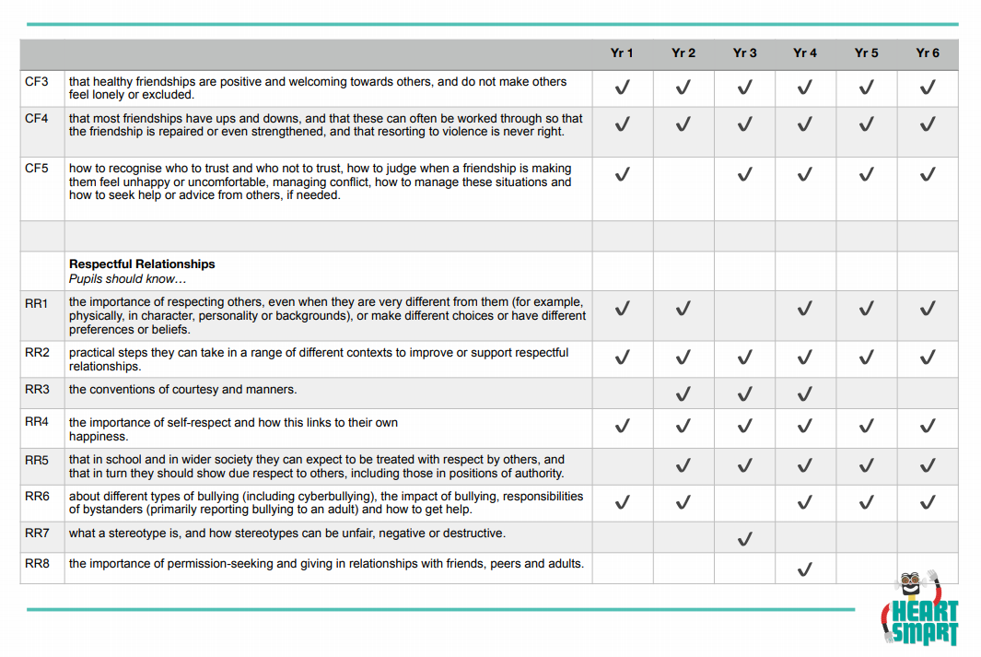
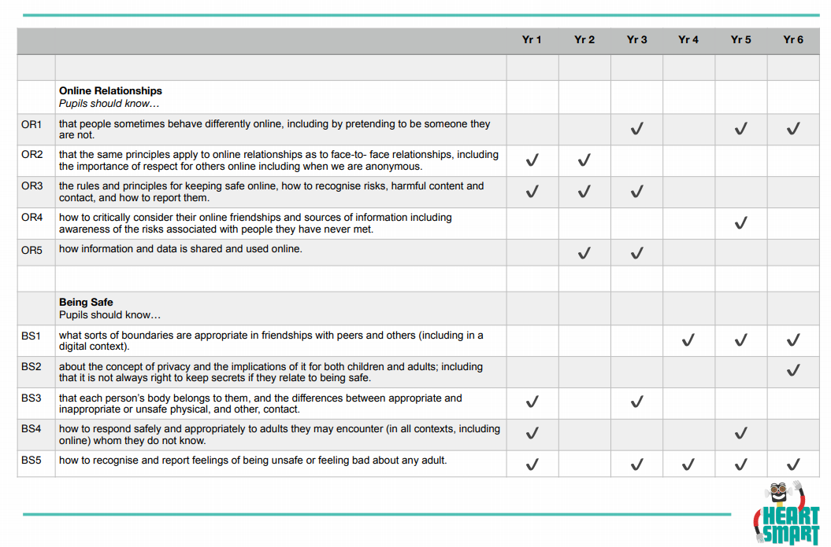

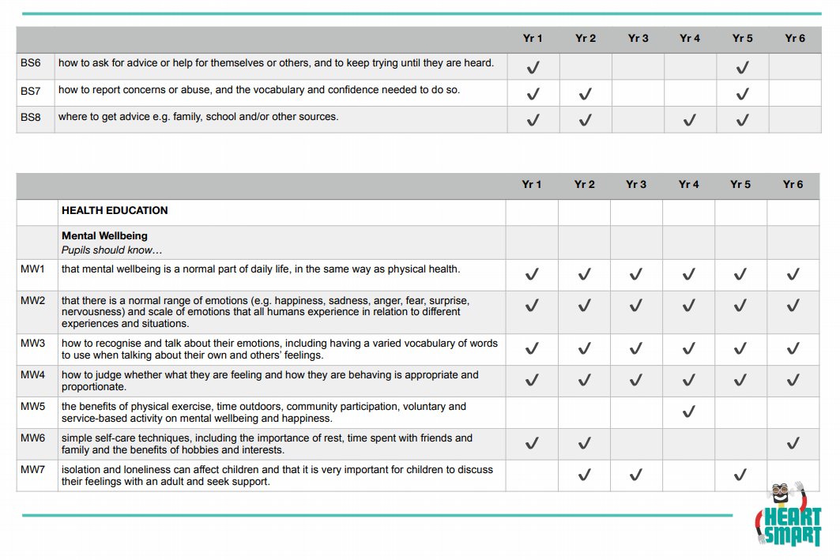

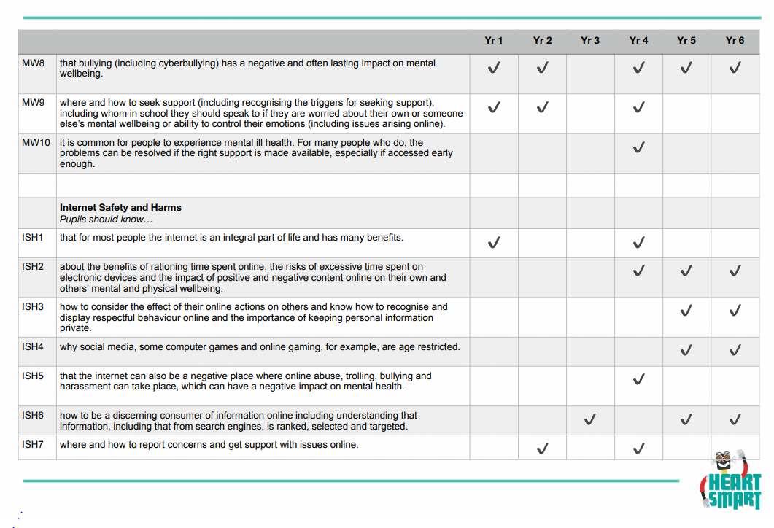
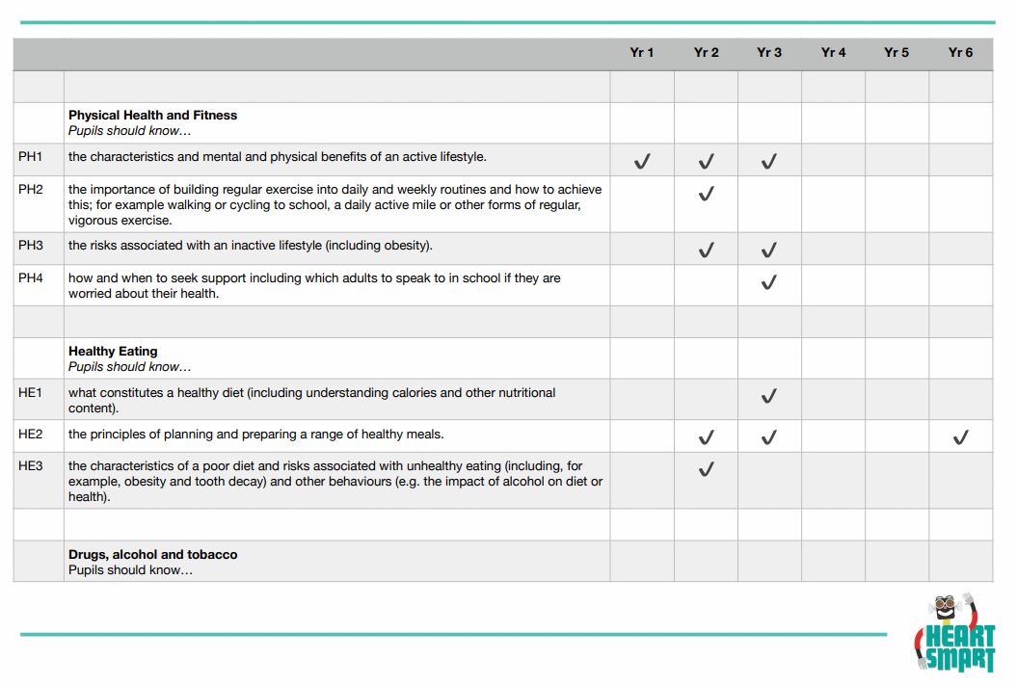

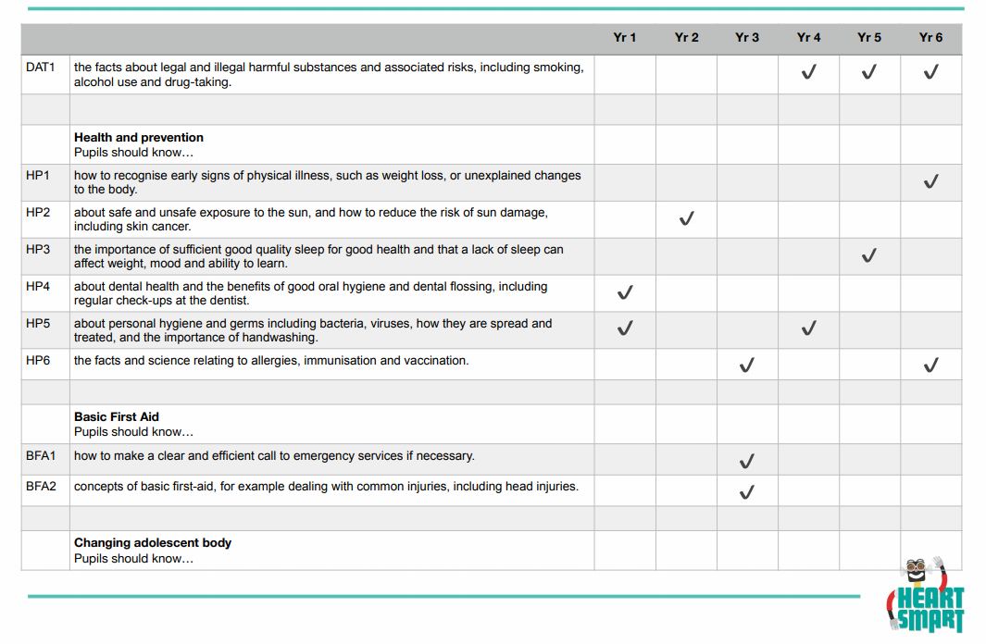

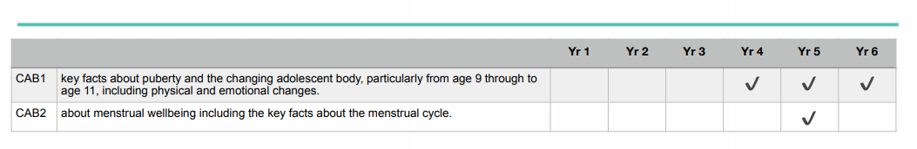

Appendix 2 – Table to show coverage of Science and Sex Education

 | Science  (cannot opt out) | Sex Education  (can opt out)
EYFS | Pupils should be taught to:  ♣ he/she knows about similarities and differences in relation to places, objects, materials and living things. He/she makes observations of animals and plants and explains why some things occur, and talk about changes.
Year 1 | Pupils should be taught to:  ♣ identify, name, draw and label the basic parts of the human body and say which part of the body is associated with each sense.
Year 2 | Pupils should be taught to:  ♣ notice that animals, including humans, have offspring which grow into adults  ♣ find out about and describe the basic needs of animals, including humans, for survival (water, food and air)
Year 3
Year 4
Year 5 | Pupils should be taught to:  ♣ describe the changes as humans develop to old age including puberty and the menstrual cycle.  ♣ describe the life process of reproduction in some plants and animals.
Year 6 | Pupils should be taught:  ♣ about where to get more information, help and advice about growing and changing, especially about puberty. | Pupils should be taught:  ♣ about the processes of reproduction and birth as part of the human life cycle; how babies are conceived and born (and that there are ways to prevent a baby being made); how babies need to be cared for.

Appendix 3 – Form for parents to opt out of Year 6 Sex Education

TO BE COMPLETED BY PARENTS
Name of child |  | Class
Name of parent |  | Date
Reason for withdrawing from sex education within relationships, sex and health education
Any other information you would like the school to consider
Parent signature

Appendix 4- Letter to be sent home at the start of the term

Dear Parent/Carer,

Sex Education in Year 6,
During this term we will be looking at the following areas as part of our Relationships, Sex and Health Education (RSHE) within school. These topics cover both the RSHE curriculum as well as some of the Science curriculum.

Your child will be studying the topics as detailed in the Science/RSHE table,
through the following questions:
• What sort of relationships do I have and how have they changed?
• What other types of relationships are there?
• How can I maintain and improve my relationships?
• Why are love and trust important?
• What or who might influence my decisions?
• Who can I ask for help? Where else might I get help?
• What should adults think about before they have a baby?
• How are babies made?
• How do parents not have babies?
• How does a baby develop in the uterus?

Appropriate questions that arise from the children during each lesson will be answered honestly. We recognise that parents play an important part in their child’s RSHE, and we would like to encourage you to explore these questions / topics with your child at home as well.

You have the right to withdraw your child from the elements of RSHE which are not included in the National Curriculum. Please see the table to see which elements are statutory in our Science/RSHE and which are not. If you would like to discuss this, please contact the Head of School. If you have any questions about the curriculum and its coverage please contact the class teacher or the RSHE leader.

Yours Sincerely

RSHE leader

