Topic – Childhood
Monkton Church of England Primary School
Newsletter for
Term 1 – Class 2
Compassion, Courage, Justice – Jesus said, ‘Go and do the same.’

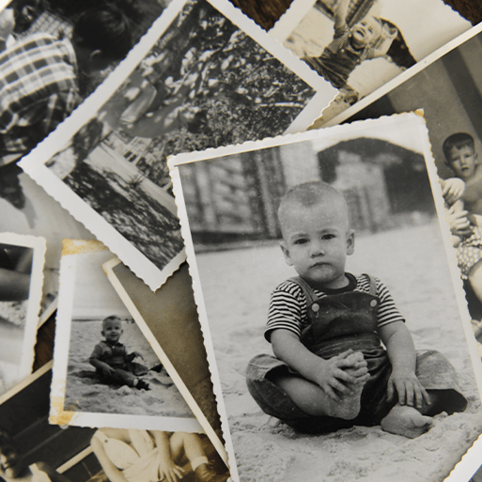
Subjects | What the children will be learning
Reading | Little Wandle Reading groups will be starting this term with new groups
Writing | Autobiographies; Non-chronological reports; Riddles
Maths | Place value and Addition and subtraction
Religious Education | Creation – Who made the world?
Science | The Human Body
Geography | Settlements; Changes over time. Physical and human features; Picture maps; Cardinal compass points; Equator and hemispheres; Continents; Oceans; Countries and capital cites of the UK; Protecting natural environments; Fieldwork
History | Historical vocabulary; Historical artefacts; Timelines; Everyday life and childhood in the 1950s; Significant events – Queen's coronation; Enquiry
Computing | Programming - Moving a Robot
Art and Design | Funny Faces and Fabulous Features - Portraiture; Collage
Design and Technology | Funny Faces and Fabulous Features - Stitching to join materials; Embellishing
Physical Education | Football and Handball
Relationships and Health Education | Stages of life; Changes & Get Heartsmart
Music | Time to play– Exploring pulse and rhythmic patterns

Vocabulary
English | Maths | Themed Words
biography  auto-biography  past tense  present tense  sequence  non-chronological  non-fiction  layout  punctuation  riddle  description | Place value  digit  tens  ones  value  numeral  addition  add  plus  subtraction  minus  take away  equals | adult  artefact  family tree  baby  birthday  teenager  child  toddler  childhood  wedding  coronation  elderly
An Inspirational and Ambitious Curriculum – Trips and Experiences
Friday 22nd September – 2pm
We would like to invite grandparents in to school for the afternoon so that the children can teach them some
modern day games and hopefully the grandparents can also teach them some games from their childhood.

Key Dates for Term
PE – will take place on a Wednesday morning (indoor) and Thursday afternoon (outdoor) so please make sure PE kits are in school for these days. Our after-school sports club will also run on a Tuesday – see separate information.
Wednesday 13th September – 2.30pm – Meet the teachers
Friday 22nd September – AM only – Forest school
Friday 20th October – AM only – Forest School

