Monkton Church of England Primary School
Newsletter for Class 3
Term 1 –“Through the Ages”
Compassion, Courage, Justice – Jesus said, ‘Go and do the same.’

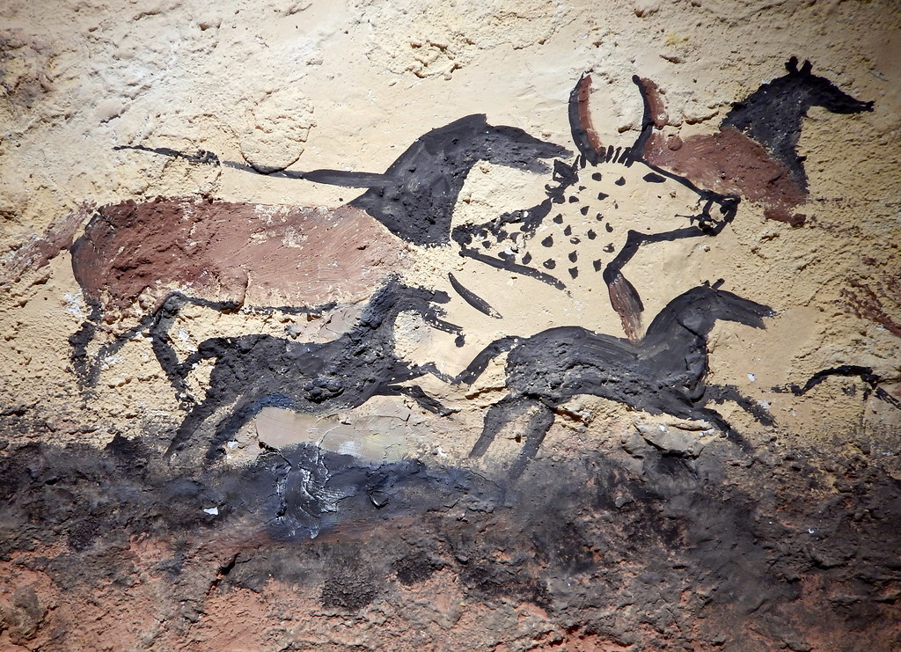
Welcome to a new school year in Class 3! Mrs Vesty and Mrs Horton have lots of exciting learning activities
planned for years three and four and are looking forward to sharing them with all of you. Our first topic of the year focusses on the Stone age, Bronze age and Iron age. We’ll be exploring this varied topic using our PRIDE learning values in lots of creative ways and we will be enjoying the classic text, ‘Stig of the Dump’ by Clive King. Our focus for home learning will be learning and practicing multiplication tables using Times Table Rock Stars and reading practice as much as possible.
Subjects | What the children will be learning
Reading | “Stig of the Dump” by Clive King/ “Stone Age Boy” by Satoshi Kitamura/ “The secrets of Stonehenge” by Mick Manning (Non-fiction)
Writing | Writing descriptive narratives and instructions
Maths | Exploring place value, addition, and subtraction. Year 4 will also investigate measuring area.
Religious Education | What do Christians learn from the Creation story?
Science | Skeletons, bones and joints. Nutrition and diet.
Geography | Analysing maps and atlases, four figure grid references,  plate tectonics, the Earth’s layers.
History | Life in the Stone Age and Bronze Age
Computing | Connecting Computers- understanding networks and linked devices.
Art and Design | Exploring the colour wheel and mixing colours to create cave paintings.
Design and Technology | Cook well, eat well: Exploring food groups and designing a healthy and delicious taco filling.
Physical Education | Football and Handball
Relationships and Health Education | Get Heart Smart! How to care for the feelings and wellbeing of ourselves and others.

Vocabulary
English | Maths | Themed Words
character/ setting/ plot  direct speech/ speech marks  prepositions  adverbs/ adjectives | place value/ digit/ estimate  ones/ tens/ hundreds/ thousands  addition/ subtraction/ partitioning Year 4- exchange/ inverse | Centuries/ Millenia/ Chronology  Neolithic/ Mesolithic/ Palaeolithic  Weapons/ Tools/ Settlement  Hunter/ Farmer/ Tribe

An Inspirational and Ambitious Curriculum – Trips and Experiences
Wednesday 20th September: Class trip to Dover Museum and Bronze Age Boat. We will spend the day exploring this fascinating museum; we will make a clay reconstruction of the Bronze age boat and then enjoy some hands-on exploration of local artefacts from the Stone age, Bronze age and Iron age.

Key Dates for Term
PE days: Tuesdays (Outdoors) and Thursdays
Forest School: Friday 15th September and Friday 13th October
Meet the Teacher afternoon: Thursday 14th September.
Class Trip to Dover Museum: Wednesday 20th September.

