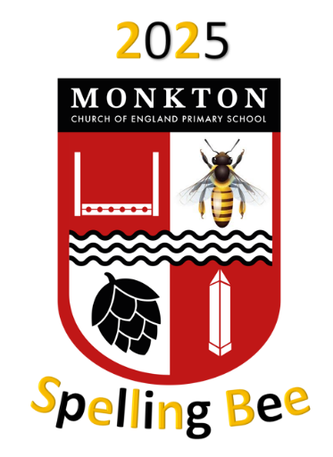

Dear Children and Parents,

Please find below a list of spellings that you have already been learning (from Term 1, 2 and 3) and also some words that you will be learning in the future (Term 4, 5 and 6 words).

Your task is to take these words home and learn them. You can learn them in whatever way you would like. You can do it on your own, with mum and dad or even the dog (woof is not a word to be tested on).

On the 24th March, you and your classmates will be tested to see how many words you have learnt to spell. The pupil with the most words spelt correctly will go through to the grand final which will be held in front of a live audience in the final week of term. Good luck and happy slepping!!

**Year 6 Spellings**

|  |  |  |
| --- | --- | --- |
| atrocious | invincible | psychiatrist |
| scrumptious | justifiable | yacht |
| residential | preconceived | temperature |
| superstitious | privilege | suite |
| committee | hindrance | prophet |
| independence | thoroughfare | storey |
| convenience | prejudice | foreign |
| controversy | recommend | harass |
| conscience | obscene | accommodate |
| Knowledgeable | campaign | mischievous |

