Dear Parent/Carer
IT’S NOT TOO LATE TO JOIN THE CHOIR AND HAVE A SING-A-LONG WITH MR MARSTON!
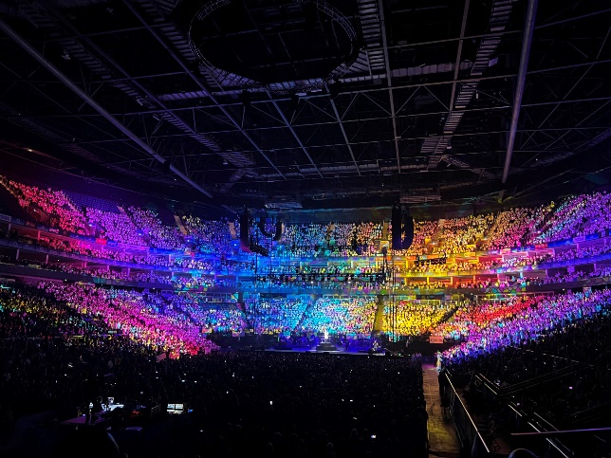
Young Voices 2024 Promises to be Spectacular!
As your child has joined Choir this year, they have the fantastic opportunity to take part in the Young Voices performing at the 02 Arena on 16th January 2024.
For those of you who are new to choir and to the Young Voices experience - take a look at www.youngvoices.co.uk to see what the fuss is all about. I guarantee you will catch the bug and want to come along every year!
As a school, we need to confirm our choir numbers very soon and it is vital that ALL parents/carers complete the slip below and return it to school NO LATER THAN Monday 25th Sep.
There is no cost for your child to attend this spectacular event. Each child will receive a Young Voices Choir pack which will include a T-shirt to wear on the day.
Below please could you indicate whether or not your child wishes to attend the concert. If so, can you highlight their t-shirt size, along with how many audience tickets you would like to buy. Choir members DO NOT need to purchase tickets as t-shirt and travel expenses are covered by the club costs. This is purely for you and your family members who wish to come and watch the show. Tickets are £25 per person (details of audience ticket payment system to follow).
Again, I must re-iterate that ALL parents/carers need to complete and return the slip below by Monday 25th September.
I really hope that your child is able to attend and enjoy the most amazing experience!
Yours faithfully
Mr Marston
Head of Choir and Former Z Factor winner

To: Reception Office, Monkton CofE Primary School
Name of Child …………………………………………………………………………………. Class …………………………………..
*Yes, my child would love to be part of the world’s largest choir on 16th January 2024.
*No, my child will not be taking part in Young Voices on 16th January 2024.
I would like to purchase ____________ audience tickets (please indicate below if you have any special seating requests, e.g. wheelchair access).
My child will need a size (CIRCLE THE CORRECT SIZE):
Age 7-8
Age 9-11
Age 12-13
Adult Small
Adult Medium
Adult Large
Adult X Large
Signed …………………………………………………………………………………
Name of Parent/Carer ……………………………………………………………
Date …………………………………………………………………………………….
*delete as appropriate

