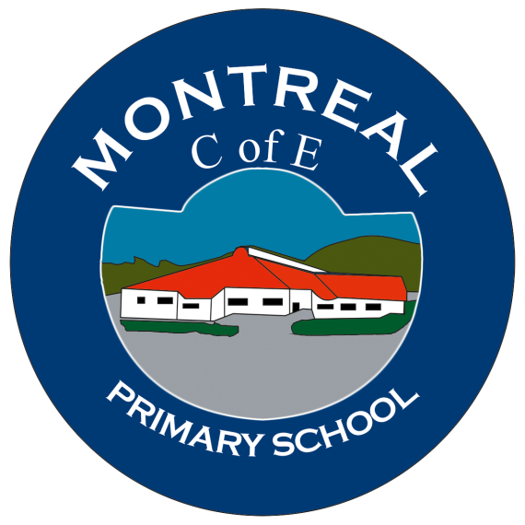
National Curriculum 2014: Progression in Art - Based upon the Durham County Council Progression of Skills Document.

 |  | Year 1/2 |  | Year 3/4 |  | Year 5/6
NC Statements | Pupils should be taught to:  - Use a range of materials creatively to design and make products.  - Use drawing, painting and sculpture to develop and share their ideas, experiences and imagination.  - Develop a wide range of art and design techniques in using colour, pattern, texture, line, shape, form and space. |  | Pupils should be taught to:  - Create sketch books to record their observations and use them to review and revisit ideas.  - Improve their mastery of art and design techniques including drawing, painting and sculpture with a range of materials (for example, pencil, charcoal, paint, clay).
Creating Ideas | For instance:  - Work from observation and known objects  - Use imagination to form simple images from given starting points or a description  - Begin to collect ideas in sketchbooks  - Work with different materials  - Begin to think what materials best suit the task |  | For instance:  - Develop sketch books  - Use a variety of ways to record ideas including digital cameras and iPads  - Develop artistic/visual vocabulary to discuss work  - Begin to suggest improvements to own work  - Experiment with a wider range of materials  - Present work in a variety of ways |  | For instance:  - Select and develop ideas confidently, using suitable materials confidently  - Improve quality of sketchbook with mixed media work and annotations  - Select own images and starting points for work  - Develop artistic/visual vocabulary when talking about own work and that of others  - Begin to explore possibilities, using and combining different styles and techniques

 | Drawing and mark making | For instance:  - Begin to control lines to create simple drawings from observations.  - Use thick felt tip pens/chalks/charcoal/wax crayon/ pastel.  - Hold a large paint brush correctly.  - Make marks using paint with a variety of tools.  - Consider consistency when applying paint  - Colour within the line.  - Draw on smaller and larger scales.  - Begin to add detail to line drawings. | For instance:  - Use sketchbooks to record drawings from observation.  - Experiment with different tones using graded pencils.  - Include increased detail within work.  - Draw on a range of scales.  - Draw using a variety of tools and surfaces (paint, chalk, pastel, pen and ink).  - Use a variety of brushes and experiment with ways of marking with them.  - Develop shadows.  - Use of tracing. | For instance:  - Use first hand observations using different viewpoints, developing more abstract representations.  - Introduce perspective, fore/back and middle ground.  - Investigate proportions.  - Use a range of mediums on a range of backgrounds.  - Work indoors and outdoors.  - Show total qualities using cross hatching, pointillism, sidestrokes, use of rubber to draw/highlight
 | Working with Colour | For instance:  - Recognise and name primary and secondary colours.  - Mix primary colours to make secondary colours.  - Share colour charts to compare variations of the same colour.  - Create and experiment with shades of colour and name some of these.  - Recognise warm and cold colours.  - Create washes to form backgrounds.  - Explore the relationship between mood and colour. | For instance:  - Mix and match colours (create palettes to match images).  - Lighten and darken tones using black and white.  - Begin to experiment with colour to create more abstract colour palettes (e.g. blues for leaves).  - Experiment with watercolour, exploring intensity of colour to develop shades.  - Explore complementary and opposing colours in creating patterns. | For instance:  - Build on previous work with colour by exploring intensity.  - Introduce acrylic paint.  - Develop watercolour techniques.  - Explore using limited colour palettes.  - Investigate working on canvas experiment with colour in creating an effect.  - Mark make with paint (dashes, blocks of colour, strokes, points).  - Develop fine brush strokes.
 | Printing | For instance:  - Finger print, sponge print, block print to form patterns, experiment with amounts of paint applied and develop control.  - Develop controlled printing against outline /within cut out shapes.  - Use matchbox to print to explore possibilities - different sized matchboxes create different lines/ shapes/patterns.  - Experiment with marbling, investigating how ink floats and changes with movement  - For | For instance:  - Use roller and ink printing. Use simple block shapes formed by children.  - Blend two colours when printing.  - Using roller & inks, take prints from other objects (leaves, fabric, and corrugated card) to show texture make string print, create low relief prints with string on cardboard and form repeated patterns, tessellations and overlays.  - Form string roller prints to create continuous patterns. | For instance:  - Create polystyrene printing blocks to use with roller and ink.  - Explore monoprinting (see below for artists).  - Explore Intaglio (copper etching) using thick cardboard etched with sharp pencil point.  - Experiment with screen printing.  - Design and create motifs to be turned into printing block images.  - Investigate techniques from paper printing to work on fabrics.
 | Sculpture | For instance:  - Develop understanding of 2D and 3D in terms of artwork - paintings/sculptures  - Investigate a range of different materials and experiment with how they can be connected together to form simple structures.  - Look at sculptures and try to recreate them using everyday objects/range of materials.  - Begin to form own 3D pieces.  - Consider covering these with papier-mâché  - Investigate clay - pinching, rolling, twisting, scratching and coiling and add details and textures using tools.  - Look at sculptures by known artists and natural objects as starting points for own work. | For instance:  - Develop confidence working with clay adding greater detail and texture.  - Add colour once clay is dried.  - Investigate ways of joining clay - scratch and slip  - Introduce ‘modroc’.  - Create work on a larger scale as a group.  - Use pipe cleaners/wire to create sculptures of human forms | For instance:  - Design and create sculpture, both small and large scale.  - Make masks from a range of cultures and traditions, building a collage element into the sculptural process.  - Use objects around us to form sculptures.  - Use wires to create malleable forms.  - Build upon wire to create forms which can then be padded out (e.g. with newspaper) and covered (e.g. with modroc).  - Create human forms showing movement.
 | Textile and Collage | For instance:  - Develop collages, based on a simple drawing, using papers and materials.  - Collect natural materials to create a temporary collage (an autumn tree/ the school building using sticks/rocks/leaves etc).  - Weave using recycled materials – paper, carrier bags.  - Investigate a range of textures through rubbings.  - Simple batik work.  - Develop tearing, cutting and layering paper to create different effects.  - Dye fabrics using tea, red cabbage, beetroot, onion, spinach.  - Weave with wool. | For instance:  - Research embroidery designs from around the world, create own designs based on these.  - Sew simple stiches using a variety of threads and wool  - Investigate tie-dying.  - Create a collage using fabric as a base.  - Make felt.  - Develop individual and group collages, working on a range of scales.  - Use a range of stimulus for collage work, trying to think of more abstract ways of showing views. | For instance:  - Introduce fabric block printing.  - Create tie dye pieces combining two colours.  - Investigate ways of changing fabrics - sewing, ironing, cutting, tearing, creasing, knotting etc.  - Weave using paintings as a stimulus / the natural world.  - Experiment with circular embroidery frames.  - Create detailed designs which can be developed into batik piece.

 | Year 1/2 | Year 3/4 |  | Year 5/6
NC Statements | Pupils should be taught:  - About the work of a range of artists, craft makers and designers, describing the differences and similarities between different practices and disciplines, and making links to their own work. | Pupils should be taught to:  - About great artists, architects and designers in history.
Knowledge about Artists | For instance:  - Describe the work of artwork of artists such as Jackson Pollock, Paul Klee, Kandinsky (colour) Georges Braque/Pablo Picasso (collage).  - Use work of artists such as Anthony Gormley, Louise Bourgeois, Jean Arp (sculpture) to create own pieces.  - Consider specific works such as Richard Long’s ‘Mud Hand Circle’ (printing).  - Consider works from different cultures e.g. Chinese block prints. | For instance:  - Use the work of artists to replicate ideas or inspire own work e.g. Look at the work of David Hockney e.g. photo montages (drawing) Consider the work of artists e.g. Ruth Daniels, Mark Quinn, Carol Simms (colour).  - Look at the work of artists who formed geometric abstract paintings such as Malevich, Matisse and Mondrian.  - Introduce work by artists such as Marc Quinn, as well as sculptures from Aztec and Benin civilizations (sculpture).  - Consider the High Italian Renaissance period e.g. Michelangelo, Leonardo da Vinci etc. (drawing).  - Look at the patterns/ optical illusions created by OP artist Bridget Riley (colour).  - Abstract paintings by Picasso (colour).  - Use the work of artist Stacey Chapman ‘”car” and other images on the internet (print).  - Look at work of Henry Moore (sculpture).  - Consider work by contemporary textile artist Patricia Greaves (textiles). | For instance:  - Use the work of artists to replicate ideas or inspire own work e.g. Consider work by artists such as Cezanne, Derain, Van Gogh (colour).  - Look at the style of Fauve artists Derain, Vlaminck and Braque.  - Consider the work of Seurat (pointillism –colour).  - Look at the work of artists that used nonprinting include David Hockney, Tracey Emin, Picasso and Jim Dine (print).  - Consider work of Cornelia Parker (sculpture).  - Consider the work from other cultures e, g Asia.  - Consider Georgia O Keiffe flowers showing use of line or William Morris detailed tiles - natural sources (colour).  - Look at cubist artists such as Picasso, Duchamp to show movement/ layering.  - Consider looking at Pop Art to represent popular objects from current culture (Andy Warhol).  - Artists such as Claude Lorrain, Poussin, Jan Beaney and Annemeike Mein could be discussed as starting points.

