Dear Parents,
It is that time of year when our annual book fair visits school. It will be run differently this year due to the current Covid situation and will be totally contactless. This does mean however that you would need to access their website for payment through purchasing a gift voucher. Books can be ordered from 2nd -8th December.
Therefore, in order for us to run contactless sales there will be the following things available:
- There will be a catalogue to view on our school website.
- Please note down the titles of the books you wish to purchase.
- Then visit https://bookfairs.scholastic.co.uk/giftvouchers to pay for a gift voucher to cover the amount you would like to spend online.
There will be the option to buy a voucher. It will look like this:
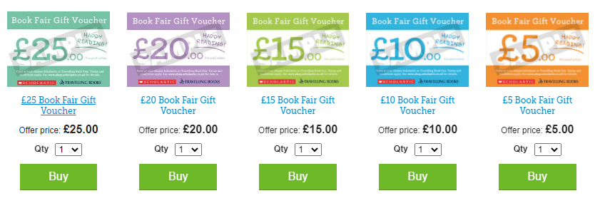
- When you have had your gift voucher emailed to you, this can be printed out, sent into school and handed in to your child’s class teacher (NOT THE OFFICE) with the books title(s) written on the back.
- If you are unable to print the voucher, please send a screen shot and book titles either to admin@moor-park.blackpool.sch.uk or send to your child’s class teacher via Teams.
- Their book will be selected from the selection of books we have in the fair and will then be packaged up by myself (for KS2) or Mrs Forrester (for KS1).
- The package will be quarantined for 72 hours before your child can bring it home.
We hope that this accessible for you all. Please note that we will not accept any cash payments and we apologise for this. If you have any questions please don’t hesitate to contact Miss Taylor or Mrs Forrester.
We thank you in advance for your continued support,
Miss Taylor and Mrs Forrester.

