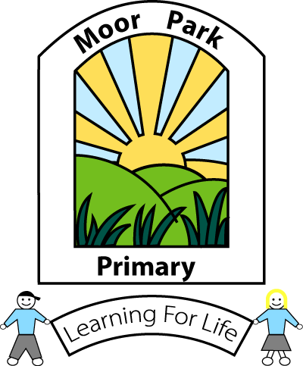
MOOR PARK PRIMARY SCHOOL & NURSERY
MOOR PARK AVENUE
BISPHAM
BLACKPOOL
FY2 OLY

Tel: 01253 353034
Email: admin@moor-park.blackpool.sch.uk

Headteacher: Mrs J L Magson
Deputy Headteacher: Mr G Kirkpatrick
Assistant Headteachers: Mrs H Jefferson & Mrs J Rhodes

Dear parents/carers,

I hope you managed to enjoy the Easter weekend, at least the weather is being kind to us. Welcome to our very first remote summer term!

We’ve all had to adapt to new ways of working, so I wanted to take the opportunity to say what an amazing job you’re doing supporting your child’s wellbeing and learning during this time.

It’s definitely been a strange and challenging time, so it’s ok if you and your child feel wobbly and worried at the moment. We’re here for you every step of the way as we figure this all out together. Remember, if you have any concerns about helping your child learn or you need any other support from the school, please let us know by contacting the school email – admin@moor-park.blackpool.sch.uk

Hopefully you have had chance to catch up with your class teacher too, don’t worry if you’ve not heard from them yet, they will be in touch over the next couple of weeks.

We miss the children very much, but we must follow the government’s guidance to keep everyone in our community safe. So, we’re carrying on with opening the school for key worker’s and our most vulnerable children. Online learning is available for children working from home.

Just because we’re not all in the same building, doesn’t mean we can’t have some fun together! Your children will have lots of activities they can get stuck into over the summer term – so keep a close eye on Yammer and our school website for ideas. I hope that you have enjoyed the pictures posted by the staff too!

We can’t say yet when we’ll be able to open the school fully, but rest assured that we’ll continue doing our utmost to keep your child learning and our school community connected.

Let’s get cracking with our summer term!

Warm regards,

J. L Magson

