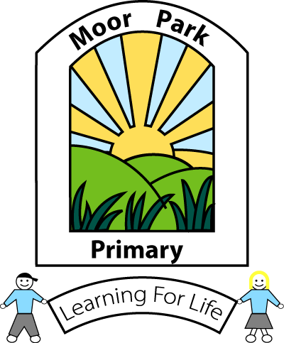
MOOR PARK PRIMARY SCHOOL & NURSERY
MOOR PARK AVENUE
BISPHAM
BLACKPOOL
FY2 OLY

Tel: 01253 353034
Email: admin@moor-park.blackpool.sch.uk

Headteacher: Mrs J L Magson
Deputy Headteacher: Mr G Kirkpatrick
Assistant Headteachers: Mrs H Jefferson & Mrs J Rhodes

Dear Parents and Carers,

I am writing to you to update you about our current situation following the Government guidance on welcoming more children back to school.

Firstly I feel it important to say that I have always considered being the Headteacher of Moor Park to be a huge privilege and that has never been more true than now. The commitment, dedication and efforts of all the staff at our school has been second to none during this most difficult and challenging time and I would like you to join me in thanking each and every one of them.

As you will be aware the government are urging primary schools to invite a small number of children from Nursery, Reception, Year 1 and Year 6 back to school, IF IT IS SAFE TO DO SO, as of the beginning of June. We are awaiting further guidance as to when the other year groups will be invited back. Online learning will continue to be provided for these children.

Our school has remained open to children of Key Workers and vulnerable pupils since the lock down began including over the Easter holidays. In order to prepare for the possibility of more pupils returning it will be necessary to conduct a deep clean of our school, and put other safety measures in place, therefore school will be fully closed from 1st June until 8th June.

We are working hard to respond to the government guidance to provide a safe plan that will enable some children from the identified year groups to attend school on the 8th June. The children of Key Workers and our vulnerable pupils will also remain a priority at this time.

I must be open and upfront with you and advise you that as robust and vigilant as our protective measures will be, because of the ages of the children and nature of the school environment, I am unable to guarantee that social distancing measures will always be possible. There is also no guarantee that your child will not come into contact with COVID.

I feel it is also important to stress that the school day and school provision will have to be very different to what your children would normally experience. For example;
- A staggered registration and home time.
- A reduced curriculum tailored to suit the needs of the children.
- Break times and lunchtimes will be staggered, in restricted areas and unlikely to be with any equipment or with their friends.
- Classrooms will look very different (individual desks spaced far apart).
- Possibility of a different teacher or adult supervising them.
- An understanding that certain behaviours and rules will HAVE to be followed.

This information is not intended to cause you alarm but merely to highlight some of the changes that will have to be implemented to go some way to protect everyone in our school community from this highly contagious virus.

Of course the staff at Moor Park will do everything possible to provide the nurture and care we always provide. But I ask that you consider these points when making the decision to send your child back to school;

- Will my child be safer at home?
- Will my child cope with a very different routine/environment?
- Will my child cope with working with unfamiliar adults?
- Will my child cope with and be able to follow social distancing rules?

Remember this is an offer for your child to attend school, it is NOT compulsory. If you feel your child would be safer at home with you at this uncertain time then we will completely respect your decision. There will be no fines or penalties for not attending school at this time.

Please indicate on the survey monkey form below if you would like your child to return to school on the 8th June. We will only have a limited number of spaces at this time (children of KEY WORKERS and VULNERABLE PUPILS will be our priority) so this DOES NOT GUARANTEE A PLACE FOR YOUR CHILD.

Survey Monkey Form Link
https://forms.office.com/Pages/ResponsePage.aspx?id=Vzp5on7E2kOXKS7MuGyM4QkwLri8XSZHvxp10j2q7EZUNjdVTVlGVFBLNDI3NzZQU0VWU1Q2UVpPTC4u

Thank you for your continued support and patience during these unprecedented times.

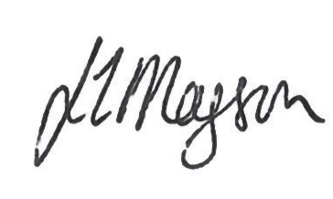
Kindest regards

J L Magson

