

org.usbornebooksathome.co.uk/MGRTBookshop/
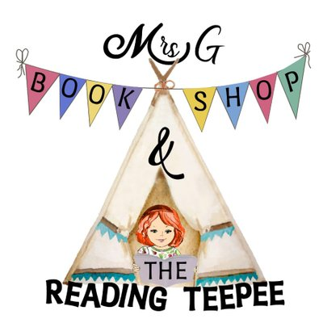

Dear KS1 Parent or Carer,

This summer, we will be taking part in an Usborne Summer Reading Adventure in association with Mrs G & The Reading Teepee Bookshop.

With your passport in hand, let’s pack our imaginary bags, put on our sunglasses, and take an adventure together through books. We’ll journey through space, learn more about our Planet Earth, and find some friends to laugh and giggle with along the way!

Children will be challenged to read 6 exciting titles during the six week holidays and will have the option to share their thoughts and feelings on the books, as well as take part in some book-themed activities over on the ‘Blackpool & Fylde School’s Reading Adventure’ Facebook group.

The books that our key stage one children will be reading are pictured below. Your child can read as many of these titles as they wish to take part. If you would like your child to be included in this Summer Book Club, then simply Email MGRTBookshop@gmail.com with the titles that you would like to purchase, quoting the code MPARK for your £1 discount on each book ordered. The deadline for registration is 11.07.20.

Each book purchased using the Moor Park code equals FREE books for school in September!

We hope that you will get involved in this initiative, designed to bring the Fylde School community together through the love of reading great books!

Yours Faithfully,



