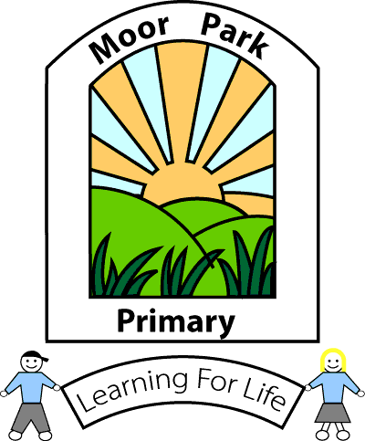
MOOR PARK PRIMARY SCHOOL & NURSERY
MOOR PARK AVENUE
BISPHAM
BLACKPOOL
FY2 OLY

Tel: 01253 353034
Email: admin@moor-park.blackpool.sch.uk

Headteacher: Mrs J L Magson
Deputy Headteacher: Mr G Kirkpatrick
Assistant Headteachers: Mrs H Jefferson & Mrs J Rhodes

10th July 2020

Dear Parents and carers,

I would firstly like to take this opportunity to say a heartfelt thank you to everyone in our Moor Park family.

I can honestly say that the past few months have proven beyond a doubt what an absolute privilege it is to be the Headteacher of such an amazing school. Yourselves, the children, staff and Governors have all worked exceptionally hard and supported each other through this most challenging of times.

We have been delighted to be able to welcome back more children and families since the 8th June and are so proud of how well the children have adjusted to the new routines and procedures. They are an absolute credit to our school and their families.

I would like to wish our Y6 pupils all the very best for High School. It is unfortunate that we have not been able to celebrate their end of time at Moor Park as we would normally do but I hope they have managed to enjoy their last couple of weeks in school and will enjoy their keepsakes. We wish them every success and happiness for their futures.

We are now fast approaching the end of the summer term and are looking at planning and preparing for the new academic year.

SEPTEMBER 2020 INFORMATION

As you may be aware the Government have issued new guidance for schools to prepare to welcome all children back to school in September. (Issued on the 2nd July)

As with all the previous government guidance documents the Department for Education recognise;

‘There cannot be a ‘one-size-fits’ all approach… School leaders will be best placed to understand the needs of their schools and communities, and to make informed judgments about how to balance delivering a broad and balanced curriculum with the measures needed to manage risk’.

The Government expect school leaders to put in place proportionate protective measures for children and staff, which also ensure that all pupils receive a high quality education that enables them to thrive and progress.

We are being asked to minimise the number of contacts that a pupil has during the school day which supports the key aim of minimising the risk of transmission in school.

The government also expect schools to plan for the possibility of a local lockdown and how we will ensure the continuity of education.

As you can imagine the preparation and discussion needed to make decisions moving forward are both complex and challenging.

With all that in mind the Leadership team and Governing body of Moor Park have prepared an opening plan to be implemented in the Autumn Term.

I think it is important to remember that we are still learning how to live with Covid-19 and the plans we have put in place are intended to minimise the risk for everyone and to hopefully sustain the provision for as long as possible. The decisions taken have been made following government guidance and with everybody’s health, safety and well-being at the centre. That has very much been mine and the Governing body’s core principle throughout this situation and will remain so.

Please see the separate document for details about September arrangements.

May I wish you and your families all the very best for a happy and safe summer break.
We are very much looking forward to welcoming you all back in September.

Yours sincerely

J L Magson

Mrs J L Magson
Headteacher
Moor Park Primary

