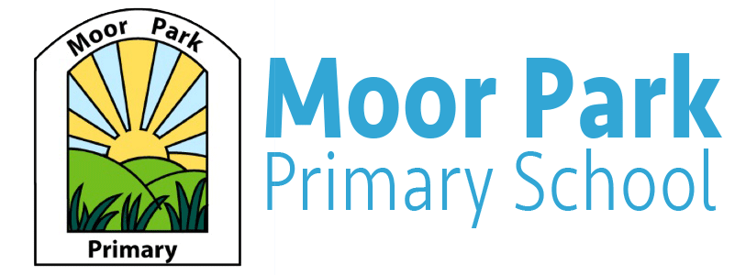

Reception Newsletter

Term: Spring Week: 1 Date: 08.01.2021
Welcome to our Newsletter:
Welcome back to School/Online Learning! We hope you have all had a lovely Christmas and a Happy New Year! This week, the children have been learning all about Dinosaurs! The children in school have enjoyed creating their own 2D shape dinosaurs, investigating frozen dinosaur eggs and pretended to be a dinosaur in out P.E session! We hope the children following the Online Learning Journey have enjoyed the dinosaur theme just as much! We have certainly enjoyed seeing all the amazing work you have been getting up to! As the children have enjoyed our dinosaur theme so much, we will be continuing this topic the following week.
Reminders
Please can we remind parents that if your child is attending school that P.E will still go ahead every Monday, so please send your child into school wearing appropriate P.E clothing.

Online Learning:
We hope you have managed to access Teams this week and have been able to have a look at the weekly Online Learning Journey on there. If you have questions, please contact your class teacher. In addition to the weekly Online Learning Journey, we will be uploading daily phonics sessions to suit your child’s ability and additional daily videos to support your child’s learning. These videos may include a story session, a Phonics challenge, a Maths challenge or a weekly welcome video.
If you are unsure of your child’s Team’s login, please email your child’s class teacher who will be happy to help you.

Miss Cross: alice.cross@moor-park.blackpool.ach.uk
Miss Horrocks: charlotte.horrocks@moor-park.blackpool.sch.uk

If you have any other questions regarding your child’s learning, please do not hesitate to contact your child’s class teacher.

Useful Apps and Websites to support learning:
Oxford Owl – help support your child with their reading/handwriting and segmenting and blending.
TopMarks – help support your child with their maths skills.
Phonics Play – help support your child with their phonics in a fun, interactive way.
ICT Games – help your child with their numeracy and literacy skills.
Cbeebies – help your child’s learning by watching programmes such as Number Blocks.

Theme: Dinosaurs
Next week, we will be continuing learning about Dinosaurs. We will be creating fact files of the different types of dinosaurs and finding out how big they were, what they ate and what they looked like.
To help your child with our topic, you could encourage your child to draw and design their own dinosaur and come up with an inventive name!

