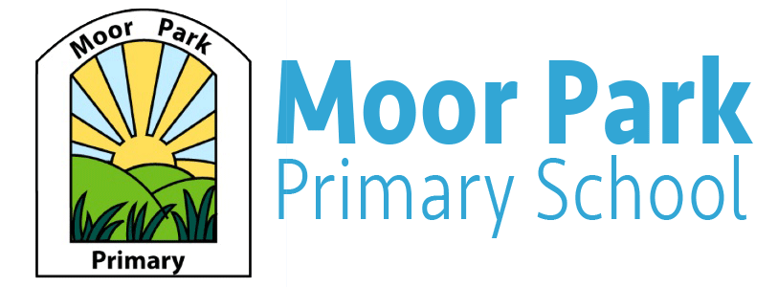

Reception Fortnightly Newsletter

Term: Autumn term 1 Week: 7 Date: 09.09.20

Welcome to our Newsletters:

Miss Cross and Miss Horrocks have been very impressed with the children this week, they have all been brilliant and have thoroughly enjoyed our theme of feelings/emotions. They have continued to settle into school and have become more familiar with their new surroundings and routines.

Can we thank you all again for your understanding with our drop off and collection routines and rules. Could we remind parents that if someone different is going to be collecting your child from school, can you please let the teacher know either at drop off or home time or ring to let the office know.
Thankyou.
Reading Books/ Phonics:
This year in Reception we have started a new Phonics scheme called Read Write Inc. We have been learning a new sound each day.
We are in the process of assessing the children to see which reading books will be most appropriate for your child.
In the meantime, you could practice reading with your child by logging into Oxford Owl (https://www.oxfordowl.co.uk)

The logins you can use at home are:
Username: recac
Password: 123
Or
Username: rcho
Password: 4567

Labelled belongings:
Please could you ensure that all your child’s belongings such as cardigans/jumpers, bags, water bottles and wellies are labelled to make it easier when trying to find lost items.
Thankyou.

Home Challenge:
This week we thought you could challenge your child to practice writing and saying the sounds we have been learning at school. Can your child make any 3 letter words with the sounds?

M a s d t g o c n c k

Snack Time:
At school, your child will be provided with their mid-morning snack, items such as brioche bread or Soreen bars. When providing our daily snack, we ensure that any allergies / diets are catered for and hand washing will be a vital part of this routine. If the children decide they would not like what is being offered on a particular day, fresh fruit is always available as an alternative and milk or water is available to them. In addition, the children may choose a fruit snack at the end of the day as we gather to get ready for home time.

Theme: Autumn/Halloween:
The themes we will be following for the 2 weeks are Autumn and Halloween.
We will be learning about the changes that happen in Autumn and observing and exploring the signs of Autumn.
To support us with our topic you could discuss with your child what have they noticed about the weather, trees and leaves recently. What colour have the leaves turned? Has it got colder?

