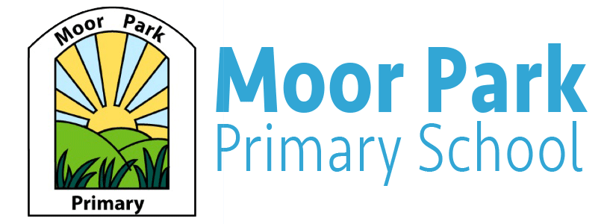

Reception weekly Newsletter

Term: Autumn Week: 10 Date: 13.11.2020
Welcome to our Newsletters:

Miss Cross and Miss Horrocks have enjoyed welcoming the children back to school this week! We have been so impressed with how well the children have remembered our classroom rules and routines and how well they have settled back in. Well Done Reception!
We would like to thank you all for your understanding of the new drop off and pick up rules and routines. Please can we remind everyone that any messages must be passed on by phoning the office or by email or Teams, not at the door.
Reminders
Please can we remind you to complete the school dinner form online each week.

P.E

P.E will be every Monday starting on the 23rd November. The children will need to come in school in their P.E kits. As it is getting colder, the children are able to wear tracksuit bottoms and a tracksuit jacket. Please can we also ask that you label your children’s items. If you have any questions or concerns please speak to either Miss Cross or Miss Horrocks by phone or email.
Your child will bring their P.E kit home next week if it is in school.

Maths

Over the past couple of weeks, the children have been learning about numbers 0-6 and how to represent these in many different ways. If you wanted to help your child with their learning at home, please can you practice writing their numbers using the correct formation.
Next week in maths, we will be introducing simple addition up to 6 with the children/ To support your child at home, you could add together household objects, such as toys, fruit, cutlery or shoes.
Reading Books

Please can all reading books be returned to school on Tuesday’s at the latest as this allows us to re-send the books out safely each Friday.
The picture books we are sending home at the moment are for parents/carers or siblings to read with your child. You may want to encourage your child to spot the sounds they have already learnt.

Theme: The Gruffalo

This week we have been learning about Diwali and the children have enjoyed making cards for their families and making paper lanterns.
Next week, we will be learning about The Gruffalo. To support us with our learning, you could go on a nature walk with your child and describe what they can see, smell and touch.
During this week, we will be focussing all areas of learning on The Gruffalo story. The children will have the opportunity to experience the different textures mentioned in The Gruffalo story and they will be able to experiment in The Gruffalo Café!

