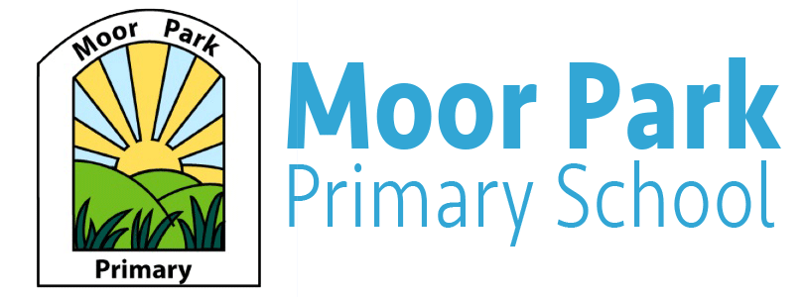

Reception Fortnightly Newsletter

Term: Autumn term 1 Week: 8 Date: 23.10.20

Welcome to our Newsletters:
This week the children have thoroughly enjoyed our Halloween Topic and the children have made some fantastic Halloween crafts and wrote a very spooky potion! Miss Horrocks and Miss Cross would like to say thank you to all the children for making our first half-term a great one! We have loved getting to know all children and seeing how well each child settles in to reception and the friendships that they have been made.
Well done Reception, we can’t wait until the next half term!
.

Online Learning
You should have now received a letter that has your child’s Teams login information. Over the half term, we will be uploading some fun and exciting challenges to complete. These challenges could be completed with the help of any siblings or any other members of your support/household bubble.
Every week, we will post a new weekly overview of what we will be doing in school so any children who are absent from school can continue their learning from home.

Phonics
This week you should have also received a letter regarding our new Read, Write, Inc phonics scheme. Your child will have also received a Phonics challenge sheet for your child to practice the sounds at home. Your child will have already learnt the sounds at school. As the children learn more sounds, a new challenge sheet will be given out.

Theme: Bonfire Night:
The theme after half term will be Bonfire Night.
To support us with our Bonfire Night theme, you could discuss with your child about traditional bonfire night foods such as toffee apples.
During this week, we will be discussing fire safety and listening to the different sounds that fireworks make and then recreating these with musical instruments.

P.E/ Outdoor Learning
As you are aware, we have not yet started doing P.E lessons in Reception, however the children have access to daily outdoor play. During this time, the children are able to able to choose from a variety of bikes and scooters to practice their balancing skills and also their co-ordination.
In our Outdoor Classroom, there are many activities that are linked to our weekly theme
that the children are able to choose from.

We let you know after half term which day we will be doing P.E.

