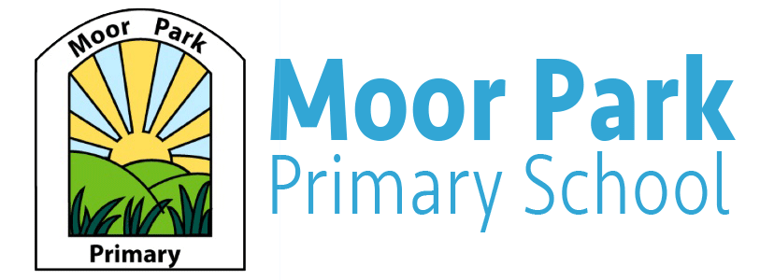

Reception weekly Newsletter

Term: Autumn Week: 12 Date: 27.11.2020
Welcome to our Newsletter:
Miss Cross and Miss Horrocks have enjoyed learning about the Arctic with the children this week and the children have enjoyed learning about the different animals that live in the Arctic. The children also enjoyed their first PE lesson where they channelled their inner arctic animals pretending to waddle like penguins, run like polar bears and slide like seals. Well done Reception for your fantastic effort during PE.
We have had a few parents asking about school photos, we aren’t too sure what is happening about these yet but we will keep you updated!
Reminders
Please can we remind you to complete the school dinner form online each week. PE will take place every Monday, your child is able to wear a tracksuit as the weather is getting colder. Please label your child’s clothing.

Maths.
This week we have been learning about addition using numbers 1 to 6.
Next week we will be learning about subtraction. To help us with our learning at home, we would like you to watch this video on YouTube about counting down from 10.
To help your child learn how to subtract, please gather together up to 6 household objects and then use this online dice to take some away. Can your child count how many is left?

Christmas Cards.
Children can send Christmas cards to the children in their class, but we would like to ask that all cards are brought in on a Monday and a Tuesday to be posted in our Reception Post-box! These cards will then be delivered to the children on Friday’s. This allows enough time for the cards to be safely sent out each week and the children can still enjoy sending their friends cards! Please can we also ask that cards could be sealed using tape or simply tucked inside the envelope.

Reading Books.
The children have now been put into the appropriate Phonics groups and starting next week, some children will be bringing home more reading books for them to practice. These books have been matched to your child’s ability and will help them to develop the key early reading skills. If your child does not come home with any additional reading books, please continue to read the picture books with your child as this well help them to progress.
Theme: Winter.
Next week, we will be learning all about Winter and how the weather changes during the Winter. The children will be able to experiment with a variety of activities that link to the Winter. We will also discuss with the children about hibernation and why animals hibernate during the winter.
As well as our Winter theme, we will be decorating our classrooms ready for Christmas! Next week, we will start our class advent calendars!

