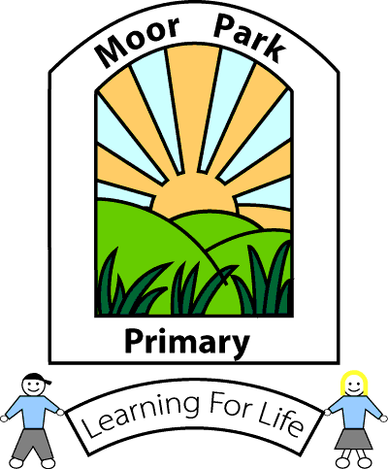MOOR PARK PRIMARY SCHOOL & NURSERY
MOOR PARK AVENUE
BISPHAM
BLACKPOOL
FY2 OLY

Tel: 01253 353034
Email: admin@moor-park.blackpool.sch.uk
Headteacher: Mrs J L Magson
Deputy Headteacher: Mr G Kirkpatrick
Assistant Headteachers: Mrs H Jefferson & Mrs J Rhodes

14th June 2020

Dear Parents,

I hope this finds you and your family keeping well. I would like to say once more, thank you for your patience and understanding during these very challenging times.

You will be aware that we opened school to more children last week. We now have a small number of our Nursery, Reception and Year one children back in school along with the key worker and vulnerable children.

I am pleased to report that our re-opening plan and risk assessment which was put in place on Monday 8th June is working extremely well for this small number and it has been a very positive experience for the children and staff.

Having assessed our current provision and allowing for fluctuation of numbers within the key worker and vulnerable bubbles we are now in a position to plan for a return of our Y6 pupils.

The provision that we are able to offer our Y6 pupils, allowing for strict health and safety measures to be followed, is as follows;

Starting from Week beginning 22nd June 2020

Bubble of no more than 8 children. 2 hourly sessions each week. Which will be delivered as follows;

6CS

Monday 22nd, 29th June, 6th, 13th July: 9.30 – 11.30 Bubble A morning session
Monday 22nd 29th June, 6th, 13th July: 1.30 – 3.30 Bubble B afternoon session

Tuesday 23rd, 30th June, 7th, 14th July: 9.30 – 11.30 Bubble C morning session
Tuesday 23rd, 30th June, 7th, 14th July: 1.30 – 3.30 Bubble D afternoon session

6EP

Thursday 25th June, 2nd, 9th, 16th July: 9.30 – 11.30 Bubble A morning session
Thursday 25th June, 2nd, 9th, 16th July: 1.30 – 3.30 Bubble B afternoon session

Friday 26th June, 3rd, 10th, 17th July: 9.30 – 11.30 Bubble C morning session
Friday 26th June, 3rd, 10th, 17th July: 1.30 – 3.30 Bubble D afternoon session

This will be repeated each week until the end of the Summer Term. This means that your child will receive four, 2 hourly sessions with their own class teacher before transitioning to high school.

Each bubble will contain no more than 8 children to allow for social distancing measures to be adhered to. There will be no lunchtime provision for the children.
We hope that you will be able to take up this offer so that your child can spend some quality time with their class teacher before they leave Moor Park.

Please complete the survey by no later than this Wednesday 17th June at 12.00pm to indicate if you will be accepting a place. Please click this link to access the survey https://bit.ly/37vV9ij

I am afraid it will NOT be possible to choose the day or session that your child will be allocated. Once we know who will be taking up the places we will do our best to put the children into friendship groups within their class.

The teachers will continue to provide on line learning over the course of the next 5 weeks of term.

I sincerely hope that we are able to welcome you back on the 22nd June as we are very much looking forward to seeing the children and being able to wish them well before they leave us for High School.

Once your child has been allocated a place you will be notified by email and further details will be included.

If you have any questions or queries, please don’t hesitate in getting in touch via the admin email address and either myself or one of our senior leaders will get in touch with you.

admin@moor-park.blackpool.sch.uk

Yours sincerely

J L Magson

Mrs J L Magson
Headteacher
Moor Park Primary

