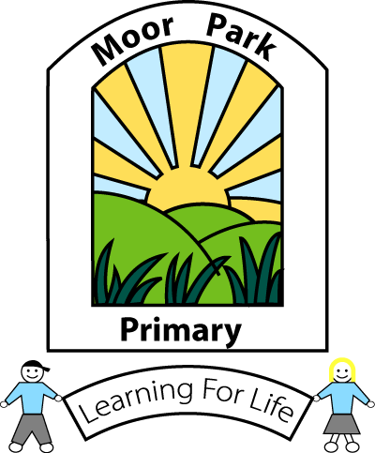
MOOR PARK PRIMARY SCHOOL & NURSERY
MOOR PARK AVENUE
BISPHAM
BLACKPOOL
FY2 OLY

Tel: 01253 353034
Email: admin@moor-park.blackpool.sch.uk

Headteacher: Mrs J L Magson
Deputy Headteacher: Mr G Kirkpatrick
Assistant Headteachers: Mrs H Jefferson & Mrs J Rhodes

Dear Parents and Carers,

Firstly, I would like to thank you for your continued patience whilst we waited for further information from the Government about the reopening of schools. More guidance has now been published and our school approach to this is summarised below.

Date for potential reopening to Nursery, Reception and Y1

Schools across the country have been asked to start reopening from 1st June to nursery, reception, year 1 and year 6 pupils, but only IF it is safe to do so. In the case of our school, the potential phased reopening date is Monday 8th June. In the first instance our school will be prioritising the safe return of Nursery, Reception and Year 1 pupils. We will NOT be opening for pupils from Year 6 at this present time.

We will continue to prioritise and provide places for the key worker children and our vulnerable pupils.

We have produced a detailed reopening plan and risk assessment which has been approved by our Chair of Governors and is supported by the Local Authority. We are currently waiting for the Risk Assessment to be approved by the Local Authority’s Health and Safety team; once we have approval, I will then be in a position to share it with you.

If you have expressed an interest in a place for your child, I will be back in touch when the plan is approved and finalised.

May I say once more, a heartfelt thank you to you all, in this time of great uncertainty. I hope that you and your families are keeping safe and well and we look forward to hopefully welcoming some of you back before the summer term.

Kind regards,
Mrs Magson

Headteacher

