Catch Up Funding Strategy 2020-22

Summary Information

Total Number of Pupils | 408 | Total Catch Up Funding | £32,640

School Approach to Developing the Strategy

At Moorfield Primary School, we believe that all children are entitled to an education which allows every child to achieve their potential regardless of their starting point in life or personal circumstances. The government has announced £1 billion of funding to support children and young people to catch up in the wake of the COVID-19 pandemic. This includes a one-off universal £650 million catch-up premium for the 2020 to 2021 academic year to ensure that schools have the support they need to help all pupils make up for lost teaching time. Schools should use this funding for specific activities to support their pupils to catch up for lost teaching over the previous months, in line with the guidance on curriculum expectations for the next academic year. Schools have the flexibility to spend their funding in the best way for their cohort and circumstances.

There is an acceptance that the overwhelming majority, if not all pupils, will have been negatively affected in some way by the COVID-19 pandemic. We have identified the following ‘COVID-19 specific’ issues affecting our pupils:

- Significant gaps in pupils’ skills and knowledge due to lack of daily teaching and daily practice.
- Pupils have missed significant experiences affecting their cultural capital and ability to make connections in their learning.
- Lack of engagement with home learning during school closure/self-isolation.
- Home environments lacking structure, routines and appropriate boundaries during school closure - affecting pupils’ behaviour for learning and mental health.
- Mental health/wellbeing issues affecting our pupils’ wellbeing and academic performance.

How is Catch Up Funding used at Moorfield Primary School?

At Moorfield, we believe that quality first teaching is crucial to ensuring our pupils catch up academically, are successful learners and are well prepared for the next stage in their education. That’s why, alongside the use of catch up funding for specific strategies and interventions, our Covid-19 Key Priorities are clear in our adapted school improvement plan 20/21 with the focus on:
- Leaders Priority – Recovery and Catch Up Curriculum
- Teachers Priority – Engaging and Inclusive Curriculum
- Learner Priority – Behaviours for Learning

Alongside an initial focus on pupil well-being, recovery and transition to a new year group, class teachers have focused on recommencing the teaching of the curriculum. In core subjects the early focus has been on assessing the impact of school closure on children’s attainment. Pupil Progress Meetings were held after October half term, involving the headteacher, SLT and class teachers. All children throughout the school were discussed in terms of academic and social and emotional progress. Appropriate intervention within school was put in place for autumn 2 and a plan carried forward to use the National Tutoring Programme from spring 1 onwards as a tool to meet need across the school.

Update Spring 2021 – Due to National Lockdown across the spring term the catch up programme will start in the summer term 2021 and continue into the autumn term 2021.

Academic Priorities to be Addressed

Teachers are working together to prioritise identification of general gaps in learning exacerbated by forced school closures.
- Reading – gaps for individuals identified by Target Tracker Gap Analysis
- Writing - gaps for individuals identified by Target Tracker Gap Analysis
- Mathematics - gaps for individuals identified by Target Tracker Gap Analysis

Social and Emotional Priorities to be Addressed

- Re-establishing feeling safe and happy in school
- Well-being of pupils following varied experiences of life without school
- Building relationships with teachers and children in class
- Re-establishing expected learning and social behaviours

Intended Outcomes and Success Criteria

- Improved number of children at age appropriate skills in reading, writing and maths | - Proportion of children in each cohort on track for ARE by the end of 2021/22
- Children have closed gaps in core subjects caused by Covid, making accelerated progress against their identified gaps. Increase in skills based on comparison of pre and post intervention. Information shared at Pupil Progress Meetings evidenced through gap analysis
- Pupil well-being is good – there is a re-established feeling of belonging in school and children feel happy and safe in school | - Children’s emotional well-being is not impacting on their ability to learn and make progress
Planned Expenditure 2020-21

Universal Approach – Implemented from Autumn 2020
Action | Intended Outcome | Resource | Evidence of Impact | Staff Lead | Review Date | Cost
All staff to be secure in their understanding of planning and delivery of basic skills and small steps in the progression of maths – introduce White Rose Hub | No child is left behind as the children progress through the maths expectations for current year and previous year | Quality first teaching  White Rose Hub | Children make good progress from their starting points  Pupil voice  Book Looks | MH | Termly pupil progress meetings | -
All staff to be secure in their understanding of planning and delivery of basic skills and small steps in the progression of reading – introduce Reading Vipers | No child is left behind as the children progress through the Reading expectations for current year and previous year | Quality first teaching  Reading Vipers | Children make good progress from their starting points  Pupil voice  Book Looks | RS | Termly pupil progress meetings | -
All staff to be secure in their understanding of planning and delivery of basic skills and small steps in the progression of writing | No child is left behind as the children progress through the writing expectations for current year and previous year | Quality first teaching | Children make good progress from their starting points  Pupil voice  Book Looks | RS | Termly pupil progress meetings | -

Targeted Approach – from PP meetings to start spring 2021 – support for children with specific academic gaps which can be reached through tutoring – revised - summer 2021due to national lockdown
Action | Intended Outcome | Resources | Evidence of Impact | Staff Lead | Review Date | Cost
Small group tuition in 5C provided by KH– focus reading, writing, maths  Specific pupils targeted following PPM with the aim to catch up peers across RWM | Small groups to allow for increased individual teaching with pupils to address specific gaps identified | Kerry H (supply teacher well known to school) to support | Pre and post gap analysis  Monitoring and joined book look  Pupil progress meetings to feedback progress/attainment | MH | Termly pupil progress meetings | 2 days per week £320 x 13 weeks = £4160
National Tuition Programme - 1-1 online maths provided by Third Space Learning for 20 pupils in Year 6 | 1-1 online tutor programme to address specific gaps in maths | Third Space Learning/IT Suite | Pre and post diagnostic assessment  Pupil progress meetings to feedback progress/attainment | MH | Termly pupil progress meetings | 20 children one hour per week – 15 hour programme summer term = £2750
National Tuition Programme – 1-3 English provided by Teaching Personnel for 20 pupils in Year 6 | 1-3 tutor programme to address specific gaps in reading and writing | Teaching Personnel Tutor - Friday | Pre and post gap analysis  Monitoring and joined book look  Pupil progress meetings to feedback progress/attainment | PA | Termly pupil progress meetings | 15 children in groups of three, 1 hour per week - 15 hour programme summer term £338.45 per week
National Tuition Programme – 1-3 English and maths provided by Teaching Personnel for 20 pupils in Year 2 and Year 4 | 1-3 tutor programme to address specific gaps in reading and writing and maths | Teaching Personnel Tutor –  Monday Year 4 maths  Tuesday Year 2 maths  Wednesday Year 4 English  Thursday Year 2 English | Pre and post gap analysis  Monitoring and joined book look  Pupil progress meetings to feedback progress/attainment | PA | Termly pupil progress meetings | 15 children in groups of three, 1 hour per week - 15 hour programme summer term £338.45 per week
 |  |  |  |  |  | = £5076.75

Targeted Approach – from PP meetings to start spring 2021 – support for children with specific social and emotional needs who would benefit from small group work to support relationships, expected learning behaviours, social behaviours etc – revised - summer 2021due to national lockdown
Action | Intended Outcome | Resources | Evidence of Impact | Staff Lead | Review Date | Cost
Group pastoral support and 1-1 where required provided by TR across KS2 | Children identified by class teachers in KS2 to work with experienced pastoral/behaviours for learning manager TR | TR from SEND Supply Agency  Outdoor Learning building and outdoor spaces | Pre and psot diagnostic assessment  Pupil progress meetings to feedback progress/attainment | PA/MH | Termly pupil progress meetings | 1day per week for each KS2 year groups( ½ a day per class) and 1 day for any identified specific 1-1 or small group follow up = 5 days per week.  £493 per day x 13 weeks = £6409
 |  |  |  | Total cost for term |  | £18,395.75
 |  |  |  | Remaining/carry forward |  | £14, 244.25

Planned Expenditure 2021-22

Targeted Approach – from PP meetings to start summer 2021 – support for children with specific academic gaps which can be reached through tutoring – revised - autumn 2nd half 2021(5 weeks) and spring 2022 (10 weeks) due to national lockdown in spring 2021
Action | Intended Outcome | Resources | Evidence of Impact | Staff Lead | Review Date | Cost
National Tuition Programme – 1-3 English and maths provided by Teaching Personnel for 15 pupils in Year 2, Year 3, Year 4 English | 1-3 tutor programme to address specific gaps in reading and writing and maths | Teaching Personnel Tutor – CO | Pre and post gap analysis  Monitoring and joined book look  Pupil progress meetings to feedback progress/attainment | PA | Termly pupil progress meetings | 15 children in groups of three 1 hour per week – 15 hour programme autumn term  Approx. £320.63 per week
National Tuition Programme – 1-3 English and maths provided by Teaching Personnel for 15 pupils in Year 5, Year 6, Year 4 Maths | 1-3 tutor programme to address specific gaps in reading and writing and maths | Teaching Personnel Tutor – JO | Pre and post gap analysis  Monitoring and joined book look  Pupil progress meetings to feedback progress/attainment | PA | Termly pupil progress meetings | 15 children in groups of three 1 hour per week – 15 hour programme autumn term  Approx £320.63 per week
 |  |  |  | Total cost for term |  | £9618.75
 |  |  |  | Remaining/carry forward |  | £4625.50 – to support Year 1 in Spring/Summer term

Targeted Approach – from PP meetings to start summer 2022 – support for Year 1 and Year 2 pupils in ‘boosting’ phonics knowledge in preparation for the Phonics Screening and to support transition to Year 2/3
Action | Intended Outcome | Resources | Evidence of Impact | Staff Lead | Review Date | Cost
Purchasing Essential Letters and Sounds resources and materials | Support teaching and learning in phonics |  |  | RS |  | £700
Phonics Booster groups provide by current Reception Teachers RS and EH using Essential Letters and Sounds | address specific gaps in reading and writing | Essential Letters and Sounds Programme  Reception teachers | Pre and post gap analysis  Phonics Screening outcomes  Monitoring and joined book look  Pupil progress meetings to feedback progress/attainment | GP | Termly pupil progress meetings | Teachers current pay scale – total of 3 hours per week for the summer term 13 weeks  £3900 for 13 weeks
 |  |  |  | Total cost for term |  | £4600
 |  |  |  | Remaining/carry forward |  | £25.50

Outcomes 2021-22

Expected Progress summer 2, 2021 – summer 2, 2022 = 6 points/1 band
Year 2 English | Year 2 Maths

Year 3 English | Year 3 Maths
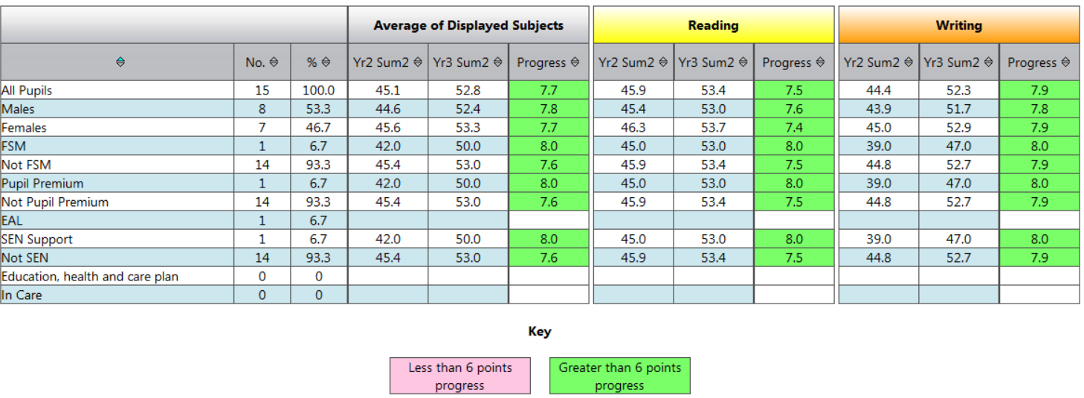 | 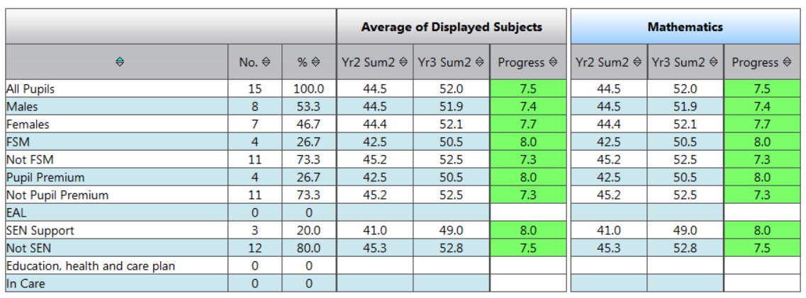

Year 4 English | Year 4 Maths
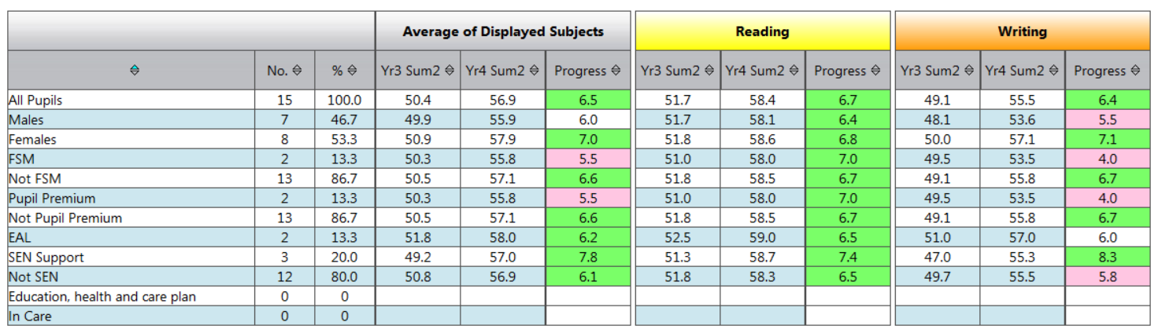 | 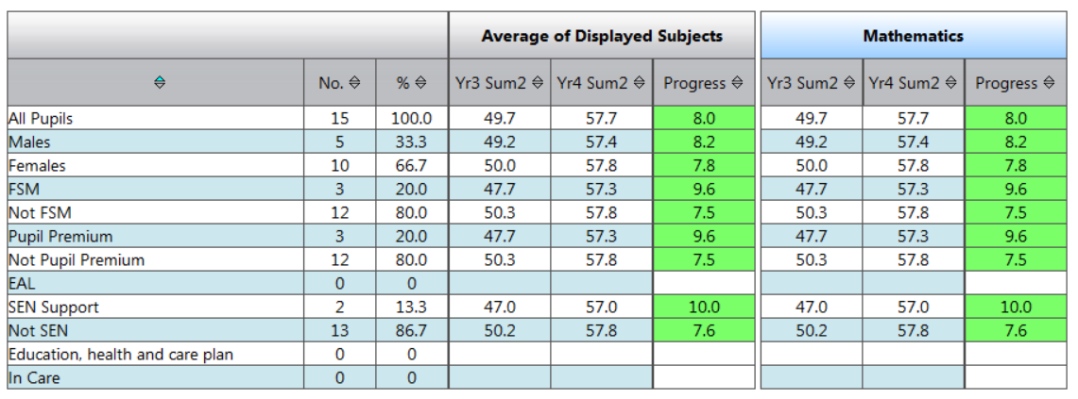

Year 5 English | Year 5 Maths
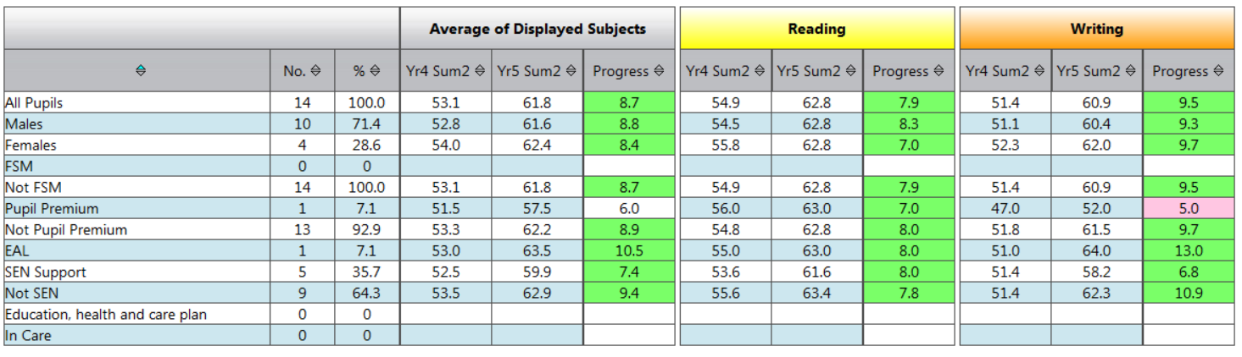 | 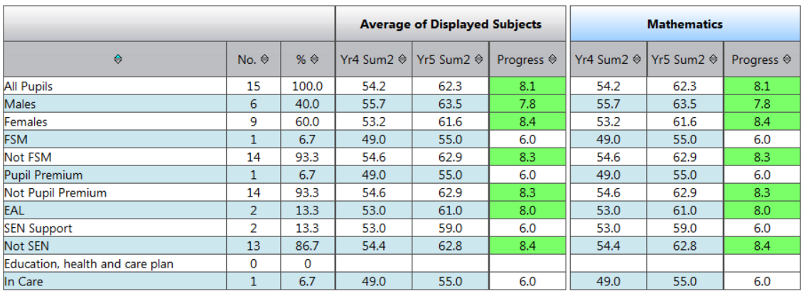

Year 6 English | Year 6 Maths
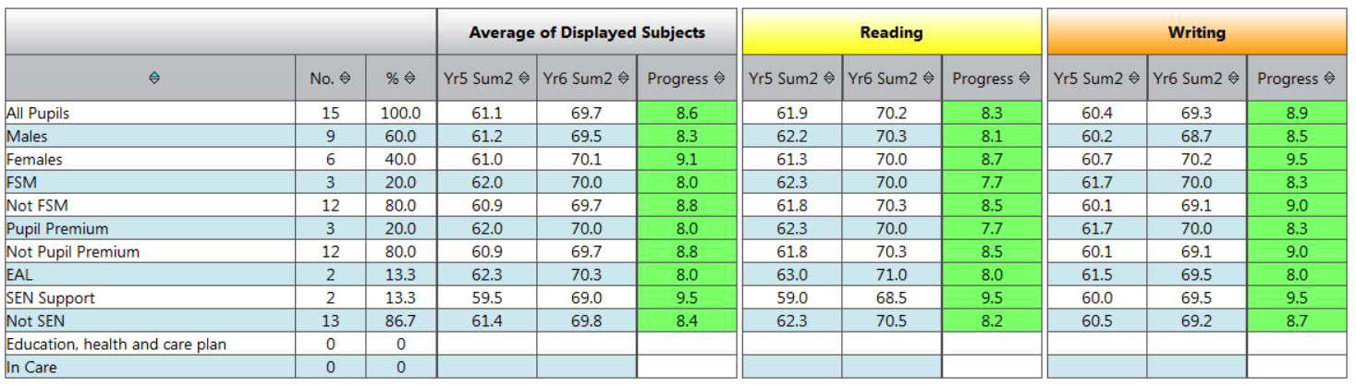 | 