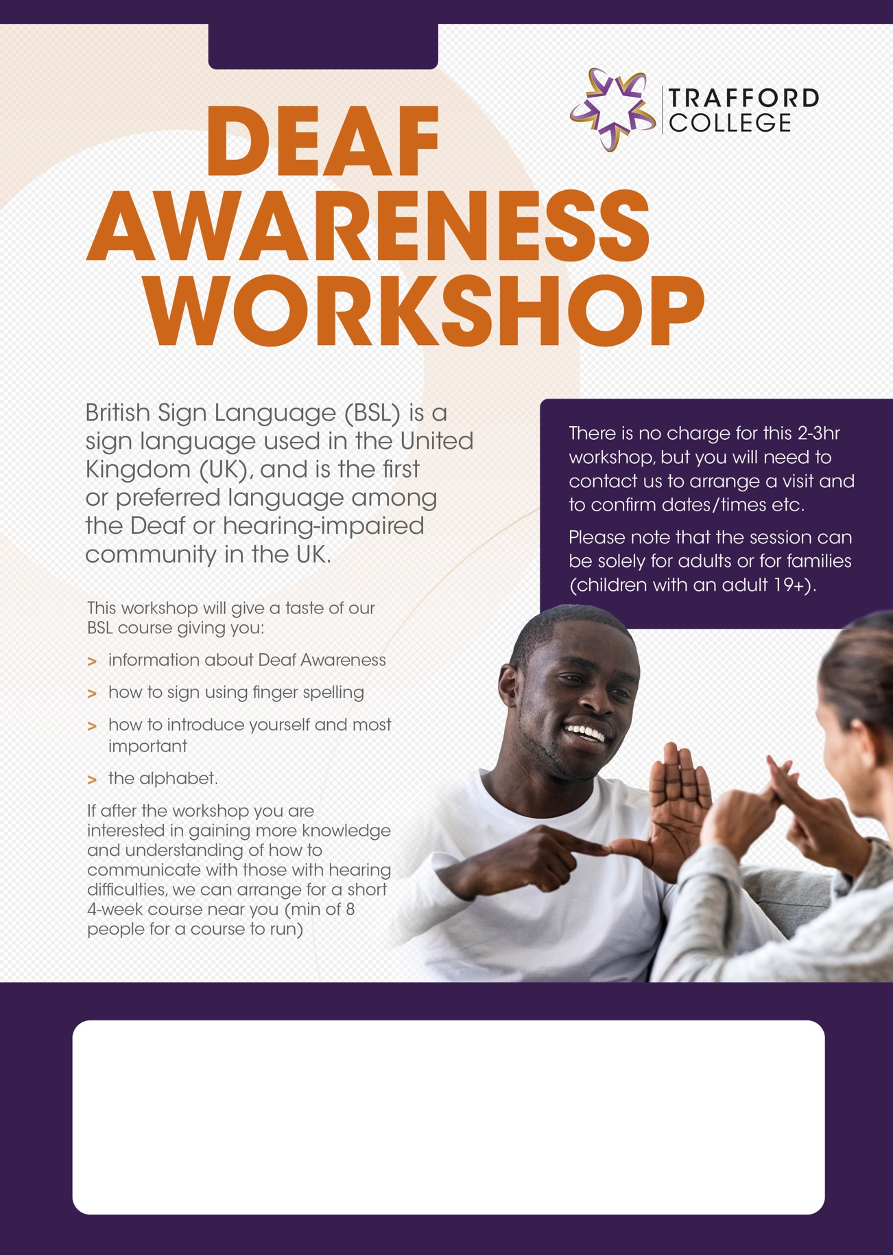

FREE Workshop - Brinnington Library

Monday 15th May

10am – 1pm

Jenny.obrien@tcg.ac.uk