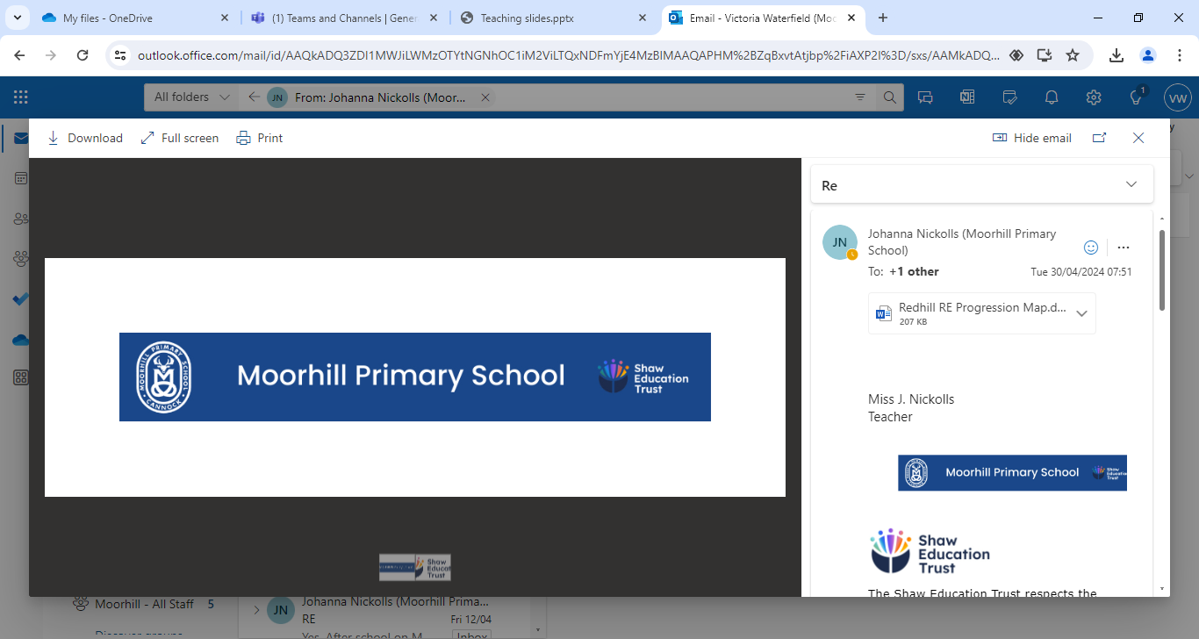 |  | Moorhill Primary School  Music development plan 2024-2025  8.6.24  V Waterfield – Subject leader |  |  | 
Key information
This plan has been written in relation the DfE vision set out in the refreshed National Plan for Music Education 2022 for all schools to have a published School Music Development Plan by September 2023.

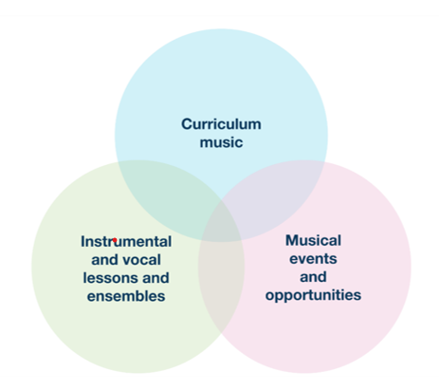
To create a meaningful and supportive action plan, the subject leader has revised the following documentation, engaged with hub services and carried out a School Music audit to identify key priorities as a school.

Key documentation:
The Power of music to change lives – national plan for music https://www.gov.uk/government/publications/the-power-of-music-to-change-lives-a-national-plan-for-music-education

National curriculum for music
https://assets.publishing.service.gov.uk/media/5a7b7f8c40f0b645ba3c4b8a/PRIMARY_national_curriculum_-_Music.pdf

Model Music curriculum
https://assets.publishing.service.gov.uk/media/6061f6a3e90e072d94e6f920/Model_Music_Curriculum_Key_Stage_1__2_FINAL.pdf
Key common features of excellent provision
The National Plan for Music Education 2022 sets out the key common features of excellent music provision as follows:

• At least one hour per week of timetabled curriculum music (in key stages 1-3)
Music is currently taught each week in KS1 for 30-40 minutes. In KS2, music is taught in rotation with French for 40-55 minutes a week for one half of each term.
• Access to instrumental/vocal lessons
Children in years 4 will have access to WCET with a specialist teacher instruction of both singing and the Ukulele. The subject lead is currently exploring 2 instrument clubs; Ukulele for KS2 and recorder for KS1. This will be led by the music lead.
All children have the opportunity to join a Rocksteady band through the Rocksteady music school.
• A school choir
Subject leader will reopen the school choir in September ready to attend Young Voices in January and maintain throughout the year. Subject leader is also looking into other performance opportunities for the choir in the local area.
• A school ensemble/band/group
Host to Rocksteady music band. The subject lead is currently exploring 2 instrument clubs; Ukulele for KS2 and recorder for KS1. This will be led by the music lead.
All children have the opportunity to join a Rocksteady band through the Rocksteady music school.
• Space for rehearsals and practice
Music room has been repurposed to Forest school Room – alternatives arrangements made for lessons (ELSA room and KS2 hall). Subject lead to make the most use of space in former music room to provide a suitable and stimulating musical environment.
• A termly school performance
Currently not in practise but this can be explored in the 24/25 academic year.
• Opportunity to enjoy live performances at least once a year
Subject lead has sought advice from the local Music Hub and will be looking to expand this in 24/25 academic year.

Actions based on Subject Audit – June 2024
What is the area to improve? | Why is it important? |  | What will success look like? | When should this be achieved? |  | What resources are needed? | Who is responsible?
1: Improved assessment framework to be developed and training delivered to staff to embed this across the school, including formal assessment, assessment strategies and evidence collection. | To allow accurate measurement of pupil progress to inform teaching and learning for the advancement of all pupils. |  | Teachers will feel confident in assessing pupils musical progress. Teachers will know where pupils are to inform next steps in delivery. | Made available to all staff in Sept 2024.  First cycle complete July 2025. |  | Assessment framework developed by music lead.  Staff meeting time. | V.Waterfield (music lead)
What is the area to improve? | Why is it important? |  | What will success look like? | When should this be achieved? |  | What resources are needed? | Who is responsible?
2: Purchase some high-quality music instruments to improve the accessibility and delivery of the KAPOW music curriculum. | To allow children to access high quality learning provided by KAPOW in instrumental instruction.  Children will be able to access a wider range of tuned and untuned instruments. |  | Children will be actively engaged in lessons through the ability to use an instrument. Ideally each children to have access to an individual instrument during instruction and activity.  Children able to grow in musical knowledge and skills through greater access and variety. | By the end of 24/25 academic year. |  | Chromatic glockenspiels  Colour/coded chime bars.  A good selection of untuned percussion instruments of high quality.  Garage band on iPad. | V Waterfield  (Music Lead)
What is the area to improve? | Why is it important? |  | What will success look like? | When should this be achieved? |  | What resources are needed? | Who is responsible?
3: Improve pupil engagement in elective musical activities through musical visits/workshops, provision of instrumental ensembles outside of the taught curriculum. | To encourage learners to follow musical ambitions and further their musical skills by engaging in musical abilities beyond the curriculum. Boost the musical profile of the school, inspire future musicians and create a collective musical voice. |  | A higher proportion of children will engage in extra-curricular provision with regular opportunities to perform and showcase their achievements.  Children will feel confident and proud of their musical abilities.  Children will feel inspired/motivate to engage in music in the wider context of the school. | Academic year 24/25 |  | Access to contact information companies/organisations to provide musical experiences/workshops – networking.  High quality instruments and specialist teachers.  Assembly time/school performance’s scheduled into calendar.  Music rehearsal space. | V Waterfield  (Music Lead)

Date of MDP:  8th June 2024 | Written by: V Waterfield  Subject lead | Date to be reviewed:  Summer 2025

