**Monday 18th September 2023**

**A REMINDER OF TIMES FOR THE START AND END OF THE SCHOOL DAY**

RECEPTION, YEAR 1 AND YEAR 2: Gates open at 8.40am and children can go to class at 8.45am. Registration is at 8.50am and this is the time that all children need to be in their classroom, ready for learning. Children finish school at 3.20pm.

YEAR 3: The gate opens at 8.30am. Children in at this time will go to the hall, by walking across the first playground, walking up the steps and turning right to enter the building by the Year 3 door, before making their way to the hall. Children can go to their classrooms from 8.45am and must be in their classrooms ready for learning by 8.55am. They finish their school day at 3.25pm.

YEARS 4, 5 AND 6: The gates open at 8.30am and children access the hall in the same way as Year 3. Children can go to their classrooms from 8.45am and must be in their classrooms, ready for learning, by 8.55am. They finish their school day at 3.30pm.

**ATTENDANCE**

What are my responsibilities for child’s attendance?

As a parent, you are legally responsible for making sure your child gets a suitable full-time education, usually for the age of 5 to 16.

For most parents, this will mean making sure your child is in school every day except when:

* Your child is too ill to go to school
* You have permission for a leave of absence from your child’s school for them not to attend. You should only ask for this in exceptional circumstances.
* Your religious body has a day especially for religious observance.

There are also some other circumstances for example where:

* Your local council is responsible for arranging your child’s transport to school and it is not available on that day or has not been provided yet.
* Your child attends an independent school that is beyond walking distance from home and your local council has not arranged for your child to board at or near the school or attend another school closer to home.
* Your child does not have a permanent address and you are required to travel for work. (This exception only applies if your child attends their usual school or another school where you are staying as often as possible. This must be 200 half days a year if they are aged 6 or older).

**GETTING TO KNOW YOU MEETINGS**

Thank you to all parents who attended the ‘Getting to Know you’ meetings last week. If you were unable to attend, please speak to your child’s class teacher and they will arrange a mutually convenient time for you to come into school for an informal meeting.

**IS MY CHILD TOO ILL FOR SCHOOL?**

**It can be tricky deciding whether or not to keep your child off school, nursery or playgroup when they are unwell.**

There are Government guidelines for schools and nurseries about managing specific infectious diseases at GOV.UK. These say when children should be kept off school and when they shouldn’t.

If you do keep your child at home, it is important to phone the school or nursery on the first day. Let them know that your child won’t be in and give them the reason.

If your child is well enough to go to school but has an infection that could be passed on, such as a cold sore or head lice, let their teacher know.

**Other illnesses**

Follow this advice for other illnesses:

**Coughs and Colds**

It’s fine to send your child to school with a minor cough or common cold. But if they have a fever, keep them off school until the fever goes.

Encourage your child to throw away any used tissues and to wash their hands regularly.

**High Temperature**

If your child has a high temperature, keep them off school until it goes away.

**Chickenpox**

If your child has chickenpox, keep them off school until all the spots have crusted over. This is usually about 5 days after the spots first appeared.

**Cold sores**

There is no need to keep your child off school if they have cold sore. Encourage them not to touch the blister or kiss anyone while they have the cold sore, or to share things like cups or towels.

**COMMUNICATION**

Please use our website for information. Regular newsletters are posted there and a text is sent with a link each time a newsletter is posted.

Can we please remind parents that if your child is absent from school due to illness, that you report this through the school office and not via DOJO, as teachers do not pick up their messages during the day whilst they are teaching. This is also the same if there is a change to who is collecting your child at the end of the day. Thank you.

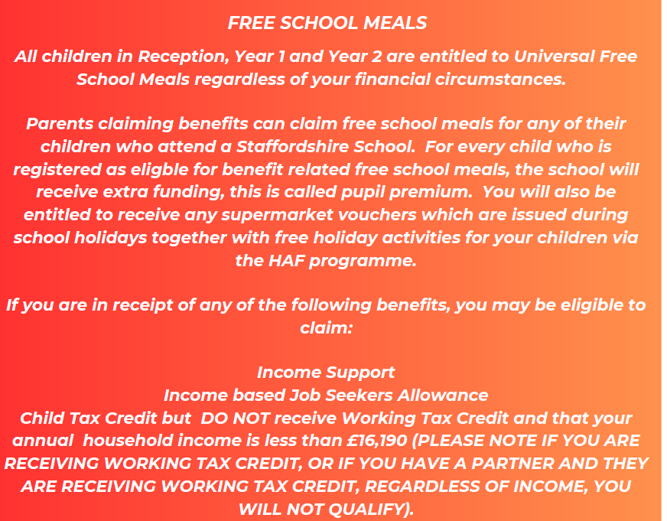

**Conjunctivitis**

You do not need to keep your child away from school if they have conjunctivitis.

Do get advice from your pharmacist. Encourage your child not to rub their eyes and to wash their hands regularly.

**Covid-19**

If your child has mild symptoms, such as a runny nose, sore throat, or slight cough and feels well enough, they can go to school.

Your child should try to stay at home and avoid contact with other people if they have symptoms of Covid-19 and they either:

* Have a high temperature
* Do not feel well enough to go to school or do their normal activities.

**Ear infection**

If your child has an ear infection and a high temperature or severe earache, keep them off school until they are feeling better or their high temperature goes away.

**Hand, foot and mouth disease**

If your child has hand, foot and mouth disease but seems well enough to go to school, there is no need to keep them off. Encourage your child to throw away any used tissues straight away and to wash their hands regularly.

**Head lice and nits**

There is no need to keep your child off school if they have head lice. You can treat head lice and nits without seeing a GP.

**Impetigo**

If your child has impertigo, they will need treatment from a GP, often with antibiotics.

Keep them off school until all the sores have crusted over and healed, or for 48 hours after they start antibiotic treatment. Encourage your child to wash their hands regularly and not to share things like towels and cups with other children at school.

**Ringworm**

If your child has ringworm see your pharmacist unless it is on their scalp, in which case you should see a GP.

It is fine for your child to go to school once they have started treatment.

**Scarlet fever**

If your child has scarlet fever, they will need treatment with antibiotics from a GP. Otherwise they will be infectious or 2 to 3 weeks. Your child can go back to school after starting antibiotics.

**Slapped cheek syndrome (fifth disease)**

You do not need to keep your child off school if they have slapped cheek syndrome because once the rash appears, they are no longer infectious.

Please let the school or teacher know if you think your child has slapped cheek syndrome.

**Sore throat**

You can still send your child to school if they have a sore throat. But if they also have a high temperature, they should stay at home until it goes away.