 | MOORHILL PRIMARY  Reading Policy  Reviewed October 2024 | 

Table of Contents
Roles and Responsibilities 2
Intent 3
Implementation 3
The Teaching of Phonics- RWI Phonics Programme 3
Reading TO children 4
Reading Aloud for Pleasure 4
Reading Authors for 2024 - 2025 4
Reading WITH children 5
Guided Reading 5
Teaching Guided Reading through Vocabulary Ninja - Fiction 5
Teaching Guided Reading through Vocabulary Ninja Non-Fiction 6
Skimming and Scanning examples 6
Order of reading (Guided Reading) 7
Teaching vocabulary resources and ideas 7
9
Guided Reading timetable for Fiction units Vocabulary Ninja 9
Guided Reading timetable for Non-Fiction units Vocabulary Ninja 10
Opening Worlds Texts 10
Book Club 11
Reading in every lesson 11
Reading BY children 11
Read Write Inc 11
Fresh Start 11
Reading Plus 11
Individual reading books 11
Reading Records Booklets 12
Class reading time: 12
Impact 12
Reading at home 13
Assessment 13
Phonics and the Screening Test 13
NTS 13
Reading Plus 13
Oral Fluency 14
Learning Environment and reading culture for pleasure 14
Book Club – teacher and peer influencers 14
Organisation of reading materials 14
Selecting books for independent reading 14
Book corner 15
Reading Incentives 15
Appendix 16
Appendix 1: The Programme of Study as stated in the National Curriculum/ EYFS Development Matters 16
Appendix 2: Preparing to read a story 19
Appendix 3 Promoting books for book club and increasing anticipation 20
Appendix 4: Guided Reading Spine Year 2-6 20

Roles and Responsibilities
The subject leader is responsible for:
• Ensuring staff are familiar with the Reading Policy document and the outcome of the reading audit based on the reading framework 2023.
• Reviewing changes to the national curriculum and advising teachers on their implementation.
• Monitoring the learning and teaching of reading, providing support for staff where necessary.
• Ensuring continuity and progression from year group to year group.
• Encouraging staff to provide effective learning opportunities for pupils.
• Helping to develop colleagues’ expertise in reading.
• Organising the deployment of resources and carrying out an annual audit of related resources.
• Liaising with teachers across all phases.
• Communicating developments in the subject to all teaching staff and the senior leadership team (SLT), as appropriate.
• Leading staff meetings and providing staff members with the appropriate training.
• Ensuring common standards are met for recording and assessing pupil performance.
• Advising on the contribution of reading to other curriculum areas, including cross-curricular and extra-curricular
activities.
• Alongside the Executive Headteacher and SLT evaluate assessment data and set new priorities for the development of reading in subsequent years.

The classroom teacher(s) is/are responsible for:
• Acting in accordance with this policy.
• Ensuring progression of pupils’ reading skills, with due regard to the national curriculum.
• Planning lessons effectively, ensuring a range of teaching methods are used to cover the content of the national curriculum.
• Liaising with the subject leader about key topics, resources and support for individual pupils.
• Monitoring the progress of pupils in their class and reporting this on an annual basis to parents.
• Ensure the classroom has access to a range of reading texts at an appropriate age.
• Provide a stimulating learning environment that promotes a culture of reading.
• Reporting any concerns regarding the teaching of the subject to the subject leader or a member of the SLT.
• Undertaking any training that is necessary in order to effectively teach reading.

Intent
At Moorhill, Reading is fundamental.
Reading is a life skill which is the cornerstone to enabling our children to become articulate communicators and we use the National Curriculum to do this effectively. We believe that all children should have the opportunity to be fluent, confident readers who are able to successfully comprehend and understand a wide range of texts.
We want pupils to develop a love of reading, a good knowledge of a range of authors and be able to understand more about the world in which they live through the knowledge they gain from texts. It is not only key for academic success across the whole curriculum but remains a crucial lifeline which prepares pupils for the next stage of their education. The aim for all of our children is to be able to read fluently and with confidence in many subjects. The foundations for successful reading at Moorhill are formed through our comprehensive phonics programme: Read Write Inc. We use Read Write Inc because it provides a succinct, repeated learning process which allows Moorhill children the opportunity to embed new skills before applying them in a comprehensive manner.
At Moorhill, we understand the importance parents and carers have in supporting their child to develop word reading, comprehension skills, fluency and a love of reading; we aim to encourage a home-school partnership which enables parents and carers to understand how to enhance the skills being taught in school through good quality texts.

Implementation

We have organised reading for into the following stages:
- Read Write Inc Phonics programme
- How we read TO children
- How we read WITH children
How children read BY themselves

The Teaching of Phonics- RWI Phonics Programme
EYFS and KS1 children will be taught phonics through the Read Write Inc programme that explicitly teaches pupils a comprehensive set of letter-sound relationships through an organised sequence. This continues into Year 1 and 2.
The programme aims to build children's speaking and listening skills in their own right as well as to prepare children for learning to read by developing their phonic knowledge and skills. A detailed and systematic programme for teaching phonic skills is taught to children starting in Reception, with the aim of them becoming fluent readers by age seven.
In Reception and Year 1 the teaching of reading focuses on word reading, working out the pronunciation of unfamiliar printed words (decoding) and word recognition, learning to recognise by sight familiar printed words. Underpinning both is the understanding that letters represent the sounds in spoken words. This is why phonics is emphasised in the early teaching of reading when children are in EYFS and Year 1. The Read Write Inc phonics programme is used for this.
Both de-coding and comprehension skills are necessary for confident and competent reading, but neither is sufficient on its own.
It is also important to remember that progress in reading requires pupils to develop motivation and engagement, which help each child to develop persistence and enjoyment in their reading.
Children will need a wider range of language and literacy experiences across the curriculum to develop their understanding of written texts in all their forms. This should include active engagement with different media and genres of texts and a wide range of content topics.
In every classroom, RWI complex speed charts and an appropriate frieze are available to aid in children’s reading of unfamiliar texts. In Key Stage Two these are replaced by Set Two and Three sounds.

Reading TO children

Reading Aloud for Pleasure
“If you are going to get anywhere in life you have to read a lot of books.” Roald Dahl
To foster a reading culture, teachers use Author Study books to model ‘good reading’ during reading aloud for pleasure. Every classroom should have 15 minutes of Reading For Pleasure daily. During this time, teachers should focus on what makes ‘good reading’ using gestures and drama to bring the print alive. Reading aloud fosters positive attitudes, enhances children’s motivation to read and develops vocabulary and other knowledge. It also contributes to their fluency as they listen to an accomplished reader bringing a text to life. The authors will be placed in every classroom for the half term for children to access when needed and shared through Book Club.
Teachers must have pre-read any books / texts shared with the children.
To prepare for reading a story, teachers should consider the following:
- Anticipation
- Pace
- Voices
- Pauses
- Cliff-hangers
- Word meanings
- Asides
- Illustrations
- Memorable words and phrases
- Joining in with poetry and stories.
Please see Appendix 2- Reading aloud for a more detailed explanation.
Reading TO children will also take place in all lessons.

Reading Authors for 2025 - 2026
 | Autumn 1 | Autumn 2 | Spring 1 | Spring 2 | Summer 1 | Summer 2
Reception | Allan Ahlberg | Jon Klassen | Oliver Jeffers | Jarvis | Mick Inkpen | Leigh Hodgkinson
Year 1 | Eric Carle | Nadia Shireen | David McKee | Rachael Bright | Jill Murphy | Benji Davies
Year 2 | Mem Fox | Kes Gray | David Lichfield | Rob Biddulph | Anthony Brown | Simon Bartram
Year 3 | Dick King Smith | Ted Hughes | Micheal Rosen | Roald Dahl | Carol Ann Duffy | Vashti Hardy
Year 4 | Micheal Morpurgo | Louie Stowell | Tom McLaughlin | Maz Evans | Louis Sachar | Serena Patel
Year 5 | David Walliams | M.G. Leonard | Pete Johnson | Christopher Edge | Marcia Williams | Jess Butterworth
Year 6 | Matt Goodfellow | Bertie Doherty | Phillip Pullman | Ross Welford | Neil Gaiman | Piers Torday

Reading TO children will also take place in all lessons.

Reading WITH children

Guided Reading
Guided Reading is the teaching of reading through ‘explicit instruction and conscious effort’. It will take place daily for 25 minutes and introduce a wide range of literature and non-fiction; explanations, modelling and support from the teacher for different aspects of reading, including fluency and allowing the children to think deeply and discuss a range of rich and challenging texts.
During these sessions, to ensure that the vocabulary gap does not widen further, children who are not able to read fluently will receive specific reading support in smaller groups. The whole school follows a similar plan so that it is sequenced effectively. Lessons will allow children to engage with a wide range of human experience: why characters make the choices that they make and why they feel what they feel. It will give them a chance to consider ideas beyond their experience.
The text for each reading lesson can be more challenging than the children might be able to understand independently because the teacher will be there for support. Even those children with less well-developed language or reading skills will be exposed to the challenging texts. Support for those children might be targeted questioning, further explanations, pre-teaching of vocabulary or the chance to re-read the text after the initial reading as a smaller group.
Teaching will also expose the idea of VIPERS (Vocabulary, Inference, Prediction, Explanation, Retrieval, Summarise and Sequence). Teachers will provide mental models for how each aspect of this works whilst activating their background knowledge and keeping inside the story. For example, asking children to talk to their partners and predicting what happens next based on what they have read, or visualise a character based on reading a description.
Socrative may be used for live assessment within Guided Reading lessons. This is accessed via Showbie.
Teachers will ensure that they use the model of I do, We do and You do, as part of the modelling process. Priority should be given to locating and retrieving information because from there inference, sequencing and explanation type questions can be accessed. We use texts provided by Vocabulary Ninja and other quality resources. Please see Appendix 4 for the Guided Reading Spine for Year 2-6.

Teaching Guided Reading through Vocabulary Ninja - Fiction
Step 1: Pre-reading and key information to identify in a text
- Teach children to pre-read the text and identify key information (THIS SHOULD BE MODELLED)
  - Children adopt a positive reading position, sat up straight and ready to read. Children read with their pencil so they move it across the page while reading. If they need to underline something they are already in the right place. Around 3/6 pieces per paragraph is generally enough. It should not be full sentences.
  - Who or which – Characters, people, animals, events etc
  - When – Time periods, times of day, days, months, years etc
  - Where – Locations or changes to location
  - What or how – actions character performs, linked to verb phrases
  - Vocabulary – key vocabulary that is relevant to understanding and words that children are unfamiliar with
  - Dialogue – conversations between characters
Step 2: Keywords in the question
- Once the children have underlined, they can begin to answer questions by spotting keywords or phrases. E.g. Why was the dinosaur near to tears? Children should underline near to tears
- Children then skim the text to find the keyword. Train children to read the sentence before and after the keyword.
Question Types
- Fill in the gap
- Five Ws and How – model thoughts aloud showing how the teacher makes mental notes
- Multiple choice – model to children that they can eliminate some answers based on their pre-read
- True or False – model how to spot key words and not guess
- Summarise
- Sequencing – model to children to give each statement a shape, then mark the shape in the text, then put in the correct order
- Find and Copy – appropriate to ask children to use best guess if struggling
- Circle a word – explore definitions

Teaching Guided Reading through Vocabulary Ninja Non-Fiction
Step 1: Pre-reading and key information to identify in a text
- Teach children to pre-read a text and identify key information (THIS SHOULD BE MODELLED)
  - Children adopt a positive reading position, sat up straight and ready to read. Children read with their pencil so they move it across the page while reading. If they need to underline something they are already in the right place. Around 3/6 pieces per paragraph is generally enough. It should not be full sentences.
  - Key information to underline
    - Names – places, people, companies, events, teams
    - Dates – days, months, years, times, periods of time from beginning to end
    - Statistics and numbers – including percentages, fractions, amounts and figures
    - Unknown vocabulary – words children do not know
    - Headings, subheading and images
Step 2: Keywords in the question
- Teach children to spot keywords or phrases in a question. E.g. How did soldiers effectively use morse code during World War II. Morse code is the keyword because soldiers and WW2 are most likely to be repeated throughout.
- Children then skim the text to find the keyword. Train children to read the sentence before and after the keyword.
Step 3: Skimming and Scanning
Skimming and scanning should be a common vocabulary with children and staff.

Skimming and Scanning examples
Skimming is a whole text process. Children skin across the text to locate a specific paragraph or area. It is unlikely you will find the answer skimming a text but you will be able to locate the area. Ask children to be think about whether the keyword was at the beginning, middle or end of the text, whether there is an image or a subheading that might help.
Scanning is then looking at that section with a greater level of scrutiny to find the answer.
Question Types
- Label
- Label and draw
- Matching
- Fill in the gap
- Multiple Choice
- True or False
- Sequencing
- Find and Copy
Underline or Highlight

Order of reading (Guided Reading)
- Teacher reads the text aloud and models good practice.
Echo Read
- Teacher models a sentence, paragraph or part of a text and the children copy the way the teacher has read it.
Choral Read
- Teacher and child read a sentence, paragraph or part of the text at the same time.
Partner Read
- Children read a paragraph to their partner and vice-versa for the whole text.
Independent Read
- Children read aloud or silently the whole text.

Teaching vocabulary resources and ideas
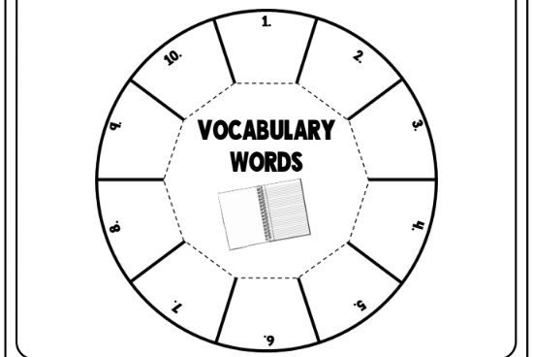 | Vocabulary Wheels  Students will love this engaging vocabulary activity. They can work individually or in pairs or groups to create one or two wheels to connect the vocabulary words with their definitions. Teachers can adapt this accurate matching activity for any age group to teach effective vocabulary in their classrooms. Learn about this fun activity as well as two others here.
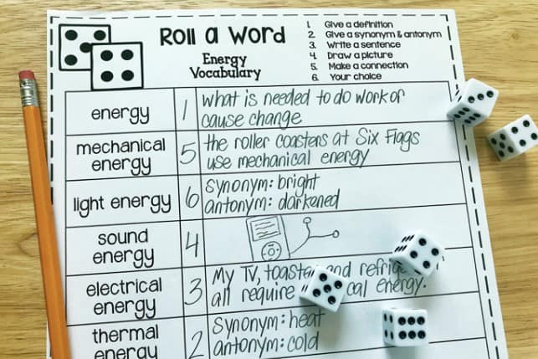 | Roll A Word  This vocabulary activity is anything but boring! The Roll a Word vocabulary sheet can be used with any vocabulary word and any age level. Children will enjoy rolling a die. The vocabulary activity depends on the number the student rolls. Choose vocabulary and pop it into a table. Children do the rest.
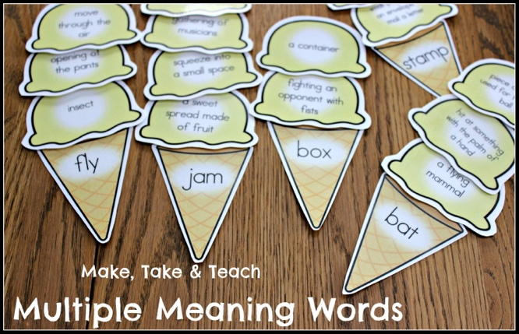 | Ice Cream Scoops  This creative activity focuses on multiple-word meanings. This activity is an efficient method for helping students understand that some words have different meanings based on how they are used in spoken or written language. Once students understand this, they will have an increase in vocabulary retention and expansion.
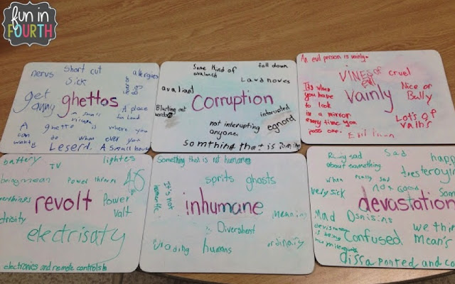 | Word Graffiti  This is a wonderful activity to use with your students before they read an assignment. It is definitely not a difficult task. The teacher can use a customized list of words for focus and write them on dry-erase boards or large paper. The students can work individually or in groups to complete this fun and engaging activity.
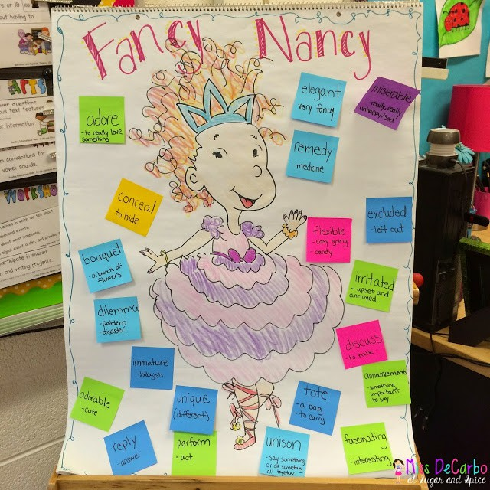 | Fancy Nancy  This chart is an astounding way to teach children to use context clues. The teacher is the facilitator and should model how the vocabulary word is used in the context of the story that is being read in class. The teacher will also provide examples of how the students could apply the vocabulary word in their daily lives.
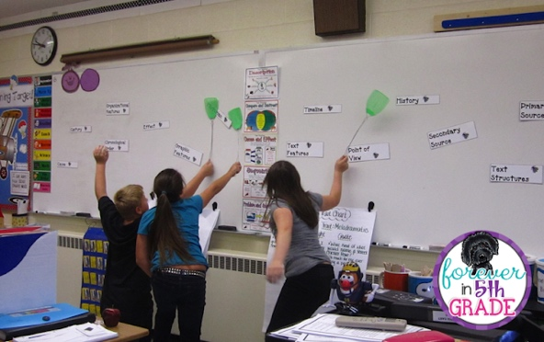 | Swat the Vocab  Write the vocabulary on card. Make sure to spread them out as much as you can. Divide your class into three or more teams. Have one player from each team come up to the front and get a fly swatter. Teacher reads a definition out loud, and watch out! The child who swats the correct vocabulary word first earns their team a point.
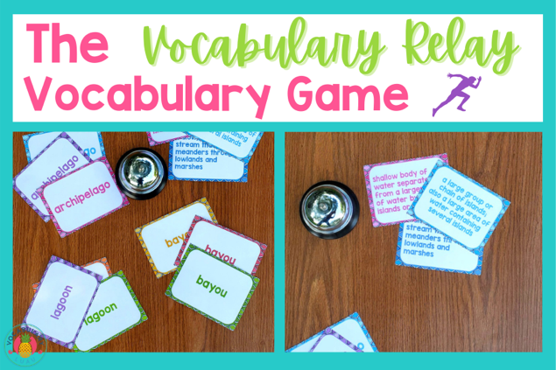 | Storytelling Vocabulary Relay  Take your children on a linguistic adventure with this storytelling activity! Have them collectively weave a story by taking turns to add to the narrative; each one incorporating a new word. This not only encourages creativity in your little ones but also improves their understanding of the contextual usage of new words.
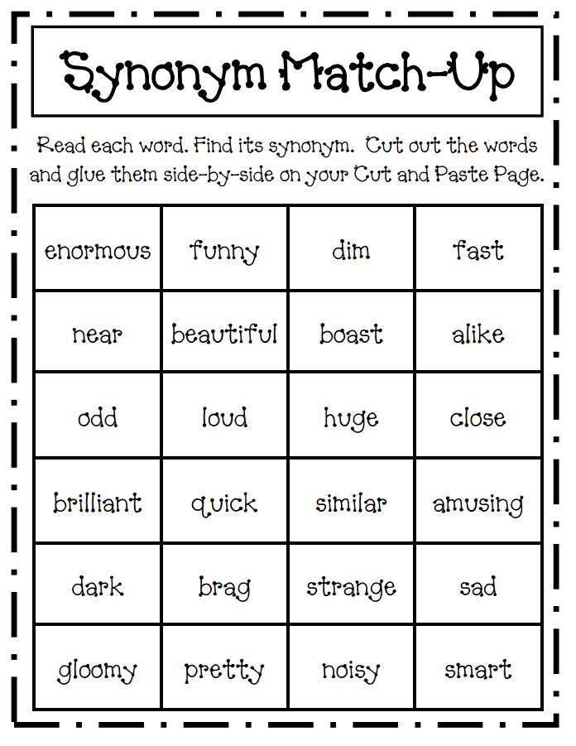 | Synonym Match-up  Synonyms are a crucial part of language acquisition. To make the learning process enjoyable for your learners, turn it into a game! Challenge them to match each word to its corresponding synonym card.
 | Vocabulary Puppet Show  Let your learners’ creativity shine by having them put on a puppet show- incorporating new vocabulary into normal dialogue. Whilst enhancing their language fluency, this activity will help them tap into some imaginative creative play.
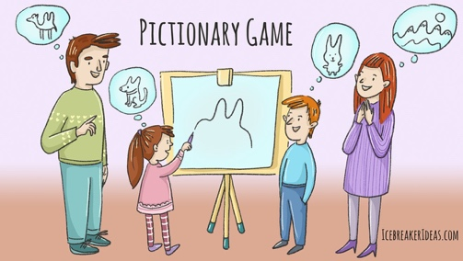 | Vocabulary Pictionary  This thrilling rendition of the popular parlour game promotes visual thinking and encourages children to think about the meaning behind words. Have them draw an image that they associate with a word before challenging the rest of their classmates to guess the word!

Guided Reading timetable for Fiction units Vocabulary Ninja
Guided Reading timetable for Fiction units Vocabulary Ninja
Day | Task 1 | Task 2 | Task 3 | Task 4
Monday | First Read-Teacher Read  Children stay in the text and listen to the whole text without interruption. | Skimming and Scanning  Children sat in ready to read pose. Teacher reads text again and discuss any underlined vocabulary underlined at the end. | Vocabulary  Children create a list of unknown words. Teacher models ways to find out what they mean. | Fill in the gap  I do- Teacher models how  We do – Teacher and child complete one as a group. Small groups if needed after  You do- Children complete task.  Peer Marking
Tuesday | Vocabulary Retrieval  Children quiz the unknown words from the previous day. Teacher to re-cover these words if needed through direct teaching. | Second Read – Choral read  Teacher and child read the text at the same time matching the pace, tone and intonation modelled by the teacher. | 5 Ws and How  I do- Teacher models how  We do – Teacher and child complete one as a group. Small groups if needed after  You do- Children complete task.  Peer Marking | Multiple Choice  I do- Teacher models how  We do – Teacher and child complete one as a group. Small groups if needed after  You do- Children complete task.  Peer Marking
Wednesday | Third Read – Echo Read  Teacher reads a sentence, paragraph or part of the text and children respond with the same pause, tone and intonation. | True or false  I do- Teacher models how  We do – Teacher and child complete one as a group. Small groups if needed after  You do- Children complete task.  Peer Marking | Summarise  I do- Teacher models how  We do – Teacher and child complete one as a group. Small groups if needed after  You do- Children complete task.  Peer Marking | Sequencing  I do- Teacher models how  We do – Teacher and child complete one as a group. Small groups if needed after  You do- Children complete task.  Peer Marking
Thursday | Fourth Read – Partner read  Children take turns in reading the text to their partner, remembering the models practiced in previous lessons. | Find and Copy  I do- Teacher models how  We do – Teacher and child complete one as a group. Small groups if needed after  You do- Children complete task.  Peer Marking | Circle a word  I do- Teacher models how (revisit words)  We do – Teacher and child complete one as a group. Small groups if needed after  You do- Children complete task.  Peer Marking | Fifth Read – Independent reading  Children read the text silently or aloud at their own pace with the tone and intonation practiced throughout the week.
Reading aloud for pleasure focus
Based on the reading aloud for pleasure text across the week, the teacher will generate a set of questions around the domains below. Children to complete these as whole class, small group and partners. Independent work is not encouraged because we want to encourage children to discuss their thoughts on the text and have a greater exposure to different thoughts, feelings and viewpoints on the text.
Friday | Vocabulary  Opportunity to discuss any vocabulary, word structures the author has used. Children could draw out what they words mean. | Inference | Prediction | Explanation

Guided Reading timetable for Non-Fiction units Vocabulary Ninja
Guided Reading timetable for Non-Fiction units Vocabulary Ninja
Day | Task 1 | Task 2 | Task 3 | Task 4
Monday | First Read-Teacher Read  Children stay in the text and listen to the whole text without interruption. | Skimming and Scanning  Children sat in ready to read pose. Teacher reads text again and discuss any underlined vocabulary underlined at the end. | Vocabulary  Children create a list of unknown words. Teacher models ways to find out what they mean. | Label/ Draw and Label  I do- Teacher models how  We do – Teacher and child complete one as a group. Small groups if needed after  You do- Children complete task.  Peer Marking
Tuesday | Vocabulary Retrieval  Children quiz the unknown words from the previous day. Teacher to re-cover these words if needed through direct teaching. | Second Read – Choral read  Teacher and child read the text at the same time matching the pace, tone and intonation modelled by the teacher. | Matching  I do- Teacher models how  We do – Teacher and child complete one as a group. Small groups if needed after  You do- Children complete task.  Peer Marking | Fill in the gap  I do- Teacher models how  We do – Teacher and child complete one as a group. Small groups if needed after  You do- Children complete task.  Peer Marking
Wednesday | Third Read – Echo Read  Teacher reads a sentence, paragraph or part of the text and children respond with the same pause, tone and intonation. | Multiple choice  I do- Teacher models how  We do – Teacher and child complete one as a group. Small groups if needed after  You do- Children complete task.  Peer Marking | True or False  I do- Teacher models how  We do – Teacher and child complete one as a group. Small groups if needed after  You do- Children complete task.  Peer Marking | Sequencing  I do- Teacher models how  We do – Teacher and child complete one as a group. Small groups if needed after  You do- Children complete task.  Peer Marking
Thursday | Fourth Read – Partner read  Children take turns in reading the text to their partner, remembering the models practiced in previous lessons. | Find and Copy  I do- Teacher models how  We do – Teacher and child complete one as a group. Small groups if needed after  You do- Children complete task.  Peer Marking | Underline or Highlight  I do- Teacher models how  We do – Teacher and child complete one as a group. Small groups if needed after  You do- Children complete task.  Peer Marking | Fifth Read – Independent reading  Children read the text silently or aloud at their own pace with the tone and intonation practiced throughout the week.
Reading aloud for pleasure focus
Based on the reading aloud for pleasure text across the week, the teacher will generate a set of questions around the domains below. Children to complete these as whole class, small group and partners. Independent work is not encouraged because we want to encourage children to discuss their thoughts on the text and have a greater exposure to different thoughts, feelings and viewpoints on the text.
Friday | Vocabulary  Opportunity to discuss any vocabulary, word structures the author has used. Children could draw out what they words mean. | Inference | Prediction | Explanation

Opening Worlds Texts
For History, Geography and R.E. lessons, vocabulary is explicitly taught. It is also built upon progressively. All of the texts provided by Opening Worlds are challenging for the year group and teachers are trained in adapting the text to the needs of the child so all children can access the complexity. Children have access to these texts during the lesson and teachers will read the text to the child and the children will then partner read it with each other.

Book Club
Please learning environment section of the reading booklet.

Reading in every lesson
Teaching sequences in writing are linked to specific texts which the children will have access to outside of the lesson. There will also be reading and the integration of text incorporated where possible in all lessons as we know that the whole curriculum is essential to develop comprehension and for the children to know more. Quality modelling will be provided so that children are engaged as historians, geographers, scientists and others. For children who cannot read well, they will have support where needed.

Reading BY children

Read Write Inc
Children following the Read Write Inc programme will follow it with fidelity. Children will have access to phonetically decodable books-Book Bag Books, which they will take home to read with their parents. They will also have access to reading this book in school so they have chance to practise the sounds known.

Fresh Start
Fresh Start is the KS2 aspect of Read Write Inc and will be used as an intervention for children who have gaps in their GPC’s during guided reading time. Monitoring of this will be completed by the phonics leader and assessments will be taken regularly so children do not remain on the programme.

Reading Plus
Reading Plus creates a reading programme that offers a personalised practice with adaptive instruction. It supports the children with silent reading fluency, vocabulary, comprehension and motivation for reading. Children have access to this both in and outside of school. They are able to select informational and literary texts from eight high-interest categories in the curriculum. Each text is followed by a set of comprehension questions. It also teaches children a research-based compilation of highly valuable, cross-curriculum, general academic vocabulary. Children who need additional fluency support are encouraged to develop their visual skills using two activities: Flash and Scan which supports children in recognising common letter clusters. Reading Plus tasks can be made bespoke by Reading Lead in consultation with SENDCO.
Children are expected to complete a reading book on Reading Plus once a day.

Individual reading books
Children will have access to a reading book based on their reading age in the NTS papers. For example, if they have a reading of 10.4 this is equivalent to 10 years and 4 months. They will then choose a book within that colour band range.
Children also have access to a wide range of texts which they can read for pleasure, and these can be found in the book corners of each classroom. The books chosen will be shared in Book Club.
Attached is an example of the reading book progression document.
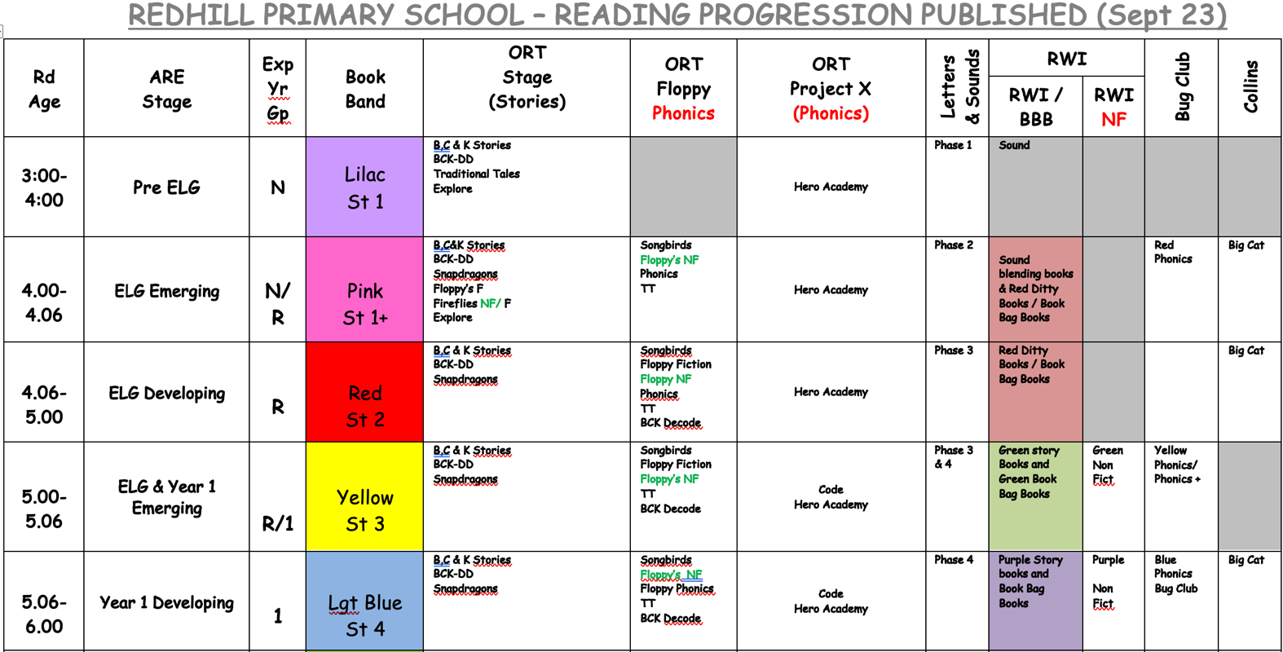
Vision:
We hope that across the year, we move away from banded books as suggested in the Reading Framework 2023 to widen further the books that children can access for pleasure.

Reading Records Booklets
Reading should take place at home every day. By improving their reading miles, how much and how wide they read, children will become better readers and a greater background knowledge to access the increasing complexity of the curriculum. Teachers are expected to write in this reading record and should monitor who is and is not reading at home daily.
Reading should take place at home every day.
Older children may begin to log their independent reading once agreed with the class teacher – this needs to be monitored carefully.
Parents and carers are encourage record their thoughts on their child’s reading this will be modelled by regular comments from both teachers and teaching assistants.

Class reading time:
Allowing children to read independently throughout the day helps build fluency. It also increase vocabulary and the ideas they encounter. Putting in the reading miles is important. Class reading time is enjoyable, something on the timetable that the class looks forward to and allows to children to settle down and get transported into a good book. It should feel like a special time for the children. It will also benefit children who do not read at home. Children are expected to read to themselves during register times each day as this also generates a period of calm.

Impact
As a school, we always aim for children to leave Moorhill as competent readers who can recommend books to their peers; have a hunger for books and seeking out new authors, texts and genres which includes poetry and have a growing confidence in evaluating and discussing authorial language.
As a Year 6 reader, transitioning into secondary school, we aspire that children are fluent, confident and able readers, who can access a range of texts for pleasure, as well as use their reading skills to unlock learning and all areas of the curriculum.
Our outcomes will always aim to be at least in line with national averages for both age-related and greater depth expectations in both Key Stage 1 and Key Stage 2.
We want our pupils to acquire a range of self-help strategies so that they have the tools to continue to improve their reading skills in the future. We firmly believe that reading is the key to all learning and so the impact of our reading curriculum goes beyond the results of the statutory assessments.

Reading at home
All children will have access to books that is matched to their reading age, based on the NTS Assessments completed. Where NTS is unable to provide an accurate reading age, the Reading Lead will complete an assessment using SALFORD.
Children are expected to read at home daily and record this in their paper diary. Children are also expected to complete their Reading Plus at home too.
All staff will promote a love of reading across the school and also within the home.
Parents are also encouraged to write their comment in a format that suits them. Children can also record their Reading Plus access in their reading records too.
Teachers are expected to monitor engagement and speak to parents if their child has not engaged with their reading at home.
All children will be supplied with a paper reading diary booklet.

Assessment

Phonics and the Screening Test
Children on the Read Write Inc programme are tested each term using the Read Write Inc assessments. The results are tracked and the Read Write Inc team support based on these assessments.
During the Summer Term, Year 1 pupils take part in the Phonic Screening check which assess their ability to apply what they have learned. Pupils who have not passed their screening will continue to have intervention to support their needs on an individual basis; they are retested in Year 2.
Any children falling behind in phonics will complete the Fast Track Program until they are back on track.

NTS
National Test-stye Standardised Assessments are completed three times a year because they reliably predict performance for Year 1 to 6 children. Teachers and leaders will then input the data to MARK, which creates standardised scores. They also show domain strengths that teachers will use to inform planning and explicit teaching. They can quickly see and analyse gaps in learning and generate reports.

Reading Plus
Reading intervention is completed through Reading Plus, a digital tool that creates an adaptive, personalised reading journey for each child based on assessment. This ensures children are reading a text at the right level. As the children work to develop the skills and stamina required for extended reading with good comprehension, they will be presented with personalised scaffolding to build independent reading skills.
Vocabulary is taught explicitly and within context. Children who need additional fluency develop their visual skills using two key activities: Flash and Scan. These activities improve the child's ability to immediately recognise common letter clusters in words and move fluently through text.

Oral Fluency
Children who have no gaps in their GPC’s (grapheme-phoneme Correspondence) and have a reading speed of 90 words a minute should be able to access reading books of their choosing. Teachers will test the oral fluency of each child regularly to ensure they access appropriate reading material.
Formative Assessment
An assessment is formative if it is designed to lead to a change in what the teacher (or the pupil) does (Black & Wiliam, 1998; Speckesser et al, 2018).
Formative assessment is useful for gathering evidence to be used as feedback to improve learner performance, identify gaps and address them, It must be integral to effective teaching on a day-to-day basis.
Assessment for Learning is constant and leads to adaptive, responsive teaching across the reading curriculum. To support with this staff use Arbor to complete regular live tracking using grades: Above Track, On Track and Below.

Learning Environment and reading culture for pleasure
The school will have a culture that promotes reading and the exploration of authors. Each classroom will have a reading display. It is impossible to force children to read for pleasure but we know that we can inspire them to engage in reading wildly. Even though we celebrate reading through activities such as World Book Day, dressing up days and other national celebrations, we also employ other core strategies to sustain voluntary reading.
- Adults to read aloud regularly
- Informal book talk and recommendations from adults and friends
- Encouraging the use of the library both in school and locally
- Providing time to read
- Sociable reading environments, reading together and sharing books.

Book Club – teacher and peer influencers
Book club will by 20 minutes and happen once a week and it should be seen as sacrosanct by the children. During this time, teachers and children will make books tempting, especially for those who do not have books in the home. It should be a space where children can browse, explore and discuss books. It might also be a time to read with a partner, explore a comic or a non-fiction text. A feast of books will be offered such as, Graphic novels, Joke books, Irreverent books and books about animals to name a few. For some it may be non-fiction texts.
The teacher will be an ‘influencer’. The children trust the judgement of the teacher who says, “I think you’ll really enjoy this one.” This will form an activity during lunch breaks for KS2 children with older children completing training before leading this (under the supervision / guidance of the reading lead).
Key Stage 1 and EYFS have access to the ‘Reading Shed’ which allows the children to access and share books during breaks and lunch periods.
Teachers are encouraged to monitor what children are reading and using the children’s 3-word-reviews to motivate other children to read. Subject leaders are also encouraged to recommend books that are linked to their subjects to motivate.
Appendix 3 gives more detail on how to promote books for book club and increase anticipation.

Organisation of reading materials

Selecting books for independent reading
Once children have completed their Read Write Inc programme of study, have no gaps in their GPCs children have access to the reading books in the library. The books are currently banded by colour and children select a book based on their reading age. These sections of books provide a wide range of text types which children can choose based on interest. We use the Reading Progression document to help children choose a book that they can access.

Book corner
Every classroom will have a book corner. In this, there will be examples of books the children have enjoyed reading in the past, books they have read during reading aloud for pleasure and books that children want to celebrate. Book corners should be similar in setup to a book shop with books front facing, recommendations from the teacher and other children and a celebration of reading achievements. They may also include hints to books coming up in book club and create a sense of joy and mystery to motivate children to read for pleasure. Images of books can be presented but the physical book itself must be available to read.
Books chosen MUST be books worth reading to help children put in those reading miles.
Book Corner checklist:
- 30-50 books in total (20-30 of which should be books the children have read and enjoyed in the past)
- Books introduced in Book Club
- Teacher as influencer recommendations/ what the teacher is reading for pleasure
- Peer as influencer recommendations
- Front facing books as well as spine-facing books
- Reading achievements for the children
- 3-word book reviews
- Organise books into very short reads, short reads, longer reads and books read
Books in the corner should be fiction, non-fiction and poetry.

Reading Incentives
Moorhill recognises that to build and develop the habit of reading, then the reward must be intrinsic motivation rather than extrinsic. Children should be driven by curiosity, recommendations, engagement with familiar characters and so on; perhaps through reading through a series that has been introduced at book club, or a poetry book that the teacher has read in class, or a friend recommendation. We recognise that research suggests that it should not be driven to move on to the next colour band in books or a higher level. Extrinsic rewards may offer short term boost but suggest that “This task is useful but undesirable so here is a reward for doing it.” The danger with this is that calculation replaces motivation and a culture of the more words and books I read the more I get. As a school we award Reading Medals (see appendix 5) these are tracked through the use of Reading Medal Booklets.
Rewards given should be linked directly to reading for example a reading book or a book voucher.

Appendix

Appendix 1: The Programme of Study as stated in the National Curriculum/ EYFS Development Matters
Pre-Reception (22-36 months)
Pupils Should:
• Has some favourite stories, rhymes, songs, poems or jingles
• Repeats words or phrases from familiar stories.
• Fills in the missing word or phrase in a known rhyme, story or game, e.g. ‘Humpty Dumpty sat on a …’.
(30-50 Months)
Pupils should:
• Enjoy rhyming and rhythmic activities.
• Shows awareness of rhyme and alliteration.
• Recognises rhythm in spoken words.
• Listen to and joins in with stories and poems, one-to-one and also in small groups.
• Join in with repeated refrains and anticipates key events and phrases in rhymes and stories.
•Beginning to be aware of the way stories are structured.
• Suggest how the story might end.
• Listen to stories with increasing attention and recall.
• Describe main story settings, events and principal characters.
• Show interest in illustrations and print in books and print in the environment.
• Recognise familiar words and signs such as own name and advertising logos.
• Look at books independently.
• Handle books carefully.
• Know information can be relayed in the form of print.
• Hold books the correct way up and turns pages.
• Know that print carries meaning and, in English, is read from left to right and top to bottom.

Reception (40-60 months)
Pupils should:
• Continue a rhyming string.
• Hears and says the initial sound in words.
• Segment the sounds in simple words and blend them together and knows which letters represent some of them.
• Link sounds to letters, naming and sounding the letters of the alphabet.
• Begin to read words and simple sentences.
• Use vocabulary and forms of speech that are increasingly influenced by their experiences of books.
• Enjoy an increasing range of books.
• Know that information can be retrieved from books and computers.

Early Learning Goal – Reading
Children read and understand simple sentences. They use phonic knowledge to decode regular words and read them aloud accurately. They also read some common irregular words. They demonstrate understanding when talking with others about what they have read.

Year 1 Word Reading
Pupils should be taught to:
• apply phonic knowledge and skills as the route to decode words
• respond speedily with the correct sound to graphemes (letters or groups of letters) for all 40+ phonemes, including, where applicable, alternative sounds for graphemes
• read accurately by blending sounds in unfamiliar words containing GPCs that have been taught
• read common exception words, noting unusual correspondences between spelling and sound and where these occur in the word
• read words containing taught GPCs and –s, –es, –ing, –ed, –er and –est endings
• read other words of more than one syllable that contain taught GPCs
• read words with contractions [for example, I’m, I’ll, we’ll], and understand that the apostrophe represents the omitted letter(s)
• read books aloud, accurately, that are consistent with their developing phonic knowledge and that do not require them to use other strategies to work out words
• reread these books to build up their fluency and confidence in word reading

Year 1 Comprehension
Pupils should be taught to:
• develop pleasure in reading, motivation to read, vocabulary and understanding by:
• listening to and discussing a wide range of poems, stories and non-fiction at a level beyond that at which they can read independently
• being encouraged to link what they read or hear to their own experiences
• becoming very familiar with key stories, fairy stories and traditional tales, retelling them and considering their particular characteristics
• recognising and joining in with predictable phrases
• learning to appreciate rhymes and poems, and to recite some by heart
• discussing word meanings, linking new meanings to those already known
• understand both the books they can already read accurately and fluently and those they listen to by:
• drawing on what they already know or on background information and vocabulary provided by the teacher
• checking that the text makes sense to them as they read, and correcting inaccurate reading
• discussing the significance of the title and events
• making inferences on the basis of what is being said and done
• predicting what might happen on the basis of what has been read so far
• participate in discussion about what is read to them, taking turns and listening to what others say
• explain clearly their understanding of what is read to them

Year 2 Word reading
Pupils should be taught to:
• continue to apply phonic knowledge and skills as the route to decode words until automatic decoding has become embedded and reading is fluent
• read accurately by blending the sounds in words that contain the graphemes taught so far, especially recognising alternative sounds for graphemes
• read accurately words of two or more syllables that contain the same graphemes as above
• read words containing common suffixes
• read further common exception words, noting unusual correspondences between spelling and sound and where these occur in the word
• read most words quickly and accurately, without overt sounding and blending, when they have been frequently encountered
• read aloud books closely matched to their improving phonic knowledge, sounding out unfamiliar words accurately, automatically and without undue hesitation
• reread these books to build up their fluency and confidence in word reading

Year 2 Comprehension
Pupils should be taught to:
• develop pleasure in reading, motivation to read, vocabulary and understanding by:
• listening to, discussing and expressing views about a wide range of contemporary and classic poetry, stories and non-fiction at a level beyond that at which they can read independently
• discussing the sequence of events in books and how items of information are related
• becoming increasingly familiar with and retelling a wider range of stories, fairy stories and traditional tales
• being introduced to non-fiction books that are structured in different ways
• recognising simple recurring literary language in stories and poetry
• discussing and clarifying the meanings of words, linking new meanings to known vocabulary
• discussing their favourite words and phrases
• continuing to build up a repertoire of poems learnt by heart, appreciating these and reciting some, with appropriate intonation to make the meaning clear
• understand both the books that they can already read accurately and fluently and those that they listen to by:
• drawing on what they already know or on background information and vocabulary provided by the teacher
• checking that the text makes sense to them as they read, and correcting inaccurate reading
• making inferences on the basis of what is being said and done
• answering and asking questions
• predicting what might happen on the basis of what has been read so far
• participate in discussion about books, poems and other works that are read to them and those that they can read for themselves, taking turns and listening to what others say
• explain and discuss their understanding of books, poems and other material, both those that they listen to and those that they read for themselves

Year 3 & 4 Word reading
Pupils should be taught to:
• apply their growing knowledge of root words, prefixes and suffixes (etymology and morphology) both to read aloud and to understand the meaning of new words they meet
• read further exception words, noting the unusual correspondences between spelling and sound, and where these occur in the word

Year 3 & 4 Comprehension
Pupils should be taught to:
• develop positive attitudes to reading, and an understanding of what they read, by:
• listening to and discussing a wide range of fiction, poetry, plays, non-fiction and reference books or textbooks
• reading books that are structured in different ways and reading for a range of purposes
• using dictionaries to check the meaning of words that they have read
• increasing their familiarity with a wide range of books, including fairy stories, myths and legends, and retelling some of these orally
• identifying themes and conventions in a wide range of books
• preparing poems and play scripts to read aloud and to perform, showing understanding through intonation, tone, volume and action
• discussing words and phrases that capture the reader’s interest and imagination
• recognising some different forms of poetry [for example, free verse, narrative poetry]
• understand what they read, in books they can read independently, by:
• checking that the text makes sense to them, discussing their understanding, and explaining the meaning of words in context
• asking questions to improve their understanding of a text
• drawing inferences such as inferring characters’ feelings, thoughts and motives from their actions, and justifying inferences with evidence
• predicting what might happen from details stated and implied
• identifying main ideas drawn from more than 1 paragraph and summarising these
• identifying how language, structure, and presentation contribute to meaning
• retrieve and record information from non-fiction
• participate in discussion about both books that are read to them and those they can read for themselves, taking turns and listening to what others say

Year 5 & 6 Word Reading
Pupils should be taught to:
• apply their growing knowledge of root words, prefixes and suffixes (morphology and etymology), both to read aloud and to understand the meaning of new words that they meet

Year 5 & 6 Comprehension
Pupils should be taught to:
• maintain positive attitudes to reading and an understanding of what they read by:
• continuing to read and discuss an increasingly wide range of fiction, poetry, plays, non-fiction and reference books or textbooks
• reading books that are structured in different ways and reading for a range of purposes
• increasing their familiarity with a wide range of books, including myths, legends and traditional stories, modern fiction, fiction from our literary heritage, and books from other cultures and traditions
• recommending books that they have read to their peers, giving reasons for their choices
• identifying and discussing themes and conventions in and across a wide range of writing
• making comparisons within and across books
• learning a wider range of poetry by heart
• preparing poems and plays to read aloud and to perform, showing understanding through intonation, tone and volume so that the meaning is clear to an audience
•understand what they read by:
• checking that the book makes sense to them, discussing their understanding and exploring the meaning of words in context
• asking questions to improve their understanding
• drawing inferences such as inferring characters’ feelings, thoughts and motives from their actions, and justifying inferences with evidence
• predicting what might happen from details stated and implied
• summarising the main ideas drawn from more than 1 paragraph, identifying key details that support the main ideas
• identifying how language, structure and presentation contribute to meaning
• discuss and evaluate how authors use language, including figurative language, considering the impact on the reader
• distinguish between statements of fact and opinion
• retrieve, record and present information from non-fiction
• participate in discussions about books that are read to them and those they can read for themselves, building on their own and others’ ideas and challenging views courteously
• explain and discuss their understanding of what they have read, including through formal presentations and debates, maintaining a focus on the topic and using notes where necessary
• provide reasoned justifications for their views

Appendix 2: Preparing to read a story
These are some ideas for preparing to read a story effectively.

Anticipation | Before story time, think of how to build up pupils’ anticipation through the day. Say things such as: ‘Today, I’ve got a new story by ... ‘; ‘I’m going to read later’; ‘I don’t want anyone looking into my drawer for the new book.’  Give clues to the new book you’ll read later – reveal them gradually throughout the day.  Hold their eyes with yours and gain their attention. Tell them the name of the author, reveal the title and then start to read.
Pace | Adjust the pace of the reading to match the sense of the story/ poem, as tension builds, and to reflect characters’ ways of talking
Voices | Choose the best voice for:  - the narrator: a neutral voice that won’t detract from the characters’ voices or a voice that gives away what the narrator is thinking  - the main characters: high- or low-pitched? quick or slow?  Not everyone can imitate accents successfully, but real life offers a multitude of voices to draw on: the ‘trying to impress’ voice, the ‘listen closely, I’ve got a good piece of gossip’ voice, the ‘I will say this only once/firm voice’, the ‘Oh, I agree (even when you don’t)’ voice.  Remember, the voices have to be maintained for the whole story. If there are too many, it can be difficult for the pupils to identify and recall them.
Pauses | Decide on the best places to pause to convey shock, concern or, sometimes, just to tease. Pausing builds anticipation.
Cliff-hangers | Decide the moment to stop each reading. Leave pupils wanting more. Dickens was a master at this; directors of TV mini-series do this at the end of every episode.
Word meanings | When reading shorter books or poems, wait until the second reading to explain words.  Tell the pupils what a word means: if they already know it, there is no point in asking; if they don’t, the question is pointless and encourages only guessing. If only a few pupils guess, it will distract others from the story. Even if some pupils know the meaning, it might not be, in any case, the correct meaning in the context of the story.  Use short asides to explain a word or a specific use of a familiar word to avoid disrupting the flow, such as ‘”self-satisfaction” – Mole is pleased with himself’; ‘”sculling” – that means “rowing”.’
Asides | Use asides to show reactions to particular events: -‘I don’t think this is appropriate!’  -‘Oh, no. This isn’t looking like things will turn out well for him.’
Illustrations | Decide which pictures, if appropriate, to show – and when.  If you have decided to show a picture, give the pupils enough time to look at it.
Memorable words and phrases | Colour your voice to give words meaning: whooped, wondered, wailed, or to convey an action: sprouted, quivered, squirmed.  Emphasise memorable words and phrases. These will feed into pupils’ vocabulary and awareness of the syntax of literary texts and increase their comprehension.
Joining in with poetry and stories | Recite the poems pupils have read and discussed during English lessons.  Choose the poem carefully – and, as with stories, get to know it before you read, taking into account the actions above.

Appendix 3 Promoting books for book club and increasing anticipation
Promoting books for book club
• Know the books you want to promote, the pupils’ interests and the books they like.
• Recommend books with similar themes, settings and characters: ‘If you liked this book, you might also like ...’
• Find series of books by the same author or illustrator.
• Promote other teachers’ and the headteacher’s suggestions
• Display your own pupils’ reading selection in a ‘story suitcase’.
• Read a teaser from a book that will be arriving soon.
• Remind pupils of the books that you have read in story times.
• Invite pupils to register to read a book, such as one that has just been read to them, e.g. signing up on a list or reserving that book for later. This can initiate conversations about the book between peers who have read the same text.

Increase anticipation for book club
• Encourage anticipation for the book club. Show excitement about and interest in the books you are going to share
• Choose those that are appropriate for pupils at different reading levels and that might interest different children.

For each book teachers could:
• Reveal the cover, author and illustrator.
• Introduce the type of book commenting on whether it is a short or long read
• Describe the setting or a few key characters.
• Read part of the opening, at least to a point where pupils would want to carry on reading by themselves.
• Read some dialogue aloud to introduce characters and bring them alive.
• Read intriguing extracts that might be key to the plot, without giving too much away.

Appendix 4: Guided Reading Spine Year 2-6
