


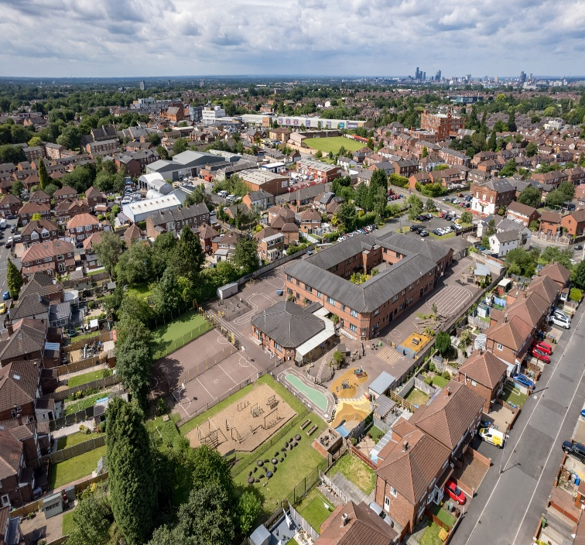
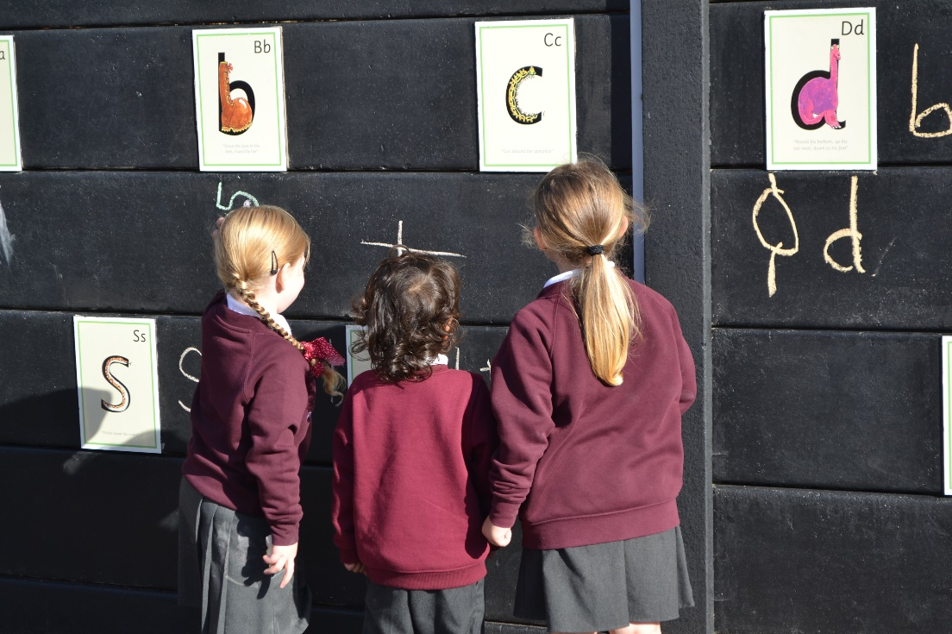







Open Day Thursday 20th November 2025 9:45am-10:30am or 2:00pm-2:45pm
Email: admin@moorside-primary.org to book onto a session. Look around our amazing school and we will answer any questions you have about a Nursery or Reception place.
Intake Deadlines
Nursery September 2026 Intake: Monday 9th February 2026 Apply via School Office
Reception September 2026 Intake: 15th January 2026 Apply via tameside.gov.uk
VIRTUAL TOUR
0161 370 3614
admin@moorside-primary.org
Are you looking for a very special school that will help your child grow and learn?
Then come and visit Moorside!

