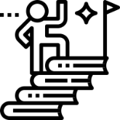

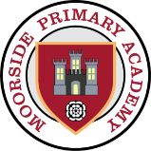

Moorside Pedagogies
Learning science places a great cognitive demand on children and we prepare for this by ensuring lessons are built upon the Moorside pedagogies:
- Reduce cognitive load through dual coding, cohesive curriculum design, purposeful small steps to deepen knowledge and consistent lesson design.
- Support the strengthening of schemata and knowledge building through the application of disciplinary concepts and the rehearsal of a tailored subject narrative.
- Monitor knowledge retention and develop metacognitive learning through assessment for learning strategies, such as low stakes quizzing, knowledge organisers, and DNA tasks.
- Utilise project-based learning at the core of each subject to guide children to rehearse a narrative of knowledge and engage in retrieval activities.

Curriculum Progression
As children begin to develop the scientific knowledge and skills to understand the material world, we ensure that children are encouraged to be curious and ask questions about the world around them. Children’s knowledge and skills will develop progressively as they move through the school, not only enabling them to meet the expectation of the National Curriculum but to inspire them to develop a curiosity and a deeper understanding about how the world works.
Curriculum Intent
A high-quality science education provides the foundations for understanding the world through the specific disciplines of biology, chemistry and physics. Science has changed our lives and is vital to the world’s future prosperity, and all pupils should be taught essential aspects of the knowledge, methods, processes and uses of science. Through building up a body of key foundational knowledge and concepts, pupils should be encouraged to recognise the power of rational explanation and develop a sense of excitement and curiosity about natural phenomena. They should be encouraged to understand how science can be used to explain what is happening, predict how things will behave, and analyse causes.

#MoorsidePAScience – Curriculum Overview


Scientific Drivers
Working Scientifically    We support children to develop their scientific thinking through careful investigation, analysis and evaluation. This means that children use variety of approaches to answer relevant scientific questions. These types of scientific enquiry include:  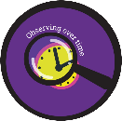    Observing over time Pattern seeking    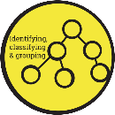  Comparative and Identifying, classifying  fair testing and grouping  Research using secondary sources | Substantive Scientific Knowledge  We support children to make sense of substantive content and encode it for long-term learning. They will build up a schemata and declarative facts that provide a sense of scientific context. The substantive concepts promote children to narrow their study and identify links with prior knowledge. | Apprentice Scientist  We recognise that studying science requires commitment to the discipline of science. We value our children as apprentice scientists and encourage children to ask questions and develop their own ideas about functions, relationships and interactions they observe in the world around them. Our ‘apprentice scientists’ will:  - Be inquisitive learners able to ask their own scientific questions  - Become independent learners by exploring their own answers to scientific questions  - Acquire specific skills and knowledge to think scientifically  - Understand the use and implications of science to explore the world around them


#MoorsidePAScience – Curriculum Overview
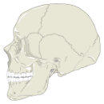

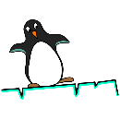


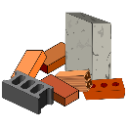


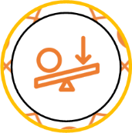
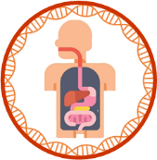

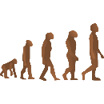


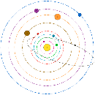

Animals including Humans

Seasons
States of Matter
Properties of Materials
States of Matter
Properties of Materials
Y6
KS3
Evolution and Inheritance
Animals including Humans
Electricity
Living Things and their Habitats
Y4
Light
Properties of Materials
Seasons
Rocks
Light
Plants

Living Things and their Habitats

Chemistry

Biology

Physics

Forces
The Earth and Space
Animals including Humans
Living Things and their Habitats

Animals including Humans
Living Things and their Habitats

Plants

Living Things and their Habitats

Forces and Magnets
Animals including Humans
Animals including Humans
Animals including Humans

Sound
Electricity
Plants
Plants
EYFS
Y1
Y2
Y3
Y5

