Creative Writing Projects

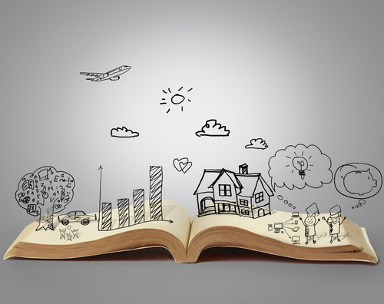

- WRITE YOUR OWN STORY

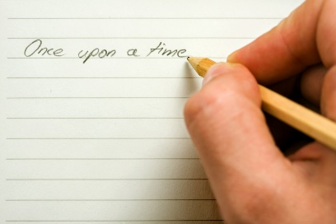

Task 1: To create a character
What to do : Think about the characters name it will need to fit the personality of your character you might change your mind later in task and give a new name. Here are some examples Hagrid, Weasley, The Trunchbull, Miss Honey.
Then draw a picture of your character or you could dress up as a character and have a photograph in the middle of the page. Then write words to describe your characters appearance - these could be around edge of picture, or in sentences or in one descriptive paragraph. Try to include some excellent descriptive adjectives.
Remember you could base your character on a real person, one from a story or TV but don’t copy - mix bits up so that it’s original. Then you need to think of some words to describe your characters personality (how they behave): these could be added to picture in different colour or as a new set of sentences or another paragraph.
Think about how your character moves and speaks, act it out at home and get your family to help think of words to describe this e.g. think about how your character walks and talks, moves, looks etc. - You'd imagine the Trunchbull to be very heavy footed, loud, deep voice, manly movements etc - how does that contrast to Miss Honey?
Task 2: Creating a setting for your character
Draw a picture stick one in from a book or photograph one. Write some words about this place and think about using your senses, what does it look like, feel like, can you smell anything? What can you hear? How does this place make you feel? You could do these as a mind-map and then you could write a paragraph about this setting
Task 3: Create the other characters for your story

Choose at least two other characters for your story – one could be a goody, the other could be a baddy, Create a page for each character, adding as much description about them as possible.
Task 4: Planning your story
Now you have a main important character, 2 other characters and a setting. You now need to start planning a story. Remember a story has a problem in it that needs resolving. You might already have a good idea about how you want your story to start or end if not here are a bank of ideas that you could develop (include some suggestions of things they could choose e.g. lost pet etc). You need to plan out a story. You could plan it as a mind map or as pictures or as a comic strip, you could act it out and take photos to show the key parts. How you choose to do this is up to you. All you need to remember is:
1) Have a start
2) Develop your character - don’t forget the personality you gave them
3) Have a problem
4) Have a solution
5) Have an ending

Task 5: Writing your story
Now comes the easy part! Some top tips are: take your time; remember to keep checking your plan; re-read the story regularly; and then edit and re-draft it. Once you have finished your story, read it to someone in your house. You could even design a poster which advertises the world premiere of your story. Good luck!

- CREATE A FABLE WITH A MORAL
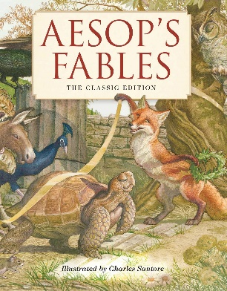
Step 1 - Decide on your two main animal characters what they look like and how they behave, record in your log as written descriptions, pictures with labels or maybe a photo of you dressed up or of toy or real animal with labels.
Step 2 - Choose your moral. If you are stuck read some fables online. Aesop’s fables are particularly interesting but make sure that you search for the kids versions as the grown-up versions can be tricky to understand. You could even swap characters e.g. in the tortoise and the hare, the tortoise could become a snail and the hare could become a cheetah
Step 3 - Draft a plan for your fable this can be on a planning sheet from school as a mind map or picture list. Don’t forget the key features of your fable need to be....
Step 4 - Draw out you fable as a story board.
Step 5 – Write your story. If you are feeling adventurous, you could:
a) Make it into a film- if this is your choice decide on how to make characters - will they be actors, toys, models etc.? Where will you have close ups etc.?
b) Make a powerpoint presentation of the story including effects such as animations and sounds.
c) Make the story into a bound book. Consider what sort of illustrations will you use; will you draw them or use photos or clip art; what font will you use; will the book use comic strip or pictures?
d) Choose a completely different approach as it is your story.

Good luck!

