Annex 1

COVID-19 school closure arrangements for
Safeguarding and Child Protection at
Moorside Primary Academy

Academy: Moorside Primary Academy
Policy owner: Mandy Taylor
Date: 26th May 2020
Date shared with staff: 26th May 2020

Context

From 20th March 2020 parents were asked to keep their children at home, wherever possible, and for schools to remain open only for those children of workers critical to the COVID-19 response - who absolutely need to attend.

Schools and all childcare providers were asked to provide care for a limited number of children - children who are vulnerable, and children whose parents are critical to the COVID-19 response and cannot be safely cared for at home. In addition to these pupils, children in Nursery, Reception, Year 1 and Year 6 will attend school from the 8th June.

This addendum of the Enquire Learning Trust Safeguarding Policy contains details of our individual safeguarding arrangements in the following areas:

1. Context 2
Designated safeguarding lead………………………………………………………..3
Children of critical workers…………………………………………………………...3
Vulnerable children……………………………………………………………………..4
EHCPs …………………………………………………………………………………..….6
Self-isolation…………………………………………………………………………..…7
Receiving other pupils……………………………………………………………..…..8
Sending pupils to other settings…………………………………………………….9
Attendance monitoring……………………………………………………………….10
Safeguarding training and induction……………………………………………..11
Safer recruitment/volunteers and movement of staff……………………….12
Online safety in schools and colleges…………………………………………….13
Children and online safety away from school………………………………….15
Supporting children not in school…………………………………………………15
Alternative provision…………………………………………………………………16
Mental health…………………………………………………………………………..16
Peer on Peer Abuse…………………………………………………………………..17
Safeguarding adults………………………………………………………………….17

Designated Safeguarding Lead

Moorside Primary school has a Designated Safeguarding Lead (DSL) and a Deputy DSL.

The Designated Safeguarding Lead is: Karen Rosenbloom

The Deputy Designated Safeguarding Leads are: Mandy Taylor, Fran Bradshaw and Ellen Patel.

The optimal scenario is to have a trained DSL (or deputy) available on site. Where this is not the case a trained DSL (or deputy) will be available to be contacted via phone or online video - for example when working from home.

Where there is not a trained DSL on site the principal will take responsibility for co-ordinating safeguarding on site. This might include updating and managing access to child protection online management system, CPOMS and liaising with the offsite DSL (or deputy) and as required liaising with children’s social workers where they require access to children in need and/or to carry out statutory assessments at the school or college.

It is important that all Moorside Primary Academy staff and volunteers have access to a trained DSL (or deputy). On each day staff on site will be made aware of that person is and how to speak to them.

The DSL will continue to engage with social workers, and attend all multi-agency meetings, which can be done remotely.

Children of critical workers:

If a parent is a critical worker and work can be done at home, they should stay at home. If they are a critical worker, they should still keep their child at home where possible. Every child who can be safely cared for at home should be, to limit the chance of the virus spreading.

Government guidance as to who qualifies as a critical worker is included in Appendix A

Critical workers new to role:

In some cases, parents will have new jobs as critical workers. Please subject them to the same scrutiny and process as used previously:

- They must provide evidence of their employment/ shift pattern before their child is allowed to attend school.
- Check the providence of this information if you feel you need to. This may mean contacting the employer for confirmation or further details.

It is essential that you try to maintain a consistent threshold. During the initial closure of schools on Monday 23rd March, you will have made some decisions as to who does and who doesn’t constitute a critical worker. Parents may use this to benchmark against.

Vulnerable children

Vulnerable pupils are classed as those who:

- are assessed as being in need under section 17 of the Children Act 1989, including children who have a child in need plan, a child protection plan or who are a looked-after child

- have an education, health and care (EHC) plan and it is determined, following risk assessment, that their needs can be as safely or more safely met in the educational environment

- have been assessed as otherwise vulnerable by educational providers or local authorities (including children’s social care services), and who could therefore benefit from continued attendance. This might include children and young people on the edge of receiving support from children’s social care services, adopted children, those at risk of becoming NEET (‘not in employment, education or training’), those living in temporary accommodation, those who are young carers and others at the provider and local authority’s discretion

Local authorities have the key day-to-day responsibility for delivery of children’s social care.
Moorside Primary Academy will continue to work with and support children’s social workers to help protect vulnerable children. This includes working with and supporting children’s social workers and the local authority virtual school head (VSH) for looked-after and previously looked-after children. The lead person for this will be: Karen Rosenbloom

There is an expectation that vulnerable children who have a social worker will attend an education setting, so long as they do not have underlying health conditions that put them at risk.

A summary of attendance expectations for vulnerable pupils is as a follows:

- for vulnerable children who have a social worker, attendance is expected unless the child/household is shielding or clinically vulnerable (see the advice set out by Public Health England on households with possible coronavirus infection and shielding and protecting people defined on medical grounds as clinically extremely vulnerable

- for vulnerable children who have an education health and care (EHC) plan, attendance is expected where it is determined, following risk assessment, that their needs can be as safely or more safely met in the educational environment

- for vulnerable children who are deemed otherwise vulnerable, at the school, college or local authority discretion, attendance is expected unless the child/household is shielding or clinically vulnerable (see the advice set out by Public Health England on households with possible coronavirus infection and shielding and protecting people defined on medical grounds as clinically extremely vulnerable

Where parents are concerned about the risk of the child contracting COVID19, Moorside Primary Academy or the social worker will talk through these anxieties with the parent/carer following the advice set out by Public Health England.

Wherever possible, daily contact should be made with your most vulnerable pupils. A RAG rating system will apply, setting out the details of how you maintain contact with different pupils. It is important that verbal contact is made with these pupils wherever possible. If you are not able to talk to them directly, it is recommended that you contact social services so that they can follow up this up.

The frequency of contact is likely to be:
Red- daily oversight
Amber- twice weekly contact
Green- weekly contact

However, this may be adapted to suit individual cases. If you are unable to make contact then home visits may be undertaken. Principles of social distancing should be observed. Again, record any home visits and the outcome on CPOMs.

Please record any communication or any attempt to communicate on CPOMs.

Vulnerable pupils at highest risk:
- Will have ongoing contact with a social worker
- Will be at risk of significant harm eg physical harm, sexual abuse, neglect, domestic violence etc
- May act as a home carer

When RAG rating pupils, aspects to consider may be that the pupil:

- Has poor prior attendance
- Has significant behavioural needs
- Lives with parents/carers with significant mental health issues or significant illness
- May have isolated parents/carers
- May have significant medical needs
- May have been excluded in the past and parents have difficulties managing behaviour
- May have recently been CP or CIN
- May speak English as an additional language so has difficulty understanding new systems and procedures

This list is not exhaustive and should be used as guidance only. Each pupil and their context should be considered on an individual basis.

Schools should ensure they have a process in place to check on the welfare of any child in need who does not attend on any day. This may mean contacting social services.

If a child who is being supported by children’s social care is self- isolating, the LA will be expected to prioritise support to the most vulnerable, including undertaking necessary visits whilst taking appropriate infection control measures.

Education Health Care Plans (EHCPs)
Schools should risk assess pupils who have an EHCP. Schools will need to consider a number of different risks to each individual, including:
- the potential health risks to the individual from COVID-19, bearing in mind any underlying health conditions. This must be on an individual basis with advice from an appropriate health professional where required
- the risk to the individual if some or all elements of their EHC plan cannot be delivered at all, and the risk if they cannot be delivered in the normal manner or in the usual setting
- the ability of the individual’s parents or home to ensure their health and care needs can be met safely
- the potential impact to the individual’s wellbeing of changes to routine or the way in which provision is delivered

Government guidance sets out that we expect most children will fall into the following categories:

- children and young people who would be at significant risk if their education, health and care provision and placement did not continue, namely those who could not safely be supported at home. This may include those with profound and multiple learning difficulties, and those receiving significant levels of personal care support. Local authorities will need to work with the individual’s educational setting – especially residential special schools and colleges – as well as local health partners, to ensure they are able to remain open wherever possible. This may mean deploying staff from other schools, to keep staffing ratios safe

- children and young people whose needs can be met at home, namely those who are not receiving personal care from their educational setting, or whose limited need for personal care can be met in their family home. As part of the government’s emergency powers, we will modify the statutory duties on local authorities to maintain the precise provision in EHC plans and will expect educational settings and local authorities to use their reasonable endeavours to support these children and their families

We anticipate that the majority of our EHCPs will fall into the second paragraph. Your risk assessments will identify this. Therefore, they should not be at school.

If the local authority has not yet issued an EHC plan for your child, then they will not automatically be included in this group of children.

Detailed advice for vulnerable pupils, including pupils who have an EHCP can be found here:

https://www.gov.uk/government/publications/coronavirus-covid-19-guidance-on-vulnerable-children-and-young-people/coronavirus-covid-19-guidance-on-vulnerable-children-and-young-people

Self-isolation

There may be requests to receive pupils who have been in self isolation.

Attendance registers will show the date that that pupil was first absent from school. These pupils should not be allowed to return to school until 14 days from their first day of absence.

It is important that you ask parents to let you know if their child is now self- isolating and from what date. You will need this information to set a 14-day period for which they are able attend school. Most children will remain at home following this 14-day period. However, you may have requests from parents of vulnerable pupils or key workers to allow their child to return to school.

Following this request, if a parent has not provided you with this information the 14-day period of self-isolation will begin from their request to return their child to school. You should alert parents to this when you put out your request for information about self- isolation.

If a parent requests that their child returns to school following a period of self-isolation, please ask the following questions:

  - What was the date self-isolation began?
  - Have the child or members of the family left the house? For what reasons? Who did they come into contact with?
  - Has the child or any members of the household displayed symptoms of the virus during this period?

Receiving pupils from other settings

For some schools, you may be asked to receive pupils from other settings. We would expect that any pupils attending your school meet the same high expectations of behaviour you demand from your own pupils. We also need to ensure that all children are kept safe.

For any pupils attending a different school, the receiving school will need:

Pupils from other settings:
  - Emergency contact details
  - Any specific dietary requirements
  - Information about any specific medical needs

Adults from other settings:
  - The names of any member/s of staff who will be working with those pupils
  - Written confirmation that no adult, attending your site has displayed symptoms of the virus to date
  - Written confirmation that they hold full single central record checks for each member of staff attending including DBS
  - Written confirmation that adults have had up to date safeguarding training, including KCSIE

Schools will need to provide adults with:
  - A copy of the school’s behaviour policy setting out your expectations (sanctions may not be relevant here but it will set out your expectations)
  - Health and Safety policy including fire procedures
  - First Aid procedures
  - Code of conduct
  - Details of the key person working in school they can request support from (this will be flexible so it may be wise to have single point where this is displayed each day)
  - A timetable of the school day and relevant collection/ drop-off points

Sending pupils to other settings:

Schools may have to send pupils to another setting. We must ensure that pupils are safe at all times. If sending pupils to another school:

You will need to provide for each pupil:
  - Emergency contact details
  - Any specific dietary requirements
  - Information about any specific medical needs

You will need to provide for each of your members of staff:
  - The names of any member/s of staff who will be working with those pupils
  - Written confirmation that no adult, attending your site has displayed symptoms of the virus to date
  - Written confirmation that you hold full single central record checks for each member of staff attending including DBS
  - Written confirmation that adults have had up to date safeguarding training, including KCSIE

You should expect the other setting to provide:
  - A copy of the school’s behaviour policy setting out your expectations (sanctions may not be relevant here but it will set out their expectations)
  - Health and Safety policy including fire procedures
  - First Aid procedures
  - Code of conduct
  - Details of the key person working in school they can request support from (this will be flexible so it may be wise to have single point where this is displayed each day)
  - A timetable of the school day and relevant collection/ drop-off points

The sharing of information will be especially important for vulnerable pupils.

For looked-after children, any change in school should be led and managed by the virtual school head with responsibility for the child. The receiving institution should be aware of the reason the child is vulnerable and any arrangements in place to support them. As a minimum the receiving institution should, as appropriate, have access to a vulnerable child’s EHC plan, child in need plan, child protection plan or, for looked-after children, their personal education plan and know who the child’s social worker (and, for looked-after children, who the responsible virtual school head is). This should ideally happen before a child arrives and, where that is not possible as soon as reasonably practicable. Any exchanges of information will ideally happen at DSL (or deputy) level, and likewise between special educational needs co-ordinators/named individual with oversight of special educational needs (SEN) provision for children with EHC plans. However, it is acknowledged this may not always be possible. Where this is the case senior leaders should take responsibility.

Whilst schools and colleges must continue to have appropriate regard to data protection law, that does not prevent the sharing of information for the purposes of keeping children safe. Further advice about information sharing can be found at paragraphs 76 to 83 of KCSIE.

Attendance monitoring

Local authorities and education settings do not need to complete their usual day-today attendance processes to follow up on non-attendance.

Moorside Primary Academy and social workers will agree with parents/carers whether children in need should be attending school - Moorside Primary Academy will then follow up on any pupil that they were expecting to attend, who does not. Moorside Primary Academy will also follow up with any parent or carer who has arranged care for their child(ren) and the child(ren) subsequently do not attend.

Parents and carers will not be penalised if their child does not attend educational provision.

To support the above, Moorside Primary Academy will, when communicating with parents/carers and carers, confirm emergency contact numbers are correct and ask for any additional emergency contact numbers where they are available.

In all circumstances where a vulnerable child does not take up their place at school, or discontinues, Moorside Primary Academy will notify their social worker.

All academies should resume taking their attendance register from 1 June and continue to complete the online Educational Setting Status form which gives the Department for Education daily updates on how many children and staff are attending.

Safeguarding Training and induction

DSL training is very unlikely to take place whilst there remains a threat of the COVID 19 virus. Professional development opportunities are, however, available to all staff through our Flick Learning platform (https://app.flicklearning.com/local/login) and through Safeguarding Pro.

For the period COVID-19 measures are in place, a DSL (or deputy) who has been trained will continue to be classed as a trained DSL (or deputy) even if they miss their refresher training.

All existing school staff have had safeguarding training and have read part 1 of Keeping Children Safe in Education (2019). The DSL should communicate with staff any new local arrangements, so they know what to do if they are worried about a child.
Where new staff are recruited, or new volunteers enter Moorside Primary Academy, they will continue to be provided with relevant safeguarding information. An up to date child protection policy (described above) will support this process as will part 1 of KCSIE.

If staff are deployed from another education or children’s workforce setting to our school, we will take into account the DfE supplementary guidance on safeguarding children during the COVID-19 pandemic and will accept portability as long as the current employer confirms in writing that:-

- the individual has been subject to an enhanced DBS and children’s barred list check

- there are no known concerns about the individual’s suitability to work with children

- there is no ongoing disciplinary investigation relating to that individual

For movement within the Trust, schools should seek assurance from the partner school that the member of staff has had relevant safeguarding training.

Upon arrival, they will be given:
  - A copy of the school’s behaviour policy setting out your expectations (sanctions may not be relevant here, but it will set out your expectations)
  - Health and Safety policy including fire procedures
  - First Aid procedures
  - Code of conduct
  - Details of the key person working in school they can request support from (this will be flexible so it may be wise to have single point where this is displayed each day)
  - A timetable of the school day and relevant collection/ drop-off points

Safer recruitment/volunteers and movement of staff

It remains essential that people who are unsuitable are not allowed to enter the children’s workforce or gain access to children. When recruiting new staff, Moorside Primary Academy will continue to follow the relevant safer recruitment processes for their setting, including, as appropriate, relevant sections in part 3 of Keeping Children Safe in Education (2019) (KCSIE).

In response to COVID-19, the Disclosure and Barring Service (DBS) has made changes to its guidance on standard and enhanced DBS ID checking to minimise the need for face-to-face contact.

Where Moorside Primary Academy appoint new staff or are utilising volunteers, we will continue to follow the checking and risk assessment process as set out in paragraphs 167 to 172 of KCSIE. Under no circumstances will a volunteer who has not been checked be left unsupervised or allowed to work in regulated activity.

Regarding members of the academy workforce already engaging in regulated activity and who already have the appropriate DBS check, there is no expectation that a new DBS check should be obtained where that member of the workforce temporarily moves to another school or college to support the response to coronavirus. The type of setting on the DBS check, for example a specific category of school, is not a barrier. The same principle applies if childcare workers move to work temporarily in a school setting. The receiving institution should risk assess as they would for a volunteer (see above). Whilst the onus remains on schools and colleges to satisfy themselves that someone in their setting has had the required checks, including as required those set out in part 3 of KCSIE in the above scenario this can be achieved, if the receiving institution chooses to, via seeking assurance from the current employer rather than requiring new checks.
There is no requirement to obtain a new DBS check for returning staff who have continued to be employed but have not been working in regulated activity during partial school closures. If for any reason the school or college have concerns about the individual, they may obtain a new check in the usual way.

Moorside Primary Academy will continue to follow the legal duty to refer to the DBS anyone who has harmed or poses a risk of harm to a child or vulnerable adult. Full details can be found at paragraph 163 of KCSIE.

Moorside Primary Academy will continue to consider and make referrals to the Teaching Regulation Agency (TRA) as per paragraph 166 of KCSIE and the TRA’s ‘Teacher misconduct advice for making a referral.

During the COVID-19 period all referrals should be made by emailing
Misconduct.Teacher@education.gov.uk

Whilst acknowledging the challenge of the current National emergency, it is essential from a safeguarding perspective that any school is aware, on any given day, which staff/volunteers will be in the school or college, and that appropriate checks have been carried out, especially for anyone engaging in regulated activity. As such, Moorside Primary Academy will continue to keep the single central record (SCR) up to date as outlined in paragraphs 148 to 156 in KCSIE. The SCR can, if a school or college chooses, provide the means to log everyone that will be working or volunteering in a school or college on any given day, including any staff who may be on loan from other institutions. The SCR can also, if a school or college chooses, be used to log details of any risk assessments carried out on volunteers and staff on loan from elsewhere.

Online safety in academies

Moorside Primary Academy will continue to provide a safe environment, including online. This includes the use of an online filtering system.

All schools and colleges should continue to consider the safety of their children when they are asked to work online. The starting point for online teaching should be that the same principles as set out in the Trust code of conduct should be followed.

Academies are likely to be in regular contact with parents and carers. Those communications should continue to be used to reinforce the importance of children being safe online. It will be especially important for parents and carers to be aware of what their children are being asked to do online, including the sites they will asked to access and be clear who from the school or college (if anyone) their child is going to be interacting with online.
Parents and carers may choose to supplement the school or college online offer with support from online companies and in some cases individual tutors. In their communications with parents and carers, academies should emphasise the importance of securing online support from a reputable organisation/individual who can provide evidence that they are safe and can be trusted to have access to children.
Support for parents and carers to keep their children safe online includes:
- Thinkuknow provides advice from the National Crime Agency (NCA) on staying safe online

- Parent info is a collaboration between Parentzone and the NCA providing support and guidance for parents from leading experts and organisations

- Childnet offers a toolkit to support parents and carers of children of any age to start discussions about their online life, to set boundaries around online behaviour and technology use, and to find out where to get more help and support

- Internet Matters provides age-specific online safety checklists, guides on how to set parental controls on a range of devices, and a host of practical tips to help children get the most out of their digital world

- London Grid for Learning has support for parents and carers to keep their children safe online, including tips to keep primary aged children safe online

- Net-aware has support for parents and carers from the NSPCC and O2, including a guide to social networks, apps and games

- Let’s Talk About It has advice for parents and carers to keep children safe from online radicalisation

- UK Safer Internet Centre has tips, advice, guides and other resources to help keep children safe online, including parental controls offered by home internet providers and safety tools on social networks and other online services
Government has also provided:
- support for parents and carers to keep children safe from online harms, includes advice about specific harms such as online child sexual abuse, sexting, and cyberbullying

- support to stay safe online includes security and privacy settings, blocking unsuitable content, and parental controls

Where students are using computers in school, appropriate supervision will be in place.

Children and online safety away from academies

It is important that all staff who interact with children, including online, continue to look out for signs a child may be at risk. Any such concerns should be dealt with as per the Child Protection Policy and where appropriate referrals should still be made to children’s social care and as required, the police.

Online teaching should follow the same principles as set out in the MAT code of conduct.

Moorside Primary Academy will ensure any use of online learning tools and systems is in line with privacy and data protection/GDPR requirements.

Below are some things to consider when delivering virtual lessons, especially where webcams are involved:

- No 1:1s, groups only
- Staff and children must wear suitable clothing, as should anyone else in the household.
- Any computers used should be in appropriate areas, for example, not in bedrooms; and the background should be blurred.
- The live class should be recorded so that if any issues were to arise, the video can be reviewed.
- Live classes should be kept to a reasonable length of time, or the streaming may prevent the family ‘getting on’ with their day.
- Language must be professional and appropriate, including any family members in the background.
- Staff must only use platforms provided by Moorside Primary Academy to communicate with pupils
- Staff should record, the length, time, date and attendance of any sessions held.

Supporting children not in school

Moorside Primary Academy is committed to ensuring the safety and wellbeing of all its Children and Young people.

Where the DSL has identified a child to be on the edge of social care support, or who would normally receive pastoral-type support in school, they should ensure that they maintain communication with that pupil directly or through the relevant social worker.

Details of communication must be recorded on CPOMS

The communication arrangements for pupils can include; remote contact, phone contact, door-step visits. Other individualised contact methods should be considered and recorded.

Moorside Primary Academy and its DSL will work closely with all stakeholders to maximise the effectiveness of any communication arrangements.

Arrangements must be reviewed regularly (at least once a fortnight) and where concerns arise, the DSL will consider any referrals as appropriate.

The school will share relevant safeguarding messages on its website and social media pages.

Moorside Primary Academy recognises that school is a protective factor for children and young people, and the current circumstances, can affect the mental health of pupils and their parents/carers. Teachers at Moorside Primary Academy need to be aware of this in setting expectations of pupils’ work where they are at home.

Alternative provision

Local arrangements are now required in order to determine the best way to protect vulnerable children in AP, including by keeping AP settings open where it is feasible to do so. Local authorities will be best placed to determine how this can be delivered locally, working closely with local schools and headteachers, and regional schools commissioners.

Where it is not possible for an AP setting to remain open to support this small group of vulnerable children, local authorities and schools will need to assess the safeguarding needs of those children on a case by case basis, working with social workers and other agencies to make appropriate arrangements for any vulnerable children that will be affected by their AP setting closing.

Mental Health

Negative experiences and distressing life events, such as the current circumstances, can affect the mental health of children and their parents. Where they have children of critical workers and vulnerable children on site, and/or more children returning to school from 8 June onwards, schools and colleges should ensure appropriate support is in place for them.
Guidance on mental health and behaviour in schools can help schools to identify children who might need additional support, and to put this support in place. The guidance sets out how mental health issues can bring about changes in a child’s behaviour or emotional state which can be displayed in a range of different ways, all of which could be an indication of an underlying problem. This can include for example being fearful or withdrawn; aggressive or oppositional; or excessive clinginess. Support for pupils and students in the current circumstances can include existing provision in the school or college (although this may be delivered in different ways, for example over the phone for those children still not attending provision) or from specialist staff or support services.

Teachers should be aware of the impact the current circumstances can have on the mental health of those pupils (and their parents) who are continuing to work from home, including when setting expectations of childrens’ work. The department has provided separate guidance on remote education practices during the coronavirus outbreak.

Peer on Peer Abuse

Moorside Primary Academy recognises that during the closure a revised process may be required for managing any report of such abuse and supporting victims.

Where a school receives a report of peer on peer abuse, they will follow the principles as set out in part 5 of KCSIE and of those outlined within of the Child Protection Policy.

The school will listen and work with the young person, parents/carers and any multiagency partner required to ensure the safety and security of that young person.

Concerns and actions must be recorded on CPOMS and appropriate referrals made.

Safeguarding Adults

It is important to ensure that our own critical workers are safeguarded against the spread of the virus.

Set out below are considerations for adults:

Vulnerable workers:
Extremely Clinically Vulnerable Workers and Vulnerable Workers:
The government have contacted approximately thousands of individuals who may be at a higher risk than most should they contract the virus. This contact has been made by the way of a ‘shielding letter’ sent by the NHS. School leaders should ensure that any staff member receiving one of these letters (or living with someone receiving such a letter) should let them know immediately. These workers should be shielded and remain at home. All those that are required to shield will have received their letter already.

There is an entire other category of workers who may be ‘vulnerable’ but not within the category above. These workers can be asked to attend work as normal so long as social distancing measures can be put in place. We therefore ask leaders to consider any amendments that can be put in place to protect these workers. This, for example, might be arranging for those individuals to work in environments with more space or older children. Where social distancing cannot be maintained for these individuals, they should be accommodated to work from home.

Maintenance
There is still a requirement for our buildings to have statutory maintenance and the need for possible reactive maintenance. This will ensure our schools to remain safe and operational whilst in use. To enable us to have works carried out, minimise disruption and prevent the spread of the COVID-19 virus by either our employees, pupils or external contractors.

Planned Preventative Maintenance (PPM)
All PPM will be deferred until further notice. Including monitoring of systems.

Reactive maintenance (emergency or non-emergency)
Works only to be undertaken if it’s to prevent an unsafe condition or that keep our buildings from operating safely.
A safe system of work needs to be provided - following the social distancing guidelines.

Projects (academy)
- Internal - all planned projects will be deferred until further notice. A safe system of work needs to place prior to restarting - following the social distancing guidelines.
- External - all planned projects will be deferred for a minimum 8 weeks. Contractors will have restricted access to areas around site and no access to school provision, such as WCs, staff rooms etc.

A safe system of work and a risk assessment clearly identifying the risk is low. Needs to be provided prior to recommencement of project - following the social distancing guidelines.

Contractors will have restricted access to school buildings or rooms and no access to WCs, rooms or facilities that the academy actively use.

Safer working-practices
For people working within school premises.
This applies to all key workers who come into school premises.
Protect yourself and others
- Keep social distance – do not shake hands and try not to touch your face / people / surfaces / objects unless necessary
- Cover your mouth with a tissue when you cough or sneeze, then throw the tissue in the bin and wash your hands
- Wash your hands for 20 seconds more often e.g. when you start or finish work, when you enter and leave the building, using electronic signing systems, or before and after eating your lunch
- Keep your work area clear and clean e.g. wipe surfaces and equipment frequently with a wipe or normal cleaning agent at the end of the day
- Consider introducing handwashing routines for all staff, i.e. stop work or lesson to wash hands once per hour
- Staff should change clothing and shower daily and we should ask parents if they could wash children’s clothes more frequently
- Electronic signing in systems and main entrance handles cleaned by person upon entry and on exit
- Where practicable, keep your distance from other employees (2 meters)
- Leave the building and stay at home for 7 days if you have COVID-19 symptoms (temperature over 37.8 and/or new and persistent cough)
- Stay home for 14 days if anyone in your household has started to have COVID-9 symptoms
If someone becomes unwell with COVID-19 symptoms whilst in our building
- Discretely move person to isolation room avoiding contact with others, surfaces & highly populated areas
- Ask person to go home or be collected and self-isolate
- Isolate room and clean after person have left build
- Try and gather any details of where else the employee has been within the building to ensure a full clean can take place

Keep up to date
It is important for us to stay up to date and work to the current guidance. Please check latest guidance on https://www.nhs.uk/

Support each other
Work together and support each other to make the system work for all associated with the Enquire Learning Trust.

For people home working.
This applies to all workers who work from home.
Protect yourself and others
- Stay at home – no unnecessary journeys or social contact
- Shop for "basic necessities" as infrequently as possible. Use delivery services where you can
- Only leave home for essential shopping, medical needs and one form of exercise a day. Keep your distance from others (2 meters)
- Only travel to work if absolutely necessary
- Avoid public gathering of more than two people (excluding people you live with)
- Don’t visit other peoples houses or socialise outside your home
- Cover your mouth with a tissue when you cough or sneeze, then throw the tissue in the bin and wash your hands
- Use a sleeve if you have to and wash clothing
- Avoid touching eyes, nose and mouth
- Wash your hands for 20 seconds more often
- Stay home for 14 days if anyone in your household has started to have COVID-9 symptoms
- If your symptoms get worse or are no better after seven days use the online 111 coronavirus service at 111.nhs.uk
- Keep in regular contact using either; mobile phones, telephones or e-mail
- Home workers should be capable of responding correctly if they have an accident whilst at home

Use of computers
Some workers may experience fatigue, eye strain, upper limb problems and backache from overuse or improper use of computer whilst home working. These problems can also be experienced from poorly designed workstations or work environments. The causes may not always be obvious and can be due to a combination of factors. The key points to minimise are:

Getting comfortable
- Forearms should be approximately horizontal, and the user’s eyes should be the same height as the top of the screen.
- Make sure there is enough workspace to accommodate all documents or other equipment. A document holder may help avoid awkward neck and eye movements.
- Arrange the desk and screen to avoid glare, or bright reflections. This is often easiest if the screen is not directly facing windows or bright lights.
- Adjust curtains or blinds to prevent intrusive light.
- Make sure there is space under the desk to move legs.
- Avoid excess pressure from the edge of seats on the backs of legs and knees.
- A footrest may be helpful, particularly for smaller users.

Portable computers
These same controls will also reduce the risks associated with portable computers. However, the following may also help reduce manual handling, fatigue and postural problems:
- Consider potential risks from manual handling if users have to carry heavy equipment and papers.
- Whenever possible, users should be encouraged to use a docking station or firm surface and a full-sized keyboard and mouse.
- The height and position of the portable’s screen should be angled so that the user is sitting comfortably, and reflection is minimised (raiser blocks are commonly used to help with screen height).
- More changes in activity may be needed if the user cannot minimise the risks of prolonged use and awkward postures to suitable levels.

Changes in activity
Breaking up long spells of DSE work helps prevent fatigue, eye strain, upper limb problems and backache. The following may help users:
- Stretch and change position.
- Look into the distance from time to time, and blink often.
- Change activity before users get tired, rather than to recover.
- Short, frequent breaks are better than longer, infrequent ones.

Keep up to date
It is important for us to stay up to date and work to the current guidance. Please check latest guidance on https://www.nhs.uk/

Support each other
Work together and support each other to make the system work for all associated with the Enquire Learning Trust. This is going to be a difficult time for everyone, and we need to come together to ensure all of our employees feel connected and supported. Get in touch with your colleagues and check on them. Speak to the central team if needed. Just speak up if you need any support or help – there’s always someone available at the end of a phone.

Statutory checks, safety and services of buildings
With the potential of site managers or caretakers becoming ill or self-isolating.
Those who are unaccustomed with managing the site on a day-to-day basis will need to contingency plan and consider:

Statutory Inspections /checks
- Fire call point testing – weekly check and test
- Emergency light – monthly check and test
- Fire door – monthly checks
- Firefighting equipment – monthly checks
- External play equipment – monthly checks
- Flushing of infrequently used outlets – weekly (or longer - due to the exceptional circumstances)

Fire safety
- Be made aware of fire alarm codes, contacts and procedures
- Sprinkler system checks - weekly
- Evacuation / emergency exercise drills – once per term

Services isolation points
- Be made aware of gas, electrical and water isolation points and procedures in case of emergency

Keyholders & Security
- Be made aware of keys for locks or combination codes
- Be made aware of alarm security codes, contacts and procedures

You should refer to your Management of Premises document as will provide more detailed information, contacts and guidance. This should be circulated to who’ll be in local ‘control of the building’ in the event of an absence.

Illness amongst staff

It is increasingly likely that staff will become infected by the virus. The flow charts below set out what to do should staff become ill at home and at work.

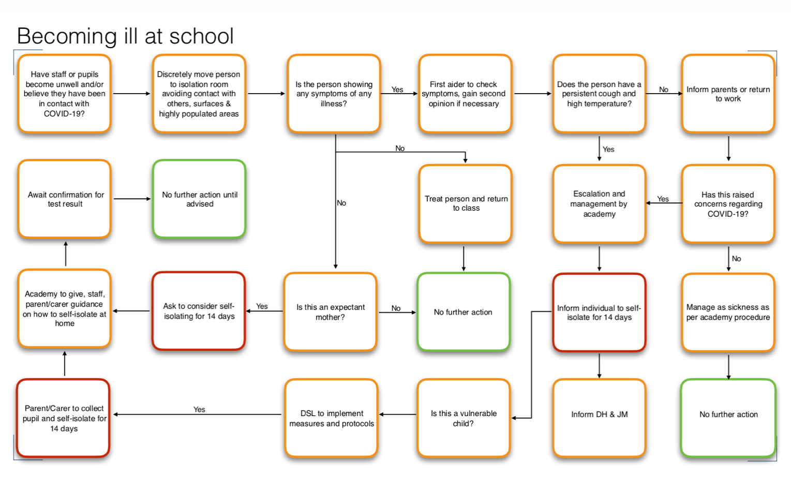

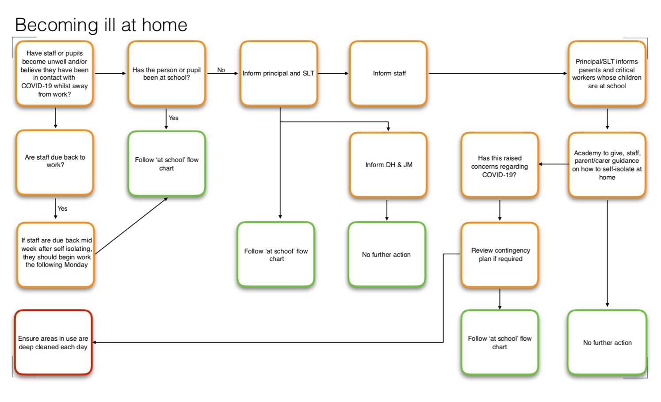

APPENDIX A

Definition of Critical Workers

Health and social care
This includes but is not limited to doctors, nurses, midwives, paramedics, social workers, care workers, and other frontline health and social care staff including volunteers; the support and specialist staff required to maintain the UK’s health and social care sector; those working as part of the health and social care supply chain, including producers and distributers of medicines and medical and personal protective equipment.
Education and childcare
This includes nursery and teaching staff, social workers and those specialist education professionals who must remain active during the COVID-19 response to deliver this approach.
Key public services
This includes those essential to the running of the justice system, religious staff, charities and workers delivering key frontline services, those responsible for the management of the deceased, and journalists and broadcasters who are providing public service broadcasting.
Local and national government
This only includes those administrative occupations essential to the effective delivery of the COVID-19 response or delivering essential public services such as the payment of benefits, including in government agencies and arms length bodies.
Food and other necessary goods
This includes those involved in food production, processing, distribution, sale and delivery as well as those essential to the provision of other key goods (for example hygienic and veterinary medicines).
Public safety and national security
This includes police and support staff, Ministry of Defence civilians, contractor and armed forces personnel (those critical to the delivery of key defence and national security outputs and essential to the response to the COVID-19 pandemic), fire and rescue service employees (including support staff), National Crime Agency staff, those maintaining border security, prison and probation staff and other national security roles, including those overseas.
Transport
This includes those who will keep the air, water, road and rail passenger and freight transport modes operating during the COVID-19 response, including those working on transport systems through which supply chains pass.
Utilities, communication and financial services
This includes staff needed for essential financial services provision (including but not limited to workers in banks, building societies and financial market infrastructure), the oil, gas, electricity and water sectors (including sewerage), information technology and data infrastructure sector and primary industry supplies to continue during the COVID-19 response, as well as key staff working in the civil nuclear, chemicals, telecommunications (including but not limited to network operations, field engineering, call centre staff, IT and data infrastructure, 999 and 111 critical services), postal services and delivery, payments providers and waste disposal sectors

Support from the Multi-Academy Trust

The Multi-Academy Trust (MAT) Central Safeguarding Team will provide support and guidance as appropriate to enable the DSL to carry out their role effectively.

The MAT will also provide regular group and individual supervision sessions. This may take the form of an online meeting.

