
Moorthorpe Primary School with Inclusion Resource
Low-Level Concerns Policy
Contents
1. Introduction............................................................................................................................................................. 1
2. Summary ................................................................................................................................................................. 1
3. Keeping Children Safe in Education September 2023 ............................................................................................. 1
4. Clarity around Allegation vs Low-Level Concern vs Appropriate Conduct .............................................................. 2
5. Storing and use of Low-Level Concerns and follow-up information ....................................................................... 2
6. Process to follow when a Low-Level Concern is raised ........................................................................................... 3
7. Low Level Concern Form .........................................................................................................................................5

1. Introduction
At Moorthorpe Primary School, we take safeguarding very seriously. This includes ensuring that adults who work with children do so in a way that is in accordance with the ethos and policies set out by the school, including the Staff Code of Conduct. This policy sets out the detail and processes for staff regarding low-level concerns they may have.

2. Summary
It may be possible that a member of staff acts in a way that does not cause risk to children, but is however inappropriate. A member of staff who has a concern about another member of staff should inform the Head Teacher about their concern using a Low-Level Record of Concern Form. If the Head Teacher cannot be contacted, an assistant DSL or Chair of Governors should be contacted instead.

3. Keeping Children Safe in Education September 2023
The following is taken from Keeping Children Safe in Education September 2023
Low-level concerns
424. As part of their whole school or college approach to safeguarding, schools and colleges should ensure that they promote an open and transparent culture in which all concerns about all adults working in or on behalf of the school or college (including supply teachers, volunteers and contractors) are dealt with promptly and appropriately.
425. Creating a culture in which all concerns about adults are shared responsibly and with the right person, recorded and dealt with appropriately, is critical. If implemented correctly, this should:
• enable schools and colleges to identify inappropriate, problematic or concerning behaviour early
• minimise the risk of abuse, and ensure that adults working in or on behalf of the school or college are clear about professional boundaries and act within these boundaries, and in accordance with the ethos and values of the institution.

What is a low-level concern?
426. The term ‘low-level’ concern does not mean that it is insignificant. A low-level concern is any concern – no matter how small, and even if no more than causing a sense of unease or a ‘nagging doubt’ - that an adult working in or on behalf of the school or college may have acted in a way that:
• is inconsistent with the staff code of conduct, including inappropriate conduct outside of work and
• does not meet the harm threshold or is otherwise not serious enough to consider a referral to the LADO.
Examples of such behaviour could include, but are not limited to:
• being over friendly with children
• having favourites
• taking photographs of children on their mobile phone, contrary to school policy
• engaging with a child on a one-to-one basis in a secluded area or behind a closed door, or humiliating children.

427. Such behaviour can exist on a wide spectrum, from the inadvertent or thoughtless, or behaviour that may look to be inappropriate, but might not be in specific circumstances, through to that which is ultimately intended to enable abuse.
428. Low-level concerns may arise in several ways and from a number of sources. For example: suspicion; complaint; or disclosure made by a child, parent or other adult within or outside of the organisation; or as a result of vetting checks undertaken.
429. It is crucial that all low-level concerns are shared responsibly with the right person and recorded and dealt with appropriately. Ensuring they are dealt with effectively should also protect those working in or on behalf of schools and colleges from becoming the subject of potential false low-level concerns or misunderstandings.

4. Clarity around Allegation vs Low-Level Concern vs Appropriate Conduct
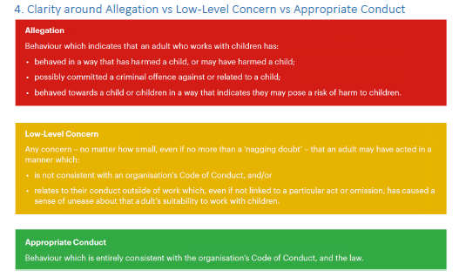

5. Storing and use of Low-Level Concerns and follow-up information
LLC forms and follow-up information will be stored securely, with access only by the leadership team. This will be stored in accordance with the school’s GDPR and data protection policies.
The staff member(s) reporting the concern must keep the information confidential and not share the concern with others apart from the Head Teacher or those aware in the senior leadership team.
Low-Level Concerns will not be referred to in references unless they have been formalised into more significant concerns resulting in disciplinary or misconduct procedures.
Whenever staff leave Moorthorpe Primary, any record of low-level concerns which are stored about them will be reviewed as to whether or not that information needs to be kept. Consideration will be given to:

(a) whether some or all of the information contained within any record may have any reasonably likely value in terms of any potential historic employment or abuse claim so as to justify keeping it, in line with normal safeguarding records practice; or
(b) if, on balance, any record is not considered to have any reasonably likely value, still less actionable concern, and ought to be deleted accordingly.

6. Process to follow when a Low-Level Concern is raised
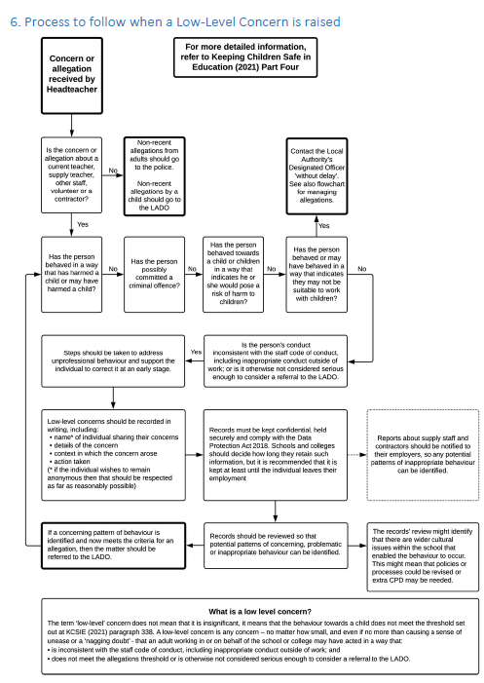

7. Low Level Concern Form
This form will be available to staff from the Office or the staffroom board.

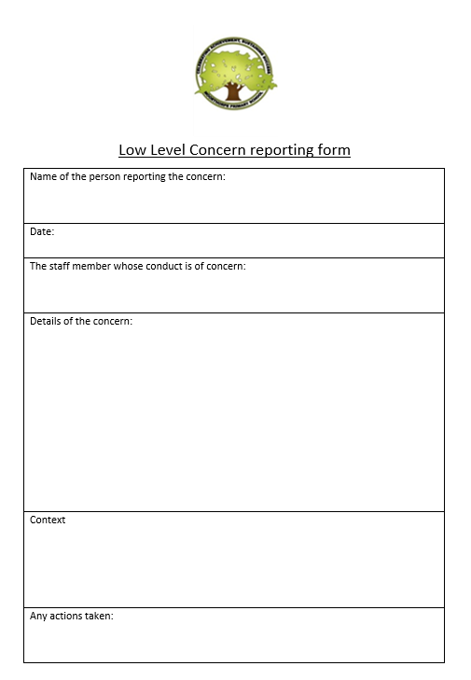

Policy created on September 2022
Adopted by Governors September 2022
Reviewed on September 2023
Next review September 2024

