MOORTHORPE PRIMARY SCHOOL WITH INCLUSION RESOURCE



Relational Behaviour Approach Policy

Created: |  | D. Birdsall November 2024
Approved:  Review date: |  | S. White November 2024  November 2025

Relational Behaviour Approach
The importance of knowing individual pupils well, so that schools and teachers know which factors might affect pupil behaviour and what the school can do to address these. Focusing on developing good relationships also ensures pupils feel valued and supported, meaning they are less likely to misbehave. EEF Improving Behaviour in Schools.
Introduction
Moorthorpe Primary School with Inclusion Resource is a highly inclusive school where every individual is cared for, supported and challenged to maximise their potential in order to create a feeling of self-worth and ambition. We, as educators, adopt an empathetic and compassionate approach to educating our pupils and in turn, raise our children to show compassion for each other. The school expectations which we all follow are: ready, respectful and safe – as a result our pupils are developing a strong moral compass.
We recognise that poor behaviour or behaviour that challenges is often driven by an unmet need in the child and that we need to use restorative approaches to support children to develop an understanding of what good behaviour looks like. Our children need to feel safe and secure in the school environment and as such, we are all trained to deal with situations in the same way: we stay calm, we give children time to correct their behaviour and then we recognise the correct behaviour as soon as it is seen - we do not speak to a child in a way which may make them feel ashamed or wrong. Our consistent approach to behaviour that challenges include strategically ignoring behaviour which is not unsafe or negatively impacting on the learning in the room whilst recognising good behaviour in others and offering positive praise to all. We recognise this can be demanding and relentless so have formed a behaviour team to our support staff and parents which includes senior leaders, our SENCO and pastoral team.
We believe good behaviour is essential to school life in order that children feel as safe and secure and for learning to take place. Our whole school community should show respect and good manners to each other at all times. As adults, we need to model the highest standards of behaviour and be respectful at all times and equally, we need to recognise and praise good behaviour in all areas of school.
Although we implement a system of positive rewards and incentives to encourage positive behaviour, it is recognised that we have high expectations for everyone in school and certain behaviours are a given so do not need rewarding.
We have clear system for managing behaviour and all staff and children are aware of it. We acknowledge the behaviour we are addressing and think of ways together to support the child to find alternative strategies to give them strategies to manage their emotions.
We include parents in the process and ensure that they are aware of the way we are managing behaviour which is challenging and what their role is.

Aims of this policy
• To create an atmosphere of mutual respect and co-operation
• To ensure that all adults in school are able to recognise that behaviour is a means of communication and should be dealt with in a calm, non-confrontational way
• To develop a sense of community and shared values by applying positive policies to create a caring atmosphere in which teaching and learning can take place in a safe and happy environment
• To help each child to develop self-respect, respect for other people, for the school environment and for property
• To encourage good behaviour rather than to simply punish bad behaviour by providing a range of rewards for children of all ages and abilities
• To make clear to children the distinction between minor and more serious misbehaviour and the range of sanctions that will follow
• To have a zero tolerance for racist, sexist and homophobic behaviour; sexual harassment and bullying

We believe that these aims will be achieved if:
• Children and staff understand what is expected of them
• Staff have regular training in ways of managing behaviour that challenges
• Staff have up to date training on trauma
• All members of the school community understand that bullying and poor behaviour will not be tolerated and that there are clear, well-publicised ways of responding to any incident.

Expectations of the Headteacher
The Headteacher has responsibility for the day-to-day management of all aspects of the school’s work, including the welfare and safety of pupils.
The Headteacher’s responsibilities include:
• Constantly model and promote the relationships and behaviour policy by recognising good behaviour in all areas of school and offering praise for it. Treating all members of the school community with respect and offering support wherever it is needed.
• Ensuring that all staff are trained and well supported in managing behaviour which challenges
• Responding in a timely manner to CPOMS regarding behaviour that challenges and develop a clear plan to support all involved
• Ensuring that parents are included in the strategies being used to support their children
• Keeping the governing body informed of all developments concerning the management of behaviour in school
• Keeping the class teachers and the Learning Mentor informed of all decisions made by outside agencies concerning children with behaviour which challenges
• Along with the Inclusion manager, ensure that the involvement of all appropriate external agencies aids the development of provision for children with behaviour which challenges whilst maintaining appropriate provision for other pupils in the school
• Facilitating regular liaison time for teaching staff and support staff to discuss concerns and interventions for children with behaviour difficulties.
Expectations of staff
• Ensure that good behaviour is acknowledged and modelled consistently by all adults
• That expectations for good behaviour are consistently high
• Ensure that the physical environment supports learning
• Use a wide repertoire of rewards and work together to maintain a high standard of behaviour
• Persistent negative behaviour, or isolated serious behaviour, is recorded on CPOMS
• Include parents in the plan moving forward
• Develop an Individual Behaviour Plan and a Risk Assessment when required
• Work with outside agencies who may offer support for children who display behaviour which challenges

Expectations of children
• Follow our school expectations: Ready, respectful, safe
• Be respectful to all members of the school community
• Speak to an adult in school if anything goes wrong; if the adult is busy, speak to another adult. Ask for adult help if other children are not behaving in the correct way
• Walk around the school quietly and sensibly (on the left in corridors)
• Know that physical violence, inappropriate language (racist, homophobic) and sexual harassment are not to be tolerated

Expectations of parents
• Discuss the school expectations with your child, emphasise your support and when possible help to reinforce.
• Work with staff. The success of the school’s relational approach policy requires close partnership between home and school
• Encourage your child to speak to a member of staff if there is a problem
• Become involved at an early stage when there are any concerns about a child’s behaviour – this will usually be with the class teacher in the first instance.
• Understand that staff deal with behaviour which challenges patiently and positively
• Attend parents’ evenings, events and other informal meetings
• Support your child to attend school, be on time and have the equipment they need. This includes correct wearing school uniform and PE kit
• If a child has a problem in school, parents are welcome to come in and discuss it. Parents are not advised to approach other children or their parents directly.

Our approach
At Moorthorpe we recognise it is important to have a positive start to each day. The headteacher (Lead DSL) and Learning Mentor (Deputy DSL) are on the playground greeting our school community. Our Wellbeing Mentor greets our KS1 children in the corridor and provides a ‘meet and greet’ session in ‘The Nest’ for pupils who struggle to leave parents.
Providing breakfast clubs, or greeting pupils individually before a lesson—can have a really positive impact on behaviour. EEF Improving Behaviour in Schools.
We understand poor mental health of pupils will affect their behaviour. Therefore, in addition to our PSHE/RSE curriculum, we put measures in place to support all children: this includes whole school wellbeing projects, pupil wellbeing sessions for all in Y2 and Y5, ELSA (Emotional Literacy support) and 1-1 support where necessary. Children are encouraged to use calm spaces near their classrooms as needed.
Across the whole school, we have implemented the Zones of Regulation. The Zones of Regulation is a social and emotional learning program that helps people understand and manage their emotions by categorising them into four colour-coded zones. We use the image below to identify emotions/dysregulation and use skills to return to the green zone. In class displays and resources support children to build the right skills/tool and learn how to regulate their emotions with or without support. We share information and work with our families to develop these skills in and outside of school.

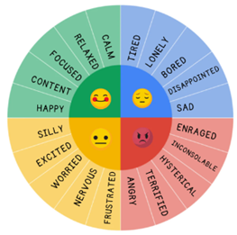
All staff in school use positive behaviour management strategies. A variety of methods are used:
• Praise;
• Stickers;
• Ring bell/wow moment;
• Name on the board;
• Certificates including Headteacher Award certificates;
• Hot chocolate with the Head;
• Dojo points;
• Ping pong jar;
• Responsibility in school (prefect, play leader, Head Boy/Girl, ambassador)

Graduated Approach
We have created a Graduated Approach to managing behaviour (See Appendix 1: One page Behaviour Code and Appendix 2: Corresponding more detailed document to refer to). While we recognise the need for a consistent approach, we recognise all children are different, have different needs and have had different experiences therefore this is not a ‘one size fits all’ system.
Trauma aware
We are committed to improving the health and wellbeing and ability to learn of our most vulnerable children, namely those who have suffered trauma, abuse, neglect and/or have mental health problems or attachment issues. Our staff have the mindset not of ‘What is wrong with you?’ but ‘What happened to you?’ Staff have had various training (Emotion Coaching, Trauma awareness and Adverse Childhood Experiences. We recognise these ACES are highly stressful, and potentially traumatic, events or situations that occur during childhood and can affect their behaviour. We recognise children who have experienced trauma will develop “survivor behaviours” and these behaviours help the child to survive extreme psychological stress in a hostile environment. Examples of this can be fighting, running away (fight or flight), shutting down (meltdowns), self-harm, eating disorders, etc.

SEN – (including ASD, ADHD)
At Moorthorpe Primary we have an increasing number of pupils with Special Educational Needs (SEN). We ensure that reasonable adjustments are made for children with SEN, including those with ASD (Autism Spectrum Disorder) and ADHD (Attention Defecit Hyperactivity Disorder). We will implement tailored strategies that cater to the diverse needs of these pupils, which may include personalised behaviour plans, additional support from teaching assistants and/or a child’s trusted adult/s and the use of visual aids to enhance understanding. Moreover, we will engage in regular dialogue with parents and external specialists to ensure that our interventions are effective and collaborative. We strive to develop a child’s self-regulation skills and emotional resilience as we value inclusivity and diversity. Pupils may have a Supporting me to learn plan (SMTLP), One page profile (OPP) or Educational Health Care Plan (EHCP) which gives further information.
Other documentation
As explained in the Graduated Approach document, some pupils will have Individual Behaviour Plans (IBP), some will require Positive Handling Plans if physical intervention is required for safety, and some pupils may be placed on report to monitor their behaviours – see appendices.
Zero-tolerance approach to sexual harassment and sexual violence
The school will ensure that all incidents of sexual harassment and/or violence are met with a suitable response, and never ignored. Pupils are encouraged to report anything that makes them uncomfortable, no matter how ‘small’ they feel it might be. This will be recorded on CPOMs and passed onto a DSL.
The school’s response will be: Proportionate, considered, supportive, decided on a case-by-case basis.

Physical restraint – Use of Reasonable Force
In some circumstances, staff may use reasonable force to restrain a pupil to prevent them:
- Hurting themselves or others
- damaging property
- causing disorder
Incidents of physical restraint must:
- Always be used as a last resort
- Be applied using the minimum amount of force and for the minimum amount of time possible
- Be used in a way that maintains the safety and dignity of all concerned
- Never be used as a form of punishment
- Be recorded electronically (CPOMs – use Team Teach tab) and reported to parents
If there is a violent incident, Team Teach may be used by trained members of staff (staff training for behaviour team November 2024) however only if absolutely necessary. The child will be supervised from a safe distance until they calm down or will be taken to the safe space if causing injury to staff to regulate themselves. When safe to do so, trained adults will use de-escalation strategies to calm the child. It will be logged as ‘Team Teach’ on CPOMs using the crib sheet (See appendices) The parent/carer will be informed.
Exclusions/ suspensions will be enforced if deemed appropriate. Please see our separate Exclusion Policy.
It may also become necessary to involve outside agencies such as the Educational Psychology Service and other relevant services in the LA. As a result, a common strategy will be adopted and recorded as a behaviour plan. This will involve the parents so that a consistent approach can be adopted.
Impact of this approach
To evaluate the impact of the relational behaviour approach and our behaviour strategies, we are constantly monitoring behaviour and will review behaviour at regular points. We complete weekly behaviour reports to track those causing concern and meet regularly (every 6-8 weeks to review individual plans with parents), this may be more frequent as necessary. We also run CPOMs reports to analyse incidents. These are shared with relevant staff and governors as appropriate.
As a behaviour team we constantly discuss how strategies are working and whether targeted pupils are calmer. Drops/ lesson observations also show whether lessons are running smoothly with minimal disruption or if further strategies are needed. Pupil voice and parent voice is crucial in the evaluation of our relational approach.

Appendices
Moorthorpe Primary School with Inclusion Resource
Graduated Approach to Behaviour
Stage | Examples of behaviour | Possible sanctions | Next steps for staff
1 | Swinging on chair  Interrupting/calling out  Silly noises  Not being on task  Ignoring instructions  Leaving class without permission  Running inside the school building  Pushing in line  Rough play at playtime/lunchtime  Rudeness/ disrespectful  Swearing  Disrupting the class affecting other pupil’s learning  Inappropriate remarks to other pupils  Minor challenges to authority (refusal to comply)  Minor damaging of school’s/pupil’s property | Non-verbal signals eg  (a hand on shoulder or tap on table as walk past, moving an object away from them etc)  Quiet reminder (Ready, Respectful, safe or pointing out the behaviours you want eg “four legs on the floor, thank you,”  “John, line order thank you”  Verbal warning 1  Change of seating (within classroom)  Change of face – different adult in class where possible (call on walkie talkie if needed for adult to come and support within the classroom if no other adult)  Reduced language | Class teacher and support staff to respond to all stage 1 behaviours.  In class behaviour system to be used to support with stage 1 behaviours: appropriate ‘fidgets’ eg coil pencil toppers, pom poms, movement breaks, give jobs, distraction, team points, Cool Time etc.  Class teacher and support staff to reflect on what else can be put in place to avoid this happening in the future. Speak to behaviour team for advice as needed.
2 | Persistent stage 1 behaviours as above  Also:  Serious challenges to authority (refusal to comply)  Serious damage to school’s/pupil’s property  Repeated incidences of playing unkindly at playtime/lunchtime  Targeted behaviour towards the same child repeatedly | Verbal warning 2  Missed minutes of play/lunch/Cool Time either with the class teacher or other known adult.  (Maximum of 10 mins)  Time out in another space to regulate near class (shared area if possible, or another suitable place eg the previous ‘Nest.’  This may be with or without work.  (Up to a maximum of 15 mins)  Use of script:  The ….. is getting done, you know my expectation…  It is my expectation that you … | Phase leader/SMT to speak to pupil to respond to stage 2 behaviours.  Class teacher to use A,B,C (below) to identify triggers and communication.  Class teacher to use a behaviour checklist to identify specific behavioural needs.  Class teacher to phone parents to inform them of persistent stage 1 behaviour or stage 2 behaviours weekly.  Incidents to be recorded ON CPOMS  Playtime incidents to be reported to the class teacher  Review provision in place and see if further intervention or resources are needed. Class teachers to support pupils learning and behaviour needs.
3 | Persistent stage 2 behaviour:  Also:  Conscious decision to hurt someone  Highly offensive remarks to children including racist or homophobic comments  Continued or more serious challenge to authority  Stealing | Sent to member of the SLT  Telephone call to inform parents  Loss of playtimes/lunchtimes time with member of SLT (As above)  At the discretion of the HT and severity of incident, internal exclusion | Name added to weekly behaviour monitoring grid.  Behaviour to be reported on CPOMS by class teacher and SLT member with further actions noted and implemented.  Individual Behaviour Plan (IBP) to be created by class teacher, pupil and SENCo/HT which indicates targets and sanctions.  IBP to be put in place.  IBP to be shared with the pupil’s parents.  IBP to be reviewed by Class teacher, SLT member to attend the review.  Pupils to be placed on a report card system.
4 | Persistent stage 3 behaviour  Biting  Bullying  Fighting  Very serious challenge to authority  Leaving school without permission | Class teacher / SLT member to investigate and then pupil to be sent to meet with the  Headteacher.  Meeting scheduled with parents  Loss of playtimes/lunchtimes time with member of SLT  Fixed period of internal exclusion or external inclusion to be applied | Situation to be monitored by teacher and SMT.  External Agency support to be sought to provide additional support and guidance.  IBP’s to be continued as in stage 3.  Pupils to be placed on a report card system. Monitored daily.
5 | Persistent stage 4 behaviour  Persistent verbal abuse to a member of staff | Exclusion for a fixed term | Situation to be monitored by teachers, SMT and Headteacher.  Team around the child meetings.  IBP’s to be continued as in stage 3.  Pupils continue to be on a report card system.
6 | Repeated stage 5 behaviours | Governor disciplinary subcommittee convened  Permanent exclusion from school | Same as stage 5.
All the above sanctions are put in place at the discretion of the Headteacher/senior leaders, and the context and child’s needs will be fully considered when sanctions are applied.

The ABCs in more detail
All ABC charts record the core components of antecedents, behaviours and consequences.

Antecedents
Antecedents are the events that directly precede the observed behaviour and are also known as ‘triggers’. They may include:
- Being asked to stop or start specific tasks or activities, e.g., task transition.
- A particularly easy or difficult assignment/activity.
- Independent work.
- Group work.
- Being told ‘no’.
- Loud noises or bright lighting.
- A comment or action from another child.
- Absence of attention (e.g., teacher diverted to another student, or peers working quietly and not looking at the child).
- Being in ‘free-play’ (no instructions or guidance).
- Praise.
It is also important to consider antecedents that are not immediate and include the wider environment. These ‘slow’ triggers are noted at the start of a recording session, and could include:
- Time of day (influencing hunger and energy levels/tiredness).
- Medication.
- Routine disruption.
- Family events such as new sibling or bereavement.
- Specific people/children being present.

Consequences
Consequences may serve to maintain, decrease or increase the frequency of behaviour depending on whether they are positive or negative. Typical consequences could include:
- Repeat of request by teacher or another adult.
- Being given a choice.
- Behaviour being ignored (no action).
- Item or toy taken away/received.
- Time-out/sent out of class to another area.
- Reprimand by teacher or other adult – to be done in private (negative attention).
- Praise or reassurance from a teacher or other adult (positive attention)
- Pupils should know that every action has a positive or negative reward/ consequence
Examples:
- Logical and restorative consequences eg refuses to come off laptop (loses) ipad time later in day?
- Hurts a child intentionally on the playground – then sent inside or misses next playtime (Rainbow Rm for safety)
- Does not finish work due to behaviour escalation – catch up on work at another time in the day
Reminder: a dysregulated child who is in fight/flight/fear/freeze mode is not making conscious choices!

This behaviour code is displayed in classrooms as a one-page reminder.
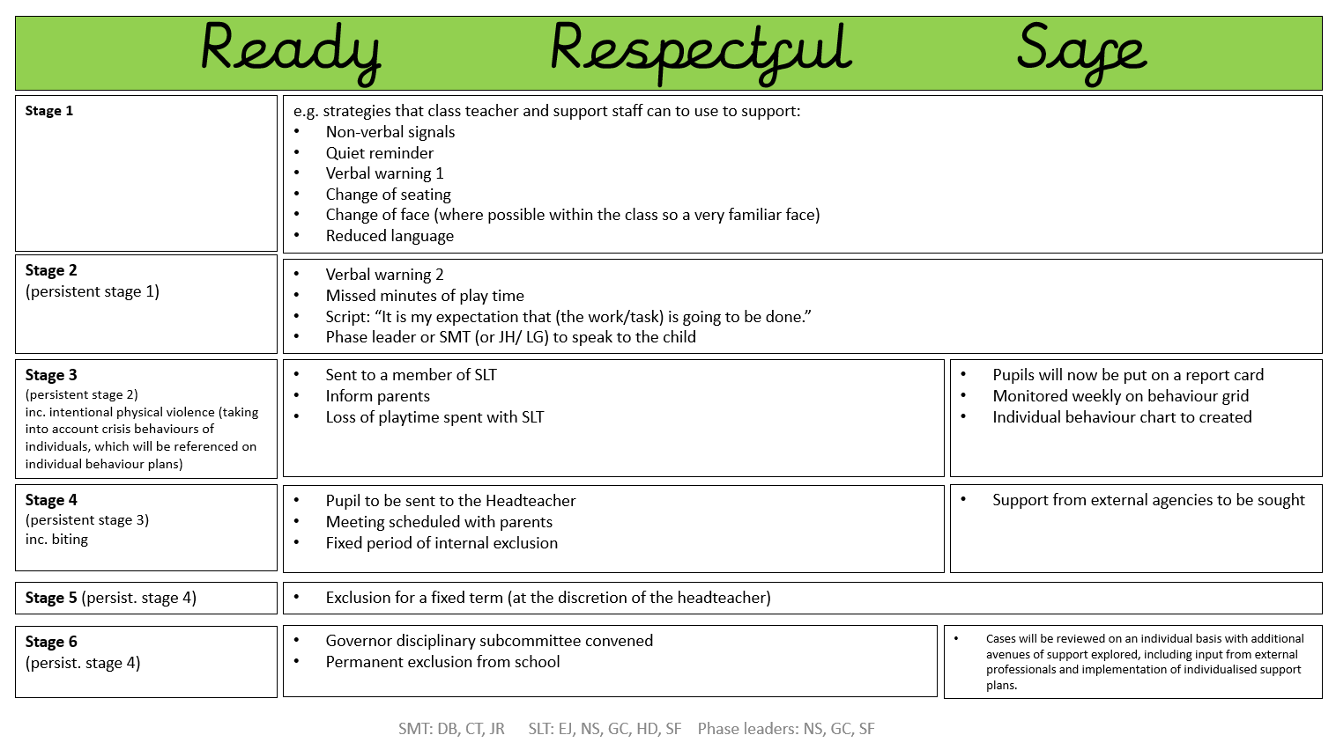

Parent meeting proforma
Pupil name: |  |  | Class:
Date: | Meeting Number: |  | Attendees:
Strengths: |  |  | Challenges:
Likes: |  |  | Dislikes:
What behaviours have been witnessed? At home and at school

What have you been thinking about school? How have you been feeling about school?
What worries or concerns do you have?

Who has been affected by these choices? How have they been affected?

What can you do to make better choices?

How can we support you to make better choices?

What are we going to do in the future?
Child: |  | Parent/Carer: |  | School:
Signed: |  | Signed: |  | Signed:
Review date:

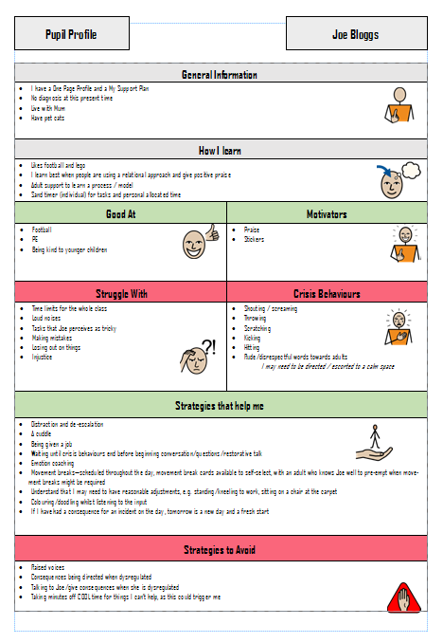

This is an example Individual Behaviour Plan (IBP)

Positive Handling Plan

Child’s Name: Date of Plan: Review Date of plan:

What does the behaviour look like?
Stage 1 Anxiety Behaviours | Stage 2 Defensive Behaviours | Stage 3 Crisis Behaviours
- Refusing to work  - Hood up  - Angry face  - Tenses up  - Makes noises  - Talks in a voice much younger | - Growling  - Shouting  - Screaming  - Absconding from the classroom  - Running around the school  - Climbing on furniture  - Knocking furniture  - Throwing items  - Putting his fists up at others | Kicking door/wall (at home)  Biting others/staff  Hitting others/staff  - Kicking others/staff  - Hurting others with pencils  - Jumping/diving on others  - Hitting self  Head Butting  - Hitting self in the head with fists  - Banging head on wall, floors and  hard surfaces  - Shouting, swearing  - Scratching,  - Nipping  - Spitting

What are common triggers?
- The end of break/lunch – not wanting to come in, not wanting to walk/wants carrying
- Disagreements with peers
- Environment
- Writing/phonics
- Numeracy
- Change in staff members
- Change of routine
- Perceive an injustice
- Adult direction
- Transitioning between activities
- Transition from leaving Mum
- Previous bad day or bad morning at home
- Loud noises
- Raised voices
- Being called names by peers
- Consequences passed over to the following day

De-escalation skills

Try Avoid Notes
Verbal advice and support  _____________________
Giving space _____________________
Reassurance  _____________________
Negotiation  _____________________
Choices  _____________________
Humour  _____________________
Consequences  _____________________
Planned ignoring  _____________________
Time-out  corridor/reset room/old nest
Supportive touch _____________________
Transfer adult  _____________________
Success reminded  _____________________
Simple listening  _____________________
Removing audience  clear boundaries
Others 

Diversions and distractions / Praise Points
- Catch pupil being good – Discrete praise, stickers on him
- Offering visual cues e.g. thumbs up, high five
- Distraction/divert – little job/task/alternative activity
- Sensory break - sand or water

Any medical conditions to be taken into account before using Physical interventions?

None

Preferred method Physical intervention?

Try Avoid Notes

Friendly escort  _____________________

Single elbow  _____________________

Caring C guide 

Smaller children – below chest height

Single person double elbow 

Elbow cradle and cup 

Bring bean bag to the child 

Larger children – above chest height

Double elbow  _____________________

Single elbow in seats  _____________________

Figure of four  _____________________

Are there any factors to consider when debriefing? E.g. Communication aids staff etc.
Hear  Explain  Link  Plan | - Talk to pupil when they are calm and explain why they were held or taken to corridor/reset room (be specific/name the behaviour) was unsafe so we held you to keep you safe until you could keep yourself safe  - Listen to the pupil’s point of view, acknowledge what they say and how they feel about what happened. Problem solve around this acknowledging the pupil’s solutions whether positive/negative. If the pupil’s solutions continue to be negative give them a positive solution

How should we record incidents and who should we inform?
Record the incident on Cpoms. This must include a chronological accurate detail of the antecedents/trigger, factual description about the behaviour displayed, description of de-escalation used or attempted and the outcomes from that. The restraint used, the length of time it was used from start to finish and the conclusion/outcome. Use crib sheet and use the Team Teach Tab if TT is used.
- Inform senior management of serious Incident
- Inform parents/ guardians
- Record a clear description of the incident / behaviour displayed and conclusion/outcome
- What was the outcome/conclusion? Repair and rebuild processes following the incident: What intervention was used/how did staff make sure the pupil had fully recovered/calmed down from the incident e.g. restorative practice, pupil asked to return to his work, activity pupil enjoys. The recovery period is important to prevent pupils having multiple incidents throughout the day.
- Record incidents in the Reset Room e.g. Time spent in there.
- What did Staff learn from the incident moving forward? Was this reflected in the pupils plan/risk assessment?).
- Look at risk assessment to see if anything has changed. Change if new behaviour has been displayed. Update Risk Assessment and PHP if necessary
- Inform parent/s of serious incidents

Signed (parent)
Signed (staff)

Date
Date reviewed

Moorthorpe Primary School KS1 Behaviour Card

Name: ………………………………………… Class: ………………………… Date: __________
 | 8.40-10.00 | Break | 10.20-12.00 | Lunch | 1.00-2.00 | 2.00-3.10 | SMT sign & comment
Monday
Tuesday
Wednesday
Thursday
Friday

Moorthorpe Primary School KS2 Behaviour Card

Name: …………………………………………………… Class: …………………… Date: ……………………
 | 8.40-10.30 | Break | 10.45-12.15 | Lunch | 1.00-2.00 | 2.00-3.10 | SMT sign & comment
Monday
Tuesday
Wednesday
Thursday
Friday
This card must be given to your teacher to be completed at the end of the lesson.

