

Morecambe Bay Community Primary School

Attendance Policy

April 2024

Introduction

This is a successful school and your child plays their part in making it so. We aim for an environment which enables and encourages all members of the community to reach out for excellence. For our children to gain the greatest benefit from their education it is vital that they attend regularly and your child should be at school, on time, every day the school is open unless the reason for the absence is unavoidable.

It is very important therefore that you make sure that your child attends regularly and this Policy sets out how together we will achieve this.

Why Regular Attendance is so important

Any absence affects the pattern of a child’s schooling and regular absence will seriously affect their learning. Any pupil’s absence disrupts teaching routines so may affect the learning of others in the same class.
Ensuring your child’s regular attendance at school is your legal responsibility and permitting absence from school without a good reason creates an offence in law and may result in prosecution.
Please see the attached graph which illustrates the impact poor attendance can have on your child’s education. See appendix 1

Promoting Regular Attendance

Helping to create a pattern of regular attendance is everybody’s responsibility - parents, pupils and all members of school staff.

To help us all to focus on this we will:

- Promote a culture across the school which identifies the importance of regular and punctual attendance;

- Carry out transition work with pupils moving between nursery and reception, and before leaving for high school;

- Further develop positive and consistent communication between home and school

- Make attendance and punctuality a priority for everyone associated with school, including parents, pupils, staff and governors.

- Set targets to improve individual pupil and whole-school attendance.

Understanding types of absence

Every half-day absence from school has to be classified by the school as either AUTHORISED or UNAUTHORISED. This is why information about the cause of any absence is always required.

Authorised absences are mornings or afternoons away from school for a good reason like illness, medical/dental appointments which unavoidably fall in school time, emergencies or other unavoidable cause. Please make appointments outside of school time wherever possible.

Unauthorised absences are those which the school does not consider reasonable and for which no 'leave' has been given. This type of absence can lead to the Authority using sanctions and/or legal proceedings.

This includes:

- Parents/carers keeping children off school unnecessarily
- absences which have never been properly explained
- children who arrive at school after the register has closed
- shopping, looking after other children or birthdays

Whilst any child may be off school because they are ill, sometimes they can be reluctant to attend school. Any problems with regular attendance are best sorted out between the school, the parents and the child. If your child is reluctant to attend school it is better to speak to school to resolve the issue, rather than trying to cover up their absence, or give in to pressure to let them stay at home. This gives the impression that attendance does not matter and usually make things worse.

Persistent Absenteeism (PA)

A pupil becomes a ‘persistent absentee’ when they miss 10% or more of their schooling across the school year for whatever reason. Absence at this level is doing considerable damage to any child’s educational prospects and we need parents' fullest support and co-operation to tackle this.
We monitor all absence thoroughly, therefore any pupil whose attendance indicates they are likely to reach the PA threshold we will be given priority consideration, and parents will be informed of this immediately.
PA pupils are tracked and monitored carefully through our pastoral system and we also combine this with academic mentoring where absence affects attainment.
All our PA pupils and their parents are subject to an Action Plan and the plan may include: allocation of additional support through a Mentor, use of circle time, individual incentive programmes and parenting contracts.

Absence Procedures

If your child is absent you must

- Contact us before 9.30 a.m or as soon as possible on the first day of absence

- Phone 01524 401002 press option 1 to record a message

- Email office@morecambebay.lancs.sch.uk

- Call into school and report to reception.

- Contact school everyday thereafter unless otherwise requested by the school office.

- A courtesy call will be made on the 3rd day of absence.

If your child is absent we will

- Telephone you on the first day of absence if we have not heard from you;

- Text you via Parent Pay text messaging service.

- Attempt to contact you via your email address.

- Issue an attendance email via Parent Pay requesting reason for absence.

- If contact has not been made with the school parent/carer must provide prompt and adequate written explanation for the absence of the child on their return. Failure to do so will result in the child receiving an unauthorised absence.

- If you child is off for two consecutive days and we have not had any contact from you we may do a home visit, if we still have not had contact we may also ask the police to do a welfare check on our behalf.

- Invite you in to discuss the situation with our Headteacher if absences persist;

- Refer the matter to the Local Authority School Attendance Team where appropriate as per Local Authority protocol. (PAST)

Telephone numbers and Email addresses

There are times when we need to contact parents about lots of things, including absence, so we need to have your up to date contact numbers and email address. if these are not kept up to date something important may be missed. There will be regular checks on telephone numbers and emails throughout the year.

In-School Strategies to Improve Attendance/Punctuality

Parents are expected to contact school at an early stage and to work with the staff in resolving any problems together. This is nearly always successful. School may consider using the following strategies to help support parents in improving their child's attendance and/or punctuality. This includes:

- Reward/incentive schemes.

- Meetings in school between parents, pupils, pastoral staff, assistant head or deputy head

- Parenting contracts

- Use of the Common Assessment Framework (CAF) and/ or referral to outside agencies
- Penalty notices

Lateness

Poor punctuality is not acceptable. If your child misses the start of the day they can miss work and do not spend time with their class teacher getting vital information and news for the day. Late arriving pupils also disrupt lessons, which can be embarrassing for the child and can in turn, encourage absence. Being 10 minutes late every day throughout the academic year is the same as missing two weeks of school. See appendix 2

How we manage lateness

The bell will ring at 8.45 a.m. KS2 children should line up on the yard where they will be greeted by their teacher
KS1, Reception and Nursery children should meet their teacher at the classroom door.

Registers are marked by 8.50 am and your child will receive a late mark after this time.

Any child arriving in school after this time must report to the school office and sign in on the entry system.

At 9.20.am the registers will be closed. In accordance with the Regulations, if your child arrives after that time they will receive a mark that shows them to be in school, but this will not count as a present mark and it will mean they have an unauthorised absence. This may mean that you could face the possibility of a Penalty Notice if the problem persists.

If your child has a persistent late record you will be asked to meet with a member of the pastoral support team to resolve the problem, but you can approach us at any time if you are having problems getting your child to school on time.

Fixed Penalty Notices

When are they issued?

Lancashire County Council considers that regular attendance at school is of such importance that penalty notices may be used in a range of situations where unauthorised absence occurs, such as:

- Unauthorised absence
- Unauthorised holidays in term time
- Truancy (including pupils found during truancy sweeps) parentally condoned absence without good reason
- Persistent late arrival at school
- Excessive delayed return from an extended holiday without prior school permission;

How much is the fine?

Your local council can give each parent a fine (whether they live in the same household or not) of £60, which rises to £120 each if you do not pay within 21 days. If you do not pay the fine after 28 days you may be prosecuted for your child’s absence from school.

Holidays in Term Time will not be authorised and a Penalty Notice will be applied for.

Taking holidays in term time will affect your child’s schooling as much as any other absence and we expect parents to help us by trying not to take children away in school time.
Remember that any savings you think you may make by taking a holiday in school time are offset by the cost to your child’s education.
There is no automatic entitlement in law to time off in school time to go on holiday.

All applications for leave must be made in advance using the 'Request for leave of absence' form from the school office. From September 2013 Headteacher’s may not grant any leave of absence during term time unless there are exceptional circumstances.

Extended Leave in Term Time:

Only in 'exceptional' circumstances will 'leave' of over 10 days (but no more than 20 days) be authorised by the school. In certain circumstances, parents’ risks losing their child’s place on the school roll if the pupil does not return to school on the agreed return date, and readmission cannot be guaranteed. The specific circumstances which outline when a pupil can be removed from roll are laid out in Regulation 8 (1) (f) (i-iii) of The Education (Pupil Registration) (England) Regulations 2006 (Amended 2010)

Parents may also be asked to attend a meeting to discuss educational opportunities for their child whilst on extended leave.

Religious Absence:

The school will authorise one day 'leave' (i.e. the day set aside by the Religious Body of which the parent is a member) per religious festival, e.g. Eid, but no more than 3 days in any one academic year. Parents must request this leave in advance.

Roles and responsibilities for attendance matters in this school:

Parents

- Support/maintain home routines which support their child’s health, readiness for learning and attendance/punctuality.
- Support routines including use of devices and screen time.
- Ensure children attend regularly and punctually and where possible accompanied by an adult, this applies to all children below year 5.
- Year 5 and 6 children can bring themselves to school, this must be confirmed in writing.
- Contact school on 1st day of absence before 9.30a.m wherever possible, and everyday thereafter unless otherwise requested by the school office.
- Arrange for the collection of their child, on time, at the end of the school day.
- Accept that once their child has left the school grounds responsibility for the welfare of their child rests entirely with the parent or carer.
- Participation in Parenting Contracts and Common Assessment Framework, and cooperate in support and interventions offered by school or other agencies.
- Recognise that if a child walks out of school grounds, the school will:
- Ring parent or carer concerned
- Ring Police if the parent or carer cannot be contacted.

Pupils

- Acknowledge behaviour needed out of school, e.g. early bedtime, screen time.
- Attend school/registration punctually
- Speak to parents/teacher if issues arise that may have an effect on school attendance
- Cooperate and participate in interventions and support offered by school or other agencies

School Attendance Mrs Gillon

Daily

- First day response: Contact parents if a reason for absence has not been provided.
- Record attendance information on CPOMS
- Alert duty DSL to any concerns.
- Pass all relevant attendance/punctuality information to the appropriate members of staff.
- Ensure that systems are in place to monitor registers and record data onto the SIMS system daily.

Deputy Head. Mrs Jones.

- Half termly monitor all children that are below 95%.
- Half termly monitor all children who arrive late in school.
- Send letters to parents informing them and offering further support.
- For children who are persistently below 90% invite parents in for a meeting to discuss further.
- Contact parents by letter to celebrate 95% and above attendance.

Other strategies school may initiate

- Conduct home visits if no appropriate telephone contact can be gathered within 48 hours, (24 hours if deemed a vulnerable family)
- Work with children and parents to remove barriers to regular and punctual attendance, initiate Parenting Contracts and CAF where appropriate.
- Regularly communicate pupil attendance and punctuality levels to parents.
- Arrange and conduct meetings with parents/carers to address persistent attendance/punctuality issues.
- Initiate ‘Fixed Penalty Notices’
- Sign post to parenting courses.

All School Staff

- Provide a welcoming atmosphere for children and provide a safe learning environment
- Ensure an appropriate and responsive curriculum
- Provide a sympathetic response to any pupils' concerns
- To be aware of factors that can contribute to non-attendance
- To see pupils' attendance as the responsibility of all school staff

Governors
- Adopt the whole-school policy and review regularly
- Monitor the consistent implementation of the attendance policy
- Set aspirational targets for improving the school's attendance figures

School targets, projects and special initiatives:

The school has targets to improve attendance and your child has an important part to play in meeting these targets.

The minimum level of attendance for this school is 95% attendance and we will keep you updated regularly about progress to this level and how your child’s attendance compares.
Our target is to achieve better than this however because we know that good attendance is the key to successful schooling and we believe our pupils can be amongst the best in the area.

Through the school year we monitor absences and punctuality to show us where improvements need to be made.
Information on any projects or initiatives that will focus on these areas will be provided in newsletter and we ask for your full support.

Summary:

The school has a legal duty to publish its absence figures to parents and to promote attendance. Equally, parents have a duty to make sure that their children attend.
All school staff are committed to working with parents and pupils, as this is the best way to ensure as high a level of attendance as possible.

Date of Policy: December 2019
Date Reviewed: April 2021
Date Reviewed: September 2022
Date Reviewed: September 2023
Date Reviewed: October 2023

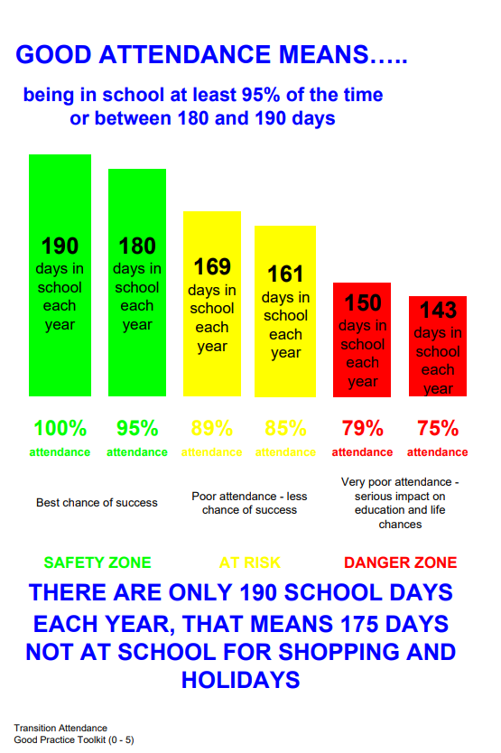

Appendix 1

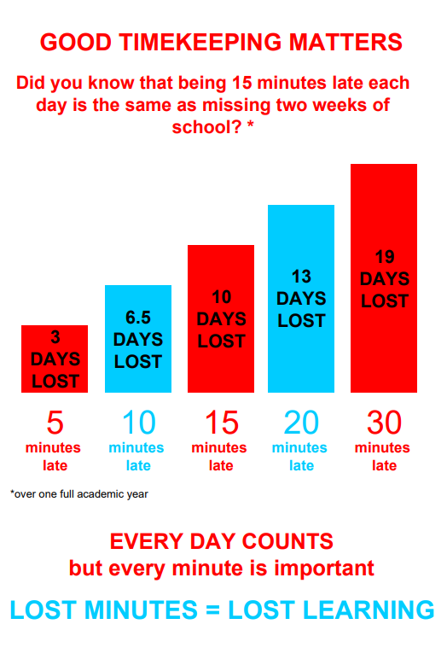

Appendix 2

