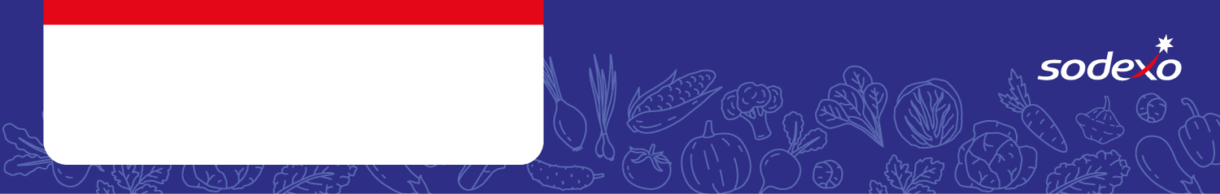
Food Safety Management System
Forms
DESSERTS

Menu Item   Tick the allergens that are in the dish  Insert ‘MC’ where the label states ‘May Contain’ | Celery | Cereal  containing  gluten * | Crustaceans | Eggs | Fish | Lupin | Milk | Molluscs | Mustard | Nuts** | Peanuts | Sesame seeds | Soya | Sulphur  Dioxide &  Sulphites
Iced School Cake |  | Wheat
Pineapple Upside Down Pudding |  | Wheat
Peach Crumble Cake |  | Wheat / Oats
Vanilla Cookie/ Chocolate Cookie |  | Wheat
Chocolate/ Strawberry Mousse

Iced Carrot Cake, Chocolate & Beetroot Cake |  | Wheat
Apple & Cinnamon Flapjack |  | Oats
Apple Shortbread, Lime & Coconut Cake |  | Wheat
Fruit Jelly |  | Wheat
Ice Cream

