KS2 Learner

Acceptable Use Agreement
We would like you to read, understand and use these rules, to help you and others stay safe and behave responsibly when using the internet and digital technology.

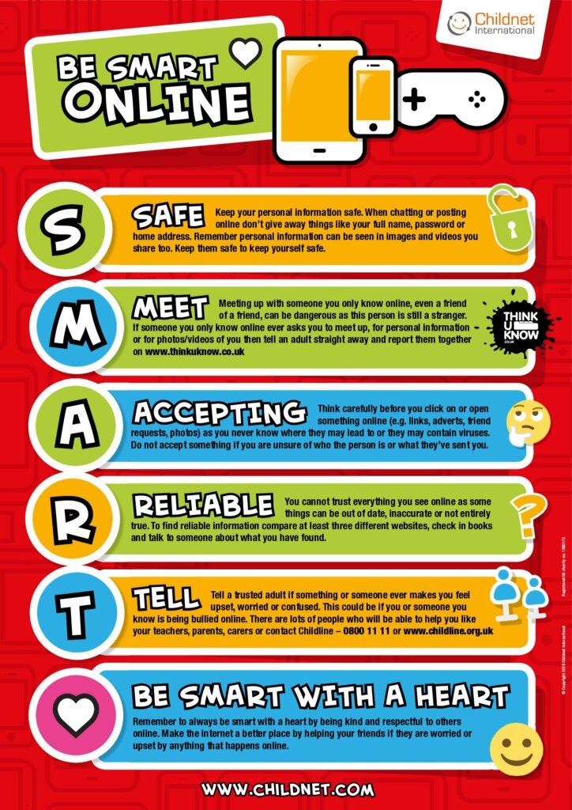

For my own personal safety, I will be SMART online:

- I will keep my username and password safe and secure. I will not share it or write it down.
- I will not share personal information about myself or others when online (e.g., full name, age, address, email address, telephone numbers, school).
- I will be aware of “stranger danger” when I am online. I will never arrange to meet people in real life who I’ve only met online. I will remember that people online might not always be who they say they are.
- I will think carefully before clicking on a link in case it could be a virus.
- When I am using the internet to find information, I should take care to check that the information is accurate and reliable. I understand that the work of others may not be truthful and may be a deliberate attempt to mislead me.
- I will immediately tell an adult or report anything I see online that is inappropriate or makes me feel uncomfortable.

I will look after the devices I use, so that the school and everyone there can be safe:

- I will handle all the devices carefully and only use them if I have permission. I understand that there will be a consequence if anything is deliberately damaged or broken.
- I will try not to alter the settings on any devices or install any software or programmes.
- I will tell an adult if a device is damaged or if anything else goes wrong.
- I will only use the devices to do things that I am allowed to do in school e.g., activities I’ve been asked to do, visit age-appropriate websites.

I know that there are other rules that I need to follow:

- I will think about how my behaviour online might affect other people:
- When online, I will act as I expect others to act toward me.
- I will not copy or use anyone else’s original work or files without their permission.
- Where work is protected by copyright, I will not try to download copies (including music and videos).
- I will be polite and responsible when I communicate with others, and I appreciate that others may have different opinions to me.
- I will not take or share photos/ videos of anyone without their permission.
- I understand that what I do online will be supervised and monitored.
- I will only use my own personal mobile phone in the school if a parent/ carer has completed a mobile phone permission slip. If I am allowed, I must continue to follow all the other school rules.
- I will not use any social media sites in school.
- I understand that if I do not follow these online safety rules, there will be consequences. This could include my parents/ carer being told, loss of access to the school computer/tablets/internet, I may lose privileges and in the event of illegal activities the police will be involved.

Please sign below, to show that you take responsibility for your actions when using digital technology and being online, both in and out of school.
Group/Class:
Date:
Class signatures

