Your learning journey to new horizons.

The White Horse Federation – Moredon Primary and Nursery School

Address:‐ Moredon Road, Moredon, Swindon, SN2 2JG

Website:‐ www.thewhitehorsefederation.org.uk

School opening hours for children:‐ 8:30 – 15:30 Mon‐Thurs and 8:30‐13:30 on Friday

Point of contact:‐ Claire Leach Principal 01793 600344 head@moredon.swindon.sch.uk

Type of Provision:‐ Nursery and Primary Education

Age range: ‐ We cater for children aged 3 ‐ 11

Admission arrangements: ‐ The White Horse Federation subscribes to the Swindon Borough Council admissions procedures and policies. Parents can apply through Swindon Borough Council for Primary School admissions. For the Nursery, parents apply through the school office to register their child for a place.

Referrals: ‐ Children can be referred to the school if they are accommodated by the Local Authority or if they have an Education Health and Care Plan on parental request.

Cost: ‐ Pupil Premium funding will follow the child as well as funding from Swindon Borough Council.

Special Educational Needs: - At Moredon Primary and Nursery School, we aim to provide an inclusive, broad and balanced curriculum for all pupils, including those with SEND (Special Educational Needs and/or Disability). We are a school where each child’s individuality is valued and where our aim is to inspire all children to realise and value their potential. We have a range of systems in place for early identification of barriers to learning and participation and we set high expectations for all.
We currently support a wide range of needs within the following categories:

- Cognition and Learning – children with moderate learning difficulties and specific learning difficulties including dyslexia and dyspraxia.
- Communication and Interaction – children with Autism (ASD) and also a wide range of speech and language difficulties
- Sensory, Medical and Physical – children with hearing impairment, visual impairment, sensory processing difficulties diabetes and epilepsy
- Social, Emotional and Mental Health – children experiencing specific anxieties and ADHD

Provision for children with SEN is a matter for the whole school. All teachers are teachers of children with SEN.

Partnership agencies: ‐ We work with:
- Educational Psychologists,
- Speech and Language Therapists
- Occupational Therapists,
- CLASS – Cognition and Learning Advisory Support Service
- ASD Advisory Service, (ARC)
- TaMHS
- Visual impairment advisory services
- Hearing impairment advisory services
- Assistive technology Service
- Advisory Teacher for Physical Disabilities
- Health Care professionals (School Nurse, Community Paediatrician and Physiotherapists)
- SIAS – Swindon SEND information, advice and support service
- Early Help Hub
- MASH team (Multi‐Agency Safeguarding Hub)
- Swindon Virtual School (Child in Care)
- Special Educational Needs Assessment Team (SENAT)
- Education Welfare Officer
- SEMH outreach team (Social, Emotional and Mental Health)
- Swindon Young Carers
- Swindon Women’s Aid
- Project Me
- SEND Family Voice

Curriculum: ‐ The Early Years Foundation Stage Curriculum and the 2014 National Curriculum are followed. Moredon Primary and Nursery School has a skills based, active approach to the curriculum with learning taught through a theme or topic which will excite and motivate the children. Developing a wide range of values is key to everyday school life. The needs of the child could influence the curriculum they receive which would be tailored individually.

Identification and assessment: ‐ We assess the pupil’s progress and attainment regularly throughout the year as set out in the school assessment calendar. Parents will receive a written report on their child’s progress and attainment at the end of the year. Twice a year, parents are invited to discuss their child’s progress and attainment at Parent’s Evenings. Parents of children with an EHCP receive termly updates. In addition to this, parents are also invited to an annual review meeting for children with an Education Health Care Plan for Special Educational Needs. Children identified as having SEN School Support may also have Pupil Progress Meetings which you will be invited to.

If situations occur where the child’s behaviour is of concern or needs the assistance of Positive Handling, these are reported to the parents the same day and recorded in a Bound and Numbered Book, and the school CPoms system.

Any health concerns are reviewed as appropriate and necessary and children with a care plan have these reviewed annually with the support of the School Nurse and other professionals as appropriate.

Where a specific need for a child is identified, the school will seek support from outside agencies to carry out specialist assessments, these can include assessments completed by the Educational Psychologist, Speech and Language therapist, Social Communication and Interaction/ASD team and CLASS – Cognition and Learning Advisory Support Service.
Some children who do not have an EHCP may still need extra support and so we will use the Swindon Core Standards system to carefully assess a child’s needs and to plan individual support. This may result in a child having a ‘Progress Plan’. Targets will be set and reviewed regularly to evaluate the impact of the support provided and parental input is sought at every stage. We value and respect parental input and want to ensure a partnership is possible and successful.
Twice a year, teachers will make judgements on all pupils’ attainment, judgements are made using the child’s works or a formal assessment. Pupils are assessed as to whether or not they meet the expected standard for a child their age. BLW (Working below) if they are working well below the year group standards, WTS (working towards standard) if they do not yet fully meet that standard or are still working towards it, EXS (expected standard) if they do meet it and GDS (greater depth standard) if they exceed that standard and are working at a greater depth.
For children who are identified as working below or working towards year group expectations, they complete additional assessments in reading, spelling and maths so that individual learning needs can be identified, and progress tracked.
When children start in Nursery and Reception, the teacher’s carryout a baseline assessment for all areas of the EYFS curriculum.
Transition: ‐ Before any child starts at Moredon Primary and Nursery School, parents will have a meeting with a member of school staff, in the EYFS this is through home visits and phone calls to parents, and from Year 1 upwards, parents meet with one of the Senior Leadership Team members. Any specific needs of a child will be identified and referred to the SENCO. The SENCO will ensure that any agencies supporting the child are contacted before they start school, and using the information from parents and professionals, appropriate support will be put into place.
When a pupil transitions from Moredon Primary and Nursery School (a mainstream school) to a specialist setting, as soon as we know that this transition is happening, we will work closely with the new setting to create a bespoke transition package which supports the child’s specific needs.
Any child moving on to another school will have a carefully structured plan based on individual need. There is appropriate support given to the receiving school and our Year 6 pupils have a structured transition plan in place in Term 6. If a child has a statement of SEN needs or an EHCP, then a transitional review will take place in year 5 and all possible school options are discussed.
Staff Expertise: ‐ The SENCO is a fully qualified teacher and holds the National Award for Special Educational Needs Coordinators.

Moredon Primary and Nursery School and TWHF expectations are that all teachers are responsible and teachers of SEN and have the support of the SENCO to ensure good progress and attainment of all children. All teachers are expected and committed to having a good understanding and awareness of SEND. This is achieved through on-going CPD. Throughout the school year, a number of staff training sessions are spent on SEND and new practices.

Teaching Assistants are employed to support the learning needs of all the children with the exception of targeted support for children with high needs to enable them to access a mainstream curriculum.

At Moredon Primary and Nursery Team, the SENCO is part of the NEST (Nurture, Educate, Support, Team). This includes the Learning Mentor who is also ELSA trained, (ELSA stands for Emotional Literacy Support Assistant and is a national programme of staff training to support children and young people with Social, Emotional and Mental Health (SEMH) needs run by the Educational Psychology service) and the Family Support Worker.
Monitoring of the effectiveness of the provision: ‐ There are robust systems in place for SENCO to monitor the effectiveness of the school provision these include:

- intervention tracking
- book scrutiny
- progress meetings
- learning walks
- monitoring of planning
- provision mapping
- data analysis
- case studies
- annual review meetings

The SEN Governor will meet with the SENCO and quality assure both procedures and practices are exemplary for children with SEND. Subject leaders/teams also monitor the delivery of their subject and the progress made. The Principal monitors and quality assures the impact of the SEN action plan/School improvement plan. Ofsted and the Local Authority moderate as part of a cycle for KS1 phonics monitoring/KS1 SATs monitoring/KS2 SATs monitoring visit and end of EYFS data to validate or challenge.

Equal Opportunities: ‐ All pupils have equal access to all facilities, activities, and resources, regardless of SEND, race, religion, gender, culture, sexuality or disability determined by a thorough rigorous risk assessment procedure and adaptations will be made as needed. The Accessibility Plan details how the school aims to treat all its pupils fairly and with respect.

Spiritual, Moral, Social and Cultural Curriculum: ‐ The WHF is a values-based organisation and therefore recognises the contribution that all children can make to all aspects of school life including representation on:

- School council
- Pupil voice
- Pupil governance
- Community events
- Religious festivals
- Special school days
- Build strong meaningful relationships between staff and pupils
- Anti-bullying Ambassadors
- National initiatives, such as eco‐weeks, charity events, religious celebrations
This list is not exhaustive.

From the parent carer’s point of view:-

1. How does the school know if children need extra help and what should I do if I think my child may have special educational needs?

You or your child’s teacher may have a concern about your child, the concern may be about the progress that they are making in their learning, their speech and language, how they are managing the school routines and being with other children or it may be to do with their physical or mental well-being.
If you have a concern, please talk to your child’s class teacher. We have an open-door policy at Moredon Primary and Nursery School and you are welcome to express your concerns to the class teacher at any time however avoiding teaching time. Please phone the school to make an appointment. If the teacher identifies a concern and an area of need for your child, they will ask to meet with you to discuss this.

At Moredon Primary and Nursery School we use the Swindon Core Standards to identify if a child has a Special Educational Need. Teachers will work alongside parents to discuss concerns that school or home may have and identify any support that can be put into place in the classroom.

Teachers will discuss, with the SENCO, the concerns and the progress that children have made when the additional support has been put into place. If parents and school agree that the child meets the criteria of need within the Core Standards, the school will place the child onto the SEN register. The school will verbally speak to parents during parents evening meetings and 1:1 meeting with the class teacher or SENCO to ask permission for this to happen.

If appropriate, the school will ask your permission to involve one or more external agencies.

Additional information can also be found in our SEN policy which can be found on our website.

2. How will the school support my child?

The school has many options to enable your child to access mainstream learning, these include the following:

- Extra support in class
- Use of additional resources to support learning
- Individual or group work
- A provision map that states how a child is supported what resources are required to enable successful delivering of the support (See Appendix A)
- Pupil passports that outline a profile of the child’s needs and support that works well for them
- Qualified and trained teaching staff including the SENCO who can advise on strategies to support and help your child to progress
- The school has many options to enable your child to progress in his/her learning. A range of the activities and intervention programmes
- Access to other professionals for advice

3. How will the curriculum be matched to my child’s needs?

The curriculum is carefully differentiated to meet the needs of every child. The child is then able to learn at his own level and make the progress they need to make. Children learn in different ways and the learning styles are also catered for, multi‐ sensory approaches are often used, and some children work on a personalised curriculum that is time bound and reviewed regularly.

4. How will I know how my child is doing and how will you help me to support my child’s learning?

School will communicate regularly with you, and this may include:

- Informal conversations between parent/carers with the teacher
- Discussions around the child’s individual learning needs and provision in place
- All children with an EHCP will have an Annual Review once a year, children in the EYFS will have this twice a year. Parents can request an interim Annual Review of an EHCP.
- Formal parent/teacher interviews twice a year. Discussions around how to support and help your child at home. As well as an end of year open evening to meet the new class teacher
- During parent/teacher interviews, provision maps will be shared with parents and parents will be able to contribute additional information
- A written report at the end of the academic year, including targets for your child to progress
- Conversations with parent/teacher/school
- Class dojo/informal reporting as required
- School website with helpful links and strategies to support your child’s learning
This list is not exhaustive

5. What support will there be for my child’s/young person’s overall well‐being?

We are a fully inclusive school, and all staff are passionate about the well‐being of each child. Our Values Curriculum, in which all adults try to model good behaviour to children, is used throughout the school by all members of staff. Health, safety, and well‐being are also taught through lessons and assemblies.

Children will be consulted, where appropriate, and will have opportunity for their voice to be heard via pupil passports, pupil surveys and activities such as student council and pupil governance.

Continuous care, support, and guidance in class and around school may also include:

- PSHE curriculum
- Fully inclusive school where every child matters,
- Enrichment activities (clubs, Pupil Premium activities, residential trips)
- Medical care plans/ personal care plans
- Some staff are trained Mental Health First Aiders
- Staff trained in First Aid
- Some staff are trained in positive physical intervention (Team Teach). Any physical intervention is recorded appropriately according to safeguarding and LA guidelines and is reported to parents. Physical intervention is a last resort to maintain the safety of a child and others around them. It is always deemed to be reasonable and proportionate to the circumstances they were intended to prevent.
- Learning Mentor / Pastoral care

6. What specialist services and expertise are available at or accessed by the school?

- SENCO
- Educational Psychologists
- Speech and Language Therapists
- Occupational Therapists
- CLASS _ Cognition and Learning Advisory Support Service
- SIAS – Swindon SEND information advice and support service
- ASD Advisory Service
- TaMHS
- Visual impairment advisory services
- Hearing impairment advisory services
- Assistive technology Service
- Advisory Teacher for Physical Disabilities
- Health Care professionals (School Nurse, Community Paediatrician and Physiotherapists)
- MASH team (Multi‐Agency Safeguarding Hub)
- Early Help Hub
- Swindon Virtual School (Child in Care)
- Special Educational Needs Assessment Team (SENAT)
- Education Welfare Officer
- SEMH Outreach team (Social, Emotional and Mental Health)
- Young Carers
- Project Me
- SEND Family Voice

7. What arrangements are there for handling complaints from parents/carers of children with SEN about provision made at the school?

All details about handling complaints can be found within the school Complaints Policy which is on the school website.

8. What training have the staff supporting children with SEND had or are having?

All staff have access to CPD which is tailored to the needs of the children. These include:

Training programme | When / Time | Who
Communication | 2019 | Some Teaching Assistants
CLICKER 6 - assistive technology and alternative  methds methods of recording  methods of recording | 2018 | Some teachers
Effective teaching assistant (SEN specialist) | 2018 | Some Teaching Assistants
ASD basic awareness training | 2018 | Some teachers and Teaching Assistants
ADHD Foundation | 2019 | Some teachers
Mental Health and Emotional Wellbeing | 2019 – 6 sessions | SENCO and PSHE leads
Core standards | 2019 | All teaching staff
ASD basic awareness training | 2019 | Some teachers and Teaching Assistants
Emotional Wellbeing – Self-esteem and resilience EP traiing | 2019 | All Staff
BRISC training | 2019 | SENCO
How to engage young children with communication differences | 2019 | SENCO
Interaction and Behaviour | 2019 | SENCo and some Teaching Assistants
Solution Focused Conversations | 2019 | Learning Mentor and FSW
Comic Strip Conversations | 2019 | Learning Mentor
Jigsaw Families | 2019 | Family Support Worker and SENCo
ASC – intensive interactions | 2020 | Specific TAs
Condition Specific introductory training | 2020 | All TAs
ELSA | 2020 | Learning Mentor
Communication techniques | 2020 | Specific TAs
Attachment Disorder | 2020 | SENCo
Inclusion | 2021 | All teachers
Sensory Processing Level 1 | 2021 | SENCo
Precision Teaching | 2021 | All TAs
ACES | 2021 | SENCo
PECS | 2021 | Specific TAs
Neurodevelopmental Difficulties | 2021 | SENCo
Widgit | 2022 | All staff
Engagement Model | 2022 | Specific TAs
Metacognition and self-regulation | 2022 | SENCo
Downs Syndrome and Communication | 2022 | Specific teacher and TA
Condition specific medical training – diabetes and hemophilia | 2022 | Specific staff
Supporting Early Communication Skills | 2023 | Specific TAs
Primary Downs Syndrome | 2023 | Specific teacher and TA  SENCo
SPARK overview | 2023 | SENCo
Lego Therapy | 2023 | Specific TAs, Learning Mentor, SENCo
Understanding and supporting Maths Difficulties | 2023 | Maths lead  SENCo
Understanding Attachment | 2023 | All TAs
Team teach positive  handling and de-escalation strategies  Reviewed every 2 years  6 or 12 hour course  dependent on level  Some teaching and TA  staff | Reviewed every 2 years 6 or 12 hour course dependent on level ing and TA staf | Some staff
CP training and Safeguarding Yearly updates 2 hours All staff Medical training Yearly updates 1 hour All staf | Yearly updates | All staff
Medical Training | Yearly updates | All staff

9. How will my child be included in activities outside the classroom including school trips?

We are a fully inclusive school, however, access to activities outside of the classroom / school trips will be determined through a rigorous risk assessment procedure.

10. How accessible is the school environment?

The school is wheelchair accessible and there is a disabled toilet. Reasonable adjustments are made for children who have a physical, hearing, visual or sensory impairment. The Accessibility plan is available on the school website.

11. How will the school prepare and support my child to join the school or transfer to a new school?

- In the EYFS, parents will have a meeting with a member of school staff, this is through home visits and phone calls to parents.
- From Year 1 upwards, parents meet with a member of the Senior Leadership Team.
- When pupils transition from Moredon Primary and Nursery School (a mainstream school) to a specialist setting, a bespoke transition package that supports the child’s specific needs will be put into place. Parents will be asked to work with the schools to ensure that the correct support is put into place.
- Before Year 6 pupils move on to Secondary schools, transition meetings take place between our school and secondary colleagues and pupils are invited to visit their new schools. Extra visits may be arranged for pupils with Special Educational Needs. The SENCO will liaise with parents to ensure that they are receiving information from the Secondary School and ensure that the correct transition support is in place for the child’s individual needs.
- When a child joins from another primary school, we will contact the school to discuss the provision and support that has been in place and ensure that they school transfers all record to us.
- When a child leaves Moredon Primary and Nursery School we will contact the new school to transfer records and ensure that the school understands need so that the appropriate support can be put into place
12. How are the school’s resources allocated and matched to children’s special educational needs?

The school has funding for all children including children with Special Educational Needs and Disabilities. In addition, additional funding can be allocated for children with an Education Health and Care Plan. The Principal and the SENCO will discuss each child’s needs in detail and then ensure that school-based provision meets the needs of each child as detailed in the EHCP.
This may include access to:
Additional resources
Additional learning support
Support from outside agencies

13. How is the decision made about what type and how much support my child will receive?

- Through initial assessments and using the criteria on Swindon Core Standards. If appropriate additional support may be put into place to support the child’s specific needs.
- A progress plan may be put into place, this is where there are regular meetings between parents, SENCO, teacher, and any additional support agencies. In these meeting specific targets will be made and reviewed, referrals made to other agencies, or it may be discussed with parents that it is appropriate for an application for an EHCP to be made.
- Where appropriate assessments may be sought from outside agencies, parents will be asked for their permission for this to happen.
- If parents feel that the school is not giving their child the support they need, we ask that they arrange a meeting with the SENCO to discuss their concerns.

14. Who can I contact for further information?

If you wish to discuss your child and the support that they are receiving, please speak to their class teacher,
If you wish to discuss the curriculum offer please contact the SENCO, Angie Harris on 01793 600344 or admin@moredon.swindon.sch.uk.

If you have queries or concerns, please contact Principal Claire Leach, who will be happy to meet with you or refer you to other agencies if they may be more helpful.

More information on the support and services that Swindon Local Authority have for children who have needs, can be found on the Swindon Local Offer website. https://localoffer.swindon.gov.uk/home
Parents can also seek advice and support from the SEND Information, Advice and Support Services (SIAS). https://www.swindonsias.org.uk/

APPENDIX A

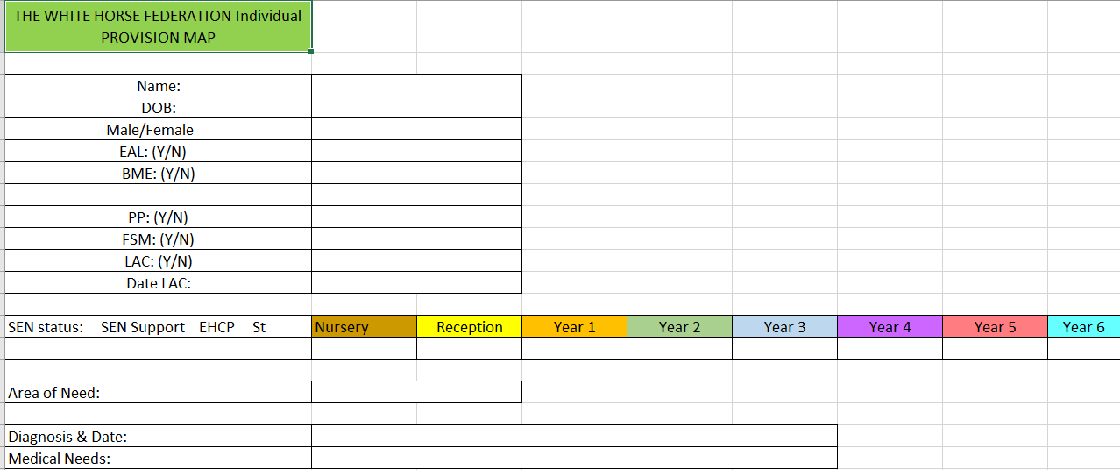
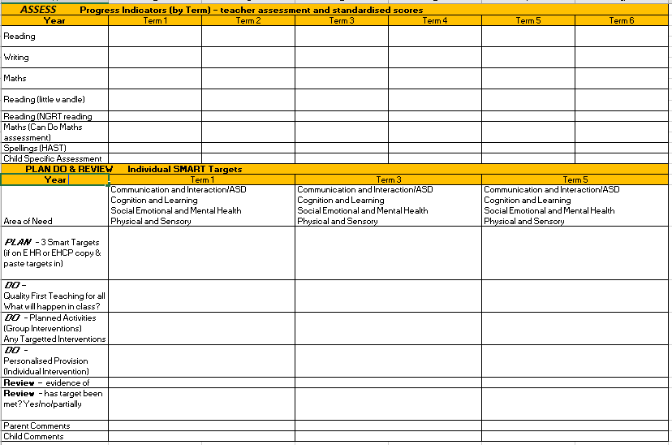

Appendix B – Glossary of terms
- WHF – White Horse Federation
- KS – Key Stage
- EYFS – Early Years Foundation Stage
- LAA – Local Authority
- SEN / D – Special Educational Needs and Disabilities
- SENCO – Special Educational Needs co-ordinator
- TA – Teaching Assistant
- SENAT – Special Educational Needs Assessment Team
- LAC – Looked After Child
- TaMHS – Targeted Mental Health Service
- AAC – Augmentative and Alternative communication
- ADHD – Attention Deficit Hyperactive Disorder
- ASD – Autistic Spectrum Disorders
- CLASS – Cognition and Learning Advisory Team
- CPD – Continued Professional Development
- EHCP – Education, Health, Care Plan

