OPAL Play Policy

LGB

Claire Leach

Claire Leach

Moredon Primary and Nursery School

1

December 2025

n/a

December 2027

Introduction to this Policy
‘Play is essential for children's well-being and development. When planning and providing play opportunities, the aim is not to eliminate risk but to balance risks and benefits. No child will learn about risk if they are wrapped in cotton wool’ (Health and Safety Executive, 2012)
Children have rights enshrined in the United Nations Convention on the Rights of the Child (UNCRC, 1989). Those rights are concerned with freedom and protection to access and do the things that make life worth living. Article 31 of the UN Convention acknowledges that all children have a right to play. At Moredon Primary and Nursery School we recognise that play is an essential part of a happy and healthy childhood. We aim to provide high-quality, enjoyable play experiences for all children across the school. We will do this by providing carefully considered outdoor spaces, play structures and resources that offer a rich choice of accessible play experiences for every child. We will refer to this play policy in all decisions that affect our children's play. We are committed to providing the strategic and operational leadership needed to provide and maintain quality play provision for all our children. The Health and Safety Executive (HSE) supports the provision of diverse play environments, recognising that well-managed spaces may involve some degree of risk and occasional danger and that safety concerns should not create restrictive environments that limit challenge, preventing children from expanding their learning and capabilities (HSE, 2012). This policy provides a framework for supporting play and making decisions about the associated risks.

To support the development of high-quality play times, our school has invested in the OPAL Programme, providing us with a tried and tested framework for improving children’s opportunities for play. We will be following the principles and practices recommended by OPAL, as we seek to ensure every child in our school has an amazing play time every day.
Policy Rationale
‘The opposite of play isn’t work, it’s depression’
(Brian Sutton-Smith, 1997)
Play is often trivialised as childhood frivolity - either treated as an unimportant pastime or valued only when it contributes to adult-focused outcomes. This instrumental approach can lead to overzealous adult intervention, where play is expected to be "purposeful", discouraging spontaneous and imaginative forms of play. As a result, many of children’s play environments have become overly controlled by adults, limiting children’s ability to create uncertain, open-ended experiences. This issue is further exacerbated by fears of litigation, shifting the focus toward safety rather than play itself.
Beyond adult-supervised settings, children’s opportunities for self-directed play in public spaces have also declined. In the UK, traffic is a major constraint on children’s freedom of movement and play. Economic priorities have marginalised outdoor play, prioritising the movement of goods and workers or the use of land for building. Economic factors have also placed more parents and carers in work, increasing the use of childcare and reducing the time for playing out with friends in local neighbourhoods after school. A range of anxieties also exists about community safety, further eroding opportunities for children’s self-directed outdoor play.
Furthermore, a risk-averse culture has developed in the UK and North America, where risk is typically seen as something to be controlled or eliminated. This perspective frames children as vulnerable and incapable, leading again to overprotective adult intervention. The result is a "cotton-wool culture", where attempts are made to remove risks completely, or children are kept away from them entirely. This failure to recognise children’s natural play behaviours and self-led development has restricted children’s freedom to play in both staffed settings and public spaces. The drive to limit liability undermines children’s well-being and growth and has significant costs. This includes reductions in physical activity levels, increases in sedentary lifestyles, higher rates of childhood obesity, diabetes, hyperactivity and attention deficits, increases in adolescent mental ill-health, and other long-term health risks.
These long-term risks far outweigh the minor physical risks children encounter in play. If children’s freedom to play in public spaces is constrained, school play times become even more essential. To ensure children benefit fully from their play, existing risk-averse practices must change. At Moredon Primary and Nursery School we take a balanced approach to risk management — one that loosens adult control while maintaining "safe enough" environments for play. We recognise that play spaces should offer:
- Freedom for children to engage with uncertainty.
- A relaxed atmosphere where adults support play rather than overly manage it.
- Recognition that children’s natural risk-taking builds resilience, confidence, and well-being.
By developing fantastic play times for all our children, where they can experience self-directed play, we can compensate them for the loss of time, space and permission for play outside of school and support their growth and development, and mental and physical health.

What is Play and Why is it Important?
Our Children told us:
- Play is fun.
- That they wanted more things to play with.
- That when playing, everybody should be able to play the way they want.
- That they wanted to be able to play with their siblings.
- They wanted to have more space and explore the grounds, particularly the school field.

The United Nations’ Committee on the Rights of the Child defines play as: ‘any behaviour, activity or process initiated, controlled and structured by children themselves; it takes place whenever and wherever opportunities arise. Caregivers may contribute to the creation of environments in which play takes place, but play itself is non-compulsory, driven by intrinsic motivation and undertaken for its own sake, rather than as a means to an end’.
Play can be understood as a non-serious, self-directed behaviour, free from external rules and constraints. At its core, play is about joy, freedom, and exploration. It provides a temporary escape from life’s complexities. Playing shakes up space, bringing light and optimism to difficult situations, fosters a sense that life is worth living, and creates moments of delight, laughter, friendship, adventure, and silliness.
Through play, children explore, express, and refine their capacities to navigate the world and their place in it. Play supports children’s physical, emotional, and social health, but this relies on adults creating supportive conditions⁴. The intrinsic value of play lies in its freedom and autonomy, making it profoundly important in ways that adult-structured activities cannot replicate.
Research into play has identified a range of unique features that make play what it is. Our play environments and staff practices will focus on nurturing these unique features of play (as set out below), and creating the conditions that support them:
- Personal control - In play, children have the freedom to decide their own actions. Playing has a spontaneous quality that cannot be totally planned for.
- Intrinsic motivation - play is driven by joy and curiosity, not external outcomes or rewards.
- Social - playing is pro-social, helping children develop attachments, cooperation and empathy.
- Emotional resonance - play provides a space to explore emotions and process experiences.
- Flexibility and variability - play is ever-changing, helping children to adapt, cope with change and be creative.
- Imagination and pretence - play is often not the real thing. Children create imagined scenarios, playing with actions and ideas in pretend ways.
- Novelty and uncertainty – children seek out challenge and uncertainty in their play, developing resilience and risk perception.
These unique features of play work together as a kind of "ordinary magic", enabling children to contribute to their own wellbeing and resilience through continued opportunities to:
- Form attachments to people and places.
- Regulate emotions and coping with stress.
- Develop cognitive skills such as creativity and problem-solving.
- Build motivation through experiences that bring joy and fulfilment.
The Health and Safety Executive also recognises that play is vital for children, providing opportunities to explore abilities, learn, and develop while engaging with real-world risks. Play is not risk-free, but it helps children develop risk awareness and prepare for their future lives (HSE, 2012).
Providing for Play
So far as is reasonably practicable, we want children in our school to have freedom of movement across the whole school grounds, making the most of the opportunities for play the environment affords. We also recognise the value of different ages and abilities of children mixing and the importance of promoting children’s self-regulation of their play. This includes children being allowed to be out of sight for short periods of time, enabling them to make dens, play hide-and-seek-type games, and enjoy a degree of privacy in their play. Importantly, there will be adults on hand to check in on children and offer help or guidance should they need it.

Again, so far as is reasonably practicable, children should be enabled to control what, where, with whom and how they play. To support this, we will use the principle of ‘everyone has a right to play’, meaning that children have freedom to play in ways that are of value to them, so long as this does not prevent others from doing the same.

To enable full site access, it is also essential that children have access to a change of footwear/wellies and appropriate clothing to enable them to play out in most weathers and continue accessing the field when wet and muddy. To support this, wellies and coats will be made part of the school uniform, and we will be providing suitable storage and other facilities to enable more playing throughout the year.

To further enhance and extend children’s opportunities for play, we will develop and maintain our school grounds in ways that maximise their play value. This includes providing children with easy access to a large amount and a wide variety of loose parts - junk materials and natural resources that children can use creatively in their play. Enhancing children’s opportunities for play in these ways will support children’s enjoyment of school, their learning and creativity, the development of friendships, and, in turn, their sense of well-being and resilience. These benefits of quality play time experiences are also key to the realisation of our school values including our new focus on the Five Ways to Well Being (Keep Learning, Give, Connect, Take Notice, Be Active).

Given the importance of play to children and the school’s commitment to upholding children’s right to play, children’s access to play times will only be restricted if their behaviours present an unreasonable risk to themselves or others. Such action will only be taken when necessary, and careful consideration will be given to how these children can be supported to return to play times.
Taking a Risk-Benefit Approach
Risk refers to the uncertain outcomes of a situation and is often associated with negative consequences. However, risk can also bring positive benefits. For example, balancing along a wall may result in physical injury, but it can also generate pleasure, excitement, self-awareness, confidence, risk perception and management skills, and a sense of achievement.
In the UK, the provision of play opportunities is governed by the Health and Safety at Work Act (1974), the Management of Health & Safety at Work Regulations (1992), and the Occupiers’ Liability Acts (1957, 1984). These laws require providers to:
- Reduce risks "so far as is reasonably practicable" (H&S at Work Act 1974),
- Ensure visitors are "reasonably safe in using the premises" (Occupiers Act, 1984),
- Manage and assess risks appropriately and proportionately (Management of Health & Safety at Work Regulations, 1992).
The level of risk children should be exposed to is a question of what is reasonable and practicable. Unlike occupational health and safety, where risk elimination may be favourable, for those involved in children's play, balancing risks and benefits is the primary goal (i.e. what is reasonable and practicable in the context of children’s play is different to a workplace). The Health and Safety Executive highlights this in its high-level statement, Children’s Play and Leisure – Promoting a Balanced Approach¹:
‘Striking the right balance between protecting children from the most serious risks and allowing them to reap the benefits of play is not always easy. It is not about eliminating risk. Nor is it about complicated methods of calculating risks or benefits. In essence, play is a safe and beneficial activity. Sensible adult judgements are all that is generally required to derive the best benefits to children whilst ensuring they are not exposed to unnecessary risk.’
In 2023, the International Organisation for Standardisation (ISO) also adopted this approach as a best practice for managing risks in sports and recreation (including play) facilities. The ISO uses the term "benefit-risk assessment", but both terms mean the same thing. ISO 4980:2023 defines this as:
‘A form of risk assessment that considers both risks and benefits in parallel when making decisions. Benefit-risk assessment is a balanced approach involving judgment based on clear values and understandings. Where appropriate, it takes account of local circumstances and includes an evaluation of social, physical, and developmental considerations.’
We will use a risk-benefit approach when making decisions about what is reasonable and the desirability of children engaging with heightened levels of risk. This approach aims to ensure that children can experience the benefits of uncertainty in their play while seeking to reduce the risk of serious harm and those risks that are not beneficial to children. This decision-making will be based on evaluating:
- The benefits of the activity (e.g., skill development, resilience, confidence).
- The likelihood and severity of harm.
- Expert guidance, best practices, and comparative examples.
- The impact of restrictions on play quality and its associated benefits.
Strategic Risk Management
Our risk management strategy is an ongoing process informed by OPAL’s R.A.P.I.D. approach to risk management in play. R.A.P.I.D. stands for Risk-benefit assessments, Assemblies, Policy, Inspections, and Dynamic risk management. These different elements of our risk management strategy work together (as depicted in the diagram below), ensuring we have robust systems in place to support good decision-making and the ongoing maintenance of a ‘safe enough’ environment for play.
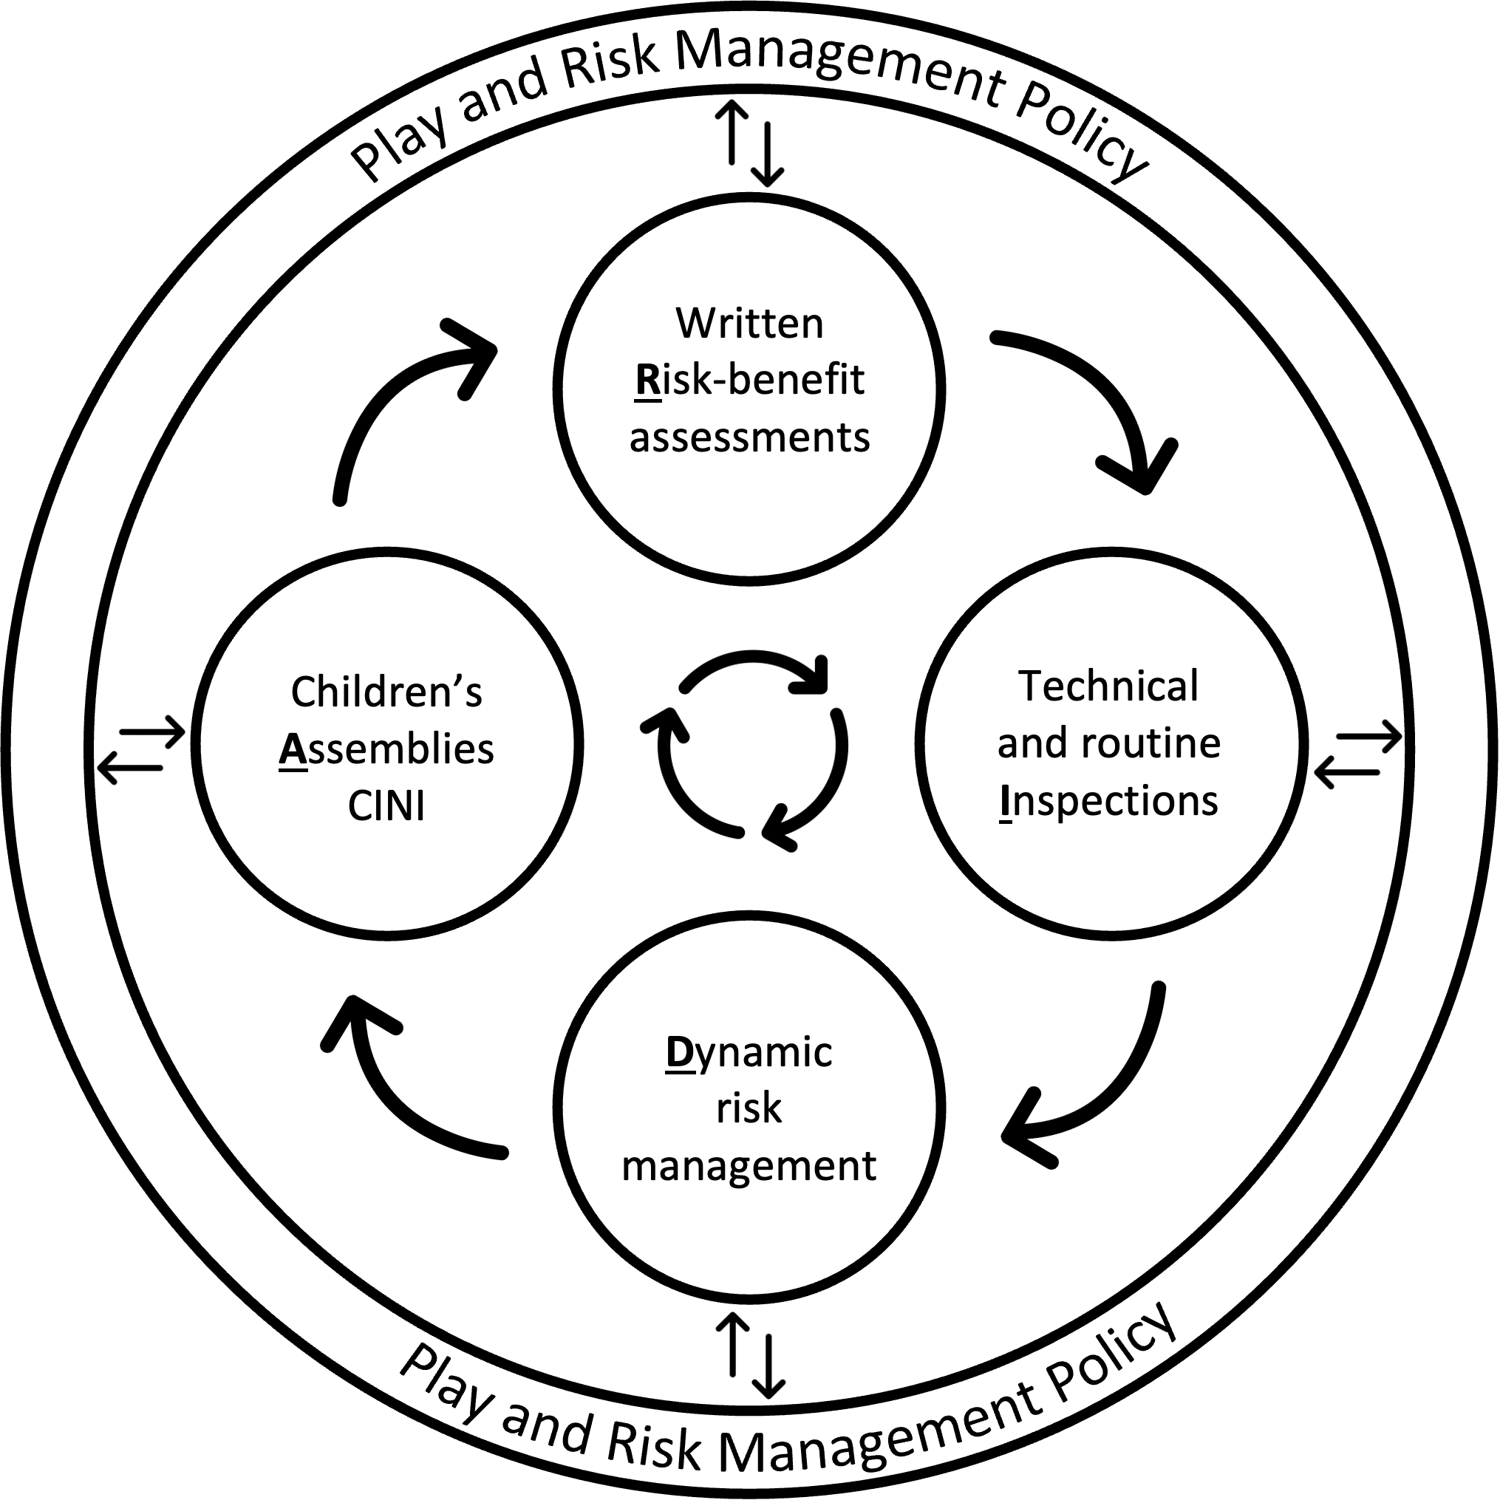
Following HSE guidance (see Appendix 1), we recognise that detailed risk-benefit assessments for every scenario are unnecessary, impractical, and time-consuming. Instead, we take a proportionate and balanced approach to risk assessment, ensuring that higher-risk activities receive greater scrutiny but low-risk opportunities (whilst still subject to professional judgement), remain unburdened by excessive paperwork.
We use the Tolerability of Risk Framework (diagram below) to guide professional judgements about the opportunities we provide, and the level of risk management required. The broadly acceptable region refers to opportunities where the risk is perceived to be low enough to be acceptable to most people without the need for a detailed risk-benefit assessment. For play opportunities that are considered to fall into this lowest region, this play and risk management policy represents an overarching risk-benefit assessment for our play time provision. Sections of this policy take account of the behavioural characteristics of children’s play, their associated benefits and risks, and describe approaches and systems for managing the everyday play behaviours that are likely to occur in our play environment/s.

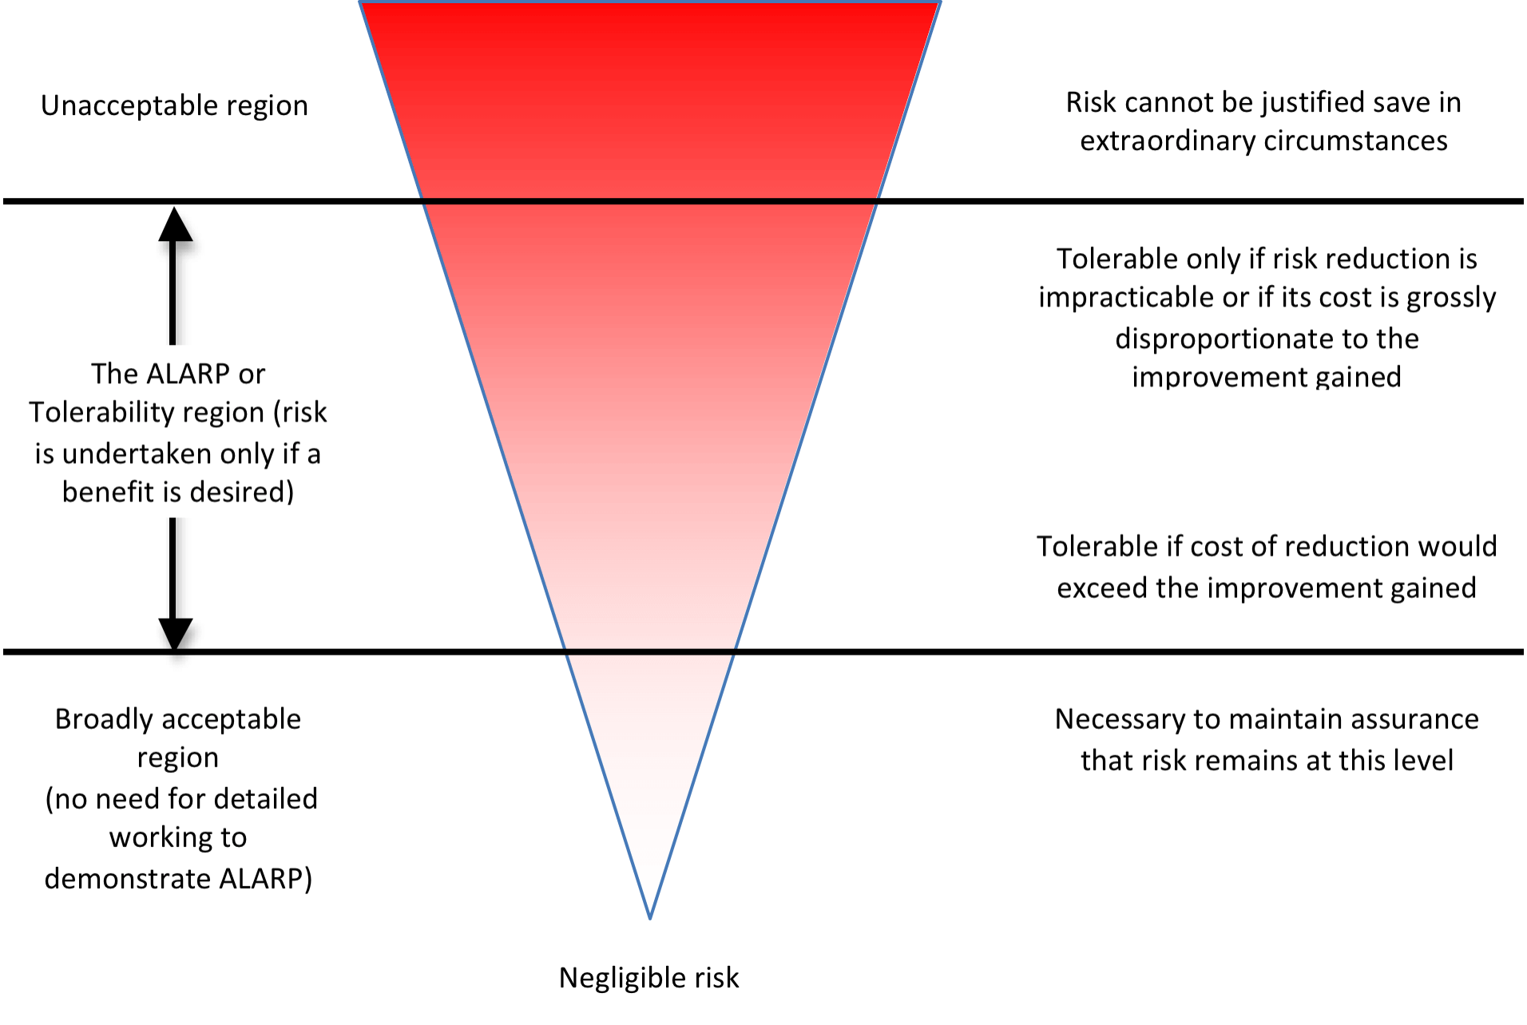
Inverted triangle represents that the higher the risk, the greater the emphasis on safety should be
When planning for play, any environmental feature or opportunity that we deem to present a level of risk beyond the broadly acceptable region will be subject to its own detailed risk-benefit assessment. This assessment will evidence our decision-making processes and set out actions to manage the associated risks so that they remain as low as is reasonably practicable (whilst maintaining the benefits of play). This might include situations where:

- Play structures, site-specific features, or impact surfaces fall outside of commonly accepted standards (for example, the European Standards for Fixed Play Equipment and Impact Attenuating Surfaces).
- Through adults’ actions, children are exposed to a greater risk of injury than they might normally encounter of their own volition.
- Staff are unsure about the risks involved and how to manage them (the process of completing risk-benefit assessments can aid discussion and provide greater clarity and confidence).
- Staff feel additional justification is required due to concerns about how risks may be perceived by the public.
There will also be situations where children, during play, create their own heightened levels of risk which adults may not have planned for. In such situations, risk-benefit assessments may be applied in two ways:
- Routine play opportunities with heightened levels of risk - if a play opportunity is regularly occurring (e.g., most days or weeks), it should undergo a written risk-benefit assessment.
- Novel play opportunities with heightened levels of risk - when such play opportunities emerge spontaneously, such as something children invent in the moment, a dynamic risk-benefit assessment should be applied.
Our written risk-benefit assessments will be regularly reviewed and updated based on experience, knowledge, and new evidence, ensuring they remain effective and proportionate.
Dynamic Risk-Benefit Assessment
Children’s play is inherently exploratory, flexible, and varied. While playing, children naturally seek uncertainty, which means risks can emerge in the moment. To manage these ‘real-time’ risks, we adopt a dynamic risk-benefit assessment approach, where staff assess risks as they arise, considering the environment and play context to determine the most appropriate response.
Risk perception is subjective, and individual staff may differ in their tolerance of risk. To support consistency in decision-making, we have adopted guidance on dynamic risk-benefit assessments (see Appendix 4), supporting staff in making balanced and informed choices.
Our approach aims to balance intervention with the benefits of freedom and uncertainty in play. Whenever possible, staff should observe how children navigate risks for themselves before deciding if intervention is necessary. In doing so, staff should consider:
- Children’s self-management of risk – Have they removed hazards, adjusted their behaviour, or set their own safety rules?
- Contextual factors – Are children adapting to different ages and abilities while keeping risks balanced with benefits?
- Intervention necessity – If intervention is needed, it should aim to preserve play benefits while reducing the level of risk. Staff should stop activities only in cases of imminent and serious harm.
When staff make a dynamic risk-benefit assessment that enables a higher-risk opportunity, they will reflect on these experiences with peers in team meetings and, where necessary, integrate them into routine risk-benefit assessments or inform staff training and development opportunities.
Good and Bad Hazards
In making risk-benefit decisions, we will use the concept of good and bad hazards, recognising that the type of hazards children should be exposed to depends on what is both reasonable and practicable, and of benefit to children.
- Acceptable/Good Hazards – objects or situations where the associated risks can reasonably be foreseen by children and which offer potential benefits to children when encountered or navigated. We aim to manage these hazards, so the risks remain at a reasonable level.
- Unreasonable/Bad Hazards – objects or situations where children cannot reasonably be expected to recognise the associated risks, with those risks also offering little to no benefit. While absolute protection is impossible, we aim to protect children from hazards that pose an unreasonably high risk of serious injury, in line with reasonable safety measures.

Inspection and Maintenance
We conduct regular inspections of the play environment and resources to ensure risks remain at a reasonable and acceptable level. This includes:
- Daily/weekly site inspections – visual checks of the play environment, its features, structures and equipment.
- Routine inspections of play resources – visual checks of loose parts on an agreed schedule to ensure they are safe enough for use in play.
- Monthly/quarterly site inspections – more in-depth checks involving closer inspection of moving parts and structural integrity, ground conditions, and natural features that may require attention due to growth or decay.
- Annual inspections – formal and thorough inspections of engineered play equipment, self-built structures and tree conditions, often carried out by an external party.
Throughout these inspection processes, hazards that are not beneficial to play should be removed, taken out of use, and/or scheduled for repair/maintenance as appropriate.

Supervision of playtimes

At Moredon Primary and Nursery School, we understand the importance of suitable and sufficient supervision during play times. The law requires that children in school be supervised, but for primary school play times, there are no stated adult-to-child ratios, only that there should be one or more adults present when children are playing outdoors.

At Moredon Primary and Nursery School, we will use OPAL’s three models of supervision: direct, remote and ranging. In order to allow children to make full use of our school grounds, direct supervision is not always possible or beneficial. Whilst direct supervision may be used for our youngest children starting school, the majority of our playtime supervision will take remote and ranging models. This will mean that children can quickly find an adult, and adults can patrol large areas of the site to gain an awareness of the types of play and levels of risk emerging.

Our school grounds will be divided into supervision zones with an adult patrolling each area. An additional ‘floating’ member of staff will be present during each playtime to have an overview of the whole site and to offer support in specific areas as necessary. Adults within each zone with communicate via walkie-talkies, and a fixed first aid point will be used for any significant accidents.

The staff involved in supervising playtimes are called our Play Team. The Play Team’s role is to facilitate and enhance children’s play, enabling all children to play in ways that are of value to them, and encouraging children to assess the risks and benefits of their play behaviours. We will help children maximise the benefits they can gain from playing by training our Play Team to work in accordance with the Playwork Principles (see Appendix 2). These principles will help to guide how supervising staff interact and intervene in children’s play.
Ultimately, we strive to facilitate an environment which nurtures children’s self-directed play. However, children’s play is complex and allowing children freedom is not always an easy thing for adults to do. The Play Team will therefore be provided with regular opportunities to reflect on and develop their practice, as well as what is available in the play environment.

Whole school communication
At Moredon Primary and Nursery School, we, as an entire staff team, are fully committed to working with children to provide the play experiences that they want and need in their school. We will maintain an open dialogue with children about our play provision, with the aim of further developing their playtime experiences using their voices and ideas as guidance.
Play assemblies are a key aspect of our risk management strategy. This includes meeting with children at least once per half term and discussing with them the play opportunities on offer, the play environment and their play behaviours, as well as our approach to working with play. We use OPAL’s C.I.N.I format, which incorporates Celebrating children’s play, Informing children about aspects of our play provision, Negotiating with children about aspects of the play offer, and Innovating with children about improving our play offer. These assemblies routinely include conversations with children around various aspects of risk management.
As a school, we will also maintain an OPAL working group, which will oversee the implementation of the OPAL Programme, ensuring that all aspects of school life that influence our play times are aligned with the aims and aspirations of this policy. The diagram in Appendix 3 sets out the staffing structure we have in place to support quality play times.

Appendix 1

Health & Safety Executive: Children’s Play and Leisure – Promoting A Balanced Approach

Appendix 2

The Playwork Principles

Appendix 3

Staffing structure to support play times:

Play Team
(facilitates playtimes)

Play Coordinator
(oversees delivery of play times)

Curricula Lead for Play
(oversees development of play times)

OPAL Working Group
(maintains a whole school approach to play times)

Appendix 4
Dynamic Risk Benefit Assessment Flow Chart

Health and Safety Executive (2012) Children’s Play and Leisure – Promoting a balanced approach, HSE.
Sutton-Smith, B. (1997) The Ambiguity of Play, Cambridge, MA: Harvard University Press.
Meire, J. (2007) Qualitative Research on Children’s Play: A review of recent literature, in Jambor, T. and van Gils, J.(eds) Several Perspectives on Children’s Play: Scientific Reflections for Practitioners, Antwerp: Garant, pp. 29-78.
Russell, W., Barclay, M. and Tawil, B. (2024). Playing and being well: A review of recent research into children’s play, social policy and practice, with a focus on Wales (summary). Play Wales.
Gill, T. (2007) No Fear: Growing up in a risk averse society, London: Calouste Gulbenkian Foundation;
United Nations Committee on the Rights of the Child (2it 013) General Comment 17 on the Right of the Child to Rest, Leisure, Play, Recreational Activities, Cultural Life and the Arts (art. 31), Geneva: United Nations
Lester, S. and Russell, W. (2008) Play For a Change: Play Policy and Practice. A review of contemporary perspectives. London: Play England; Cowan, K. (2020) A Panorama of Play: A literature review, Digital Futures Commission, London: 5Rights Foundation.
Masten, A (2001) Ordinary Magic: Resilience processes in development, American Psychologist, 56 (3): 227-238
HSE, 1992

