MOREDON PRIMARY & NURSERY SCHOOL SCIENCE OVERVIEW

2025-2026
 | Autumn term |  | Spring Term |  | Summer Term
 | Autumn 1 | Autumn 2 | Spring 1 | Spring 2 | Summer 1 | Summer 2
Year 1 | Humans / the body 5 senses  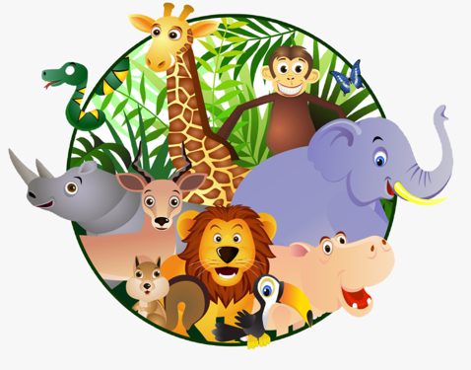 | Animals, including humans (Animals) | 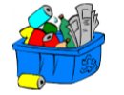  Everyday materials | 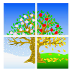  Seasonal Changes | Animals, including humans  (Animals) |   Plants
Year 2 | Living things & their habitats  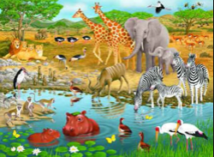 | Everyday materials and their uses | Everyday materials and their uses – properties | Plants | Plants | Animals incl Humans
Year 3/4 | Living Things/ Animals-food chains | Animals including humans |   Sound | 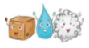  States of matter | Living things & their habitats/Plants | Electricity  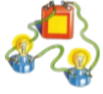
Year 5 | Living things & their habitats | Forces & Mechanisms   | 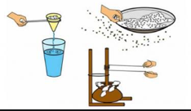  Properties and changes of materials | Space   | Animals, including humans | Catch up  Gaps and go over all topics
Year 6 | Living Things & their habitats | Electricity |   Light | 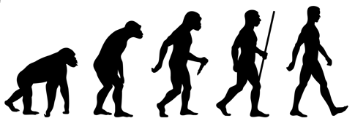  Evolution & Inheritance | Animals including humans | Properties and changes of materials
Working Scientifically
Planning, Observing, Recording, Concluding, Evaluating,
Biology Chemistry Physics

