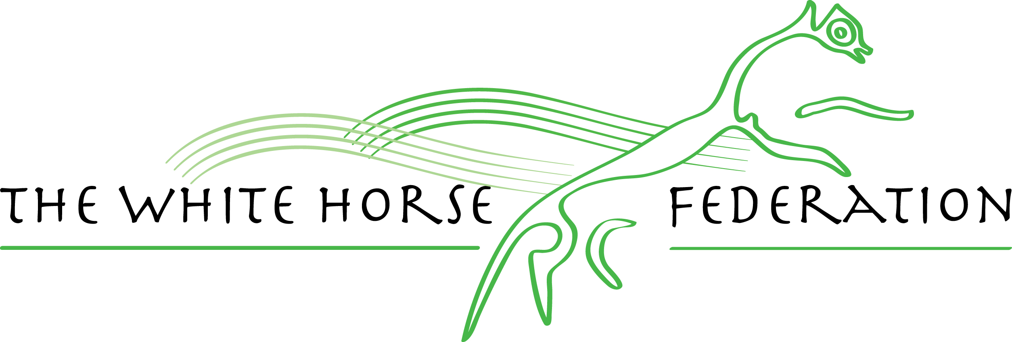

Moredon Primary and Nursery School



Science Policy

|  |  |  |  |
| --- | --- | --- | --- |
| Key Document details: | | | |
| Author: | Simone Marr and Sarah Smith | Approver: | Claire Leach |
| Owner: | Simone Marr and Sarh Smith | Version No.: | Version no 7 |
| Date: | 21st October 2019 | Next review: | October 2021 November ‘21  September’22  April 2023 April 2024  January 2025 |
| Ratified: | October 2019 |  |  |

**Intent**

At Moredon Primary and Nursery School we want all children to be confident when discussing key scientific vocabulary. We want the children to be confident scientists who understand key concepts. We want lessons to have a clear progression so that each year knowledge is built upon.

Philosophy

At MPNS, we believe that Science teaches an understanding of natural phenomena. It aims to stimulate a child’s curiosity in finding out why things happen in the way they do. It teaches methods of enquiry and investigation to stimulate creative thought. Children learn to ask scientific questions and begin to appreciate the way science will affect their future on a personal, national, and global level.

.

Principles

We aim to enable children to:

* ask and answer scientific questions;
* plan and carry out scientific investigations, using equipment, including computers, correctly;
* know and understand the life processes of living things;
* know and understand the physical processes of materials, electricity, light, sound and natural forces;
* know about the nature of the solar system, including the Earth;
* evaluate evidence and present their conclusions clearly and accurately.

Procedures

We will:

Use a variety of teaching and learning styles in science lessons. Our principle aim is to develop children’s knowledge, skills, and understanding. Sometimes we do this through whole-class teaching, while at other times we engage the children in an enquiry-based research activity. We encourage the children to ask, as well as answer, scientific questions. They have the opportunity to use a variety of data, such as statistics, graphs, pictures, and photographs. They use ‘Computing’ in science lessons where it enhances their learning. They take part in role-play and discussions and they present reports to the rest of the class. They engage in a wide variety of problem-solving activities. Wherever possible, we involve the pupils in ‘real’ scientific activities, for example, researching a local environmental problem or carrying out a practical experiment and analysing the results.

We recognise that there are children of widely different scientific abilities in all classes and we ensure that we provide suitable learning opportunities for all children by matching the challenge of the task to the ability of the child. We achieve this in a variety of ways by:

* setting common tasks which are open-ended and can have a variety of responses;
* setting tasks of increasing difficulty (we do not expect all children to complete all tasks);
* grouping children by ability in the room and setting different tasks for each ability group;
* providing resources of different complexity, matched to the ability and age of the child;
* where appropriate, using classroom assistants to support the work of individual children or groups of children.

Science curriculum planning

The school uses the national curriculum scheme of work for science as the basis of its curriculum planning. The national scheme has been adapted to the local circumstances of the school in that we make use of the local environment, particularly our own school grounds.

We carry out our curriculum planning in science in line with the National Curriculum. It maps the scientific topics studied in each term during the key stage. This informs topics to be taught in each year group. In some cases we combine the scientific study with work in other subject areas, at other times the children study science as a discrete subject. (The school has developed a creative curriculum approach with a clear progression of skills across the year groups.)

The National Curriculum based on the national scheme of work in science, give details of each unit of work for each year group. The science subject leader keeps and reviews these plans. The school has a yearly over view which can be amended by class teachers to link with topics they are teaching.

The class teacher is responsible for writing termly lesson plans. These plans list the specific learning objectives of each lesson and incorporates differentiation, particularly for SEND pupils, more-able pupils (HA) disadvantaged children (PP) and boys (see SDP.) Weekly planning will also include a ‘Let’s Talk Science’ starting activity using resources such as Explorify as a means of Assessment For Learning (AFL) and as an introduction to the lesson focus.

We have planned the topics in science so that they build upon prior learning. We ensure that there are opportunities for children of all abilities to develop their skills and knowledge in each unit and we also build progression into the science scheme of work, so that the children are increasingly challenged as they move up through the school.

In mixed age classes the class teacher will decide which year group planning to follow which best suits their class.

Foundation Stage

As Nursery and the Reception class is part of the Foundation Stage of the National Curriculum, we relate the development of the children’s knowledge and understanding of the world to the objectives set out in the EYFS (Early Years Foundation Stage). These underpin the curriculum planning for children aged three to five. Science makes a significant contribution to the objectives in the EYFS by developing a child’s knowledge and understanding of the world (UTW). All topics and ongoing child and adult initiated activities, both inside and out, incorporate the EYFS objectives for exploration and investigation. We teach science in foundation stage classes as an integral part of the topic work covered during the year. We encourage the development of skills, knowledge and understanding that help Nursery and Reception children make sense of their world. These early experiences include asking questions about how things work, investigating and using a variety of resources that encourage exploration, observation, problem solving, critical thinking and discussion. These activities, indoors and outdoors, strive to attract the children’s interest and curiosity. Lots of learning is conducted as part of Welly Walks and use of the local environment. We also plan visits to the local Garden centre and Community gardens to enhance the children’s learning and as means to make comparisons.

The contribution of science to teaching in other curriculum areas

English

Science contributes significantly to the teaching of English in our school by actively promoting the skills of reading, writing, speaking and listening. Some of the texts that the children study in English are of a scientific nature. The children develop oral skills in science lessons through discussions (for example of the environment) and through recounting their observations of scientific investigations/experiments. They develop their writing skills through recording observations, writing reports and projects.

Mathematics

Science contributes to the teaching of mathematics in a number of ways. The children use weights and measures and learn to use and apply number. Through working on investigations they learn to estimate and predict. They develop the skills of accurate observation and recording of events. They use numbers in many of their answers and conclusions.

Computing

Children use Computing in science lessons where appropriate. They use it to support their work in science by learning how to find, select, and analyse information on the Internet. Children use various Technology to record, present and interpret data and to review, modify and evaluate their work and improve its presentation.

Personal, social and health education (PSHE) and citizenship

Science makes a significant contribution to the teaching of personal, social and health education. This is mainly in two areas. Firstly, the subject matter lends itself to raising matters of health education, citizenship and social welfare. For example, children study food and healthy eating, the way people recycle materials and how environments are changed for better or worse. Secondly, children benefit from the nature of the subject in that it gives them opportunities to take part in debates and discussions. Science promotes the concept of positive citizenship. The Jigsaw scheme cross links with lots of objectives in Science especially those linked to Humans and Health.

Spiritual, moral, social and cultural development

Science teaching offers children many opportunities to examine some of the fundamental questions in life, for example, the evolution of living things and how the world was created. Through many of the amazing processes that affect living things, children develop a sense of awe and wonder regarding the nature of our world. Science raises many social and moral questions. Through the teaching of science, children have the opportunity to discuss, for example, the effects of smoking, medicines as drugs and the moral questions involved in this issue. We give them the chance to reflect on the way people care for the planet and how science can contribute to the way we manage the earth’s resources. Science teaches children about the reasons why people are different and, by developing the children’s knowledge and understanding of physical and environmental factors, it promotes respect for other people.

Teaching science to children with special educational needs

At our schoolwe teach science to all children, whatever their ability. Science forms part of the school curriculum policy to provide a broad and balanced education to all children. Through our science teaching we provide learning opportunities that enable all pupils to make progress. We do this by setting suitable learning challenges and responding to each child’s different needs. Assessment against the National Curriculum allows us to consider each child’s attainment and progress against end of year expectations.

When progress falls significantly outside the expected range, the child may have special educational needs. Our assessment process looks at a range of factors – classroom organisation, teaching materials, teaching style, and differentiation – so that we can take some additional or different action to enable the child to learn more effectively. This ensures that our teaching is matched to the child’s needs.

We enable pupils to have access to the full range of activities involved in learning science. Where children are to participate in activities outside the classroom, for example, a trip to a science museum, local gardens we carry out a risk assessment prior to the activity, to ensure that the activity is safe and appropriate for all pupils.

High quality first teaching, differentiated for individual pupils, is the first step in responding to pupils who have, or may have SEND. Differentiation occurs in the support and intervention provided to different pupils, through questioning, scaffolding and resources for individual pupils. This is an inclusive approach to individual learners’ needs, ensuring language, questioning, concepts and ultimately learning is accessible to all.

Assessment and recording

Attainment in Nursery and Reception classes is recorded under ELG’s for knowledge and ‘Understanding of the world- UTW’ and will inform the Foundation Stage record in Reception. We also use EYFS TAPS assessment activities as a resource for planning activities and assessment.

In KS1 and 2 we assess children’s work in science by making informal judgements as we observe them during lessons. On completion of a piece of work, the teacher marks the work (if it is written) or assesses the child’s understanding orally and comments as necessary. In KS1 most Science work is practical with limited amounts of recording. At the end of a unit of work s/he makes a summary judgement about the work of each pupil in relation to the National Curriculum level. The teacher records working scientifically and knowledge, which are the basis for assessing the progress of each child and we pass this information on to the next teacher at the end of the year.

TAPS is a formal assessment that we will complete during each topic in years 1-6. This should be planned to be completed at approx week 3/4 of a term to enable time to address any misconceptions rather than at the end of a term.

Resources

We have sufficient resources for all science teaching units in the school. We keep these in a central store. The library contains a good supply of science topic books to support children’s individual research.

Performance

It is the responsibility of the science subject leader to monitor the standards of children’s work and the quality of teaching in science. The science subject leader is also responsible for supporting colleagues in the teaching of science, for being informed about current developments in the subject and for providing a strategic lead and direction for the subject in the school. The science subject leaders gives the Principle an annual action plan which is RAG highlighted periodically. The science subject leader has a monitoring schedule to fulfil over the academic year and feeds backs to SLT

Updated November 2021 Simone Marr

Updated September 2022 Simone Marr

Updated April 2023 Simone Marr

Updated April 2024 Simone Marr and Sarah Smith

Updated January 2025 Simone Marr and Sarah Smith