Science  In Science we are learning about habitats. Go on a habitat walk and see how many different habitats you can spot. | Maths  Can you count different objects in your house? How many objects can you find?  This term we are looking at place value. Can you partition 2 digit numbers into their tens and ones? | English  Create a story about your own very hungry lion. Perhaps in your story he is very fussy about food and doesn’t like normal lion food.
PSHE  Our values this term are Patience, Perseverance and Curiosity. Our overall theme is ‘Keep Learning’. Each week we will be trying to learn a new skill. What new skill can you learn at home? Maybe you are learning to ride a bike or try a new sport. Take a photo and send it to us on dojo. | Year Two - Term 1  2025  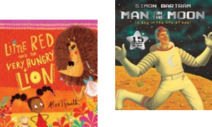 | Computing  Create an information leaflet on the technology that you have in your home.  Your Purple Mash log in details are stapled in the front of your reading record. Why not log in and play some of the educational games there.
History  We are looking at our own, personal histories. You could make a memory box and fill it up with your favourite and different memories. You could draw the memory or add an object.  Or you could draw your family tree to share with us. | PE  Make your own obstacle course. Using garden equipment. Time yourself and try to beat you own personal best. Remember to take a picture or video to share with the class. | DT  We are learning to use practical skills such as cutting, peeling and grating to make a fruit salad.  Why not make a fruit salad for your family – you could try cooking or baking something else. We can’t wait to see what you have made!

