S

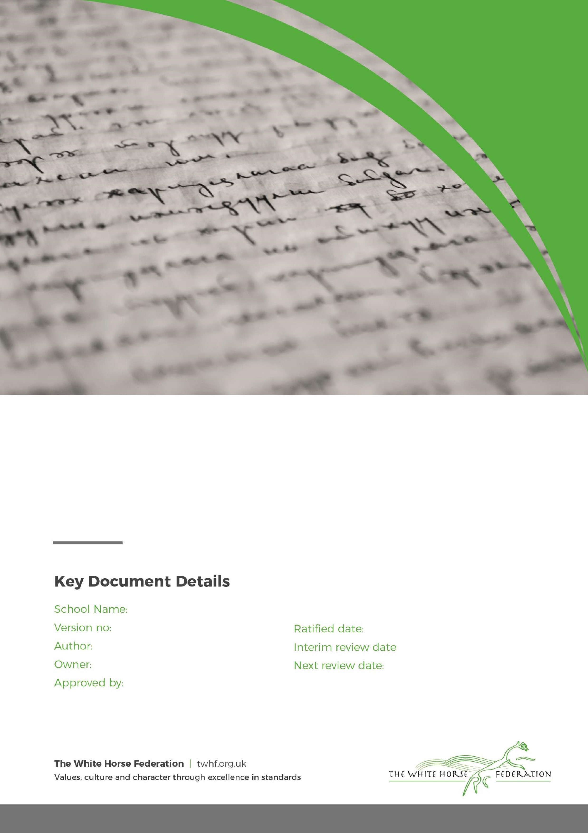

Special Education Needs (SEN)

Information Report

1

Tim James

Tim James

September 2025

September 2026 Year

Moredon Primary and Nursery School

Month / Year

Approver

# **Dear Parents and Carers,**

The aim of this information report is to explain how we implement our SEND policy. In other words, we want to show you how SEND support works in our school.

You can find out more about our arrangements for SEND, here in our SEND policy:



Or you can find it on our website [Policies & Procedures | Moredon Primary and Nursery](https://moredon.swindon.sch.uk/about-us/school-information/policies-procedures)

**Note:** If there are any terms, we’ve used in this information report that you’re unsure of, you can look them up in the Glossary at the end of the report.

# **1. What types of SEN does the school provide for?**

Our school provides for pupils with the following needs:

|  |  |
| --- | --- |
| **Area of need** | **Condition** |
| **Communication and interaction** | Autism spectrum disorder |
| Speech and language difficulties |
| **Cognition and Learning** | Specific Learning Difficulties (SpLD) (including dyslexia, dyspraxia, dyscalculia) |
| Moderate Learning Difficulties |
| Severe Learning Difficulties |
| **Social, emotional and mental health** | Attention deficit hyperactive disorder (ADHD) |
| Attention deficit disorder (ADD) |
| **Sensory and/or physical** | Hearing impairments |
| Visual impairment |
| Multi-sensory impairment |
| Physical impairment |

# 

# **Which staff will support my child, and what training have they had?**

At Moredon Primary and Nursery School, the SENCO is part of the NEST (Nurture, Educate, Support, Team). This includes the Learning Mentor Diane Townsend and the Family Support Worker Kirsty Mapstone Davies.

The Learning Mentor is also an ELSA.

Our special educational needs co-ordinator, or SENCO

Our SENCO is Angie Harris who is a full time, non-teaching member of our team.

She has 6 years’ experience in the SENCO role and she is a qualified teacher having previously worked as a Reception and Key Stage One teacher for 18 years.

She achieved the National Award in Special Educational Needs Co-ordination in 2022.

Contact details – [aharris@moredon.swindon.sch.uk](mailto:aharris@moredon.swindon.sch.uk), 01793600344

Class teachers

We ensure that teachers have the skills that they need to teach the range of SEND in their class through teacher training and professional development using in school and external professional development. Where more specific

intervention is required, staff are trained to deliver evidence based interventions to support children in reading,

writing and maths.

Teaching assistants (TAs)

We have a team of 24 TAs.

Our TAs are trained to deliver interventions appropriate to the age range that they work within. In the last academic year some of the training has included, Little Wandle, Precision Teaching, Language for Thinking, Write from the Start, Time to Talk

External agencies and experts

Sometimes we need extra help to offer our pupils the support that they need. Whenever necessary we will work with external support services to meet the needs of our pupils with SEN and to support their families. These include:

* Speech and language therapists
* Educational psychologists
* Occupational therapists
* GPs or paediatricians
* School nurses
* Child and adolescent mental health services (CAMHS)
* Education welfare officers
* Social services and other LA-provided support services
* Voluntary sector organisations
* ASD Advisory Service
* Assistive Technology Service
* Advisory Teacher for Physical Disabilities
* Education Welfare Officer
* SEMH outreach team (Social Emotional and Mental Health)
* Be U Swindon

# **3. What should I do if I think my child has SEN?**

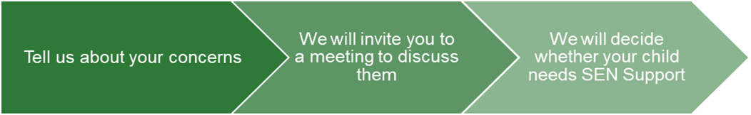

|  |  |  |
| --- | --- | --- |
| If you think your child might have SEN, the first person you should tell is your child’s teacher. You can contact them at the classroom door, via the Class Dojo App or by calling the school office.  This will then be passed on to the SENCO Angie Harris who will be in touch.  You can also contact the SENCO directly. | We will meet with you to discuss your concerns and try to get a better understanding of what your child’s strengths and difficulties are.  Together we will decide what outcomes to seek for your child and agree on next steps.  We will make a note of what’s been discussed and add this to your child’s record. You will also be given a copy of this. | If we decide that your child needs SEN support, we will formally notify you in writing and your child will be added to the school’s SEN register. |

# **4. How will the school know if my child needs SEN support?**

All our class teachers are aware of SEN and are on the lookout for any pupils who aren’t making the expected level of progress in their schoolwork or socially. This might include struggling to learn new phonics and decode words when reading, finding it difficult to understand and complete maths work including understanding numbers and calculations, struggling to accurately write using the spelling, grammar and punctuation that has been taught, or having ongoing difficulties following the routines of the school day, make friends or communicate their needs.

If the teacher notices that a pupil is falling behind, they try to find out if the pupil has any gaps in their learning. If they can find a gap, they will give the pupil extra tuition to try to fill it. Pupils who don’t have SEN usually make progress quickly once the gap in their learning has been filled.

If the pupil is still struggling to make the expected progress, the teacher will talk to the SENCO, and will contact you to discuss the possibility that your child has SEN.

The SENCO may observe the pupil in the classroom or in the playground to see what their strengths and difficulties are. They will have discussions with your child’s teacher/s, to see if there have been any issues with, or changes in, their progress, attainment or behaviour. They will also compare your child's progress and development with their peers and available national data.

The SENCO will ask for your opinion and speak to your child to get their input as well. They may also, where appropriate, ask for the opinion of external experts such as a speech and language therapist, an educational psychologist, or a paediatrician.

Based on all of this information, the SENCO will decide whether your child needs SEN support. You will be told the outcome of the decision in writing.

If your child does need SEN support, their name will be added to the school’s SEN register, and the SENCO will work with the class teacher to create a Pupil Profile for them.

# 

# **5. How will the school measure my child’s progress?**

We assess the progress and attainment of all pupil’s regularly throughout the year using key assessment tasks and through ongoing teacher assessment. We compare progress to pupil’s prior levels of attainment and we compare attainment between pupils and against national standards.

We will follow the ‘graduated approach’ to meeting your child’s SEN needs.

The graduated approach is a 4-part cycle of **assess, plan, do, review**.

**Assess**

**If your child is not making the expected level of progress, we will make an assessment using the Swindon Core Standards to find out what strengths and difficulties your child has.** **We will ask for you and your child’s input, as well as getting help from external professionals where necessary.**

**Review**

**We will assess how well the support we put in place helped the pupil to meet the outcomes we set. We will use our improved understanding of   
your child’s needs to improve the support we offer.**

**Plan**

**In discussion with you and your child, we will decide what outcomes we are hoping to achieve. We will make a plan of the support we will offer your child to help them meet those outcomes. We will make a record of this and share it with you and all relevant school staff.**

**Do**

**We will put our plan into practice.**

**The class teacher, with the support of the SENCO, will be responsible for working with your child making sure the support we put in place is having the impact we intended.**

As a part of the planning stage of the graduated approach, we will set outcomes that we want to see your child achieve.

Whenever we run an intervention with your child, we will assess them before the intervention begins. This is known as a ‘baseline assessment’. We do this so we can see how much impact the intervention has on your child’s progress.

We will track your child’s progress towards the outcomes we set over time and improve our offer as we learn what your child responds to best.

This process will be continual. If the review shows a pupil has made progress, they may no longer need the additional provision made through SEN support. For others, the cycle will continue and the school's targets, strategies and provisions will be revisited and refined.

# **6. How will I be involved in decisions made about my child’s education?**

We will provide an annual report of your child’s progress.

Your child’s class teacher will meet you 3 times a year to:

* Set clear outcomes for your child’s progress
* Review progress towards those outcomes
* Discuss the support we will put in place to help your child make that progress
* Identify what we will do, what we will ask you to do, and what we will ask your child to do

The SENCO may also attend these meetings to provide extra support.

We know that you’re the expert when it comes to your child’s needs and aspirations. So, we want to make sure you have a full understanding of how we’re trying to meet your child’s needs, so that you can provide insight into what you think would work best for your child.

We also want to hear from you so that we can build a better picture of how the SEN support we are providing is impacting your child outside of school.

If your child’s needs or aspirations change at any time, please let us know right away so we can keep our provision as relevant as possible.

After any discussion we will make a record of any outcomes, actions and support that have been agreed. This record will be shared with all relevant staff, and you will be given a copy.

If you have concerns that arise between these meetings, please contact your child’s class teacher either at the classroom door or via Class Dojo.

# 

# **7. How will my child be involved in decisions made about their education?**

The level of involvement will depend on your child’s age, and level of competence. We recognise that no 2 children are the same, so we will decide on a case-by-case basis, with your input.

We may seek your child’s views by asking them to:

* Attend meetings to discuss their progress and outcomes
* Prepare a presentation, written statement, video, drawing, etc.
* Discuss their views with a member of staff who can act as a representative during the meeting
* Complete a survey

**8. How will the school adapt its teaching for my child?**Your child’s teacher is responsible and accountable for the progress and development of all the pupils in their class.

High-quality teaching is our first step in responding to your child’s needs. We will make sure that your child has access to a broad and balanced curriculum in every year they are at our school.

We will adapt how we teach to suit the way the pupil works best. There is no '1 size fits all’ approach to adapting the curriculum, we work on a case-by case basis to make sure the adaptations we make are meaningful to your child.

These adaptations include:

* Adapting our curriculum to make sure all pupils are able to access it, for example, by grouping, 1-to-1 work, adapting the teaching style or content of the lesson, etc.
* Adapting our teaching, for example, giving longer processing times, pre-teaching of key vocabulary, reading instructions aloud, etc.
* Adapting our resources and staffing
* Using recommended aids, such as laptops, coloured overlays, visual timetables, larger font, etc.
* Teaching assistants will support pupils in small groups or on a 1-to-1 basis when the teacher has identified that they may need additional support to understand the learning or be supported to engage in an appropriate learning activity which matches the child’s learning needs.

We may also provide

|  |  |
| --- | --- |
| **Area of Need** | **Intervention** |
| **Cognition and Learning** | Little Wandle (phonics)  Lexia  Language for Thinking  Precision Teaching  Numicon  Maths Mastery  5 minute number box  Coloured overlays  Touch Typing |
| **Communication and Interaction** | Individual speech interventions  Bucket Time/Attention Autism  Workstation  Intensive Interaction  Communication boards  Communication device  Language for Thinking  Time to Talk |
| **Social, Emotional and Mental Health (SEMH)** | ELSA  Learning Mentor support including social skills/friendships, nurture  LEGO Therapy  Play Therapy  Movement breaks |
| **Sensory and/or Physical** | SPARKS and SPARK EY  Write From the Start  Handwriting  Fine Motor skills including dough disco  Sensory play/ toys |

These interventions are part of our contribution to Swindon Borough Council’s local offer.

# **9. How will the school evaluate whether the support in place is helping my child?**

The Head Teacher, SENCO and the leadership team regularly monitor and evaluate the quality of provision for all

pupils.

We will evaluate the effectiveness of provision for your child by:

* Reviewing their progress towards their goals each term
* Reviewing the impact of interventions after a term or 6-8 weeks
* Using pupil questionnaires
* Monitoring by the SENCO and subject leads
* Using provision maps to measure progress
* Holding an annual review (if they have an education, health and care (EHC) plan)

# **10. How will the school resources be secured for my child?**

It may be that your child’s needs mean we need to secure additional resources. We will always endeavour to remove barriers to learning and will seek advice from other professionals in order to best do this. It may be that we need:

* Extra resources
* More teaching assistant time
* Further training for our staff

If the funding needed is in excess of the SEND allocated budget for an individual child, we will discuss with you the need to apply for this from our local authority.

# **11. How will the school make sure my child is included in activities alongside pupils who don’t have SEND?**

We have an inclusive ethos embedded across the school so that pupils with SEN are planned for so that they can be included alongside their peers.

Our school visits are available to all our pupils.

All pupils are encouraged to go on our school trips, including our residential trips to Grittleton House and Pencelli.

All pupils are encouraged to take part in sports day/school plays and productions/music concerts and other whole school events.

No pupil is ever excluded from taking part in these activities because of their SEN or disability and we will make whatever reasonable adjustments are needed to make sure that they can be included.

We represent pupils with SEN on pupil bodies such as the School Council and the Orange Star Committee, also within special roles and responsibilities such as monitors.

# **12. How does the school make sure the admissions process is fair for pupils with SEN or a disability?**

The White Horse Federation subscribes to the Swindon Borough Council admissions procedures and policies. Parents can apply through Swindon Borough Council for Primary School admissions. For the Nursery, parents apply through the school office to register their child for a place. You will be offered a tour of the school. We also offer open days for new prospective parents.

* If a pupil has SEN the SENCO will arrange to meet with you to discuss their needs.
* If your child has an EHCP, the Local Authority manage the admissions process and any changes in school placement. Please email [SENDService@swindon.gov.uk](mailto:SENDService@swindon.gov.uk) to ask any questions regarding your child’s school placement if they have an EHCP.

The Admissions policy can be found here:



Or on the school website here [Policies & Procedures | Moredon Primary and Nursery](https://moredon.swindon.sch.uk/about-us/school-information/policies-procedures)

# **13. How does the school support pupils with disabilities?**

All pupils have equal access to all facilities, activities, and resources, regardless of SEN, race, religion, gender, culture, sexuality or disability determined by a thorough rigorous risk assessment procedure and adaptations will be made as needed. The Accessibility Plan details how the school aims to treat all its pupils fairly and with respect.

You can find it here:



Or on the school website here [Policies & Procedures | Moredon Primary and Nursery](https://moredon.swindon.sch.uk/about-us/school-information/policies-procedures)

We actively seek to include all pupils in all areas of school life and monitor that they are fairly represented.

* All pupils are encouraged to go on our school trips, including our residential trips to Grittleton House and Pencelli.
* All pupils are encouraged to take part in sports day/school plays and productions/music concerts and other whole school events.
* No pupil is ever excluded from taking part in these activities because of their disability and we will make whatever reasonable adjustments are needed to make sure that they can be included.
* We represent pupils with disabilities on pupil bodies such as the School Council and the Orange Star Committee, also within special roles and responsibilities such as monitors.
* The school is wheelchair accessible and there is a disabled toilet. Reasonable adjustments are made for children who have a physical hearing, visual or sensory impairment.

# **14. How will the school support my child’s mental health and emotional and social development?**

We provide a culture of openness and tolerance so that pupils feel confident to seek support. We also provide support for pupils to progress in their emotional and social development in the following ways:

* Pupils with SEN are encouraged to be part of school organisations such as the School Council or the Anti Bullying Ambassadors.
* Some pupils with SEN are also encouraged to be part of the our Neurodiversity support group to promote inclusion and diversity awareness.
* We provide extra pastoral support for listening to the views of pupils with SEN by making the NEST team available for pupils to drop in.
* We have worry boxes for pupils to use and we have wellbeing boxes in each classroom.
* We teach self-regulating strategies alongside raising awareness of mental health by celebrating World Mental Health Day each year.
* We run a lunch club for pupils who need extra support with social or emotional development.
* We have a ‘zero tolerance’ approach to bullying. We prevent bullying in the school by regularly discussing what bullying means as part of our PSHE lessons. We encourage the children to report concerns and the children are confident in speaking to trusted adults about any concerns they have. The open culture within the school allows children to share their worries and concerns before incidents develop further. We have a dedicated team of Anti Bullying Ambassadors who meet termly.

# **15. What support will be available for my child as they transition between classes or settings, or in preparing for adulthood?**

Between years

To help pupils with SEND be prepared for a new school year we:

* Organise a handover meeting between current teacher and new teacher.
* Arrange a transition day where pupils spend the day with their new teacher
* Schedule weekly short visits with the new teacher towards the end of the summer term
* Provide targeted support for children identified as needing more, with the ELSA/Learning Mentor
* Provide a visual transition document for all displayed on Class Dojo
* Create visual transition books and posters for children who need extra support.

Between schools

When your child is moving on from our school, we will ask you and your child what information you want us to share with the new setting.

We will contact the previous school and ask for a handover of SEN information.

**Between phases (for primary schools)**

The Secondary school will ask us to complete a document identifying pupils with SEN, their needs and the supports they receive. There may be additional conversations between both schools about pupils with SEN and they may visits our setting. There will be transition days to the Secondary School and some schools provide additional days for pupils who are identified as needing more support.

Pupils will be prepared for the transition by:

* Finding out about life at Secondary School.
* Visiting a local Secondary School for a taster.
* Plugging any gaps in knowledge.
* Working with the ELSA/Learning Mentor to prepare for those children who need more support.

# **16. What support is in place for looked-after and previously looked-after children with SEN?**

Angie Harris, the SENCO is the designated teacher for looked after children and previously looked after children. She will make sure that all teachers understand how a looked-after or previously looked-after pupil’s circumstances and their SEN might interact, and what the implications are for teaching and learning.

Children who are looked-after or previously looked-after will be supported much in the same way as any other child who has SEN. However, looked-after pupils will also have a personal education plan (PEP). We will make sure that the PEP and any SEN support plans or EHC plans are consistent and complement one another.

# **17. What should I do if I have a complaint about my child’s SEN support?**

The school’s complaints policy can be found here:



Should you have a concern, it should be brought to the attention of the class teacher in the first instance. If you feel it has not been resolved or if you wish to make a complaint about SEN provision in our school this should be made to the SENCo or headteacher. We will then refer you to the school’s complaints policy.

If you are not satisfied with the school’s response, you can escalate the complaint. In some circumstances, this right also applies to the pupil themselves.

To see a full explanation of suitable avenues for complaint, see pages 246 and 247 of the [SEN Code of Practice](https://www.gov.uk/government/publications/send-code-of-practice-0-to-25).

If you feel that our school discriminated against your child because of their SEND, you have the right to make a discrimination claim to the first-tier SEND tribunal. To find out how to make such a claim, you should visit: <https://www.gov.uk/complain-about-school/disability-discrimination>

You can make a claim about alleged discrimination regarding:

* Admission
* Exclusion
* Provision of education and associated services
* Making reasonable adjustments, including the provision of auxiliary aids and services

Before going to a SEND tribunal, you can go through processes called disagreement resolution or mediation, where you try to resolve your disagreement before it reaches the tribunal.

To discuss or request mediation advice and meditation or request independent disagreement resolution please contact:

A Global Mediation Adviser on 0800 064 4488. This service is free of charge and your conversation is confidential.

Email: sen@globalmediation.co.uk

# **18. What support is available for me and my family?**

If you have questions about SEND, or are struggling to cope, please get in touch to let us know. We want to support you, your child and your family.

To see what support is available to you locally, have a look at Swindon Borough Council’s local offer. Swindon Borough Council publishes information about the local offer on their website:

[SEND Local Offer | Swindon Borough Council](https://www.swindon.gov.uk/sendlocaloffer)

Our local SEND Information, Advice and Support service (SIAS) organisation is:

[Swindon SEND Information, Advice & Support (swindonsias.org.uk)](https://www.swindonsias.org.uk/)

Local charities that offer information and support to families of children with SEND are:

[swindonsendfamiliesvoice.org.uk](https://swindonsendfamiliesvoice.org.uk/)

[STEP Swindon (councilfordisabledchildren.org.uk)](https://councilfordisabledchildren.org.uk/work-us/membership/meet-our-members/step-swindon)

[Dressability](https://www.dressability.org.uk/)

[Swindon Down's Syndrome Group (swindondownsgroup.org.uk)](https://www.swindondownsgroup.org.uk/)

[Dash (dashswindon.com)](https://www.dashswindon.com/)

[Swindon Advocacy Movement](https://www.swindonadvocacy.org.uk/)

National charities that offer information and support to families of children with SEND are:

* [IPSEA](https://www.ipsea.org.uk/)
* [SEND family support](https://sendfs.co.uk/)
* [NSPCC](https://www.nspcc.org.uk/keeping-children-safe/support-for-parents/)
* [Family Action](https://www.family-action.org.uk/what-we-do/children-families/send/)
* [Special Needs Jungle](https://www.specialneedsjungle.com/)

# **19. Glossary**

* **Access arrangements** – special arrangements to allow pupils with SEND to access assessments or exams
* **Annual review** –an annual meeting to review the provision in a pupil’s EHC plan
* **Area of need** – the 4 areas of need describe different types of needs a pupil with SEND can have. The 4 areas are communication and interaction; cognition and learning; physical and/or sensory; and social, emotional and mental health needs.
* **CAMHS** – child and adolescent mental health services
* **Adapt** – when teachers adapt how they teach in response to a pupil’s needs
* **EHC needs assessment** – the needs assessment is the first step on the way to securing an EHC plan. The local authority will do an assessment to decide whether a child needs an EHC plan.
* **EHC plan** –an education, health and care plan is a legally-binding document that sets out a child’s needs and the provision that will be put in place to meet their needs.
* **ELSA -** Emotional Literacy Support Assistant who has completed a national programme of training to support children and young people with Social, Emotional and Mental Health (SEMH) needs.
* **First-tier tribunal/SEND tribunal** – a court where you can appeal against the local authority’s decisions about EHC needs assessments or plans and against discrimination by a school or local authority due to SEND
* **Graduated approach** – an approach to providing SEN support in which the school provides support in successive cycles of assessing the pupil’s needs, planning the provision, implementing the plan, and reviewing the impact of the action on the pupil
* **Intervention** – a short-term, targeted approach to teaching a pupil with a specific outcome in mind
* **Local offer** – information provided by the local authority which explains what services and support are on offer for pupils with SEN in the local area
* **Outcome** – target for improvement for pupils with SEND. These targets don't necessarily have to be related to academic attainment
* **Reasonable adjustments** – changes that the school must make to remove or reduce any disadvantages caused by a child’s disability
* **SENCO** – the special educational needs co-ordinator
* **SEN** – special educational needs
* **SEND** – special educational needs and disabilities
* **SEND Code of Practice** – the statutory guidance that schools must follow to support children with SEND
* **SEN information report** – a report that schools must publish on their website, that explains how the school supports pupils with SEN
* **SEN support** – special educational provision which meets the needs of pupils with SEN
* **Transition** – when a pupil moves between years, phases, schools or institutions or life stages