Making the most of your policy
- Find and replace ‘Name of School’ with your school’s name (top tip: press ctrl+h to find and replace all instances in no time, remember to select ‘Match case’).
- As you read through the policy, add and amend school-specific details as necessary. To help you find these amendable elements, such as responsibilities and timescales, we’ve highlighted them in yellow and underlined them, e.g. two years.
- Where prompted, enter school-specific information such as your unique policies and procedures.
- Enter your review date – remember to make a note!
- When you’ve finished amending your document, simply click the ‘Insert’ tab, select ‘Cover Page’ and click ‘Remove Current Cover Page’ to remove this page.
- Remember to add the policy’s article page to your ‘Watchlist’ to be notified immediately when any change is made to our model policy. If you use TheSchoolBus Compliance Manager, skip this stage and we’ll take care of this for you.

Your school’s unique, so your policy must be too!
You must ensure that any policy derived from the guidance in this model policy reflects your establishment’s specific requirements. When making changes to certain policies, such as those affecting pay and conditions, schools are required to consult with any recognised unions. Further information regarding your requirements to consult with recognised unions can be found here.
‘School’ – in the majority of our policies we use the term school, this is simply a generic term and represents all school types. You can easily amend the policy to match your school type using Microsoft Word’s ‘Find and Replace’ function.
‘Governing board’ – we use ‘governing board’ and ‘governor’ in our policies, but this can easily be amended to reflect the accountable body and individuals in your establishment type.

TheSchoolBus Compliance Manager
Change the way you manage policies forever
TheSchoolBus Compliance Manager is a cloud-based document management solution enabling schools, academies and MATs to safely store and easily manage important policies and documents.

To find out more, visit http://www.theschoolbus.net/compliancemanager
www. theschoolbus.net
© Hub4Leaders Ltd.

Morton Primary School

Behavioural Policy

Date policy adopted

Review due October 2020

Signed Chair of Governing Board

Signed Headteacher
Last updated: October 2019

Last updated: 10 April 2019

Contents:

Statement of intent
- Legal framework
- Roles and responsibilities
- Definitions
- Smoking and controlled substances
- Prohibited sexual harassment
- Items banned from the school premises
- Effective classroom management
- Positive relationships and approach
- The classroom environment
- Understanding behaviour
- De-escalation strategies
- Intervention
- Managing behaviour
- Isolation rooms
- Detentions
- Behaviour off the school premises
- Staff training
- Monitoring and review
Appendices
Appendix 1 – Managing In-Class Incidents Flowchart
Appendix 2 – Agreed Sanctions for Unacceptable Behaviour
Appendix 3 – Behaviour Contract
Appendix 4 – Classroom Rules Agreement
Appendix 5 – Behavioural Incident Form
Appendix 6 – Behavioural Management Observations Review Form

Statement of intent
Morton Primary School believes that, in order to facilitate teaching and learning, acceptable behaviour must be demonstrated in all aspects of school life.
The school acknowledges that behaviour can sometimes be the result of educational, mental health, other needs or vulnerabilities, and will address these needs via an individualised graduated response.
The school is committed to:
- Promoting desired behaviour.
- Promoting self-esteem, self-discipline, proper regard for authority, and positive relationships based on mutual respect.
- Ensuring equality and fair treatment for all.
- Praising and rewarding good behaviour.
- Challenging and disciplining misbehaviour.
- Providing a safe environment, free from disruption, violence, discrimination, bullying and any form of harassment.
- Encouraging positive relationships with parents.
- Developing positive relationships with pupils to enable early intervention.
- A shared approach which involves pupils in the implementation of the school’s policy and associated procedures.
- Promoting a culture of praise and encouragement in which all pupils can achieve.

Signed by:
 | Headteacher | Date:
 | Chair of governors | Date:

Legal framework
  - This policy has due regard to all relevant legislation and statutory guidance including, but not limited to, the following:
- Education Act 1996
- Education Act 2002
- Equality Act 2010
- Educations and Inspections Act 2006
- Health Act 2006
- The School Information (England) Regulations 2008
- DfE (2016) ‘Behaviour and discipline in schools’
- DfE (2018) ‘Sexual violence and sexual harassment between children in schools and colleges’
- DfE (2018) ‘Mental health and behaviour in schools’
- DfE (2015) ‘Special educational needs and disability code of practice: 0 to 25 years’
- DfE (2013) ‘Use of reasonable force’
- Voyeurism (Offences) Act 2019
  - This policy operates in conjunction with the following school policies:
- Pupil Code of Conduct
- Anti-Bullying Policy
- Social, Emotional and Mental Health (SEMH) Policy
- Special Educational Needs and Disabilities (SEND) Policy
- Child Protection and Safeguarding Policy
- Exclusion Policy
- Drug and Alcohol Policy
- Physical Restraint and Reasonable Force Policy
- Complaints Procedures Policy
- Searching, Screening and Confiscation Policy

Roles and responsibilities
  - The governing board has overall responsibility for:
- The monitoring and implementation of this Behavioural Policy and of the behaviour procedures at the school. This includes the policy’s effectiveness in addressing any SEMH-related drivers of poor behaviour.
- Ensuring that this policy, as written, does not discriminate on any grounds, including, but not limited to, age, disability, gender reassignment, marriage and civil partnership, race, religion or belief, sex and sexual orientation.
- Promoting a whole-school culture where calm, dignity and structure encompass every space and activity.
- Handling complaints regarding this policy, as outlined in the school’s Complaints Procedures Policy.
  - The headteacher is responsible for:
- Establishing the standard of behaviour expected by pupils at the school.
- Determining the school rules and any disciplinary sanctions for breaking the rules.
- The day-to-day implementation of this policy.
- Publishing this policy and making it available to staff, parents and pupils at least once a year.
- Reporting to the governing board on the implementation of this Behavioural Policy, including its effectiveness in addressing any SEMH-related issues that could be driving disruptive behaviour.
  - The Headteacher is responsible for:
- Overseeing the whole-school approach to mental health, including how this is reflected in the school’s Behavioural Policy, how staff are supported with managing pupils with SEMH-related behavioural difficulties, and how the school engages pupils and parents with regards to the behaviour of pupils with SEMH difficulties.
- Collaborating with the SENCO, headteacher and governing board, as part of the SLT, to outline and strategically develop behavioural and SEMH policies and provisions for the school.
- Coordinating with the SENCO and mental health support teams to provide a high standard of care to pupils who have SEMH-related difficulties that affect their behaviour.
- Advising on the deployment of the school’s budget and other resources, such as SEND resources and the pupil premium, to effectively meet the needs of pupils with SEMH-related behavioural difficulties.
- Providing professional guidance to colleagues about SEMH difficulties and the links with behaviour, and working closely with staff, parents and other agencies, including SEMH charities.
- Referring pupils with SEMH-related behavioural difficulties to external services, e.g. specialist children and young people’s mental health services (CYPMHS), to receive additional support where required.
- Overseeing the outcomes of interventions on pupils’ behaviour, education and overall wellbeing.
- Liaising with parents of pupils with SEMH-related behavioural difficulties, where appropriate.
- Liaising with other schools, educational psychologists, health and social care professionals, and independent or voluntary bodies.
- Liaising with potential future providers of education, such as secondary school teachers, to ensure that pupils and their parents are informed about options and a smooth transition is planned.
- Leading CPD on mental health and behaviour.
  - The SENCO is responsible for:
- Collaborating with the governing board and the Headteacher, as part of the SLT, to determine the strategic development of behavioural and SEMH policies and provisions in the school.
- Undertaking day-to-day responsibilities for the successful operation of the behavioural and SEMH policies to support pupils with SEND.
- Supporting subject teachers in the further assessment of a pupil’s strengths an areas for improvement and advising on the effective implementation of support.
  - Teaching staff are responsible for:
- Being aware of the signs of SEMH-related behavioural difficulties.
- Planning and reviewing support for their pupils with SEMH-related behavioural difficulties in collaboration with parents, the SENCO and, where appropriate, the pupils themselves.
- Setting high expectations for every pupil and aiming to teach them the full curriculum, whatever the prior attainment.
- Planning lessons to address potential areas of difficulty to ensure that there are no barriers to every pupil achieving their full potential, and that every pupil with SEMH-related behavioural difficulties will be able to study the full national curriculum.
- Being responsible and accountable for the progress and development of the pupils in their class.
- Being aware of the needs, outcomes sought, and support provided to any pupils with SEMH-related behavioural difficulties.
- Keeping the relevant figures of authority up-to-date with any changes in behaviour. The relevant figures of authority include: SENCO/Headteacher/subject leader.
  - All members of staff, volunteers and support staff are responsible for:
- Adhering to this policy and ensuring that all pupils do too.
- Promoting a supportive and high-quality learning environment, and for modelling high levels of behaviour.
- As authorised by the headteacher, punishing pupils who display poor levels of behaviour. This responsibility includes the power to discipline pupils even when they are not in school or in the charge of a member of staff.
  - Pupils are responsible for:
- Their own behaviour both inside school and out in the wider community.
- Reporting any unacceptable behaviour to a member of staff.
  - Parents are responsible for the behaviour of their child(ren) inside and outside of school.

Definitions
  - For the purpose of this policy, the school defines “serious unacceptable behaviour” as any behaviour which may cause harm to oneself or others, damage the reputation of the school within the wider community, and/or any illegal behaviour, including, but not limited to, the following:
- Discrimination – not giving equal respect to an individual on the basis of age, disability, gender reassignment, marriage and civil partnership, pregnancy and maternity, race, religion or belief, sex, and sexual orientation
- Harassment – behaviour towards others which is unwanted, offensive and affects the dignity of the individual or group of individuals
- Vexatious behaviour – deliberately acting in a manner so as to cause annoyance or irritation
- Bullying – a type of harassment which involved criticism, personal abuse or persistent actions which humiliate, intimidate, frighten or demean the individual
- Cyberbullying – the use of electronic communication to bully a person, typically by sending messages of an intimidating or threatening nature
- Possession of legal or illegal drugs, alcohol or tobacco
- Possession of banned items
- Truancy
- Refusing to comply with disciplinary sanctions
- Theft
- Swearing, racist remarks or threatening language
- Fighting or aggression
  - For the purpose of this policy, the school defines “low level unacceptable behaviour” as any behaviour which may disrupt the education of the perpetrator and/or other pupils, including, but not limited to, the following:
- Lateness
- Low level disruption and talking in class
- Failure to complete classwork
- Rudeness
- Lack of correct equipment
- Refusing to complete homework, incomplete homework, or arriving at school without homework
- Disruption on public transport
- Use of mobile phones without permission
- Graffiti
  - “Unacceptable behaviour” may be escalated as “serious unacceptable behaviour”, depending on the severity of the behaviour.
  - “Challenging behaviour” is defined as:
- Discriminative abuse
- Verbal abuse
- Bullying
- Persistent disobedience or destructive behaviour
- Extreme behaviour – e.g. violence, running away from school, vandalism
- Any behaviour that threatens safety or presents a serious danger
- Any behaviour that seriously inhibits the learning of pupils
- Any behaviour that requires the immediate attention of a staff member

Smoking and controlled substances
  - In accordance with part 1 of the Health Act 2006, this school is a smoke-free environment. This includes all buildings, out-buildings, playgrounds, playing fields and sheltered areas.
  - Parents, visitors and staff are instructed not to smoke on school grounds and should avoid smoking in front of pupils and/or encouraging pupils to smoke.
  - Pupils are not permitted to bring smoking materials or nicotine products to school. This includes, but is not limited to, cigarettes, e-cigarettes, lighters, matches or pipes.
  - In the interest of health and hygiene, the school requests that people refrain from smoking outside the school gates.
  - The school has a zero-tolerance policy on illegal drugs and legal highs. Pupils and staff are required to follow the school’s Drug and Alcohol Policy.
  - Following the identification and confiscation of a controlled substance, the staff member will seal the sample in a plastic bag and include details of the date and time of the confiscation and any witness/witnesses present.
  - The staff member will store the sample in the RED BOX in the main office.
  - The incident will be reported to the police immediately. The police will then collect the item and deal with it in line with their agreed protocols.
  - The school will not hesitate to name the pupil from whom the drugs were taken to the police, and a full incident report will be completed.
  - Any further measures will be undertaken in line with the school’s Child Protection and Safeguarding Policy.
  - Where controlled substances are found on school trips away from the school premises, the parents of the pupil, as well as the local police, will be notified.

Prohibited sexual harassment
  - The school prohibits all forms of sexual discrimination including sexual harassment, gender-based bullying and sexual violence.
  - Types of conduct that are prohibited in the school and may constitute sexual harassment under this policy include, but are not limited to, the following:
- Unwelcome sexual flirtations or propositions, invitations or requests for sexual activity
- Sexual comments, such as making lewd comments or sexual remarks about clothing and appearance, and calling someone sexualised names
- Sexual “jokes” or taunting, threats, verbal abuse, derogatory comments or sexually degrading descriptions
- Unwelcome communication that is sexually suggestive, degrading or implies sexual intentions, including written, verbal, online, etc.
- Physical behaviour, such as deliberately brushing against, grabbing, massaging or stroking an individual’s body
- Taking, displaying, or pressuring individuals into taking photos of a sexual nature
- Exposing, or causing exposure of, underclothing, genitalia, or other body parts that are normally covered by an individual, through means including, but not limited to, mooning, streaking, “up skirting”, “down blousing”, or flashing
- Purposefully cornering or hindering an individual’s normal movements
- Engaging in the improper use of school-owned devices and the internet including, but not limited to, the following:
- Accessing, downloading or uploading pornography
- Sharing pornography via the internet or email
- Creating or maintaining websites with sexual content
- Participating in sexual discussions through email, chat rooms, instant messaging, social media, mobile phone or tablet apps, or any other form or electronic communication
  - The school will respond promptly and appropriately to any sexual harassment complaints in line with the Child Protection and Safeguarding Policy; appropriate steps will be taken to stop the harassment and prevent any reoccurrence.
  - Punishments for incidents of sexual harassment will be determined based on the nature of the case, the ages of those involved and any previous related incidents.
  - The school will address the effects of harassment and will provide counselling services for victims, or academic support services if the harassment has affected performance.

Items banned from the school premises
  - The following items are banned from the school premises:
- Fire lighting equipment:
- Matches, lighters, etc.
- Drugs and smoking equipment:
- Cigarettes
- Tobacco
- Cigarette papers
- Electronic cigarettes (e-cigs)
- Alcohol
- Solvents
- Any form of illegal drugs
- Any other drugs, except medicines covered by the prescribed medicines procedure
- Weapons and other dangerous implements or substances:
- Knives
- Razors
- Catapults
- Guns (including replicas and BB guns)
- Laser pens
- Knuckle dusters and studded arm bands
- Whips or similar items
- Pepper sprays and gas canisters
- Fireworks
- Dangerous chemicals
- Other items:
- Liquid correction fluid
- Chewing gum
- Caffeinated energy drinks
- Offensive materials (i.e. pornographic, homophobic, racist, etc.)
- Aerosols including deodorant and hair spray
  - All members of staff can use their power to search without consent for any of the items listed above.
  - Searches will be conducted by a same-sex member of staff, with another same-sex staff member as a witness, unless there is a risk that serious harm will be caused to any person(s) if the search is not done immediately, and it is not practicable to summon another member of staff.
  - Staff members may instruct a pupil to remove outer clothing, including hats, scarves, boots and coats.
  - A pupil’s possessions will only be searched in the presence of the pupil and another member of staff, unless there is a risk that serious harm will be caused to any person(s) if the search is not done immediately, and it is not practicable to summon another member of staff.
  - A staff member carrying out a search can confiscate anything upon which they have reasonable grounds to suspect is a prohibited item.
  - The school is not liable for any damage to, or loss of, any confiscated item.
  - The police will be contacted if any weapons, knives, illegal substances and extreme or child pornography are discovered by a member of staff.
  - For all other items, it is at the discretion of the member of staff to decide if, and when, an item will be returned to a pupil.
  - Parents will be informed of any confiscated item and may be required to collect the item (unless the item relates to alcohol, illegal drugs or tobacco), from the school office.
  - The headteacher will always be notified when any item is confiscated.
  - Staff will follow the provisions outlined in the school’s Searching, Screening and Confiscation Policy when conducting searches and confiscating items.

Effective classroom management
  - The school understands that well-managed classrooms:
- Start the year with clear sets of rules and routines that are understood by all pupils.
- Establish agreed rewards and positive reinforcements.
- Establish sanctions for misbehaviour.
- Establish clear responses for handling behavioural problems.
- Encourage respect and development of positive relationships.
- Make effective use of the physical space available.
- Have well-planned lessons with a range of activities to keep pupils stimulated.
  - Subject to reasonable adjustments (e.g. those made for pupils whose SEND may affect their behaviour), pupils will be expected to follow the school ‘Good to be Green’ Code of Conduct which requires pupils to:
- Conduct themselves around the school premises in a safe, sensible and respectful manner.
- Arrive to lessons on time and fully prepared.
- Follow reasonable instructions given by staff.
- Behave in a reasonable and polite manner towards all staff and pupils.
- Show respect for the opinions and beliefs of others.
- Complete classwork as requested.
- Hand in homework at the time requested.
- Report unacceptable behaviour.
- Show respect for the school environment.
  - Well-managed classrooms are paramount to preventing disruptive and challenging behaviour – the school establishes four core areas to effective classroom management which each contribute to preventing behaviour problems, these are as follows:
- Classroom rules
- Routines
- Praise
- Rewards

Classroom rules
  - Teachers establish classroom rules on an annual basis in conjunction with pupils which define what is acceptable behaviour and consequences if rules are not adhered to.
  - Teachers ensure that classroom rules are always clear, comprehensive and enforceable.
  - Attention is given to how rules are worded – teachers ensure they use positive language rather than negative, e.g. “I will act respectfully towards my peers and teachers”, rather than “do not act disrespectfully towards your peers and teachers”.
  - Before committing to the classroom rules, teachers ensure that all pupils fully understand what they involve and what is expected of them.
  - Teachers explain the rationale behind the rules in order to help pupils understand why rules are needed.
  - Rules are placed on the classroom walls to ensure they are visible to pupils at all times, and they are regularly reinforced within the classroom, e.g. before any lesson activity.
  - Teachers explain clearly to pupils what will happen if they breach any of the rules so they are aware of the sanctions that may be imposed.
  - All rules outlined in the ‘Good to be Green’ Code of Conduct are applicable to pupils’ behaviour elsewhere on the school premises and outside of the school – teachers ensure pupils understand this.

Routines
  - The school understands that pupils work best when there is an established routine, and that most behavioural problems arise as a result of a lack of a consistent routine.
  - Teachers establish classroom routines at the beginning of the academic year in conjunction with pupils and revisit these daily.
  - Routines may include activities such as the following:
- Standing behind chairs before the class starts and sitting down upon the teacher’s instruction
- Handing out exercise books and pens/pencils at the beginning of the lesson
- Writing lesson objectives down
- Putting chairs on top of the desk at the end of the day
  - Once a routine has been established, the teacher models this for pupils to ensure they understand it.
  - Routines are displayed alongside the classroom rules on the wall so that they are clearly visible to pupils.
  - Teachers explain the rationale behind the routine to help pupils understand why it is needed, as well as the sanctions that will be imposed if a pupil does not adhere to the routine.
  - Teachers ensure that the routine remains consistent and is practised throughout the year to create a more productive and enjoyable environment.

Praise
  - The school recognises that praise is key to making pupils feel valued and ensuring that their work and efforts are celebrated. Whilst it is important to receive praise from teachers, the school also understands that peer praise is effective for creating a positive and fun environment, and value amongst pupils.
  - When giving praise, teachers ensure:
- They define the behaviour that is being rewarded.
- The praise is given immediately following the desired behaviour.
- The way in which the praise is given is varied.
- Praise is related to effort, rather than only work produced.
- Perseverance and independence are encouraged.
  - Teachers ensure that praise is not given continuously without reason and only when a pupil’s efforts, work or behaviour needs to be recognised.
  - Praise that is given is always sincere and is never followed with immediate criticism.
  - Teachers encourage pupils to praise one another, and praise another pupil to the teacher, if they see them modelling good behaviour.

Rewards
  - The school understands that when rewards are used following certain behaviour, pupils are more likely to model the same behaviour again. For rewards to be effective, the school recognises that they need to be:
- Immediate – immediately rewarded following good behaviour.
- Consistent – consistently rewarded to maintain the behaviour.
- Achievable – keeping rewards achievable to maintain attention and motivation.
- Fair – making sure all pupils are fairly rewarded
  - The school uses three different categories of rewards – these are:
- Social – praise and recognition, e.g. a positive phone call or email home.
- Physical – material rewards, e.g. tokens, stickers or certificates.
- Activity – activity-based rewards, e.g. extra play, free time.
  - Teachers may implement different types rewards as they see fit with approval from the Headteacher; however, as a general rule, the following rewards are used:
- Tokens and stickers
- Raffle tickets
- Certificates
- Free time
- Positions of responsibility, e.g. prefect
- Class celebrations
- Lucky dips
- Phone calls and emails home
- Extra breaktime
- Special privilege, e.g. non-uniform privilege

Positive relationships and approach
  - Positive teacher-pupil relationships are key to combatting challenging behaviour. The school focusses heavily on forming these relationships to allow teachers to understand their pupils and create a strong foundation from which behavioural change can take place.
  - Teachers will enforce a number of strategies to establish positive relationships with their pupils – these may include:
- Welcoming pupils as they enter the classroom.
- Ensuring pupils understand what is expected of them.
- Creating a positive environment where every pupil feels comfortable and respected.
- Showing an interest in each pupil’s interests, talents, goals, likes and dislikes, and their family.
- Engaging with pupils during lunchtime and breaktime.
- Focussing on using positive language when interacting with pupils to guide them towards positive outcomes rather than highlighting their mistakes.
  - Within the classroom, teachers establish clear expectations for manners and respect for pupils – this includes:
- Acknowledging and giving praise when a pupil demonstrates good manners.
- Encouraging pupils to treat others with respect by modelling the desired behaviour.
- Informing pupils of the importance of treating others the same way they like to be treated.
- Role playing various situations to demonstrate appropriate responses, so they understand how to act in a given context.
- Establishing a politeness policy to help pupils understand basic manners and respect.
- Teaching pupils the importance of showing respect to each other – e.g. writing thank you notes.
  - The school aims to create a safe and calm environment in which positive mental health and wellbeing is promoted and pupils are taught to be resilient, reducing the likelihood of SEMH-related behavioural issues.
  - The school aims to promote resilience as part of a whole-school approach, using the following methods:
- Culture, ethos and environment – the health and wellbeing of pupils and staff is promoted through the informal curriculum, including leadership practice, policies, values and attitudes, alongside the social and physical environment
- Teaching – the curriculum is used to develop pupils’ knowledge about health and wellbeing
- Community engagement – the school proactively engages with parents, outside agencies and the wider community to promote consistent support for pupils’ health and wellbeing
  - Positive mental wellbeing will be promoted through:
- Teaching in health education and PSHE
- Counselling
- Positive classroom management
- Developing social skills
- Working with parents
- Peer support
  - Where vulnerable pupils or groups are identified, provision will be made to support and promote their positive mental health. The school’s SEMH Policy outlines the specific procedures that will be used to assess these pupils for any SEMH difficulties that could affect their behaviour.

The classroom environment
  - In order to prevent poor behaviour, the school understands that a well-structured environment is paramount.
  - Teachers employ strategic seating arrangements to prevent poor behaviour and enable it to be noticed early – this includes:
- Seating those who frequently model poor behaviour closest to, and facing, the teacher.
- Seating those who frequently model poor behaviour away from each other.
- Ensuring the teacher can see pupils’ faces, that pupils can see one another, and that they can see the board.
- Ensuring the teacher can move around the room so that behaviour can be monitored effectively.
  - Wherever possible, teachers avoid standing with their backs to pupils and ensure they have full view of the room at all times.
  - Before starting lessons, teachers ensure they have the full attention of all pupils, then explain the task clearly so all pupils understand what they are supposed to be doing.
  - Teachers establish different methods for regaining pupils’ attention, e.g. clapping hands twice means pupils must stop what they are doing and look at the teacher – any methods teachers use are made clear to pupils from the outset and included in their ‘Good to be Green’ Code of Conduct

Understanding behaviour
  - Where pupils frequently display negative behaviour, the school uses the antecedent–behaviour consequence (ABC) analysis to determine appropriate support – this involves:
- Antecedent (A): what happens before the behaviour occurs.
- Behaviour (B): the behaviour that occurs.
- Consequence (C): the positive or negative results of the behaviour.
  - Using the ABC analysis, staff are able to identify when the behaviour is likely to occur, and the support that needs to be put in place to minimise consequences and disruption.
  - When conducting the ABC analysis, staff will ask themselves the following questions to ensure the analysis is effective:
- What appears to be the underlying cause of the pupil’s behaviour?
- Where and when does the pupil display this behaviour?
- What are the triggers of the behaviour?
- What acceptable behaviour can the pupil use to ensure their needs are met?
- What strategies can be implemented for behaviour change?
- How can the pupil’s progress be monitored?
  - A Behaviour Contract is developed for each pupil displaying challenging behaviour once the ABC analysis is complete – this outlines the expectations of the pupil and the support required.
  - Necessary staff members will be familiar with the pupil’s Behaviour Contract to ensure staff are equipped to deal with instances of negative behaviour.
  - Pupils and their parents are involved in the development of the Behaviour Contract, and this is reviewed on a fortnightly basis by the parent, pupil and their teacher – the contract will be reviewed sooner if it is not effective.

De-escalation strategies
  - Where negative behaviour is present, staff members will implement de-escalation strategies to diffuse the situation – this includes the following:
- Appearing calm and using a modulated, low tone of voice
- Using simple, direct language
- Avoiding being defensive, e.g. if comments or insults are directed at the staff member
- Providing adequate personal space and not blocking a pupil’s escape route
- Showing open, accepting body language, e.g. not standing with their arms crossed
- Reassuring the pupil and creating an outcome goal
- Identifying any points of agreement to build a rapport
- Offering the pupil a face-saving route out of confrontation, e.g. that if they stop the behaviour then the consequences will be lessened
- Rephrasing requests made up of negative words with positive phrases, e.g. “if you don’t return to your seat, I won’t help you with your work” becomes “if you return to your seat, I can help you with your work”

Intervention
  - In line with the school’s Physical Restraint and Reasonable Force Policy, all members of staff have the legal right to use reasonable force to prevent pupils from committing an offence, injuring themselves or others, or damaging school property, and to maintain good order and discipline in the classroom.
  - Physical restraint may be appropriate in the following situations:
- A pupil attacks a member of staff or another pupil
- A pupil tries to, or does, conduct deliberate damage or vandalism to property
- A pupil is causing, or is at risk of causing, injury or damage by accident, by rough play or by misuse of dangerous materials or objects
- A pupil is running on a corridor or stairway in a way that may cause an accident or injury to themselves or others
- A pupil leaves the classroom, or tries to leave the classroom or school premises, at an unauthorised time – only where doing so may lead to a risk of injury, property damage or serious disruption
- A pupil is behaving in a way that is seriously disrupting a lesson, event or educational visit
- A pupil is behaving a way that is seriously compromising good order and discipline
- A pupil persistently refuses to obey an order to leave the classroom
  - Physical restraint will only be used as a last resort and as a method of restraint. Staff members will use their professional judgement of the incident to decide whether physical intervention is necessary.
  - All staff will attempt to use the de-escalation strategies before the use of physical intervention; however, the school understands that intervention may be the only resolution in some severe incidents, such as violence or where there is an immediate risk of injury.
  - The headteacher and other authorised members of staff are permitted to use reasonable force when conducting a search without consent for certain prohibited items, including the following:
- Knives
- Weapons
- Illegal drugs
- Stolen items
- Tobacco and cigarette papers
- Fireworks
- Pornographic images
- Any articles that have been used, or could be used, to commit an offence or harm
  - Though members of staff can search for all the items listed in section 6 of this policy, reasonable force will only be used, if necessary, to search for the items listed in 12.5.
  - Any physical intervention used will be conducted in line with the Physical Restraint and Use of Reasonable Force Policy.
  - Wherever possible, staff will ensure that a second member of staff is present to witness the physical intervention used.
  - After an instance of physical intervention, the pupil will be immediately taken to the Headteacher and the pupil’s parents will be contacted – parents may be asked to collect the pupil and take them home for the rest of the day.
  - Any violent or threatening behaviour will not be tolerated by the school and may result in a fixed-term exclusion in the first instance. It is at the discretion of the headteacher as to what behaviour constitutes for an exclusion.
  - [New] When using reasonable force in response to risks presented by incidents involving pupils with SEND or medical conditions, the school will recognise and consider the vulnerability of these groups.

Managing behaviour
  - Instances of poor behaviour are taken seriously and dealt with immediately. Where de-escalation strategies are not effective, the school adopts a four-stage process for handling challenging incidents.
  - The class teacher and Headteacher will keep a record of all reported incidents to help identify pupils whose behaviour may indicate potential mental health problems.
  - After an initial incident of negative behaviour, the class teacher will follow the ‘Good to be Green’ code of conduct
- They will record the incident in the Behaviour Log.
- Victims of any challenging behaviour will be offered the opportunity for counselling from an appropriate member of staff.
- A Behaviour Contract will be developed for the pupil in line with section 10 of this policy for a set period of time as determined by the Headteacher.
- If the pupil demonstrates any unacceptable behaviour during this time, their teacher, or member of staff present for poor behaviour that occurs outside of the classroom, will record comments in their Behaviour Contract.
- The pupil will present their Behaviour Contract.
- To their teacher at the end of each lesson for a comment – the class teacher will also review the contract at the end of each day.
- At the end of the specified period, the pupil will present their Behaviour Contract.
- To the Headteacher for a comment and a review.
- If the headteacher is not satisfied with the pupil’s behaviour during the specified period, the Behaviour Contract.
- Duration may be extended.
- Parents will be informed that the pupil has a Behaviour Contract.
- Any further instances of challenging behaviour may result in exclusion.
  - Following a third incident of challenging behaviour, the following sanctions are implemented:
- The headteacher will consider whether the pupil should be excluded (for a fixed term) in line with the school’s Exclusion Policy and determine the length of the exclusion.
- Although challenging behaviour does not necessarily mean a pupil has SEND, an assessment will be carried out at this stage to determine whether there are any undiagnosed learning or communication difficulties, or mental health issues that may be contributing to the pupil’s behaviour.
- [New] Where a pupil is identified as having SEMH difficulties, SEND support will be put in place from the school’s national SEND budget.
- [New] SEND support, which outlines a specific programme of graduated adjustments, interventions and support relevant to the pupil’s needs, will consist of the following three stages:
- Stage 1: Universal support – the adjustments, interventions and support accessible to all pupils that is delivered at a whole-school level.
- Stage 2: Selected support – the support and interventions delivered using the school’s resources, led by the SENCO.
- Stage 3: Targeted support – the support and interventions for pupils who have more complex and enduring SEMH needs.
- Where the decision to implement an individualised graduated response has been unsuccessful, the school will consider whether to request an EHC needs assessment, in line with the school’s SEND Policy. This could lead to the creation of an EHC plan.
- Where SEND is not identified, but the Headteacher and SENDCo determines that support is still required for the pupil, an Individual Behavioural Plan will be created to outline the necessary provisions in place.
- The behaviour support team will be informed and will complete a common assessment framework, if multi-agency support is necessary.
- If behaviour is increasingly volatile, the behaviour support team will be informed, and a Pastoral Support Plan implemented.
  - Following a fourth incident of challenging behaviour, the following sanctions are implemented:
- The headteacher will enforce a fixed-term exclusion in line with the school’s Exclusion Policy.
- The local pupil referral service may be contacted to conduct a home visit to offer support to the pupil and their family.
- When the pupil returns to the school, the Headteacher, pupil and parents will agree, in writing, a strategy for identifying instances of challenging behaviour and how to avoid them.
- When returning to the school, the pupil will have an individual behavioural plan in place.
- Parents will be made aware, in writing, that a further incident could result in permanent exclusion.
- Where a pupil is identified as having SEMH difficulties, but a request for an EHC needs assessment is rejected, or has been approved but the implementation of an EHC plan fails to address the pupil’s behaviour, further sanctions, such as exclusion, could be considered.
  - For punishments to be lawful, the school will ensure that:
- The decision to punish a pupil is made by a paid member of school staff, or a member of staff authorised to do so by the headteacher.
- The decision to punish a pupil is made on the school premises or whilst the pupil is under the charge of a member of staff, such as during an educational trip/visit.
- The decision to punish a pupil is reasonable and will not discriminate on any grounds – as per the Equality Act 2010.
  - The school will ensure that all punishments are reasonable in all circumstances, and will consider the pupil’s age, religious requirements, SEMH needs and any SEND.

Isolation rooms
  - The school may decide to move pupils to a separate room away from other pupils for a limited period – these are known as isolation rooms.
  - The school will only move pupils to isolation rooms where absolutely necessary, and where the process outlined in section 13 of this policy has been followed and has failed to resolve the behaviour issue.
  - The school will ensure that pupil’s health and safety is not compromised during their time in the isolation room, and that any additional requirements, such as SEND needs, are met.
  - The amount of time that a pupil spends in the isolation room is up to the school to decide. This could be for more than one school day.
  - The school will ensure that the pupil is not kept in isolation any longer than necessary.
  - The staff member in charge and supervising the pupil will decide what the pupil may and may not do during their time spent in isolation.
  - The Headteacher will request that the pupil’s class teacher(s) sets them appropriate work to complete.
  - Pupils are permitted to eat during the allocated times of the school day and may use the toilet as required.

Detentions
  - The school will make it clear to parents and pupils that they are able to use detention as a sanction, both during and outside of school hours.
  - All teachers at the school can impose detention on a pupil, unless the headteacher decides to withdraw this power from any teacher.
  - The Headteacher may decide to delegate the power to impose detention to volunteers, such as parents who assist during educational visits or trips.
  - The following indicate the times during which detention can be issued outside of school hours:
- Any school day where the pupil is not authorised to be absent
- During weekends, except for any weekend preceding or following a half-term
- Any non-teaching day, e.g. INSET days
  - Parental consent is not required for detentions and, therefore, the school is able to issue detention as a sanction without first notifying the parents of the pupil.
  - When issuing detentions, members of staff will ensure that they do so reasonably within the given circumstances, and that they consider any additional needs of the pupil.
  - If the detention is during lunchtime, 30 minutes will be allocated to allow the pupil time to eat, drink and use the toilet.
  - When issuing detentions which are set to be outside of school hours, the member of staff doing so will consider:
- Whether the detention is likely to put the pupil at risk.
- Whether the pupil has identified caring responsibilities which would make the detention unreasonable.
- Whether the parents ought to be informed of the detention, e.g. it may not be necessary to do so if the detention is for short period after school and the pupil is able to return home safely.
- Whether suitable transport arrangements are in place between the parents and the pupil. NB. It does not matter whether these transport arrangements are inconvenient to the parents.

Behaviour off school premises
  - Pupils at the school must agree to represent the school in a positive manner.
  - The guidance laid out in the Pupil Code of Conduct applies both inside school and out in the wider community, particularly if the pupil is dressed in school uniform.
  - Staff can punish pupils for misbehaviour outside of the school premises.
  - Staff may discipline pupils for misbehaviour off the school premises when the pupil is:
- Wearing school uniform.
- Travelling to or from school.
- Taking part in any school-related activity.
- In any way identifiable as being a pupil at the school.
  - Staff may also discipline pupils for misbehaviour off the school premises that, irrespective of the above:
- Could negatively affect the reputation of the school.
- Could pose a threat to another pupil, a member of staff at the school, or a member of the public.
- Could disrupt the orderly running of the school.
  - Any bullying witnessed outside of the school premises and reported to a member of staff, will be dealt with in accordance with the school’s Anti-Bullying Policy.
  - The school will impose the same behaviour sanctions for bullying incidents and non-criminal misbehaviour which is witnessed outside of the school premises, as would be imposed for the same behaviour conducted on school premises.
  - In all cases of misbehaviour outside of the school premises, staff will only impose any behaviour sanctions once the pupil has returned to the school premises or when under the supervision of a member of staff.
  - Complaints from members of the public about misbehaviour by pupils at the school are taken very seriously and will be dealt with in accordance with the Complaints Procedure Policy.

Staff training
  - The school recognises that early intervention can prevent misbehaviour. As such, teachers will receive training in identifying problems before they escalate; this can be behavioural problems in the classroom or during breaks and lunchtime.
  - Teachers and support staff will receive training on this policy as part of their new starter induction.
  - All staff members are provided with sufficient training in de-escalation strategies and dealing with disruptive and challenging behaviour as part of their induction programme – this training is updated on an annual basis.
  - Training may also be refreshed in light of recent incidents and challenging behaviour, or where it is apparent that existing methods are not as effective as they could be.
  - All staff members are trained in the approved methods of physical intervention in line with the school’s Physical Restraint and Use of Reasonable Force Policy.
  - All staff will also receive training on the common symptoms of SEMH problems, what is and isn’t cause for concern, and what to do if they think they have spotted a developing problem.
  - At least one member of staff will know every pupil and receive training on how to spot where challenging or unusual behaviour may have an underlying cause that needs addressing.
  - Teachers and support staff will receive regular and ongoing training as part of their development.

Monitoring and review
  - This policy will be reviewed by the Headteacher and SEND lead on an annual basis, who will make any necessary changes and communicate these to all members of staff.
  - This policy will be made available for Ofsted inspections and review by the chief inspector, upon request.
  - The next scheduled review date for this policy is October 2020.

Managing In-Class Incidents Flowchart
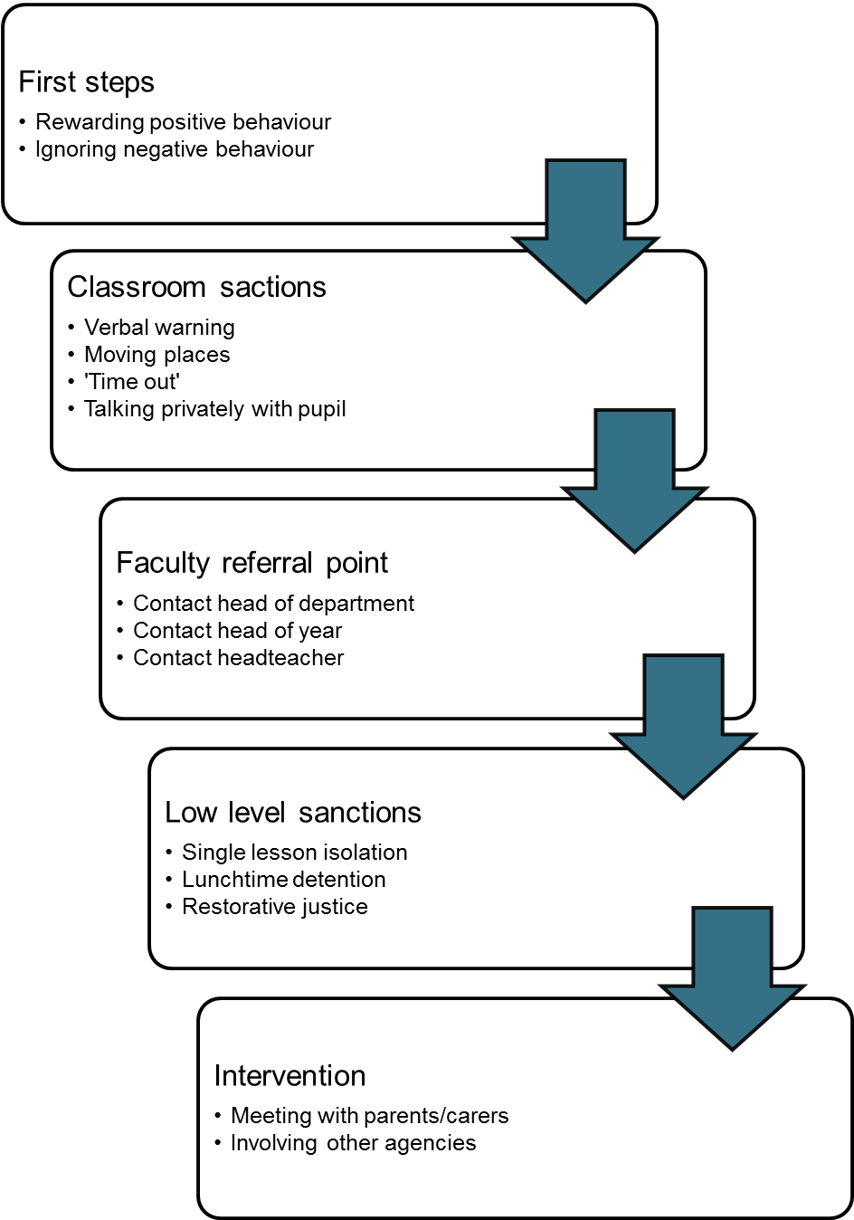

Agreed Sanctions for Unacceptable Behaviour
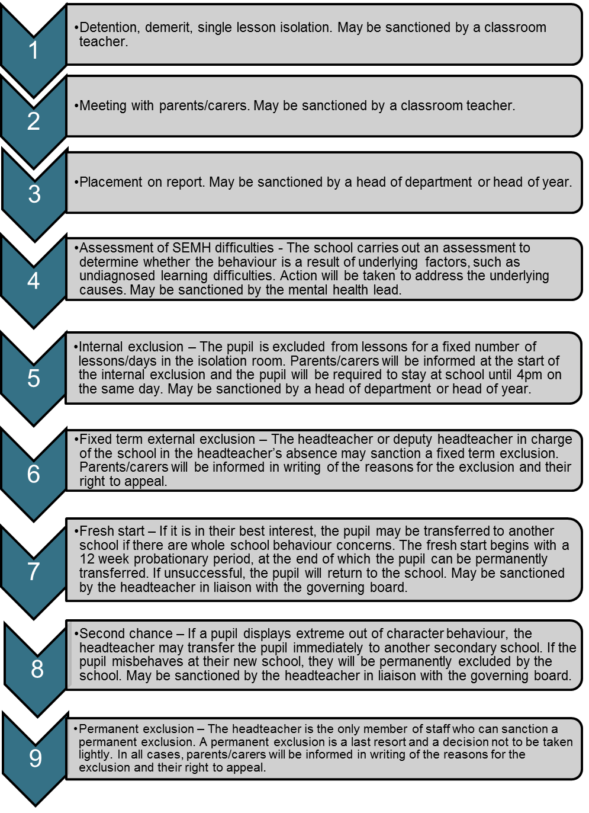

Behaviour Contract
Section 1 – agreement
This contract is a written agreement between you and your teacher. The aim is to identify clear goals for you and support you in the classroom to improve your behaviour. Once this contract is in place, you should do everything you can to stick to your goals.

Pupil name: ________________________________ Date: ____________________

My goals
1

________________________________________________________

2

________________________________________________________
3

_________________________________________________________

To prevent my challenging behaviour, I can:

1. _______________________________________________________________________
2. _______________________________________________________________________
3. _______________________________________________________________________

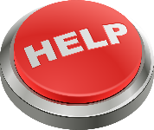
When I demonstrate challenging behaviour, you can help me by:

1. _______________________________________________________________________
2. _______________________________________________________________________
3. _______________________________________________________________________
These are the consequences if I don’t meet my goals:

___________________________________________________________________________________________________________________________________________________________________________________________________________________________
These are the rewards if I meet my goals:
_________________________________________________________________________
_________________________________________________________________________
_________________________________________________________________________

My contract will be reviewed on: date
Pupil signature: ____________________________________
Teacher signature: __________________________________

Classroom Rules Agreement

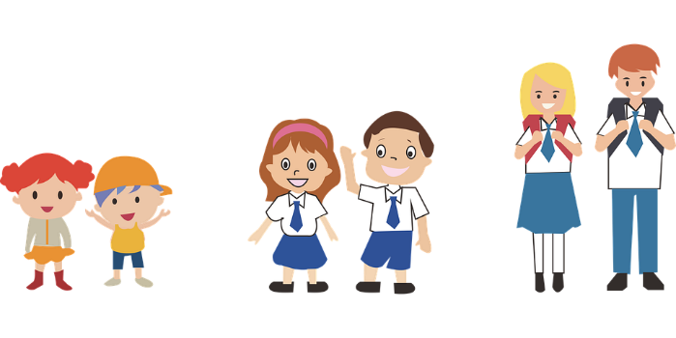
Our classroom rules

Our class, class number/name, has created this agreement so that all pupils know how to behave when they are in class and around the school. Together, we have created our rules and agreed that we will stick to them. This will make sure our whole class is happy and we can get on with our work.
Please read the rules to make sure you understand them – we want to make sure our school is a happy learning environment!
I will:
- Put my hand up when I want to say something.
- Listen to others when they are talking.
- Be respectful of others – my teachers and my class mates.
- Treat others as I would like to be treated.
- Be respectful of the environment and not damage any school property.
- Do as the teacher asks and follow instructions.
- Complete all tasks I have been set and try my best with my work.
- Stop what I’m doing when my teacher claps their hands twice.
- Take responsibility for my own behaviour.
- Tell the teacher if I feel frustrated or distracted.

I understand that if I don’t follow the rules there may be consequences:
[Outline the sanctions your school imposes for breach of classroom rules – examples are below]
1st warning: The teacher tells me to stop the behaviour. I should stop doing what I’m doing.
2nd warning: The teacher asks me to leave the classroom. I must calm down before I come back in.
3rd warning: The teacher tells me to stay behind at breaktime or after school. I must think about why I am acting this way and make sure it does not occur tomorrow.
Pupil name: ________________________ Date: _______________________

Behavioural Incident Form

Name of pupil: |  | Year group:
Date: |  | Time:
Location of observation: |  | Name of staff member:

Before the incident: what led to the behaviour?
During the incident: what did the pupil do?
After the incident: what were the consequences of this behaviour?

Additional comments

Behavioural Management Observations Review Form

Name of pupil: |  | Year group:
Name of key worker: |  | Date:

Do there appear to be any patterns triggering the pupil’s behaviour?
Are our existing management systems effective?
What achievable targets could we implement for the pupil to work towards?
What are the pupil’s strengths?
What effective strategies could we implement to help the pupil achieve their targets?

Additional comments

