Morton Primary School Catch Up Premium Planning 2020-21
In order to support schools with school planning whilst we are in a world pandemic, the Education Endowment Foundation (EFF) has produce two help guidance documents:
“The EEF guide to supporting school planning – A tiered approach to 2020-21”
https://educationendowmentfoundation.org.uk/public/files/Publications/Covid-19_Resources/The_EEF_guide_to_supporting_school_planning_-_A_tiered_approach_to_2020-21.pdf
and
“Covid-19 support guide for schools”
https://educationendowmentfoundation.org.uk/public/files/Publications/Covid-19_Resources/Covid-19_support_guide_for_schools.pdf
These documents suggests schools plan using a tiered approach with respect to school improvement and also with respect to planning how to support children to catch-up.
“Catch-up” in this context refers to the children learning the main aspects of the curriculum them missed when they were in the first lockdown (March-August 2020.)
This, aforementioned, tiered approach describes 3 tiers and the areas of provision within the tiers which schools they suggest should be focussed on to have the greatest impact this year.
(The green text are the areas within the “The EEF guide to supporting school planning” and the red text are those areas detailed in the “Covid-19 support guide for schools.”)
Tier 1 – Teaching (High-quality for all, effective diagnostic assessment, supporting remote learning and focussing on professional development.) Teaching and wholes school strategies (Supporting great teaching, Pupil assessment and feedback and Transition support)
Tier 2 – Targeted academic support (high quality one to one and small group tuition, teaching assistants and targeted support, academic tutoring, planning for pupils with SEND.) Targeted approaches (One to one and small group tuition, Intervention programmes and extended school time)
Tier 3 – Wider strategies (supporting pupils social, emotional and behavioural needs, planning carefully for adopting SEL (social and emotional learning) curriculum, supporting parents with pupils of different ages and successfully implementation in challenging times) Wider strategies (Supporting parent and carers, access to technology and summer support)
It is suggested the a school’s focus should also be split ½ on Tier 1 and a ¼ on Tier 2 and a ¼ on Tier 3, please see the diagram below:

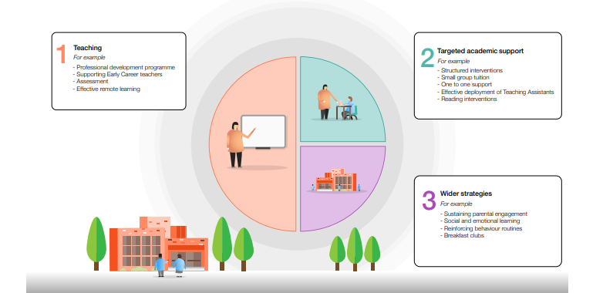

Catch Up Premium
The Government has allocated funding to each school to support “Catch-up”
https://www.gov.uk/guidance/coronavirus-covid-19-catch-up-premium#use-of-funds
This DFE guidance states:
Schools should use this funding for specific activities to support their pupils to catch up for lost teaching over the previous months, in line with the guidance on curriculum expectations for the next academic year.

Catch Up Premium for this school
Our school has been allocated a total of £3533 or this academic year and this is financial split between two financial years.
The DFE guidance on catch-up premium references the two school planning documents so we as a school have decided to use the tiers to support our decision-making with respect to how we spend our catch-up premium. The decisions are also guided by the school’s vision and our determination to ensure all our children “catch-up” and we do not allow this pandemic to adversely effect any of our children’s academic or emotion development.
The diagram details the additional provision we will be putting in place, which will be funded by our “Catch-up Premium.”

