# C:\Users\headteacher\Desktop\fiel.JPGC:\Users\headteacher\Desktop\oLYMPIC VALUES.jpgC:\Users\headteacher\Desktop\mps.jpgC:\Users\headteacher\Desktop\SGMARK+GOLD.jpgC:\Users\headteacher\Desktop\download (1).jpgC:\Users\headteacher\Desktop\download.jpgE:\Users\simon.roche\AppData\Local\Microsoft\Windows\Temporary Internet Files\Content.Word\Evidencing the Impact of the Primary PE and Sport Premium Template 2019 7.3 Images_Page_1.jpg

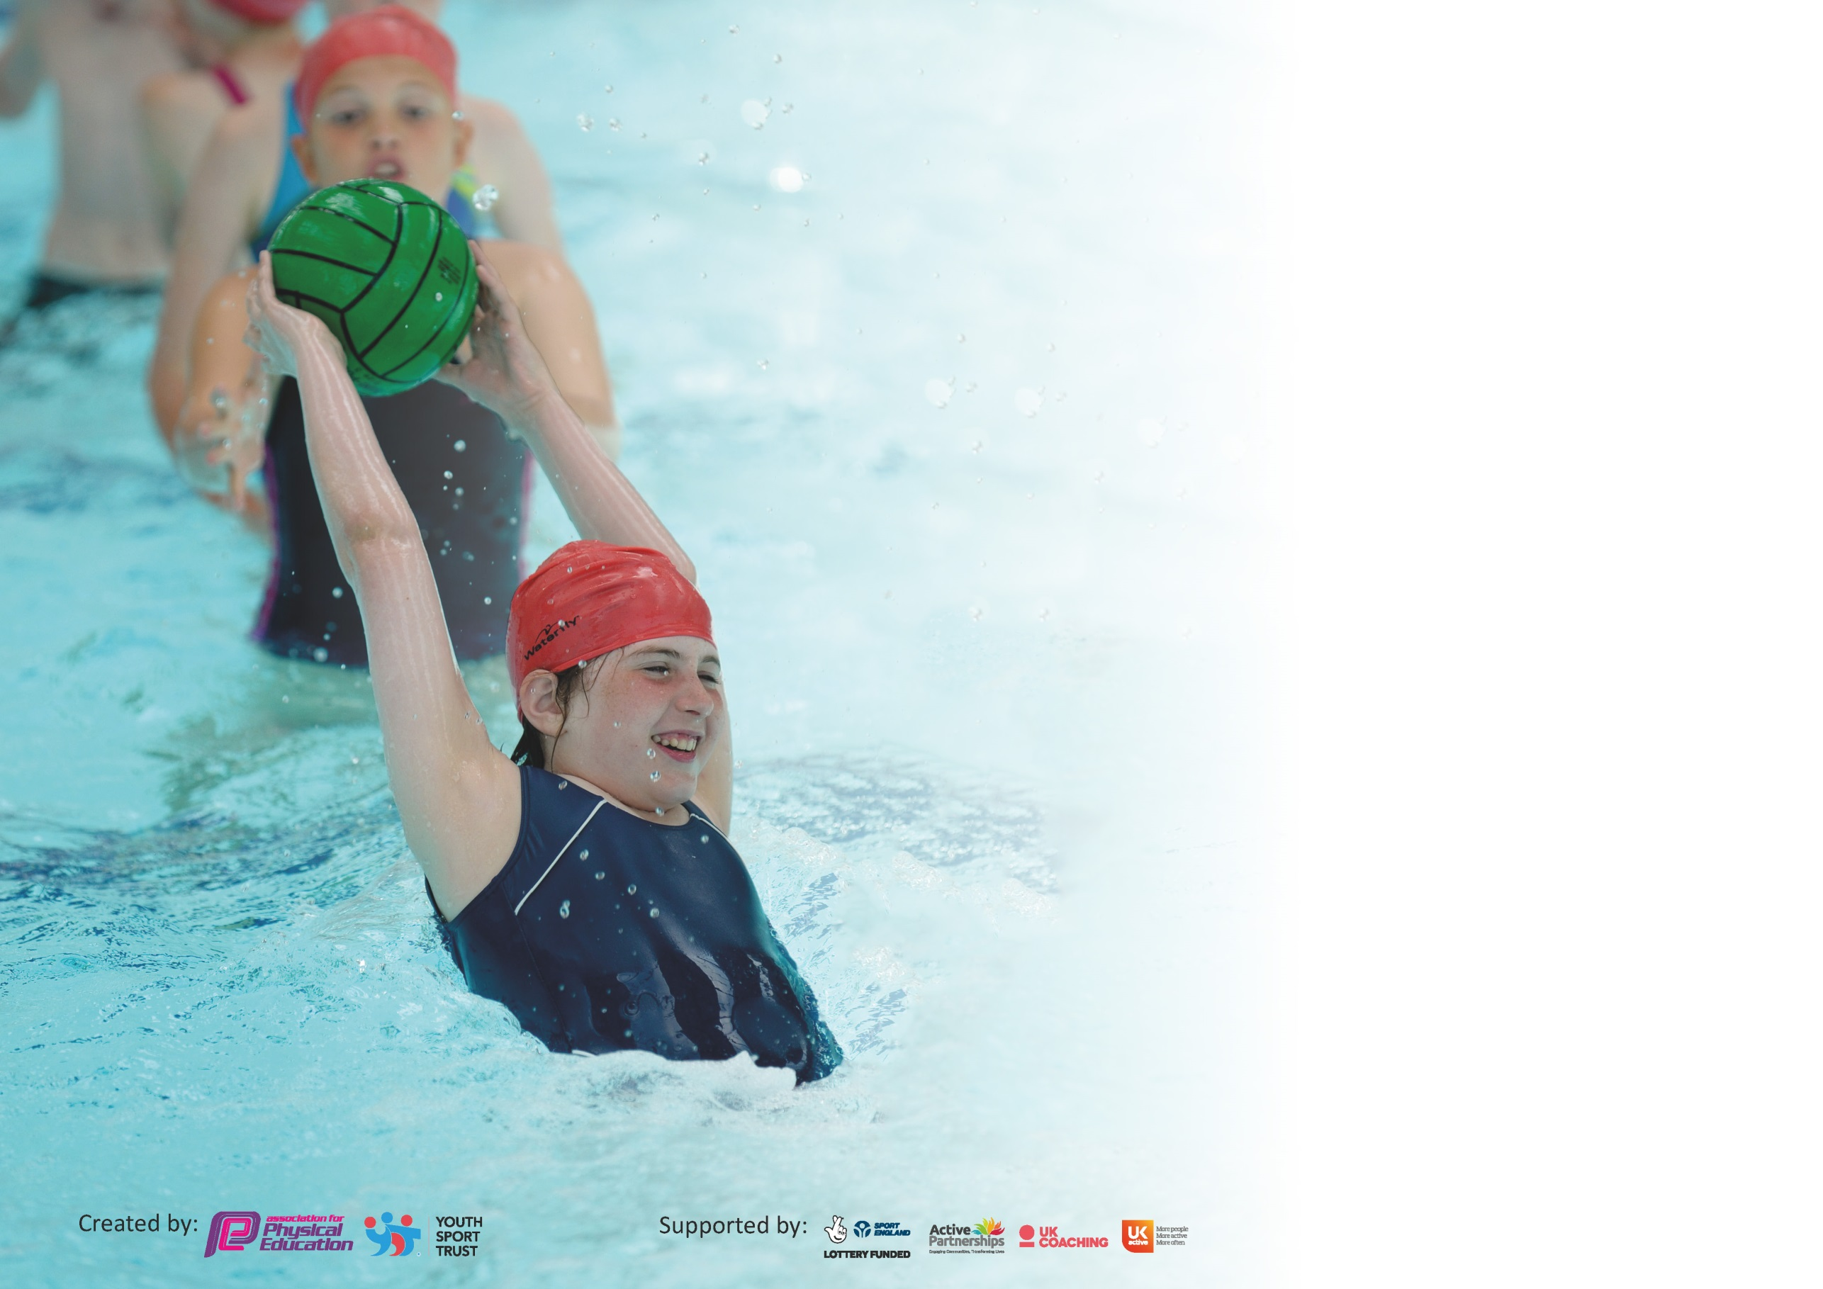

It is important that your grant is used effectively and based on school need. The [Education Inspection Framework](https://assets.publishing.service.gov.uk/government/uploads/system/uploads/attachment_data/file/843108/School_inspection_handbook_-_section_5.pdf) (Ofsted 2019 p64) makes clear there will be a focus on **‘whether leaders and those responsible for governors all understand their respective roles and perform these in a way that enhances the effectiveness of the school’**.

Under the [Quality of Education criteria](https://assets.publishing.service.gov.uk/government/uploads/system/uploads/attachment_data/file/843108/School_inspection_handbook_-_section_5.pdf) (p41) inspectors consider the extent to which schools can articulate their curriculum (INTENT), construct their curriculum (IMPLEMENTATION) and demonstrate the outcomes which result (IMPACT).

To assist schools with common transferable language this template has been developed to utilise the same three headings which should make your plans easily transferable between working documents.

Schools must use the funding to make **additional and sustainable** improvements to the quality of Physical Education, School Sport and Physical Activity (PESSPA) they offer. This means that you should

use the Primary PE and Sport Premium to:

* Develop or add to the PESSPA activities that your school already offer
* Build capacity and capability within the school to ensure that improvements made now will benefit pupils joining the school in future years

Please visit [gov.uk](https://www.gov.uk/guidance/pe-and-sport-premium-for-primary-schools) for the revised DfE guidance including the 5 key indicators across which schools should demonstrate an improvement. This document will help you to review your provision and to report your spend. DfE encourages schools to use this template as an effective way of meeting the reporting requirements of the Primary PE and Sport Premium.

We recommend you start by reflecting on the impact of current provision and reviewing the previous spend.

Schools are required to [publish details](https://www.gov.uk/guidance/what-maintained-schools-must-publish-online#pe-and-sport-premium-for-primary-schools) of how they spend this funding as well as on the impact it has on pupils’ PE and sport participation and attainment by the end of the summer term or by **31st July 2020** at the latest.

We recommend regularly updating the table and publishing it on your website throughout the year. This evidences your ongoing self-evaluation of how you are using the funding to secure maximum, sustainable impact. Final copy must be posted on your website by the end of the academic year and no later than the 31st July 2020. To see an example of how to complete the table please click [HERE](http://www.afpe.org.uk/physical-education/wp-content/uploads/afPE-Example-Template-Indicator-2018-Final.pdf).

Support for review and reflection - considering the 5 key indicators from DfE, what development needs are a priority for your setting and your pupils now and why? Use the space below to reflect on previous spend and key achievements and areas for development.

|  |  |
| --- | --- |
| Key achievements to date until July 2019: | Areas for further improvement and baseline evidence of need: |
| * Achieved School Games **GOLD AWARD** 2019-20 * Achieved School Games **GOLD AWARD** 2018-19 * Achieved School Games **GOLD AWARD** 2017-18 * Achieved School Games **GOLD AWARD** 2016-17 * Achieved School Games **GOLD AWARD** 2015-16 * Achieved School Games **SILVER AWARD** 2014-15 * Achieved **Derbyshire Healthy Schools Community Award** Nov 2018 * Bolsover **Active School of the Year 2018** * Established new Play Leaders and development of an effective School Sports Crew * **Cluster Schools Participation**   Boys Football Winners (4) Y5 (4) Y6  Rugby Megafest (3) Y5 (4) Y6  Girls Football 4th (3) Y5 (4) Y6  Cross Country Boys Y5/6 Team Runners Up (2) Y5 (3) Y6  Cross Country Boys Y3/4 Team 6th (2) Y3 (2) Y4  Cross Country Girls Y5/6 Team A Runners Up (3) Y5  Cross Country Girls Y5/6 Team B 5th (1) Y5 (2) Y6  Cross Country Girls Y3/4 Team A Winners (2) Y3 (2) Y4  Cross Country Girls Y3/4 Team B 5th (3) Y3  Tag Rugby Runners Up (3) Y5 (5) Y6  Sportshall Athletics A Team Winners 2 (Y3) (3) Y5 (5) Y6  Sportshall Athletics B Team Runners Up (6) Y5 (3) Y6  Dance Festival (10) Y5 (11) Y6  Large School Swimming Gala 3rd (20 Y5 (60 Y6  Mixed Y3/Y4 Football 6th (3) Y3 (3) Y4  Boccia (SEND) 4th (2) Y3 (1) Y4 (1) Y5   * **District School Participation**   Boys Football Winners (4) Y5 (4) Y6  Sportshall Athletics A Team Winners 2 (Y3) (2) Y5 (6) Y6  Sportshall Athletics B Team 4th (5) Y5 (4) Y6  Basketball Team A 3rd (2) Y5 (5) Y6  Basketball Team B 6th (5) Y5 (3) Y6   * **County School Participation**   Boys Football 4th (4) Y5 (4) Y6   * Ensuring that children are accessing a wide variety of sports through using specialist coaches to deliver PE in curricular time and through offering a wide range of extra-curricular PE opportunities to facilitate more sporting opportunities, through learning new skills e.g. Fencing, Paceball, Archery, Tri-Golf & Lacrosse. * Links to local clubs through Swimming, Football, Rugby, Cricket, Golf, Dance, Tennis and Martial Arts. * Outdoor Gymnasium built and used at break and lunchtimes * Outdoor Activall installed and used at break and lunchtimes. | * Achieve School Games Platinum **AWARD** 2020-21 * Established School Sports Crew to run intra-school competitions and other activities regularly. * Continue to identify less active pupils and put support in place to encourage participation. * Nominate pupils for recognition at the Bolsover Sports Awards. |

|  |  |
| --- | --- |
| Meeting national curriculum requirements for swimming and water safety. |  |
| What percentage of your current Year 6 cohort swim competently, confidently and proficiently over a distance of at least 25 metres?  **N.B.** Even though your pupils may swim in another year please report on their attainment on leaving  primary school at the end of the summer term 2020. | 75 % |
| What percentage of your current Year 6 cohort use a range of strokes effectively [for example, front crawl, backstroke and breaststroke]? | 75 % |
| What percentage of your current Year 6 cohort perform safe self-rescue in different water-based situations? | 75 % |
| Schools can choose to use the Primary PE and Sport Premium to provide additional provision for swimming but this must be for activity **over and above** the national curriculum requirements. Have you used it in this way? | No |

**Action Plan and Budget Tracking**

Capture your intended annual spend against the 5 key indicators. Clarify the success criteria and evidence of impact that you intend to measure to evaluate for pupils today and for the future.

|  |  |  |  |  |  |
| --- | --- | --- | --- | --- | --- |
| **Academic Year:** 2019/20 | | **Total fund allocated:** £ | **Date Updated:** | |  |
| **Key indicator 1:** The engagement of all pupils in regular physical activity – Chief Medical Officer guidelines recommend that primary school pupils undertake at least 30 minutes of physical activity a day in school £4750.97 | | | | | Percentage of total allocation: |
| 27.9 % |
| **Intent** | | **Implementation** | | **Impact** |  |
| Your school focus should be clear what you want the pupils to know and be able to do and about  what they need to learn and to  consolidate through practice: | | Make sure your actions to achieve are linked to your intentions: | Funding allocated: | Evidence of impact: what do pupils now know and what can they now do? What has changed? | Sustainability and suggested next steps: |
| Children have a core knowledge of fundamentals of movement from Reception to Year 6 and the importance of regular exercise. | | PE timetabled weekly for 2 hours per class for 100% of children. | BSSP Membership through Shirebrook Academy  £2676.00.  Bolsover School Sports Partnership  £1949.97  YST membership £125.00 | PE core curriculum based on developing the fundamentals of movement and sport leading to increased participation in sports competitions as the children become more proficient in playing any sports. | Membership to continue while schools receive the Sports Premium.  Investigate remote Physical Activity schedule for post Covid19 in case of future lockdowns. Discuss this at 5PPS meeting in September 2020. |
| Participation in Intra and Inter school competitions. | | Attend cluster, district and county competitions through association with Shirebrook Academy and the School Sports Partnership | As above | 31 different children (57 %) of those eligible represented school in competitions and festivals 161 different times.  This would have increased to over 70% school participation if the summer festivals for KS 1 had not been cancelled due to Covid19. | Continued subscription to enable participation in cluster. District and county events. |
| **Key indicator 2:** The profile of PESSPA being raised across the school as a tool for whole school improvement £2 002 | | | | | Percentage of total allocation: |
| 11.8 % |
| **Intent** | **Implementation** | | | **Impact** |  |
| Your school focus should be clear what you want the pupils to know and be able to do and about  what they need to learn and to  consolidate through practice: | Make sure your actions to achieve are linked to your intentions: | | Funding allocated: | Evidence of impact: what do pupils now know and what can they now do? What has changed?: | Sustainability and suggested next steps: |
| Continued development of Play Leader Role in school to increase participation in intra school competitions and personal challenges.  Play leader to continue to develop Sports Crew in their leadership skills. | Employment of daily Play Leader dedicated to providing extra-curricular sporting activities for all children during lunchtimes as well as supporting intra competitions.  Developing responsibilities of Sports Crew and Mimi Leaders to develop and take responsibility for sports board and timetable of break/lunchtime activities allowing participation of all year groups in a variety of sporting activities. | | £2002 | Pupils exposed to wide range of physical activities through extra-curricular opportunities | Play Leader to remain in place and continue developing new Sports Crew/Play Leaders in developing their own leadership skills. |

|  |  |  |  |  |
| --- | --- | --- | --- | --- |
| **Key indicator 3:** Increased confidence, knowledge and skills of all staff in teaching PE and sport £1600 | | | | Percentage of total allocation: |
| 9.4 % |
| **Intent** | **Implementation** | | **Impact** |  |
| Your school focus should be clear | Make sure your actions to | Funding | Evidence of impact: what do | Sustainability and suggested |
| what you want the pupils to know | achieve are linked to your | allocated: | pupils now know and what | next steps: |
| and be able to do and about | intentions: |  | can they now do? What has |  |
| what they need to learn and to |  |  | changed?: |  |
| consolidate through practice: |  |  |  |  |
| PE Specialists used to work alongside other adults in school to develop personal skills through CPD and to support accuracy of assessment leading to next steps of learning and differentiation for all children. | Team teaching with specialist sports coaches through subscription to Bolsover School Sports Partnership.  Other Specialist Coaches used  Paceball  Fencing  Lacrosse  Kids tricks | £350.00  £450.00  £450.00  £350.00 | High quality PE lessons being taught and staff skill levels being improved as part of CPD. | Continued subscription to further develop staff CPD so they become fully skilled to lead PE lessons in the absence of PE specialists. |
| **Key indicator 4:** Broader experience of a range of sports and activities offered to all pupils £10 265.32 | | | | Percentage of total allocation: |
| % |
| **Intent** | **Implementation** | | **Impact** |  |
| Your school focus should be clear | Make sure your actions to | Funding | Evidence of impact: what do | Sustainability and suggested |
| what you want the pupils to know | achieve are linked to your | allocated: | pupils now know and what | next steps: |
| and be able to do and about | intentions: |  | can they now do? What has |  |
| what they need to learn and to |  |  | changed?: |  |
| consolidate through practice: |  |  |  |  |
| To increase physical activity above the two hours quality PE per week through improved facilities/activities available. | Maths of the Day used to develop physical learning through active mathematics. | £445.00 | Children more active through physical lessons on curriculum to support extended physical activity. | Continued subscription to MOTD |
| New and replaced equipment to enable increased physical activity as part of the school day.  Improve the facilities in school to ensure a high quality environment and resources are available. | Continued development of a broad range of sports and PE activities across the school and its curriculum. Children continue to improve skills and ability and the experiences they are given continues to be varied across the curriculum. | £5649.43  Hall floor  Mat trolley  Curling  £228.99  Counting Skipping ropes  PE equipment storage shed £818.90  Anomaly Interactive wall boards £2750  Hurdles £93.00  Bikeability £80.00  Premier Sports Fitness Evaluation £200 | EYFS, KS1 and KS2 have an improved knowledge and understanding of a broader range of sports. Fundamental skills continue to improve leading to transferable skills in a range of sports. Continued increase in breaktime and lunchtime sports activities through use of a range of equipment, play leaders and Sports Crewe organistaion. | To continue to enable children to challenge themselves with personal best targets set.  Collection of data for EYFS and KS1 participation |

|  |  |  |  |  |
| --- | --- | --- | --- | --- |
| **Key indicator 5:** Increased participation in competitive sport | | | | Percentage of total allocation: |
| 60.3 % |
| **Intent** | **Implementation** | | **Impact** |  |
| Your school focus should be clear | Make sure your actions to | Funding | Evidence of impact: what do | Sustainability and suggested |
| what you want the pupils to know | achieve are linked to your | allocated: | pupils now know and what | next steps: |
| and be able to do and about | intentions: |  | can they now do? What has |  |
| what they need to learn and to |  |  | changed? |  |
| consolidate through practice: |  |  |  |  |
| Intra school competition to give every child the opportunity to compete.  Encouraging children to compete against themselves, focusing on being the best they can be.  Interschool competitions, to give children the opportunity to compete against other schools.  Additional Physically active cross curricular lessons to give more children the confidence to participate in competitive sport. | Sports crew on the playground supported by play  leader to run intra competitions Personal Challenges – supplied by BSSP Bolsover School Sport Partnership Competition calendar support Bolsover district council gold package | As above KI 1 | More children competing in intra school competitions, and being more active at breaks and lunch times. Encouraging children to reach their personal best Attending varied and interesting inter competitions which children really enjoy taking part in, more festival style competitions entered this year to give children the opportunity to represent their school. Fundamentals to provide children the confidence to participate in competitions. | To develop Y4 leadership skills, and have a sports crew across both bubbles within school. To continue to raise the profile of personal challenges across school. To continue to attend a wide variety of inter school events. To attend primary plus inclusion festival, SEND event cancelled for this year (Covid19) |

|  |  |
| --- | --- |
| Signed off by | |
| Head Teacher: | Kevin Flint |
| Date: | 3/09/2020 |
| Subject Leader: | K.Allen |
| Date: | 03/09/2020 |
| Governor: | H.Bramley |
| Date: | 03/09/2020 |