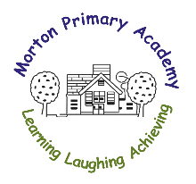
Morton Primary Academy
Main Road, Morton, Alfreton, Derbyshire
DE55 6HH
Tel: 01773 872360
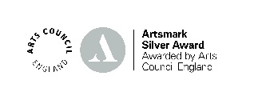
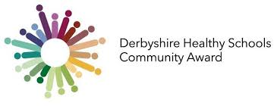
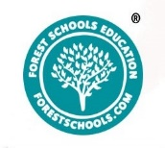
Email: info@morton.derbyshire.sch.uk
Headteacher: Miss L Jackson __________________________________________________________________________________________

Dear Parent/Carer

Parents and carers are now able to check their eligibility and apply for Free School Meals instantly via a Parent Portal.
It is easy to create a Parent Portal account, parents and carers please click the link below, or visit www.derbyshire.gov.uk and use the search box at the top of the page to search for free school meals.
http://www.derbyshire.gov.uk/freeschoolmeals
Once signed in, it is quick to check if your child(ren) can receive Free School Meals.
Applications for Free School Meal funding can also still be made via paper form or contacting the Free School Meals Team on the contact details below:
Phone: 01629 536 481 Mon – Fri, 01629 535 743 Wed – Fri
E-mail: checking@derbyshire.gov.uk
Thank you.

