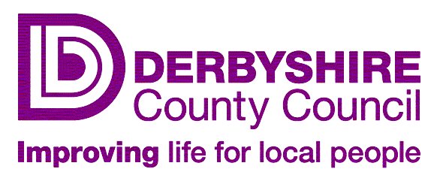

Morton Primary School
Main Road, Morton, Alfreton, Derbyshire DE55 6HH
Tel/Fax: 01773 872360
email: info@morton.derbyshire.sch.uk
Headteacher: Kevin Flint
_________________________________________________________________________________

4th September 2018

Good to be Green Behaviour Reward System.

Dear Parents/Carers,
During the Summer Term we looked at how ‘safe’ the children feel in school and the ‘behaviour for learning’ of children. To gain a ‘Pupil Voice’ we consulted with the children.

The children were asked 2 questions

- What stops you feeling safe at school?
- What stops you learning at school?

As a result of these discussions the children have come up with a number of rules that will allow them to feel safe and have a good behaviour for learning ethos across school. This is going to be implemented through the ‘Good to be Green’ Reward System that will run right through the school from Reception through to Year 6.

We understand that while children get used to the ‘Good to be Green ‘system there may be a few teething problems and therefore we will work on ensuring the children fully understand how the rewards and sanctions work during the first term. Although we will still record all types of behaviour in the first term this will only be to demonstrate to the children how the system works and it will go live from the October half term.

I am happy to discuss any concerns you have with the new Good to be Green Behaviour Reward System and hope by us implementing this the children will feel safer in school and the behaviour for learning helps towards the children making their expected progress.

Attached is a booklet explaining this in more detail and it will also be on the school website by half term when it goes live.

Kind Regards

Kevin Flint
Headteacher

