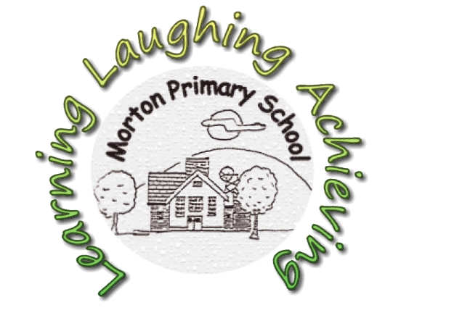

MORTON PRIMARY SCHOOL

Parental use of Social Media
Overview
Social networking sites such as Facebook and Twitter are now widely used. This type of media allows people to communicate in ways that were not previously possible. However, such sites can be inappropriately used by some as a means of expressing negative or offensive views about schools and their staff. This document sets out this School’s approach to parental use of such sites and sets out the procedures we will follow and action we may take when we consider that parents have used such facilities inappropriately. When we have referred to “parent” in this document, we also include carers; relatives; or anyone associated with the School.
Objectives
The purpose of this policy is to:
• Encourage social networking sites to be used in a beneficial and positive way by parents;
• Safeguard pupils, staff and anyone associated with the school from the negative effects of social networking sites;
• Safeguard the reputation of the School from unwarranted abuse on social networking sites;
• Clarify what the School considers to be appropriate and inappropriate use of social networking sites by parents;
• Set out the procedures the School will follow where it considers parents have inappropriately or unlawfully used social networking sites to the detriment of the School, its staff or its pupils, and anyone else associated with the School; and
• Set out the action the School will consider taking if parents make inappropriate use of social networking sites.

Appropriate use of social networking sites by parents
Social networking sites have potential to enhance the learning and achievement of pupils and enable parents to access information about the School and provide feedback efficiently and easily. In addition, the School recognises that many parents and other family members will have personal social networking accounts, which they might use to discuss/share views about school issues with friends and acquaintances. As a guide, individuals should consider the following prior to posting any information on social networking sites about the School, its staff, its pupils, or anyone else associated with the School:
• Is the social networking site the appropriate channel to raise concerns, give this feedback or express these views?

• Would private and confidential discussions with the School be more appropriate? E.g. if there are serious allegations being made/concerns being raised. Social media/internet sites should not be used to name individuals and make abusive comments about those people. Please contact the school to discuss any concerns you may have.

• Are such comments likely to cause emotional or reputational harm to individuals which would not be justified, particularly if the School has not yet had a chance to investigate a complaint?

• The reputational impact that the posting of such material may have to the School; any detrimental harm that the School may suffer as a result of the posting; and the impact that such a posting may have on pupils’ learning.
Inappropriate use of social networking sites by parents
Although social networking sites may appear to be the quickest and easiest way to express frustrations or concerns about the School (and those associated with it), it is rarely appropriate to do so. Other channels, such as a private and confidential discussion with the School, or using the School’s formal complaints process are much better suited to this.
The School considers the following examples to be inappropriate uses of social networking sites. (This list is non-exhaustive and intended to provide examples only):
• Making allegations about staff or pupils at the School/cyber-bullying;
• Making complaints about the School/staff at the School;
• Making defamatory statements about the School or staff at the School;
• Posting negative/offensive comments about specific pupils/staff at the School;
• Posting racist comments;
• Posting comments which threaten violence.

Parents should also ensure that their children are not using social networking/internet sites in an inappropriate manner.

It is expected that parents/carers explain to their children what is acceptable to post online.

Parents/carers are also expected to monitor their children’s online activity, including in relation to their use of social media.

Procedure the School will follow if inappropriate use continues

The School will always try to deal with concerns raised by parents in a professional and appropriate manner and understands that parents may not always realise when they have used social networking sites inappropriately. Therefore, as a first step, the School will usually discuss the matter with the parent to try and resolve the matter and to ask that the relevant information be removed from the social networking site in question. If the parent refuses to do this and continues to use social networking sites in a manner the School considers inappropriate, the School will consider taking the following action:

• Take legal advice and/or legal action where the information posted is defamatory in any way or if the circumstances warrant this;
• Set out the School’s concerns to you in writing, giving you a warning and requesting that the material in question is removed;
• Contact the Police where the School feels it appropriate – for example, if it considers a crime (such as harassment) has been committed; or in cases where 3 the posting has a prejudicial element, is considered to be grossly obscene or is threatening violence;
• If the inappropriate comments have been made on a school website or online forum, the School may take action to block or restrict that individual’s access to that website or forum;
• Contact the host/provider of the Social Networking site to complain about the content of the site and ask for removal of the information;
• Take other legal action against the individual.

