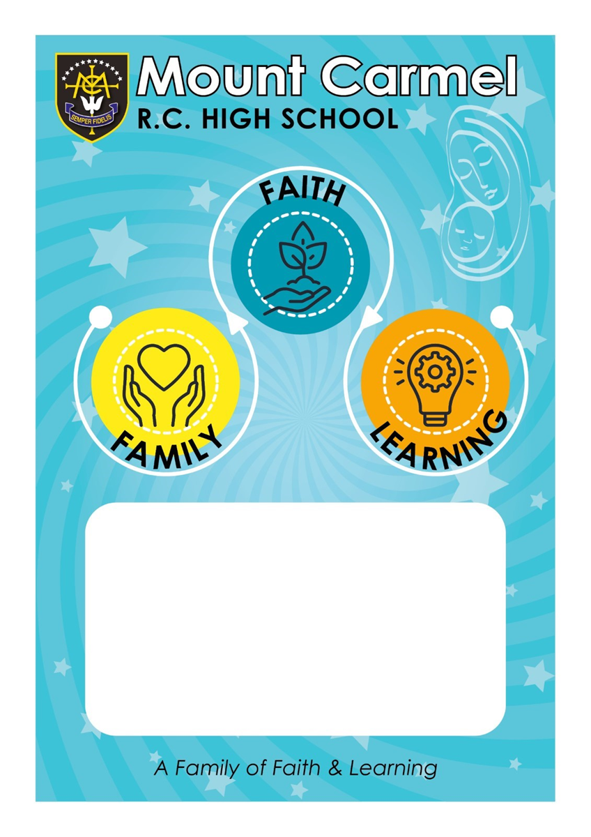

Last review date / name: 04.07.23 by C. Farrelly
Next review date / name: July 2024 by C. Farrelly

Mount Carmel Roman Catholic High School
As a school, what do we mean by the term feedback?

Feedback is a central part of a teacher’s role and is integral to pupil progress and attainment. Research suggests that providing feedback is one of the most effective and cost-effective ways of improving pupils’ learning. The over-arching aim of any feedback given is to move the learner forward and in doing so, the focus should be on improving the learner, not the work.

Feedback at Mount Carmel will be given to pupils in a range of different forms: verbal, peer, self- assessment, and teacher marking. All teachers will use a combination of these, choosing the best form as appropriate to the learning and their subject specific context. The best feedback, whether it is written or verbal, will give students a clear sense of how they can improve, with students responding and making progress as a result.

Aims of Feedback:

- To help pupils make progress.
- To provide suggestions/guidance for pupils to improve.
- To give pupils Dedicated Improvement and Reflection Time (DIRT) to make improvements.
- To inform planning and structure the next phase of learning for pupils and/or the teacher.
- To help teachers identify misconceptions so that they can readdress these in a timely fashion.
- To encourage a dialogue to develop between pupils and teacher.
- To encourage pupils to have a sense of pride in their work and to aim for a high standard of presentation.
- To correct literacy and numeracy errors across all subject areas.

Principles:

Teachers should start by laying the foundations for effective feedback to take place. This involves teachers making effective use of their department’s Progression Maps so that they, and pupils, are clear (lesson by lesson) on what good learning and progress towards this, looks like. In order to do this, teachers should:

- Follow the department Progression Maps when planning lessons so that they, and the pupils, are clear on what the learning objectives for that lesson are. These objectives should be shared with the pupils.
- Be clear on what knowledge/skills are being assessed in each lesson and use that to plan effective activities and feedback tasks/strategies that will exhibit whether pupils are able to move forward with their learning. These feedback opportunities should aim to involve ALL learners.
- Provide high quality instruction in lessons so that ALL pupils are clear on what they are expected to do.
- Provide pupils with clear success criteria for tasks; these criteria should then be used when providing feedback (peer/self or teacher).
- Be clear on what the common misconceptions are for the units that are being taught and use this information to inform lesson and task planning. These misconceptions may be subject specific or related to literacy and numeracy errors.
- Address misconceptions as and when they arise. That may be with the whole class, or, with individuals as deemed appropriate by the individual teacher.
- Use a range of strategies to assess pupil understanding to inform future teaching and lesson planning. These strategies may be a mixture of: questioning, book looks; exit tickets, plenaries.
- Use a range of strategies to provide feedback to pupils. These strategies may be a mixture of: whole class feedback sheets; starter activities (linked to maintenance marking); use of the visualiser; individual conversations with pupils; whole-class re-teaching/clarification.

Type and frequency of feedback:

Verbal Feedback:

- This is the most frequent form of feedback and will be ongoing in lessons.
- It has immediacy and relevance as it leads to direct student action.
- Verbal feedback may well be directed to individuals or groups of students; it may take the form of a question, suggestion, direction, or clarification.
- In order to provide effective, and timely, verbal feedback in lessons, teachers must be active during group/individual tasks so that they are able to respond immediately to any misconceptions.
- There is no requirement for verbal feedback to be indicated in pupils’ books by the use of stampers or any other such measure.

Written Feedback:

- There are two types of written feedback: detailed and maintenance.
- Each department will outline the frequency of their written feedback as appropriate to their subject area and key stage. As a minimum, one piece of work per half term will be given detailed written feedback and this will be marked using the department Whole Class Feedback sheets.
- The work that will be selected for detailed written feedback must be work that will move the learning forward and produce work at the end of the unit that is the best possible work for that pupil. Therefore, end of unit assessments should not be selected for detailed written feedback. These pieces should be specified by curriculum leaders.
- Teachers should only write in a pupil’s book if it is going to impact on their progress. Therefore, all detailed marking (using the WCF sheets) should be followed up with NOW tasks for the pupils to complete to move their learning forward. All NOW tasks should relate specifically to the learning objectives and success criteria.
- Maintenance marking is when teachers flick through the pupils’ books to assess how far they have understood the learning. Maintenance marking will then be used to inform future lesson activities that will address misconceptions; correct literacy/numeracy errors and reinforce presentation expectations.
- When teachers are maintenance marking, they should indicate this in books by initialling the bottom right-hand corner of the last page that has been checked.

Peer and Self-Assessment

- Self and peer feedback are most effective when it has been structured and modelled by the teacher and links specifically to the objectives/success criteria.
- Written self and peer feedback should be clearly indicated and completed in red pen.
- Students need to be well trained over time to effectively self and peer assess. This process will be clearly led by the subject teacher.

Literacy and Numeracy Feedback:

- If the literacy standards of our pupils are going to improve, we must all give appropriate and targeted feedback. Spelling, punctuation and grammar are essential in all subjects across the curriculum.
- Pupils should be encouraged to self-correct once the error has been highlighted.
- All teachers must address repeated literacy and numeracy errors through their feedback in lessons.
- We all have a duty to be vigilant about the standards of our pupils’ numeracy where appropriate. For example, concepts such as graphs, ratio, proportions etc should be monitored accurately across the curriculum and taught as directed by the Numeracy Co-ordinator.

Monitoring and Evaluation:

- Curriculum Leaders must ensure their departmental feedback policy supports the school policy. This policy should clearly identify the type and frequency of feedback in subjects.
- Curriculum Leaders should undertake quality assurance to ensure feedback is allowing students to progress their learning as per the school’s monitoring schedule.
- Curriculum Leaders should undertake quality assurance to ensure feedback is allowing students to progress their learning as per the school’s monitoring schedule. This will be discussed in line management meetings.

