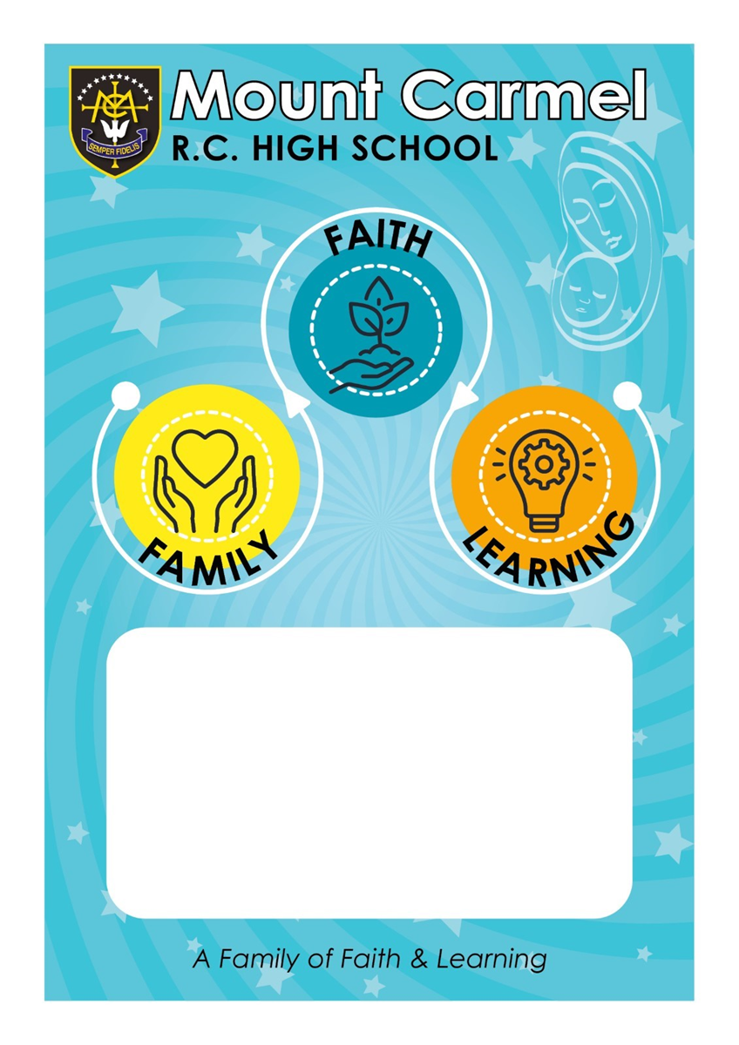
Literacy Policy 2023.24

Mount Carmel Literacy Policy 2023.24
Rationale

In line with the Mount Carmel Mission Statement, we strive to develop and nurture literacy skills in all pupils. We aim to work together to enable pupils to meet their full potential; stimulating, challenging and supporting all aspects of literacy, throughout the curriculum.

Literacy across the Curriculum

Teachers should aim to ensure that speaking, as the pre-curser to writing, is an important aspect of lessons. The use of standard English through correct grammar and pronunciation should be modelled and emphasised when talking to pupils at all times. Informal language and slang should be corrected with a continual focus to improve the quality of the spoken word. Key terms and subject specific vocabulary should be embedded within lessons.

Policy Aims:

- To create a consistent, whole school approach to literacy through providing guidance and support to staff, in the planning, delivery and assessment of pupils.
- To raise awareness of the importance of literacy skills with staff, pupils and parents.
- To improve and develop pupils’ literacy skills in reading, writing, speaking and listening.
- To develop pupils’ understanding of GCSE vocabulary and their ability to read and answer exam questions.

To support the aims above, the following is necessary:

- Teachers model good literacy skills and reinforce the importance of accuracy in spoken and written language, correcting this when necessary.
- Teachers support pupils with key elements of literacy through both marking and verbal feedback e.g. identifying errors in spelling, punctuation and grammar mark work. In this regard they also support the use of key subject specific vocabulary, sentence construction and the layout of text.
- Teachers follow their department’s ‘Disciplinary Literacy Template’ which informs how each specific department develops literacy skills within their subject area.
- Teachers make use of the whole school reciprocal reading strategies as and when appropriate in lessons.
- Teachers make use of the whole school phonics strategies (see phonics Walkthru) to support pupils with reading new and unfamiliar words
- Form tutors follow the whole school literacy booklet resources with their tutees on the assigned days for KS3
- Teachers assign the literacy homework during their dedicated fortnight for years 7,8 and 9. This should be followed up with a starter activity in lesson so that pupils are clear of the value of completing the literacy homework.

C Farrelly July 2023

