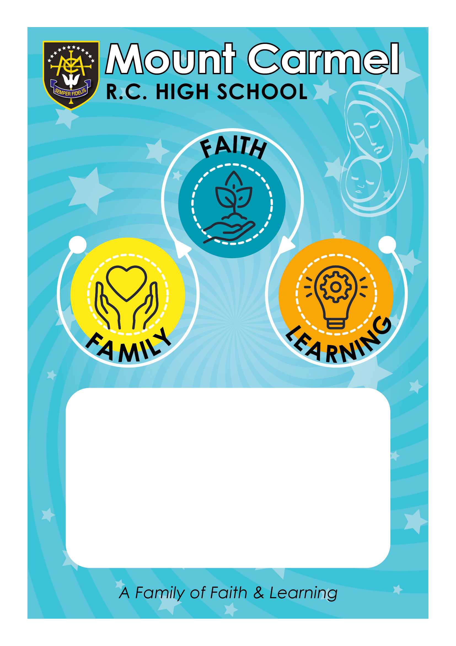
Last reviewed: 28 June 2023 / DSY and LBY
Next review: Summer Term 2024 / DSY and LBY
SEND Policy

SEND Policy

1. Introduction
Mount Carmel RC High School aims to embrace the needs of all pupils and has a whole school approach to special educational needs and disabilities (SEND). We provide effective opportunities for all pupils by responding to the pupils’ diverse learning needs, setting suitable learning challenges and overcoming barriers to learning. All teachers teach pupils with SEND. Our SEND provision is co-ordinated by the Special Educational Needs Co-ordinator (SENCO) and Learning Support team and follows Department for Education (DfE) definitions and guidance and reflects our statutory duties introduced by the Special Educational Needs and Disability Act 2001 and Disability Discrimination Act 2005.

2. Principles
The term “SEND” covers a learning difficulty or a disability which prevents, hinders or inhibits a pupil from; accessing our facilities/resources, limits progress/opportunities and constitutes a significant difficulty. These include; ADHD and some complex behavioural, emotional and social difficulties, physical impairments, speech, language and communication disorders including Tourette Syndrome, hearing impairment, visual impairment, multi-sensory impairment, conditions such as diabetes and epilepsy. Autistic Spectrum Condition and mental health disorders are among the disabilities that may also be classed as SEND if they have significant impact on the pupil’s ability to make progress and take a full part in school life. Special educational provisions are interventions which are additional to, or different from those made for other pupils. We escalate and involve experts as needed to ensure progress as part of a graduated response, in line with the SEN Code of Practice. We follow DfE guidance when we review progress, update targets, and define, manage and map special provision.

3. Identification and assessment
Many pupils with SEND will have had formal assessments or diagnoses at primary school. Our Transition Team have developed links with our primary feeder schools who inform us of the pupil’s with SEND, in preparation for transition to Mount Carmel RC High School. The SENCO takes part in Year 6 annual reviews of pupils with Educational Health Care Plans or significant need. All pupils are assessed on entry to Mount Carmel RC High School.
In some cases, a pupil without previously identified SEND may not make adequate progress, or teachers may consult the SENCO about other concerns. The Learning Support Team will arrange monitoring, assessment and observation as needed, and if appropriate will arrange for further testing or referrals.

4. Provision
At Mount Carmel RC High School, we have a policy of individual planning and recording for all pupils, and deliver personalised learning initiatives. Every pupil has individual targets and we record outcomes for them. IEPs and provision-mapping for pupils with SEND are therefore an integral part of our whole-school management systems.
For pupils with SEND our provision mapping also:
- Identifies additional or different provision and its costs
- Links provision to individuals
- Monitors and reviews provision and pupils’ targets
Special provision usually means differentiated delivery, resources or tasks managed by teachers in class settings, without involving additional adults. It may also entail in-class work or targeted group interventions by Teaching Assistants, such as literacy catch-up groups, or work on areas such as social skills or speaking and listening, to address learning gaps, boost achievement or develop strengths. Some pupils with SEND also have special (access) arrangements in exams, such as extra time, a reader or access to a word processor.
In some cases, pupils with SEND will have had medical or educational assessments designed to identify their areas of need, and report on how all stakeholders can support them. We may use elements of these reports to inform our provision mapping. Pupils with SEND who have difficulty managing their behaviour will have this reflected in their IEP. This will include an outline of their difficulties, special provision and targets, and be used for monitoring and reviewing. This work is carried out in partnership with the Pastoral Leaders/SLT. Some pupils who have a medical disability will have a Care Plan prepared with the help of the pupil, their parents/carers, and other involved professionals. Care plans detail support arrangements, medications, contact numbers and procedures, and are reviewed at least annually. Pupils for whom English is a second language, gifted and talented pupils, pupils from ethnic minorities, children looked after by the Local Authority and other vulnerable groups may get differentiated provision but do not come under the umbrella of SEND provision unless they also have a learning difficulty or disability with significant impact.

5. Resources
Funding for pupils with SEND is allocated according to a funding formula which changes from time to time. The majority of this funding is already allocated to schools for existing named pupils. Our SENCO manages our bids for funds which maybe required as part of a pupil undergoing an assessment for an EHC Plan.

6. Partnership with parents, carers and pupils
Mount Carmel RC High School emphasises the importance of involving pupils and developing a partnership with parents/carers in order to plan provision and review progress. Involvement includes discussions with relevant school staff and external agencies. Parents and carers of pupils with a formal EHC Plan are always asked to attend an annual review meeting and to be actively involved in the review process, including the agreeing of targets and strategies.

7. Monitoring and evaluation
This SEND policy is reviewed at least annually, and the SENCO prepares an Annual Report for the Governors.

8. Complaints procedure
If a parent/carer has any concerns or complaints regarding the care or welfare of their child, an appointment can be made by them to speak to the Deputy Headteacher or SENCO, who will be able to advise on formal procedures for complaint.

June 2023

