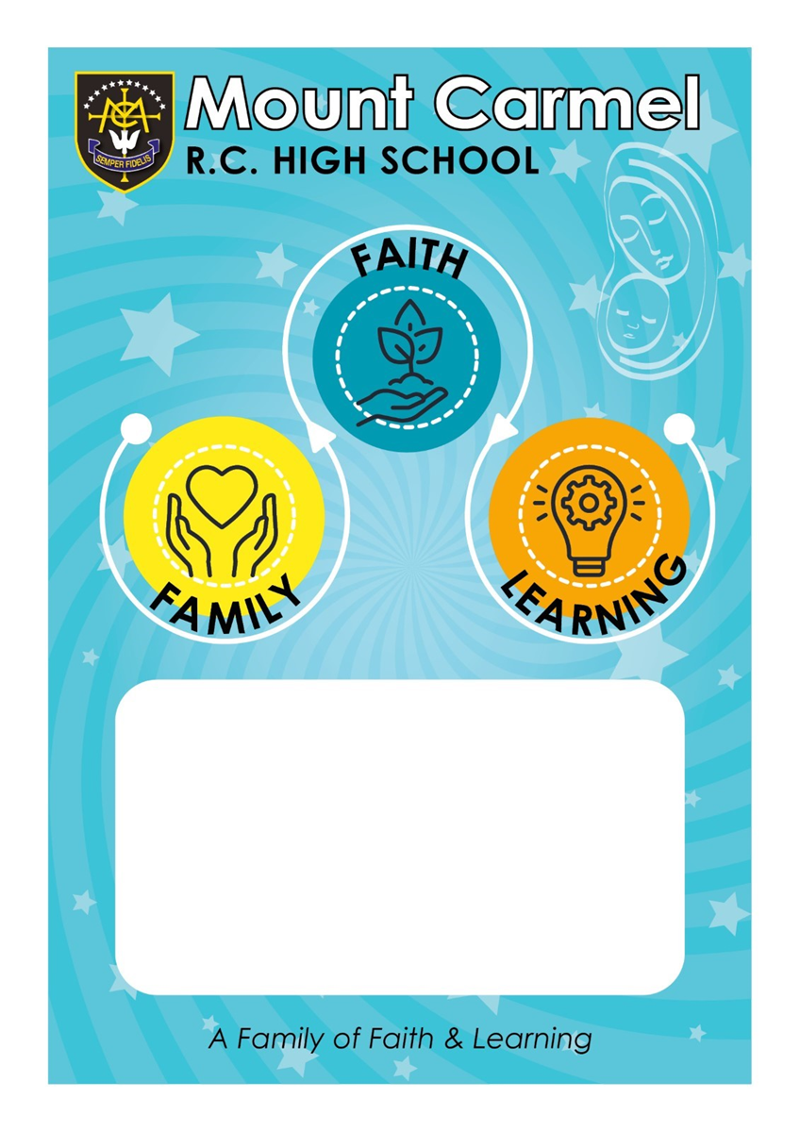
eaching and Learning Policy 2023.24

Teaching and Learning Policy 23.24
“A family of faith and learning”
At Mount Carmel RC High School, we believe in the worth and dignity of each individual. Our aim is to nurture their gifts and talents by providing a caring, challenging and stimulating environment in which effective learning and teaching takes place. We want all of our pupils to achieve as well as they possibly can. Our staff aim to plan, assess and teach effectively in order to allow our pupils to reach their potential with the support they need to get there. The intention is to provide a structure that enables teachers to provide a challenging, supportive and enjoyable learning climate where pupils can excel.

Aims of the policy:

- To create a consistent, whole school approach to teaching and learning.
- To equip all pupils with the knowledge and skills they need at each end point of their high school career.
- To ensure that teaching supports students in knowing and remembering more and being able to apply this knowledge fluently and in new contexts.
- To support students in their ability to read fluently and at an age appropriate level
Pupils learn best when they:
- Feel safe and happy in their learning environment.
- Are clear about their learning journey and can see how new learning builds on prior learning and understand what the key knowledge is for each unit of work and how, and when, they will be assessed on this
- Are engaged, challenged, stimulated to think and motivated to learn.
- Know how well they are doing and what they need to do to progress.

Planning and delivery of lessons:
Teachers should follow the Mount Carmel behaviour policy and plan and deliver lessons which:
- Have high expectations for all pupils regardless of their starting points.
- Set appropriate, relevant learning objectives and success criteria where appropriate.
- Ensure that the school’s CPD priorities (‘Walkthrus’: Explaining and Modelling; Questioning and Feedback; Think, Pair, share; Show me Boards; Metacognitive Talk) are embedded into practice.
- Ensure misconceptions are picked up on and addressed within sequences of lessons. This will be done through questioning strategies and maintenance marking.
- Introduce “big picture”/links to prior learning.
- Use a range of approaches to reward pupils appropriately and use sanctions in line with the school policy where necessary.
- Enhance the climate for learning through the appropriate use of displays that do not lead to over-stimulation or cognitive overload.
- Seat pupils strategically in accordance with the tasks planned to maximise their effectiveness to promote learning. Ensuring that pupils have an appropriate partner for ‘Think, Pair, Share’ activities.
- Allow pupils to develop and practise metacognition by modelling what this looks like in the classroom and providing pupils with opportunities to assess and reflect on their own learning within the classroom.
- Teach literacy and numeracy skills within the subject context.
- Set appropriate, relevant and challenging homework.
- Use assessment data to inform teaching and support pupils’ progress.
- Work with TAs, and other adults, to ensure pupils are best supported in their learning.
- Make use the school’s coaching programme to help support the development of quality first teaching

Reviewed July 2023: C. Farrelly

