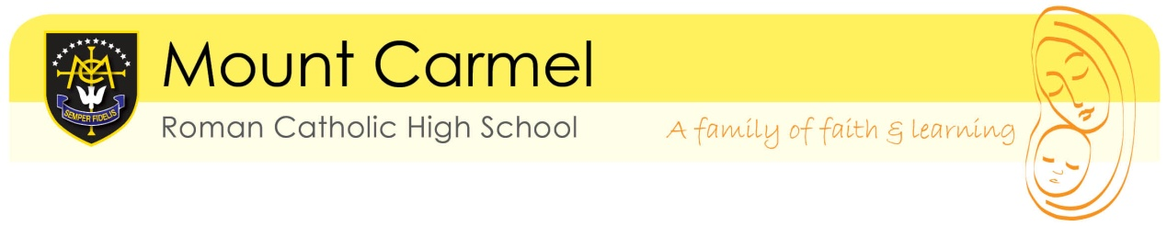
YEAR 10 PPEs APRIL 2026

DATE | TIME | LENGTH | EXAMINATION
Monday 20 April 2026 (B) | 9:00am | 1hr 45 | English Literature
Monday 20 April 2026 (B) | 11:30am | 50m | Religious Studies
Tuesday 21 April 2026 | 9:00am | 1hr 15 | Biology
Tuesday 21 April 2026 | 11:30am | 1hr 30 | Maths paper 1 non calc
Wednesday 22 April 2026 | 9:00am | 1hr 45 | English Language
Wednesday 22 April 2026 | 11:30am | 1hr 15/20 | Spanish writing
Thursday 23 April 2026 | 9:00am | 1hr 30 | Geography
Thursday 23 April 2026 | 11:30am | 1hr 30 | Computer Science
Friday 24 April 2026 | 9:00am | 1 hr 15 | Chemistry
Friday 24 April 2026 | 11:30am | 1hr 30 | Maths paper 2 calc
Monday 27 April 2026 (A) | 9:00am | 1hr 15 | Physics
Monday 27 April 2026 (A) | 11:30am | 1 hr 45 | Food and Nutrition (room G7)
Tuesday 28 April 2026 | 9:00am | 1hr 30 | History
Tuesday 28 April 2026 | 11:30am | 45/1hr 5 | Spanish reading
Wednesday 29 April 2026 | 9:am | 2 hrs | DT
Wednesday 29 April 2026 | 11:30am | 1hr | GCSE PE
Thursday 30 April 2026 | 9am | various | Catch-up session

